CROSS TALK – the Benefice Magazine
May 2019

Dear Friends,
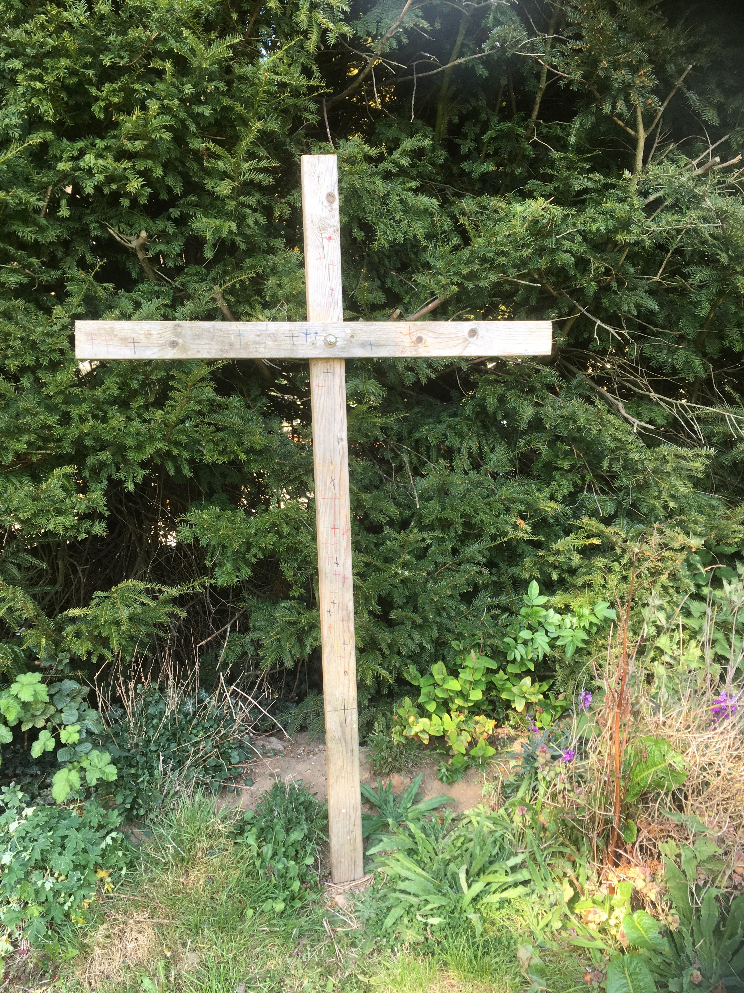
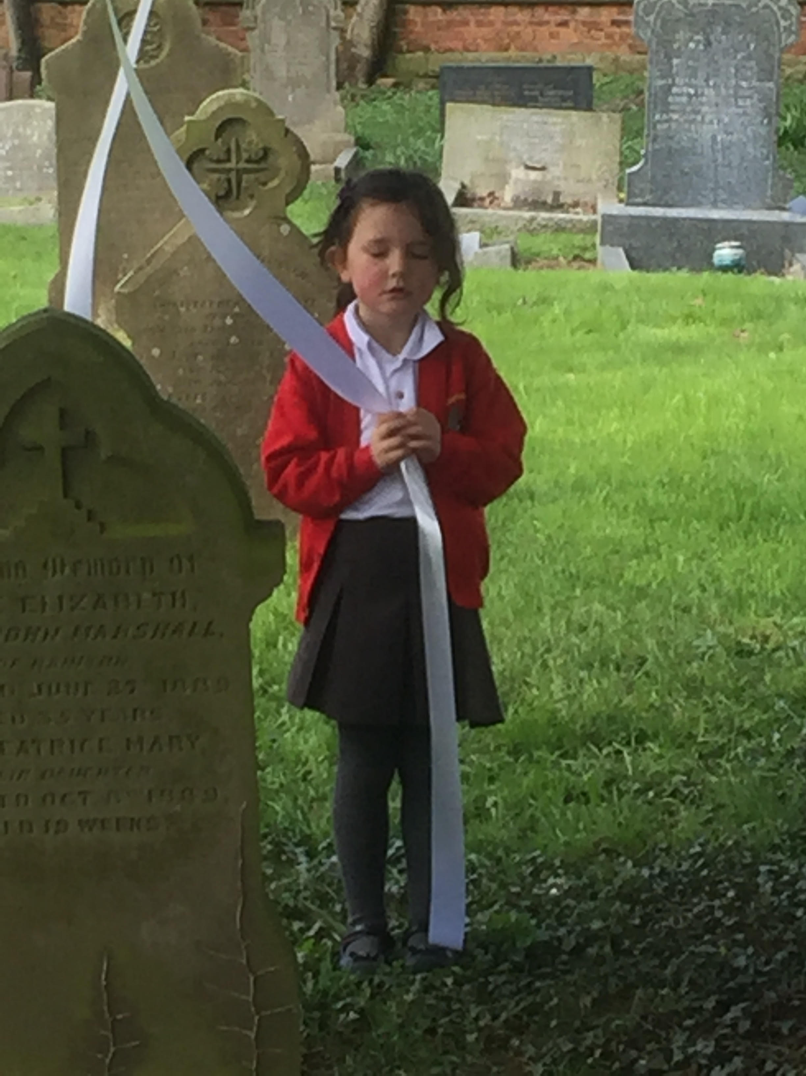
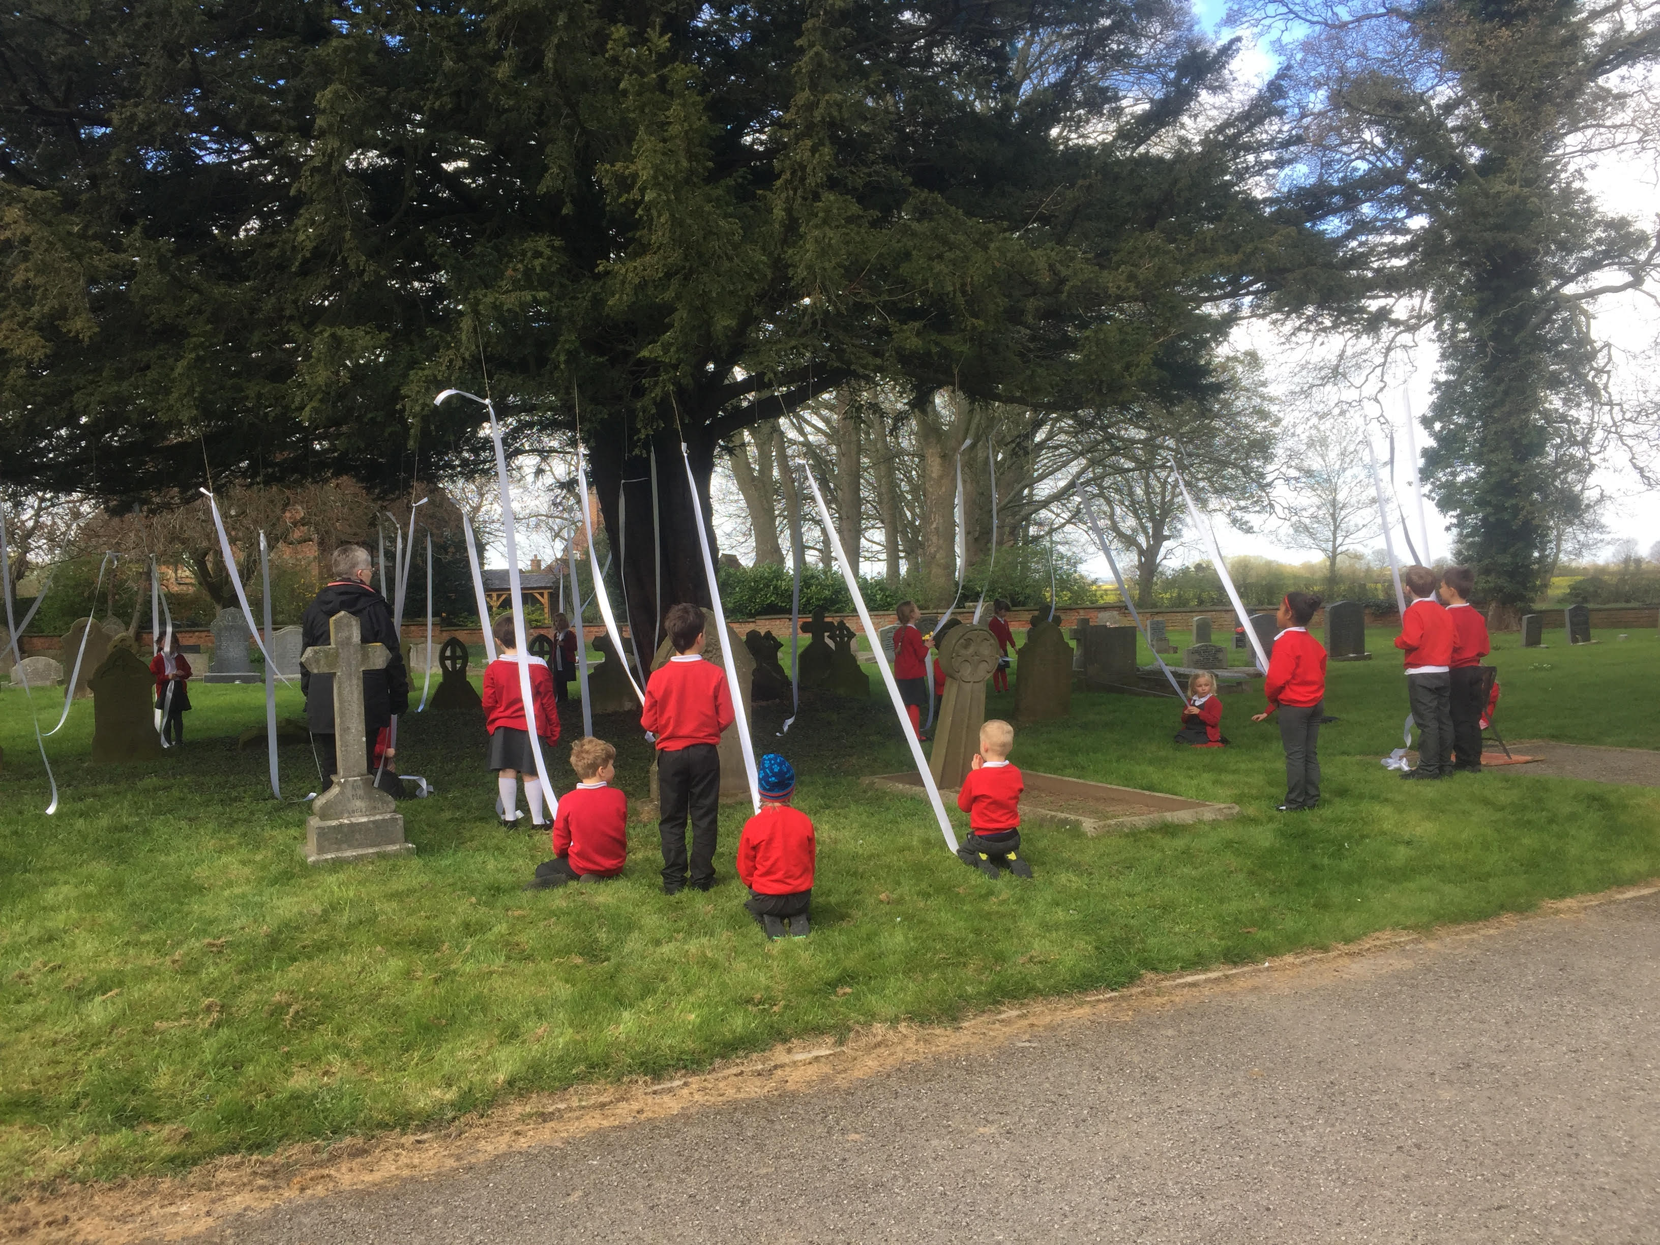
I hope you all had a good Easter and managed to do something different as a way of celebrating the resurrection from the dead of Jesus Christ, and the promise of new life that that gives us. If you have been out and about, you may have noticed something different in the churchyard at Baldersby St James. During their thinking about the Easter Story the children at Baldersby St James School remembered how when Jesus went into the Garden of Gethsemane on the Thursday evening following his last supper with is disciples, he was afraid and ‘an angel from heaven appeared to him to give him strength’ (St Luke’s Gospel, chapter 22, verse 43). The children tied white ribbons on the yew tree to represent angels – ribbons that were long enough to touch the ground, just as the angel touched the earth. The children then thought about the times when they, like Jesus, were frightened and needed strength, and holding a ribbon, they prayed for God to be their strength to see them through these times. There were five ‘stations’ in all around the churchyard and school garden, representing different parts of Jesus’ last days, that gave the opportunity to stop and reflect and pray. Coming to the cross in the school garden, the children took a felt pen and marked their own cross on the wood. As they drew the down-stroke, they reflected ‘God loves me’, and as they drew the transverse-stroke, ‘God loves everyone’. It was a different way of telling the Easter story, and it was very powerful, not just seeing the children entering into it, but also their parents and friends sharing in the occasion as well and making their own prayers. It’s always good to try something different – I hope you get the opportunity, and that whatever you do, it gives you a reminder of God, or shows you something new about him.

There are some changes to our Sunday Services during May. Please note that on 5th, there is a Benefice Service and breakfast at Queen Mary’s School, by kind invitation of Mrs Cameron. This will be followed by a Parish Walk, meeting at Studley Royal National Trust Tearooms (the Fountains Abbey ‘bottom’ tearoom) at 12.30pm, with various options for longer or shorter walks.
Also, on Sunday 19th, there will be only one service at 10.45 at Topcliffe. Full details of all events and Service times can be found elsewhere in the magazine.
With every blessing,
Susanne
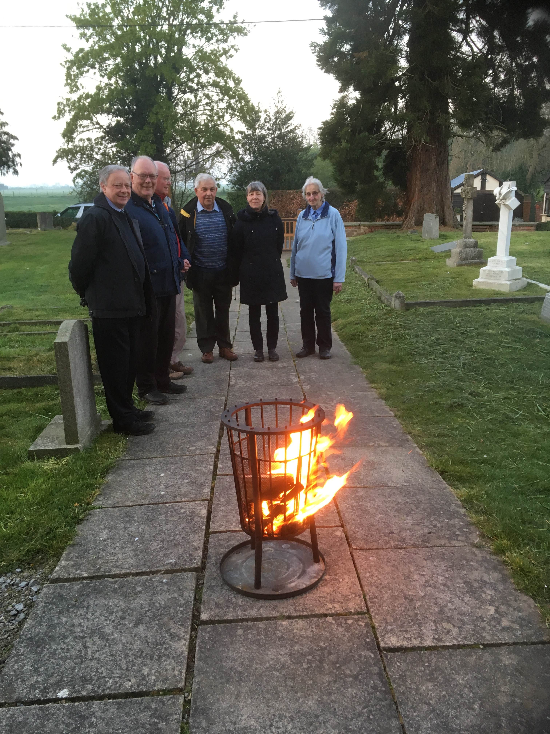

Doing it differently at Easter – Dalton-style

‘On the first day of the week, at early dawn, they cam to the tomb.’ (Luke’s Gosple, chapter 24, verse 1)
Yes, like the women in the gospel story, some people really do get up very early to meet their Risen Lord on Easter morning. Ten to five (yes, 05:50 … 5.50am) and already some people were gathering round the New Fire at Dalton Church, ready to bring in the new Light of Christ and affirm their baptismal vows (apologies to those who got ‘really wet’ during the asperges!) before sharing in Easter Communion, followed by a ‘champagne breakfast’ of Bucks Fizz and croissants.
A wonderful start to Easter Day.
Services during May 2019
Churches:
Topcliffe – St Columba’s Church, Church Street, Topcliffe YO7 3PA
BSJ – St James’ Church, Wide Howe Lane, Baldersby St James YO7 4PU
Rainton – Mission Room, Sleights Lane, Rainton YO7 3PH
Dalton – St John the Evangelist Church, Dalton YO7 3JA (follow signs to Sessay)
Skipton – St John’s Church, just off the A61 by the post-box, Skipton-on-Swale (Skipton Bridge) YO7 4SB

2nd Thursday 11.00am Topcliffe Mid-week Communion

5th Easter 3 9.30am Benefice Service at Queen Mary’s School
no other morning services today
6.30pm Topcliffe Evensong (Book of Common Prayer)

9th Thursday 11.00am Topcliffe Mid-week Prayers

12th Easter 4 9.15am Skipton Holy Communion
10.45am Topcliffe Holy Communion
12.30pm BSJ Holy Baptism

16th Thursday 11.00am Topcliffe Mid-week Prayers

19th Easter 5 Please note: no Prayer Breakfast at Rainton this week
10.45am Topcliffe Holy Communion
Please note: no service at Dalton this evening – Dalton Lunch today

23rd Thursday 11.00am Topcliffe Mid-week Communion

26th Easter 6 9.15am Skipton Holy Communion
10.45am BSJ Holy Communion
10.45am Topcliffe Matins (Book of Common Prayer)
12.30pm Dalton Holy Baptism

30th Thursday 11.00am Topcliffe Mid-week Communion
ASCENSION DAY

Services during June 2019
Churches:
Topcliffe – St Columba’s Church, Church Street, Topcliffe YO7 3PA
BSJ – St James’ Church, Wide Howe Lane, Baldersby St James YO7 4PU
Rainton – Mission Room, Sleights Lane, Rainton YO7 3PH
Dalton – St John the Evangelist Church, Dalton YO7 3JA (follow signs to Sessay)
Skipton – St John’s Church, just off the A61 by the post-box, Skipton-on-Swale (Skipton Bridge) YO7 4SB

2nd Sunday after 9.15am Dalton Holy Communion
Ascension 10.45am BSJ Holy Communion
6.30pm Topcliffe Evensong (Book of Common Prayer)

6th Thursday 11.00am Topcliffe Mid-week Communion

9th Pentecost 9.15am Skipton Holy Communion
Heritage weekend 10.45am Topcliffe Holy Communion
at Topcliffe 12.30 BSJ Holy Baptism

13th Thursday 11.00am Topcliffe Mid-week Communion

16th Trinity Sunday 9.15am BSJ Prayer Breakfast, Rainton
10.45am Topcliffe Holy Communion
6.30pm Dalton Evensong (Book of Common Prayer)

20th Thursday 11.00am Topcliffe Mid-week Communion

23rd Trinity 1 9.15am Skipton Holy Communion
10.45am BSJ Holy Communion
10.45am Topcliffe Matins (Book of Common Prayer)

27th Thursday 11.00am Topcliffe Mid-week Communion

30th Trinity 2 10.00am Topcliffe 5th Sunday Benefice Service
of Holy Communion

Sunday Readings – May 2019
Page numbers refer to the blue Common Worship Lectionary; we are now in Year C of the three-year cycle of readings; colours refer to the altar frontals, hangings, collection bags, vestments, and Service Booklets. During this month, the Order of Service for Easter and Pentecost is used

5th Easter 3 white Acts 9:1-6[7-20] page 902
Psalm 30
Revelation 5:11-end
John 21:1-19

12th Easter 4 white Acts 9:36-end page 905
Psalm 23
Revelation 7:9-end
John 10:22-30

19th Easter 5 white Acts 11:1-18 page 908 Psalm 148:1-6
Revelation 21:1-6
John 13:31-35

26th Easter 6 white Acts 16:9-15 page 911
Psalm 67
Revelation 21:10,22-22:5
John 14:23-29 or John 5:1-9

Sunday Readings – June 2019
Page numbers refer to the blue Common Worship Lectionary;
we are now in Year C of the three-year cycle of readings; For the Old Testament Readings, the continuous selection is used;
colours refer to the altar frontals, hangings, collection bags, vestments, and Service Booklet;
for the first three weeks of this month, the order of service Celebrating the Eucharist from Easter to Pentecost is used; from thereon, and for the next five months, we use Celebrating the Eucharist during Ordinary Time.

2nd Sunday after the white Acts 16:16-34 page 919
Ascension/Easter 7 Psalm 97
Revelation 22:12-14,16-17, 20-end
John 17:20-end

9th PENTECOST red Acts 2:1-21 page 923 Psalm 104:26-end
Romans 8:14-17
John 14:8-17

16th TRINITY white Proverbs 8:1-4, 22-31 page 928 Psalm 8
Romans 5:1-5
John 16:12-15

23rd Trinity 1 green 1 Kings 19:1-15a page 966
Proper 7 Psalm 42
(continuous) Galatians 3:23-end
Luke 8:26-39

30th Trinity 2 green 2 Kings 2:1-2, 6-14 page 972
Proper 8 Psalm 77:1-2, 11-end
(continuous) Galatians 5:1,13-25
Luke 9:51-end

From the Parish Registers

Baptism
17th March Baldersby St James Jasmine Isabel Mawson
24th March Baldersby St James Iliza Louise Smith
14th April Baldersby St James Edward Bryn Goacher Jones

We are children of the same heavenly Father: we welcome you.

No Weddings

Funeral
10th April Harrogate Crematorium Christine Cornmell aged 71
formerly of Rainton

Rest eternal grant unto her, O Lord, and let light perpetual shine upon her. May she rest in peace.

Church Wardens and Parochial Church Council (PCC) Members 2019

Following the elections and appointments at the Annual Meetings:

Benefice Safeguarding Representative: Gary Vale 01845 578807

Dalton:
Church Warden and Treasurer: Terry Thorpe
Deanery Synod Representative and one Churchwarden post: vacant
Vice Chair of PCC: Gary Vale
Secretary: Hannah Bissett
Electoral Roll Officer: Barbara Ramshay
PCC Members: In addition to the above: Gary Vale, Linda Vale, Margaret Thorpe, Judith Spence, Faith Bishop, Anne Dale. Co-opted: Sylvia Binks

Skipton on Swale:
Deanery Synod Representative: Pauline Wise
Church Wardens: Pauline Wise, Audrey Kitching
Vice Chair of PCC: Audrey Kitching
Treasurer and Secretary: Alan Kitching
Electoral Roll Officer: Julie Phelan
PCC Members: in addition to the above: Alison Jones, Anne Wise, Kath Hawken, Elaine Hawken-Reed,

Topcliffe:
Deanery Synod Representative: Richard Byas
Church Wardens: Linda Carver, Liz Marsh
Vice Chair of PCC: John Phillips/Richard Byas
Treasurer: Liz Green
Secretary: Roz Norris
PCC Members: in addition to the above: Dave Marsh, Kit Norris, Chris Hewlett, Joan Blair. Co-opted: Roz Norris

Baldersby St James
Deanery Synod Representative: David Potter
Church Wardens: Terry Potter, Norman Wharton
Deputy Church Warden: Rosemarie Carter
Vice Chair of PCC: Norman Wharton
Treasurer and Secretary: Jennifer Wharton
Minute Secretary: Michael Rushmere
Project Manager: Susan Brown
PCC Members: in addition to the above: James Archer, Wendy Potter, Christine Rushmere. Co-opted: Stuart Carter

Also to note:
Church of England School Foundation Governors
Dishforth Church of England School: Kirsten Lowe and the Vicar
Topcliffe Church of England Academy: Stephen Bissett and the Vicar
Baldersby St James Church of England Academy: David Potter and the Vicar

Thank you to all those who attended the Annual Meetings, and especially to those who have been prepared to stand for office/appointment. I look forward to working with you in the year ahead, as we seek to be part of the body of Christ in this area.
Susanne Jukes, Vicar

LENT LUNCHES
arranged by St Columba’s Church
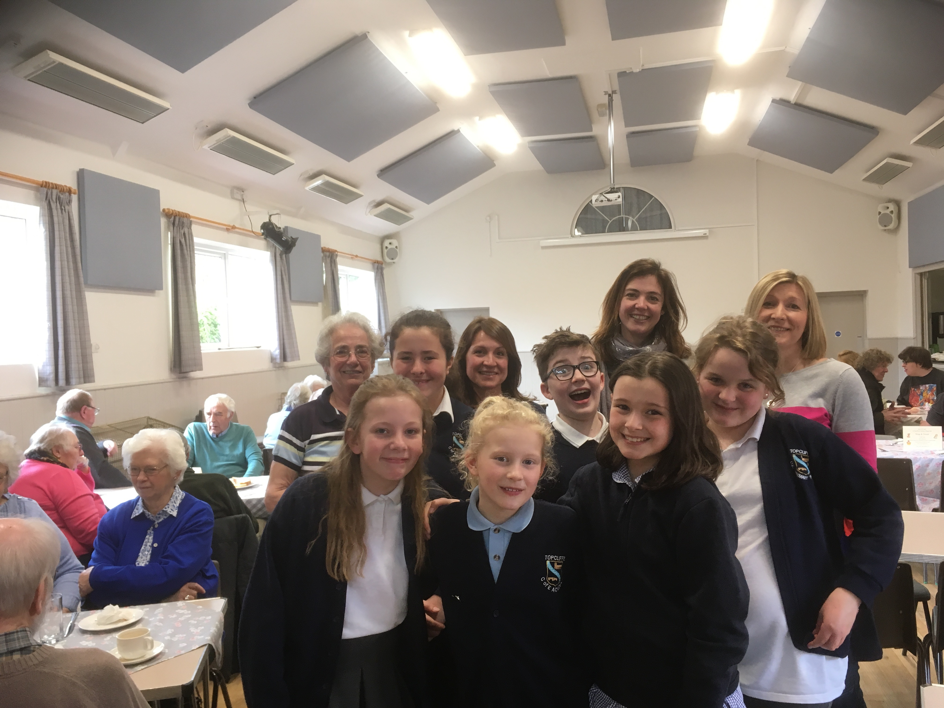

Many thanks
To Margherita, Janet, Linda, Clare and Kate – the Lent Lunch Team
(and their setting/clearing-up helpers) for all their hard work
in making Lent Lunches happen over the four weeks;
To all who have made delicious soups and cakes;
T0 the Year 6 pupils from Topcliffe Church of England Academy for their gracious welcoming and waiting at table;
To all who have supported the Lunches this year,
and for your generosity in supporting
the work of Christian Aid and Thirsk Clock

Donations for Christian Aid: £439.45
and many donations for Thirsk Clock

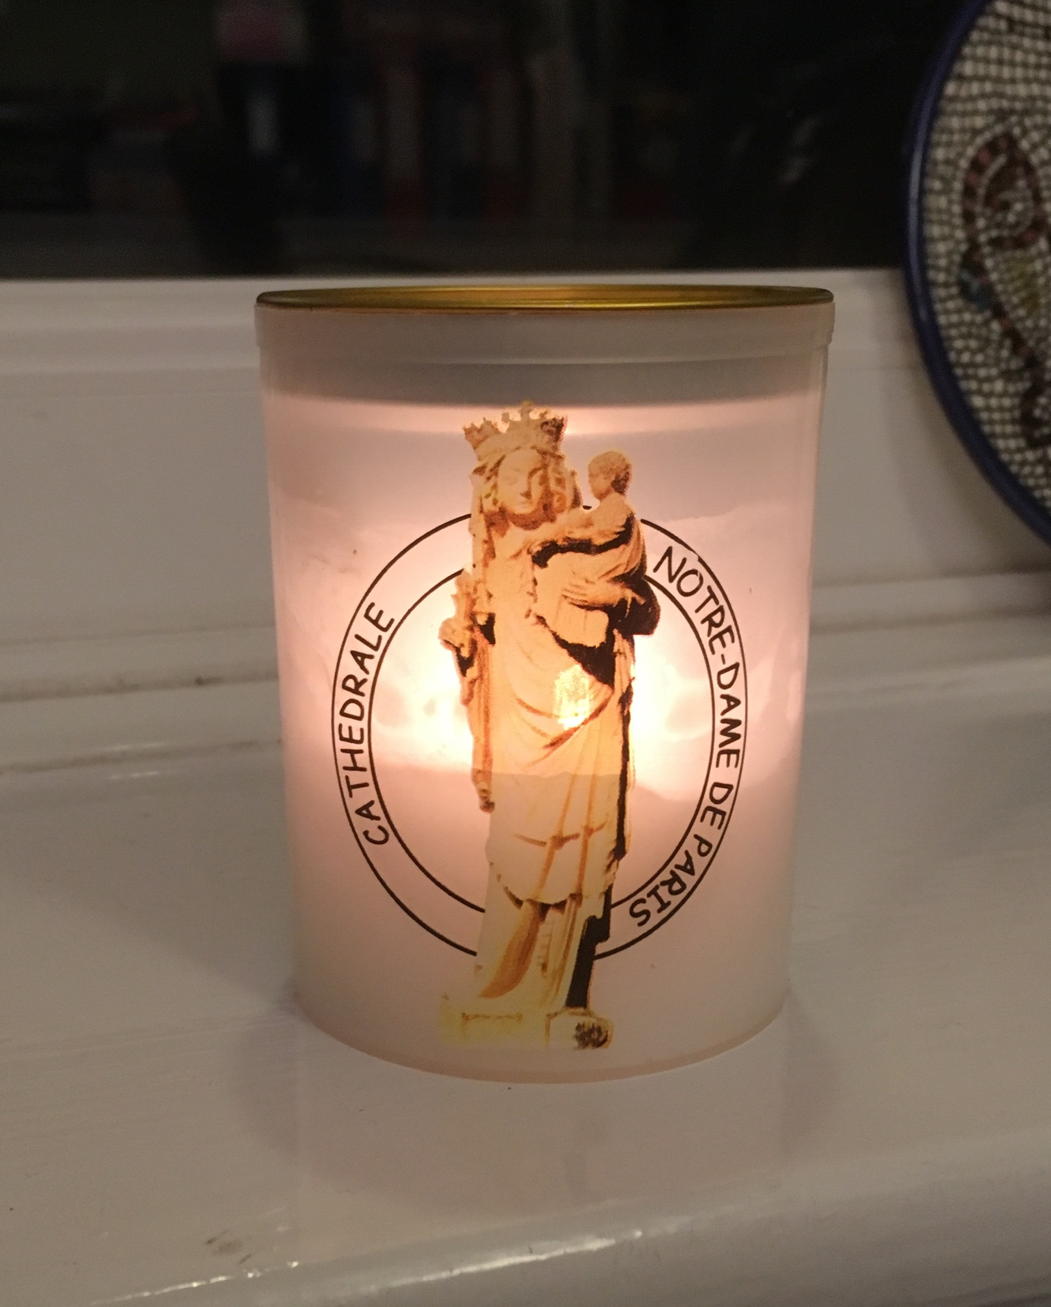
Notre Dame
As I write this, the Cathedral of Notre Dame is engulfed in flames.
Our hearts and our prayers go out to the people of France,
and to our Roman Catholic sisters and brothers wherever they are.
So sad.
“I am the resurrection and the life,” says the Lord.

The Liturgical Colours

Each Sunday (and indeed, every day) the ‘colour’ of the church is significant. The altar frontal, the pulpit and lectern falls, the vestments that the priest wears (stole and chasuble), the burse and veil that cover the Communion vessels, and the collecting bags and the front of the Orders of Service all reflect the season of the Church’s year. At this time of year, the colours are changing all the time!
We spent the six weeks of Lent in purple, the colour of penitence and preparation. We will not use purple again until Advent, when we prepare for Christmas.
During Holy Week, from Palm Sunday to Maundy Thursday, we used red, as a symbol of Christ’s suffering. This is a rare outing for red: the only other times it is used are on the Day of Pentecost, as a symbol of the fire of the Holy Spirit, and whenever there is the feast day of a saint who was martyred, as a symbol of the blood that was shed. It can however, also be used during November, often kept as the Kingdom Season, when we remember All Souls and keep Remembrance Sunday.
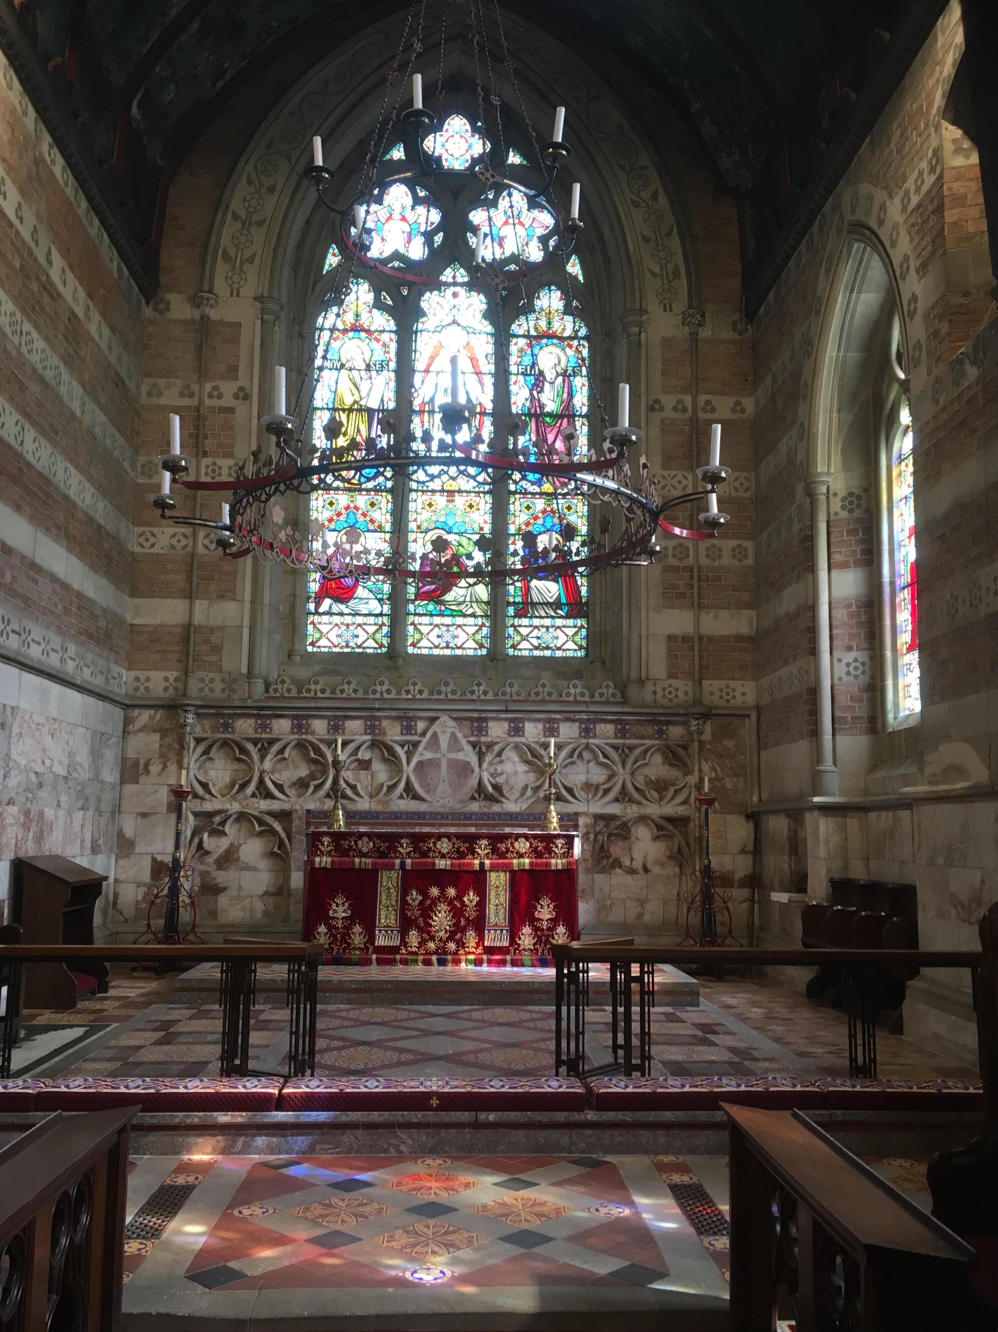
Throughout the seven weeks of the Easter season, we use white, the symbol of glorious celebration. White is used for other celebrations too: throughout the Christmas season from Christmas Day itself to the Feast of Candlemas on 2nd February; on days when we celebrate Jesus’ Ascension and Transfiguration; on Trinity Sunday; on All Saints’ Day and on the feast day of any saint who wasn’t martyred.
For the rest of the year, from after Ascension Day (30th May this year) to the end of October we use green, the symbol of ‘ordinary time’.
Do take note of the changes in the four liturgical ‘colours’. They add to the richness of our worship and help to anchor us to the mood of the season.
Baldersby St James has some incredibly fine needlework in the various colours. Here is the altar resplendent in the glorious red frontal.

Work in progress – Dalton Church

Following the gales last year, the stained glass at the west end of St John the Evangelist’s was found to be in need of restoration. In December, the window was boarded up and the glass taken away to the conservators. We were delighted that for Easter the glass was returned … well, partially. In true Dibley fashion, the window has been replaced … with clear glass! Rest assured, however, that the stained glass will return in the near future.

By the kind invitation of Mrs Carole Cameron and the community of Queen Mary’s:

Benefice Service
at Queen Mary’s School,
Baldersby Park, Topcliffe

Sunday 5th May
9.30am

followed by breakfast at Queen Mary’s

and a Parish Walk
(Meet outside the National Trust Tearooms at the Studley Royal entrance to Fountains Abbey at 12.30pm for either a short walk about the lake, or a longer walk round the Seven Bridges. Meet again at the Tearooms for refreshments afterwards. Cost: car parking; refreshments; possible option of going into Fountains Abbey grounds – National Trust entry prices)

No other services in any of the churches that morning

Sunday 19th May
Dalton Church’s Spring Sunday Lunch
Dalton Village Hall
12.30 for … 12.30pm

“The best Sunday Lunch ever!”
Tickets from any member of the PCC

A Sunday well-spent brings a week of content

Have you experience of God?

The woman whispered, “God, speak to me,” and a meadow-lark sang.
But the woman did not hear.
So the woman yelled, “God, speak to me,” and a thunder rolled across the sky.
But the woman did not listen.
The woman looked around and said, “God, let me see you,” and a star shined brightly.
But the woman did not see.
And the woman shouted, “God, show me a miracle,” and a life was born.
But the woman did not notice.
So the woman cried out in despair, “Touch me, God, and let me know you’re here,” whereupon God reached down and touch the woman.
But the woman brushed the butterfly away and walked on.

Have you really not experienced God?

