CROSS TALK – the Benefice Magazine

Dear Friends

This year, December will no doubt be busier than ever for some people – and, with the General Election being on 12th December, especially for those who have a political involvement. In a very basic way, that should be all of us. We are all members of a ‘polis’, a ‘city’ (even though our ‘cities’ are small villages) and so we are all political people. And the Church is at the heart of the ‘city’, and so very much involved in ‘city’ life, too – in politics.
So what does the Church have to say about the forthcoming elections?
Just, simply, words of encouragement to look at the person of Jesus and the things he stands for, and to make a voting choice based on who, regardless of religious affiliation, you think promotes the values of God’s Kingdom, as revealed in Jesus.
This month we will celebrate the birth of the Christ Child, and with it God’s incarnation in this world. Jesus said, ‘I have come that you might have life, and have it in all abundance,’ and the way he demonstrated this abundant life was
- to heal those who were sick, in body, in mind and in spirit;
- and to build bridges so that those who were ostracised and marginalised could be brought into community life – for the community is not complete without everyone being accepted;
- and to see God’s Kingdom as being the whole of his creation.
It’s not always an easy or comfortable calling to do this, but it was by living out these principles and putting them in action in daily life, that Jesus showed what it means to be The Prince of Peace – the Prince of Shalom, of right relationships – and to be the Light and Life of the World.
As you are thinking about who to vote for, maybe consider who it is who has the bigger picture, and who is committed to those things that bring healing to individuals and to communities.

As you prepare to celebrate the birth of Christ, the Prince of Peace and Light of the World, may you increasingly know peace in your own life.
Do join us, if you can, for Christmas worship, the details of which can be found on the following pages. Our worship is not complete without you.

May the peace of the Lord be always with you and especially this Christmas and in the year to come.
With all good wishes and every blessing,
Susanne
The Rev’d Susanne Jukes, Vicar (contact details on back page)

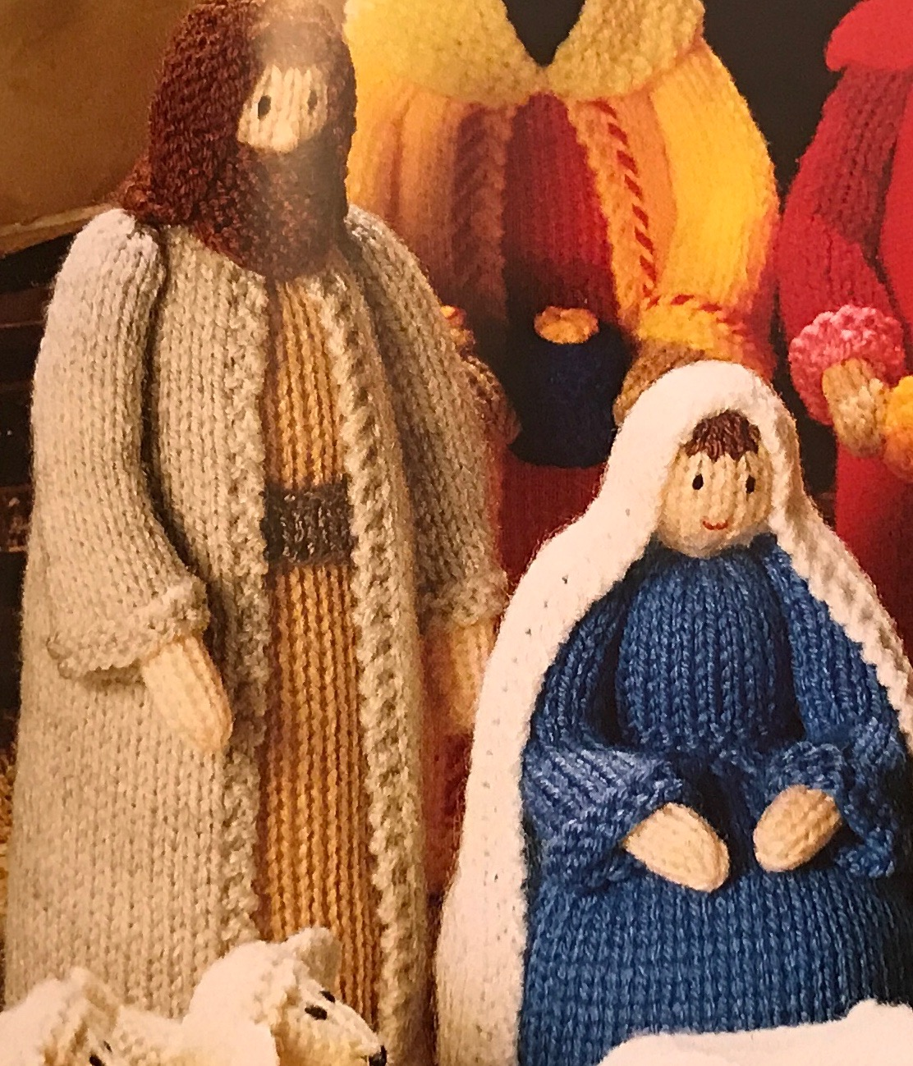
Posada – the tradition of taking the nativity figures of Mary and Joseph round the homes of the locality during the latter part of December, and giving them hospitality for a night, before they arrive at church for the birth of the Christ-Child.

Will you take part? Posadas are happening at Dalton and Skipton-on-Swale this year. See last month’s Cross Talk (paper or on-line) for full details.
Contact:
at Dalton – Jill on 01845 595925 or at the Christmas Fair;
at Skipton – Julie on 07852 205564

Service Times and Details

Services during December 2019
Churches:
Topcliffe – St Columba’s Church, Church Street, Topcliffe YO7 3PA
BSJ – St James’ Church, Wide Howe Lane, Baldersby St James YO7 4PU
Rainton – Mission Room, Sleights Lane, Rainton YO7 3PH
Dalton – St John the Evangelist Church, Dalton YO7 3JA (follow signs to Sessay)
Skipton – St John’s Church, just off the A61 by the post-box, Skipton-on-Swale (Skipton Bridge) YO7 4SB

Page numbers refer to the blue Common Worship Lectionary; we now begin Year A of the three-year cycle of readings. The new Church’s Year begins on Advent Sunday, and the ‘colour’ changes to purple in recognition of this being a season of penitential preparation for a major festival – Christmas. Once Christmas comes, we change the colour to white, in celebration.

1st December Advent Sunday
9.15am Dalton Holy Communion. Preacher: Rev’d Mary Rolls
10.45am BSJ Holy Communion. Preacher: Rev’d Mary Rolls
6.30pm Topcliffe Choral Evensong for Advent Sunday (Book of Common Prayer)

Readings: Page 3 Purple
Isaiah 2:1-5 Psalm 122 Romans 13:11-end Matthew 24:36-44

3rd December Tuesday
3.00pm BSJ Queen Mary’s Christingle Service

5th December Thursday
11.00am Topcliffe Mid-week Communion

8th December Second Sunday in Advent
9.15am Skipton Holy Communion
10.45am Topcliffe Holy Communion
Readings: Page 6 Purple
Isaiah 11:1-10 Psalm 72:1-7 Romans 15:4-13 Matthew 3:1-12

12th December Thursday
11.00am Topcliffe Mid-week Communion

15th December Third Sunday in Advent
9.15am Rainton Prayer Breakfast
10.45am Topcliffe Holy Communion
6.30pm Topcliffe Service of Nine Lessons and Carols sung by St Columba’s Choir
Readings: Page 9 Purple
Isaiah 35:1-10 Psalm 146:4-9 James 5:7-10 Matthew 11:2-11

18th December Wednesday
2.00pm Topcliffe Topcliffe Academy Carol Service
6.00pm BSJ Baldersby St James Academy Nativity/Carols

19th December Thursday
11.00am Topcliffe Mid-week Communion
7.00pm Skipton Family Carol Service

20th December Friday
9.30am Dalton Mum’s n Tot’s Nativity (in the Village Hall)
1.15pm BSJ Dishforth CofE School Carol Service

22nd December Fourth Sunday in Advent
9.15am Skipton Holy Communion
10.45am BSJ Holy Communion with Baptism
10.45am Topcliffe Matins (Book of Common Prayer)
4.00pm Dalton Family Carol Service by Candlelight

Readings: Page 13 Purple
Isaiah 7:10-16 Psalm 80:1-7 Romans 1:1-7 Matthew 1:18-end

24th December Tuesday, Christmas Eve
2.00pm Topcliffe Crib Service
6.30pm BSJ Carols by Candlelight
10.00pm Dalton Christmas Communion
11.30pm Topcliffe Midnight Mass
for Readings, see below

25th December Wednesday, Christmas Day
9.00am Topcliffe Christmas Morning Worship
9.15am Baldersby Mission Room Christmas Communion
Readings: for Midnight Services and Christmas Morning. Set III Page 26 white
Isaiah 52:7-10 Psalm 98 Hebrews 1:1-4 John 1:1-14

26th December Thursday
11.00am Topcliffe No Mid-week Communion this week

29th December First Sunday of Christmas
5th Sunday United Benefice Service
10.00am Skipton Holy Communion
12.00noon Dalton Baptism

Readings: Page 13 white
Isaiah 63:7-9 Psalm 148:4-14 Hebrews 2:10-18 Matthew 2:13-23

Christmas Celebrations 2019
at Baldersby St James and Baldersby Mission Room

at Baldersby St James Church
Carols by Candlelight Christmas Eve
Tuesday 24th December 6.30pm

at Baldersby Mission Room
Christmas Morning Christmas Day
Holy Communion Wednesday 25th December 9.15am

Christmas Celebrations 2019
at Dalton Church

Mums’ and Tots’ Nativity Friday 20th December 9.30am
in the Village Hall

Carol by Candlelight Sunday 22nd December 4.00pm

Midnight Mass Christmas Eve
Tuesday 24th December 10.00pm

Christmas and New Year Celebrations 2019
at Skipton-on-Swale Church

Carol Service Thursday 19th December 7.00pm

Christmas Communion Sunday 22nd December 9.15am

End of Year Service Sunday 29th December 2019 10.00am

Christmas Celebrations 2019
at Topcliffe Church

Nine Lessons and Carols Sunday 15th December 6.30pm

Crib Service Christmas Eve
Tuesday 24th December 2.00pm

Midnight Mass Christmas Eve
Tuesday 24th December 11.30pm

Christmas Morning Worship Wednesday 25th December 9.00am

From the Parish Registers

Baptism
We are children of the same heavenly Father: we welcome you.

Weddings
Those whom God has joined together, let no-one put asunder.

Funeral
13th November Baldersby St James Geoffrey Hall aged 85
Rest eternal grant unto him, O Lord, and let light perpetual shine upon him. May he rest in peace.

News from the Schools
Topcliffe Church of England Academy Baldersby St James Church of England Academy
Dishforth Church of England Primary Queen Mary’s School

You are invited to join our schools at their Christmas services and events:

Saturday 30th November 7.00pm Queen Mary’s School Candlelit Concert Baldersby St James’ Church (£5)

Friday 6th December 1.30pm Baldersby St James Academy Christmas Crafts Afternoon in School
Do come along and join the children in making traditional Christmas decorations that will be used to make the School look festive.

Wednesday 18th December 2.00pm Topcliffe Academy Carol Service Topcliffe Church
6.00pm Baldersby Academy Nativity and Carols Baldersby St James’ Church

Friday 20th December 1.15pm Dishforth School Carol Service Baldersby St James’ Church

Susanne Jukes, Foundation Governor

Women’s Faith Group
Therefore encourage one another and build each other up.’ 1 Thess. 5 v. 11

We had a good meeting on 6 November where a group of us met to share our reflections on Psalm 23. Sharing our experiences of faith in practice. We will meet again
5 December
at 16 Willow Bridge Lane, Dalton
at 2 pm.
We offer a warm invitation to all ladies to come and join us as we seek to encourage each other in our faith.
Jill Bailey

For more information, contact Jill, or Susanne on 01845 578513
Services during January 2020
Churches:
Topcliffe – St Columba’s Church, Church Street, Topcliffe YO7 3PA
BSJ – St James’ Church, Wide Howe Lane, Baldersby St James YO7 4PU
Rainton – Mission Room, Sleights Lane, Rainton YO7 3PH
Dalton – St John the Evangelist Church, Dalton YO7 3JA (follow signs to Sessay)
Skipton – St John’s Church, just off the A61 by the post-box, Skipton-on-Swale (Skipton Bridge) YO7 4SB

Page numbers refer to the blue Common Worship Lectionary; we are now in Year A of the three-year cycle of readings. This month we continue with the Christmas/Epiphany season, and in celebration the church ‘wears’ white.

2nd January Thursday
11.00am Topcliffe No Mid-week Communion this week

5th January Epiphany
9.15am Dalton Holy Communion
10.45am BSJ Holy Communion
6.30pm Topcliffe Evensong for Epiphany (Book of Common Prayer)

Readings: Page 39 White
Isaiah 60:1-6 Psalm 72:10-15 Ephesians 3:1-12 Matthew 2:1-12

9th January Thursday
11.00am Topcliffe Mid-week Communion

12th January Baptism of Christ
9.15am Skipton Holy Communion
10.45am Topcliffe Holy Communion
Readings: Page 43 White
Isaiah 42:1-9 Psalm 29 Acts 10:34-43 Matthew 3:13-end

16th January Thursday
11.00am Topcliffe Mid-week Communion

19th January Epiphany 2 Week of Prayer for Christian Unity
9.15am BSJ Prayer Breakfast, Rainton
10.45am Topcliffe Holy Communion
6.30pm Dalton Evensong (Book of Common Prayer)
Readings: Page 46 White
Isaiah 49:1-7 Psalm 40:1-12 1 Corinthians 1:1-9 John 1:29-42

23rd January Thursday
11.00am Topcliffe Mid-week Communion

26th January Epiphany 3
9.15am Skipton Holy Communion
10.45am BSJ Holy Communion
10.45am Topcliffe Matins (Book of Common Prayer)
Readings: Page 49 White
Isaiah 9:1-4 Psalm 27:1,4-12 1 Corinthians 1:10-18 Matthew 4:12-23

30th January Thursday
11.00am Topcliffe Mid-week Communion

Services during February 2020
Churches:
Topcliffe – St Columba’s Church, Church Street, Topcliffe YO7 3PA
BSJ – St James’ Church, Wide Howe Lane, Baldersby St James YO7 4PU
Rainton – Mission Room, Sleights Lane, Rainton YO7 3PH
Dalton – St John the Evangelist Church, Dalton YO7 3JA (follow signs to Sessay)
Skipton – St John’s Church, just off the A61 by the post-box, Skipton-on-Swale (Skipton Bridge) YO7 4SB

Page numbers refer to the blue Common Worship Lectionary; we are now in Year A of the three-year cycle of readings. This month the season of Christmas and Epiphany comes to an end with Candlemas. We then have a couple of weeks of ‘ordinary’ (green) time, before we start Lent with Ash Wednesday on 26th, and move into the 6-week purple season of penitential preparation for Easter.

2nd February Presentation of Christ in the Temple (Candlemas)
9.15am Dalton Holy Communion
10.45am BSJ Holy Communion
6.30pm Topcliffe Evensong for Epiphany (Book of Common Prayer)

Readings: Page 56 White
Malachi 3:1-5 Psalm 24:7-end Hebrews 2:14-end Luke 2:22-40

6th February Thursday
11.00am Topcliffe Mid-week Communion

9th February Third Sunday before Lent
9.15am Skipton Holy Communion
10.45am Topcliffe Holy Communion
Readings: Proper 1 Page 62 Green
Isaiah 58:1-9a Psalm 112:1-9 1 Corinthians 2:1-12 Matthew 5:13-20

13th February Thursday
11.00am Topcliffe Mid-week Communion

16th February 2nd Sunday before Lent
9.15am BSJ Prayer Breakfast, Rainton
10.45am Topcliffe Holy Communion
6.30pm Dalton Evensong (Book of Common Prayer)
Readings: Page 72 Green
Genesis 1:1-2:3 Psalm 136 Romans 8:18-25 Matthew 6:25-end

20th February Thursday
11.00am Topcliffe Mid-week Communion

23rd February Sunday next before Lent
9.15am Skipton Holy Communion
10.45am BSJ Holy Communion
10.45am Topcliffe Matins (Book of Common Prayer)
Readings: Page 77 Green
Exodus 24:12-end Psalm 2 2 Peter 1:16-end Matthew 17:1-9

26th February Ash Wednesday purple
7.00pm BSJ Holy Communion with the Imposition of Ashes

27th February Thursday
11.00am Topcliffe Mid-week Communion

Have you ever wanted to go? Now’s the time to be booking!

Pilgrimage to the Holy Land
Now may be your opportunity of a life-time!

Next year, the Rev’d Dianne Gambol, Priest-in-Charge of the Hillside Parishes (Knayton, Leake etc) and The Rev’d Derek Simpson, Vicar of Thirsk, will be leading an 11-day trip based in Jerusalem and Galillee.
The trip is organised through McCabe Pilgrimages, who are a respected and well-established tour company.
The dates: 19th – 29th October 2020. The cost: £2,345
Further details and a booking form can be found at the back of church, via the Vicar, or by contacting Dianne on 01845 537253 or Derek on 01845 574742

Wednesday Lunches
at Topcliffe Village Hall

First Wednesday of every month
(Wednesday 4th December this month)
12.00noon until 1.00pm
soup and cake

Donations will go towards
the installation of a new accessible path to St Columba’s
and for other improvements.

All Welcome

Dalton Christmas Fair

Saturday 7th December
10.00-12.00noon
in the Village Hall

Come and join the fun
and meet Father Christmas!
And sign up for Posada!

Thank You

St John’s Skipton-on-Swale
Open Church Days

Thank you to everyone who has organised and/or supported these events over the summer and autumn. They have been lovely occasions of fellowship and have helped considerably in boosting our finances.

St Columba’s Topcliffe
Christmas Fair

16th November 2019

Many thanks to you all for supporting the Fair
It was a lovely occasion and raised a fantastic amount –
just short of £800.

Dalton Church’s Sunday Lunch

Sunday 17th November 2019

Over 100 people sat down to a
lovely Sunday Lunch.

Thank you, everyone.
An amazing £1340 was raised.

Decision-making was difficult
sometimes, though!
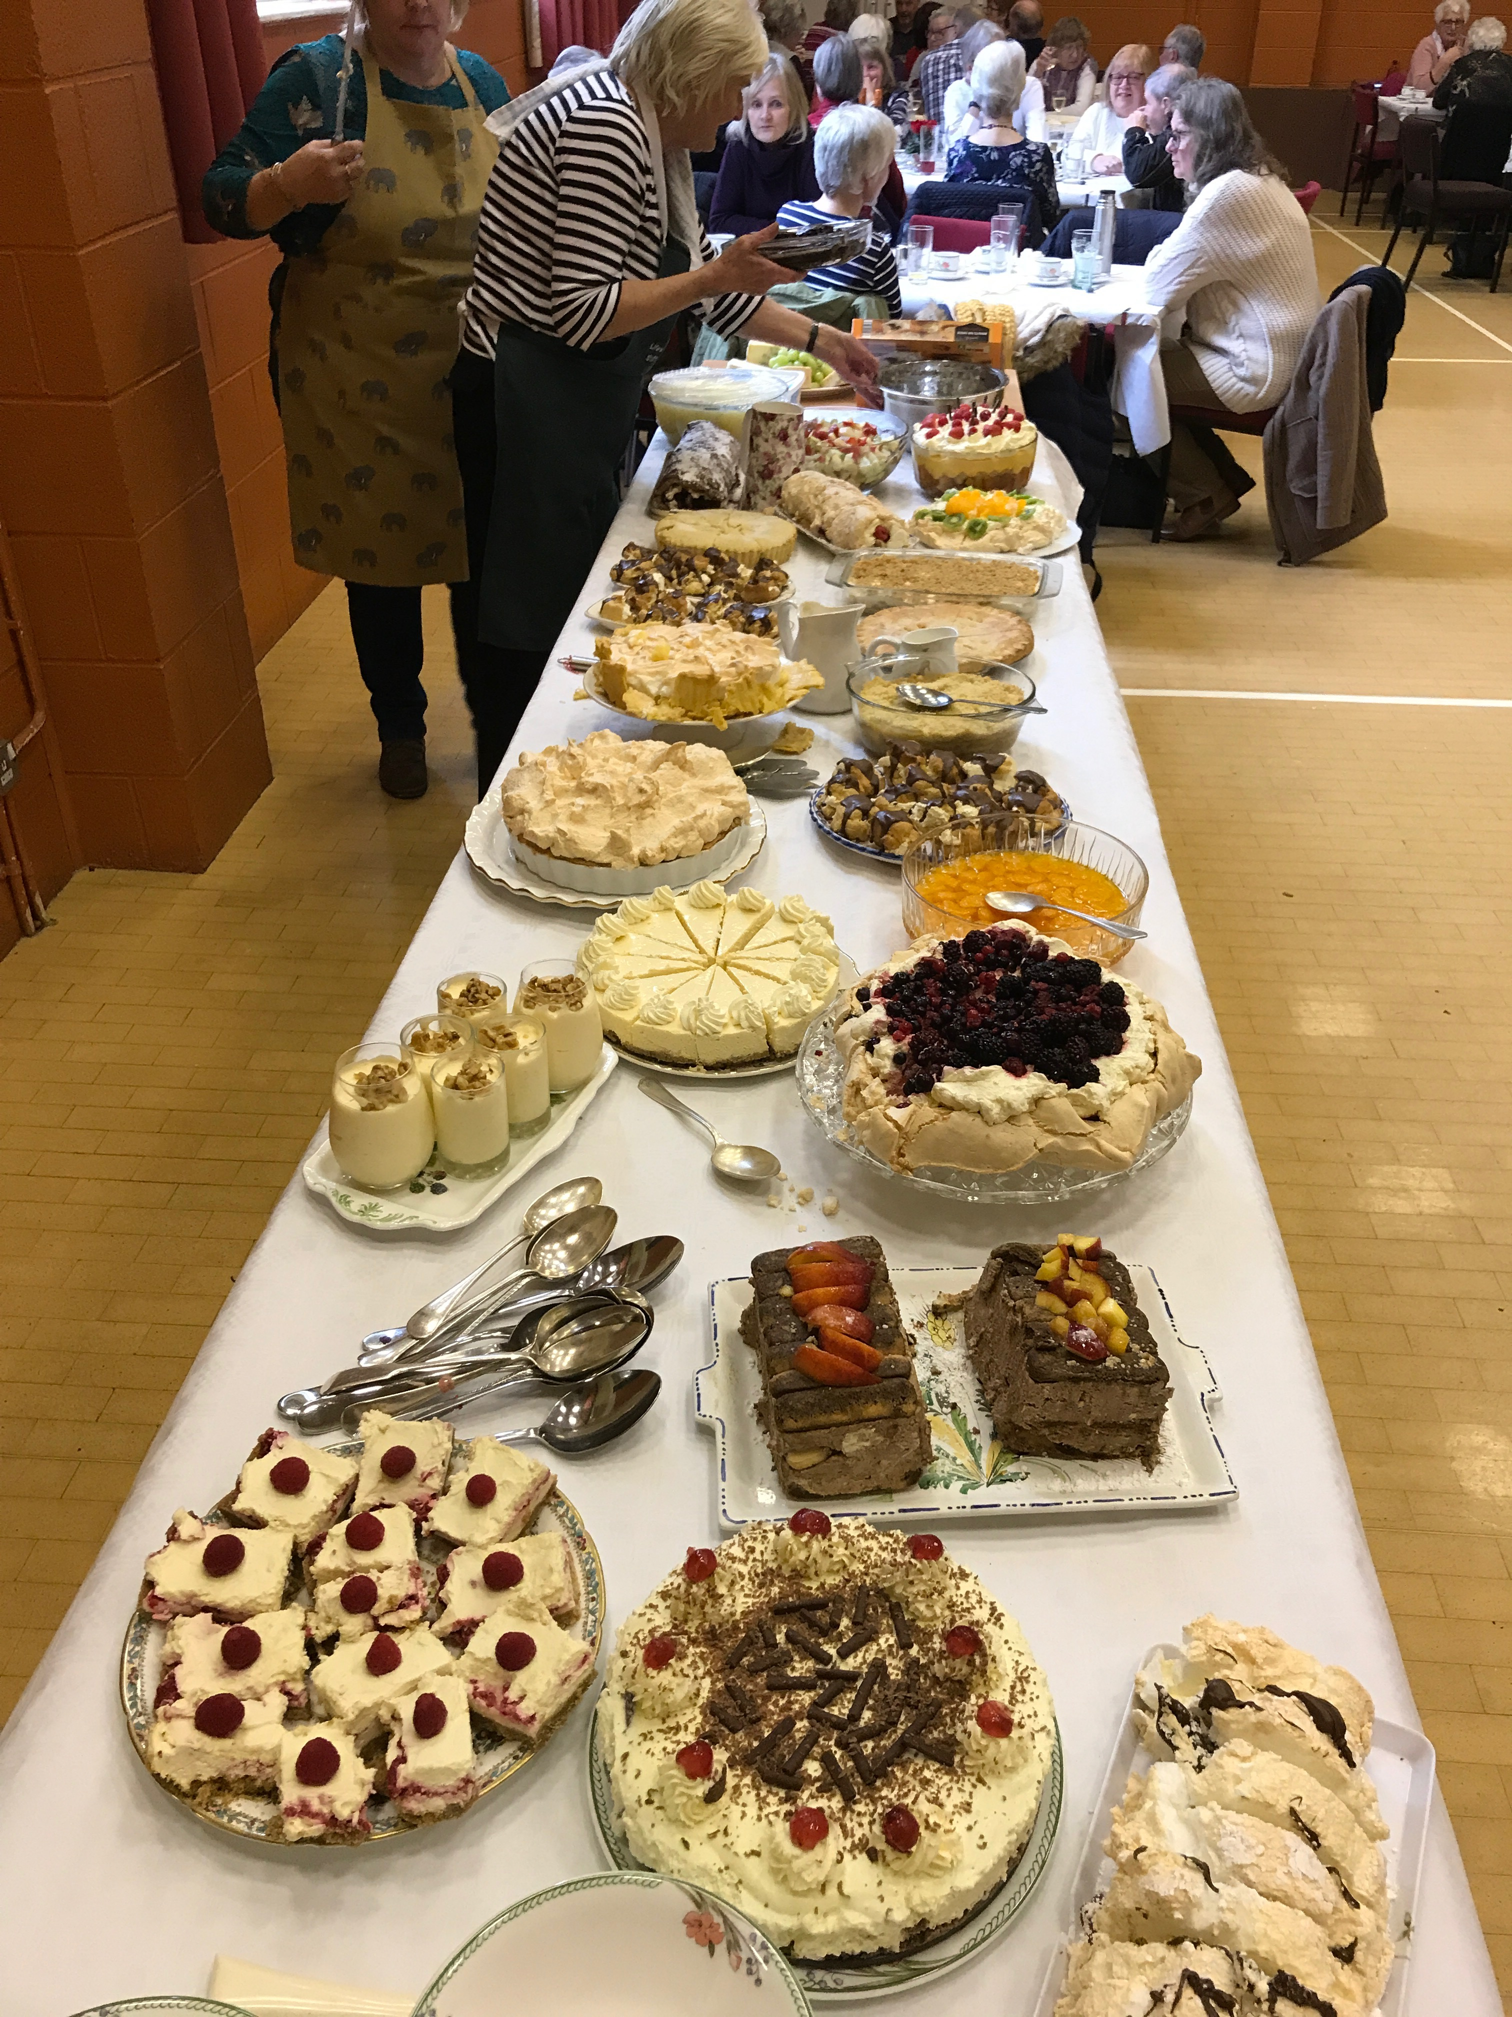

'Come and See' Mission
The Northern Bishops' Mission to the Diocese of York,
12-15 March 2020

The next day John again was standing with two of his disciples,
and as he watched Jesus walk by,
he exclaimed, ‘Look, here is the Lamb of God!’
The two disciples heard him say this, and they followed Jesus.
When Jesus turned and saw them following, he said to them,
‘What are you looking for?’
They said to him, ‘Rabbi’ (which translated means Teacher), ‘where are you staying?’
He said to them,
‘Come and see.’
John 1:35-39
Susanne
‘Come and See’ is an opportunity for us to unite in local mission and evangelism: we pray, we invite, we celebrate and we offer hospitality, all in the power of the Holy Spirit, telling the Good News of Jesus Christ. Archbishop Sentamu, together with the Bishops of the Northern Province and their teams, will be working in our Diocese from Thursday to Sunday, 12-15 March 2020. We anticipate being joined by about 30 Bishops each with a small team of lay people, children and youth workers and clergy. Each Bishop will be allocated to a deanery. In our Deanery of Mowbray, we will be joined by Bishop Paul Bayes (of Liverpool) and Bishop John Flack and their teams.
So what is being planned?
In our benefice we are looking at:
Lent Lunch at Topcliffe Village Hall on Friday 13th from 12.00noon-1.00pm
Charlie Chuck’s Guide to the Universe at Baldersby St James church on Friday 13th at 7.00pm
Open Church at Skipton-on-Swale church on Saturday 14th March, 10.00-2.00pm
Messy Church at Baldersby St James church on Saturday 14th March, 2.00-4.00pm
Messy Church at Dalton church on Sunday 15th March, 2.00-4.00pm

The idea is that these are events that we can invite people to, so that together in the name of Christ we can build community and make Christ known in the world; and at the end of each event, that there is an opportunity to invite people to ‘come and hear the next part of the story’.

Please:
PUT the dates in your diary;
PRAY for this event – and especially for the people you might invite to come with you;
THINK about whether you could help, especially with the Messy Churches. (As there are probably going to be a number of these happening in the Deanery, it is likely that there will be one central planning team that will cascade ideas to the various local groups.)

