The Parishes of Topcliffe, Baldersby with Dishforth, Dalton and Skipton on Swale

Benefice Pew Sheet Ascension Day and w/c 24th May 2020
The May edition of Cross Talk is available on the ‘A Church Near You’ website

Seventh Sunday of Easter (Sunday after Ascension Day)

In this pew sheet I’ve included the Collect and two of the readings for Ascension Day and the Collect, Readings, a short Reflection and Blessing for the Seventh Sunday of Easter.
As it looks certain that it will be quite some time before normal church services resume any contributions for this pew sheet – on-line resources, photos, book suggestions, poems or anything that may be of interest to church members in the Benefice – will be gratefully received. Richard Byas

Collect for Ascension Day 21st May 2020
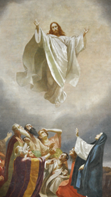
Grant, we beseech thee, Almighty God,
that like as we do believe thy only-begotten Son
our Lord Jesus Christ to have ascended into the heavens;
so we may also in heart and mind thither ascend,
and with him continually dwell,
who liveth and reigneth with thee and the Holy Ghost,
one God, world without end. Amen.

Readings for Ascension Day

Acts 1.1-11

In the first book, Theophilus, I wrote about all that Jesus did and taught from the beginning until the day when he was taken up to heaven, after giving instructions through the Holy Spirit to the apostles whom he had chosen. After his suffering he presented himself alive to them by many convincing proofs, appearing to them over the course of forty days and speaking about the kingdom of God. While staying with them, he ordered them not to leave Jerusalem, but to wait there for the promise of the Father. ‘This’, he said, ‘is what you have heard from me; for John baptized with water, but you will be baptized with the Holy Spirit not many days from now.’

So when they had come together, they asked him, ‘Lord, is this the time when you will restore the kingdom to Israel?’ He replied, ‘It is not for you to know the times or periods that the Father has set by his own authority. But you will receive power when the Holy Spirit has come upon you; and you will be my witnesses in Jerusalem, in all Judea and Samaria, and to the ends of the earth.’ When he had said this, as they were watching, he was lifted up, and a cloud took him out of their sight. While he was going and they were gazing up towards heaven, suddenly two men in white robes stood by them. They said, ‘Men of Galilee, why do you stand looking up towards heaven? This Jesus, who has been taken up from you into heaven, will come in the same way as you saw him go into heaven.’

Luke 24. 44-end

Then he said to them, ‘These are my words that I spoke to you while I was still with you—that everything written about me in the law of Moses, the prophets, and the psalms must be fulfilled.’ Then he opened their minds to understand the scriptures, and he said to them, ‘Thus it is written, that the Messiah is to suffer and to rise from the dead on the third day, and that repentance and forgiveness of sins is to be proclaimed in his name to all nations, beginning from Jerusalem. You are witnesses of these things. And see, I am sending upon you what my Father promised; so stay here in the city until you have been clothed with power from on high.’

Then he led them out as far as Bethany, and, lifting up his hands, he blessed them. While he was blessing them, he withdrew from them and was carried up into heaven. And they worshipped him and returned to Jerusalem with great joy; and they were continually in the temple blessing God.

Collect, Readings, Reflection and Blessing for the Seventh Sunday of Easter.

Collect for Sunday after Ascension Day

O God the King of glory, you have exalted your only Son Jesus Christ
with great triumph to your kingdom in heaven:
we beseech you, leave us not comfortless,
but send your Holy Spirit to strengthen us
and exalt us to the place where our Saviour Christ is gone before,
who is alive and reigns with you,
in the unity of the Holy Spirit,
one God, now and for ever. Amen

Acts 1. 6-14
So when they had come together, they asked him, ‘Lord, is this the time when you will restore the kingdom to Israel?’ He replied, ‘It is not for you to know the times or periods that the Father has set by his own authority. But you will receive power when the Holy Spirit has come upon you; and you will be my witnesses in Jerusalem, in all Judea and Samaria, and to the ends of the earth.’ When he had said this, as they were watching, he was lifted up, and a cloud took him out of their sight. While he was going and they were gazing up towards heaven, suddenly two men in white robes stood by them. They said, ‘Men of Galilee, why do you stand looking up towards heaven? This Jesus, who has been taken up from you into heaven, will come in the same way as you saw him go into heaven.’
Then they returned to Jerusalem from the mount called Olivet, which is near Jerusalem, a sabbath day’s journey away. When they had entered the city, they went to the room upstairs where they were staying, Peter, and John, and James, and Andrew, Philip and Thomas, Bartholomew and Matthew, James son of Alphaeus, and Simon the Zealot, and Judas son of James. All these were constantly devoting themselves to prayer, together with certain women, including Mary the mother of Jesus, as well as his brothers.

1 Peter 4. 12-14, 5. 6-11
Beloved, do not be surprised at the fiery ordeal that is taking place among you to test you, as though something strange were happening to you. But rejoice in so far as you are sharing Christ’s sufferings, so that you may also be glad and shout for joy when his glory is revealed. If you are reviled for the name of Christ, you are blessed, because the spirit of glory, which is the Spirit of God, is resting on you.

Humble yourselves therefore under the mighty hand of God, so that he may exalt you in due time. Cast all your anxiety on him, because he cares for you. Discipline yourselves; keep alert. Like a roaring lion your adversary the devil prowls around, looking for someone to devour. Resist him, steadfast in your faith, for you know that your brothers and sisters throughout the world are undergoing the same kinds of suffering. And after you have suffered for a little while, the God of all grace, who has called you to his eternal glory in Christ, will himself restore, support, strengthen, and establish you. To him be the power for ever and ever. Amen.

John 17. 1-11
After Jesus had spoken these words, he looked up to heaven and said, ‘Father, the hour has come; glorify your Son so that the Son may glorify you, since you have given him authority over all people, to give eternal life to all whom you have given him. And this is eternal life, that they may know you, the only true God, and Jesus Christ whom you have sent. I glorified you on earth by finishing the work that you gave me to do. So now, Father, glorify me in your own presence with the glory that I had in your presence before the world existed.
‘I have made your name known to those whom you gave me from the world. They were yours, and you gave them to me, and they have kept your word. Now they know that everything you have given me is from you; for the words that you gave to me I have given to them, and they have received them and know in truth that I came from you; and they have believed that you sent me. I am asking on their behalf; I am not asking on behalf of the world, but on behalf of those whom you gave me, because they are yours. All mine are yours, and yours are mine; and I have been glorified in them. And now I am no longer in the world, but they are in the world, and I am coming to you. Holy Father, protect them in your name that you have given me, so that they may be one, as we are one.

A prayer for those affected by the Covid-19 restrictions.
Blessing

The God of peace, who brought again from the dead our Lord Jesus that great shepherd of the sheep, through the blood of the eternal covenant, make us perfect in every good work to do his will, working in us that which is well-pleasing in his sight.
And the blessing of God Almighty,
the Father, the Son, and the Holy Spirit,
be among us and remain with us always. Amen.
Lord, I am weary, may I be renewed.
Lord, I am worn, may I be refreshed.
Lord, I am broken, may I be restored.
May your peace guard my heart and mind.
Fix my thoughts on what is true.
Hold me in your perfect peace
as today I trust in you. Amen

Around the Benefice.

Thy Kingdom Come
– the annual wave of prayer leading up to Pentecost Sunday
21st (Ascension Day) – 31st May (Pentecost) 2020

Do you want to join in the global wave of prayer
and light up the world?
See the Thy Kingdome Come website
Or, nearer the time, download the App.

The Latest from Pam Ayres with thanks to Jean Jayne for sharing this with us

I’m normally a social girl – I love to meet my mates
But lately with the virus here – we can’t go out the gates.
You see, we are the oldies now – we need to stay inside,
If they have not seen us for a while – they’ll think we’ve upped and died.

They’ll never know the things we did – before we got this old,
There wasn’t any Facebook – so not everything was told.
We may seem sweet old ladies – who would never be uncouth,
But we grew up in the sixties – if you only knew the truth!

There was sex and drugs and rock ‘n roll – the pill and miniskirts,
We smoked, we drank, we partied – and were quite outrageous flirts.
Then we settled down, got married – and turned into someone’s mum.
Somebody’s wife, then Nana, - who on earth did we become?

We did not mind the change of pace – because our lives were full,
But to bury us before we are dead – is like a red rag to a bull.
So here you find me stuck inside – for 4 weeks maybe more
I finally found myself again – then I had to close the door!

It did not really bother me – I’d while away the hour,
I’d bake for all the family – but I’ve got no flaming flour.
Now Netflix is just wonderful - I like a gusty thriller.
I’m swooning over Idris – or some random sexy killer.

At least I have a stash of booze – for when I am being idle,
There’s wine and whisky, even gin – if I’m feeling suicidal!
So let’s all drink to lockdown – to recovery and health
And hope this awful virus doesn’t decimate our wealth.

We’ll all get through the crisis – and be back to join our mates.
Just hoping I’m not far too wide – to fit through the flaming gates.

Thank you, Jane Naylor, for submitting this

A sign of spring - update
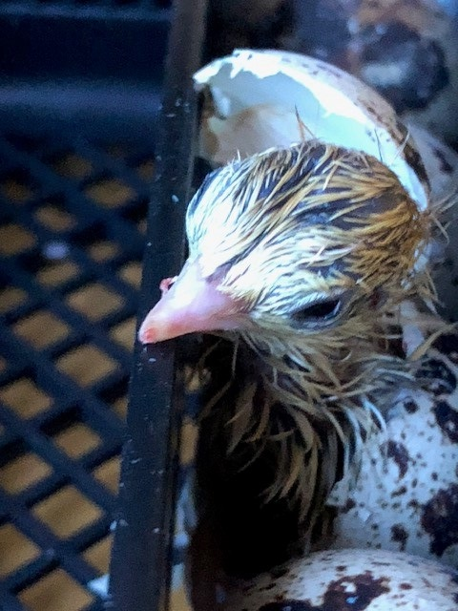
The quail eggs I put into the incubator have now hatched and are growing rapidly. It doesn’t matter how many times I see eggs hatch I always find it amazing.

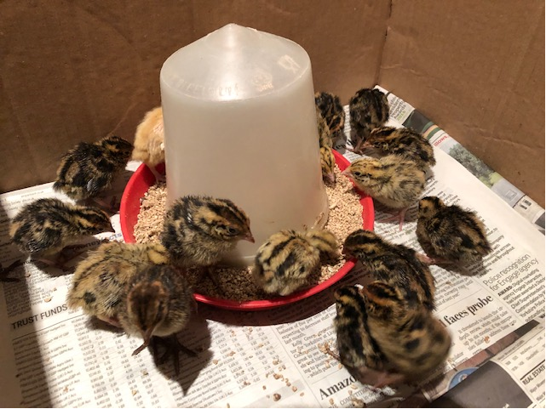
The chicks are now 6 days old and very lively.

© Richard Byas

Archbishop of York to preach in Church of England
national online service on 7th June

The Archbishop of York is to preach as part of the national online service broadcast by the Church of England on Sunday 7th June at 9.00am. This will be the last day in his role as Archbishop of York. His wife, the Revd Margaret Sentamu, will lead a time of prayer in the service.

The Archbishop said, “I am pleased to have this opportunity for the second time to take part in this online service on what will be my last day in office. Like many of us, I too, am missing being able to worship alongside others. I hope that many will join us on 7th June as we continue this way of worshipping.

The vicar decided that a visual demonstration would add emphasis to his Sunday sermon.
Two worms were placed into two separate glasses.
The first worm was put into a glass of whisky and the second worm into a glass of tap water.
The vicar showed the glasses to the congregation.
The first worm in whisky . . . dead, the second worm in water . . . still alive
So the vicar asked his congregation, "What did you learn from this demonstration?"

There was silence, until one Scotsman answered confidently: "If you have worms drink whisky!"

The Parishes of Topcliffe, Baldersby with Dishforth, Dalton and Skipton on Swale

During the interregnum our Area Dean is The Revd Fiona Mayer-Jones. on 07450 402953 or revdfmj@gmail.com
Items for next week’s Benefice Pew Sheet should be emailed to Richard Byas at richard@sandhillvet.co.uk

