The Parishes of Topcliffe, Baldersby with Dishforth, Dalton and Skipton on Swale

Benefice Pew Sheet Ascension Day and w/c 31st May 2020
The May edition of Cross Talk is available on the ‘A Church Near You’ website

Day of Pentecost (Whit Sunday)

The current situation can fuel anxiety in a range of ways including concerns about health - our own and others - isolation, job security, difficult ethical decisions for some, overwork for some, lack of work for others, family issues and loss of routine to name a few. Linked to this we can have a sense of frustration with being stuck in the situation we are in.
The Archbishop’s Adviser in Pastoral Care, Revd Andrew de Smet, has produced a paper on managing anxiety and I have published the first part of his paper later in this Pew Sheet for those who have not yet seen it. This first part explores a range or sources of help including the Christian spiritual tradition. The second part, which I hope to include next week, looks at more general ideas, including secular ideas, to help with the current range of anxiety problems.
And although the present Coronavirus situation has brought heartache and anxiety to many, we must remember that there have also been some positives such improved community spirit with people supporting their neighbours, quieter roads, better air quality and more wildlife around.
Richard Byas

Collect, Readings, Reflection and Blessing for the Day of Pentecost (Whit Sunday)
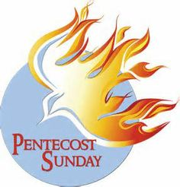
Collect for Day of Pentecost 31st May 2020

God, who as at this time
taught the hearts of your faithful people
by sending to them the light of your Holy Spirit:
grant us by the same Spirit
to have a right judgement in all things
and evermore to rejoice in his holy comfort;
through the merits of Christ Jesus our Saviour,
who is alive and reigns with you,
in the unity of the Holy Spirit,
one God, now and for ever. Amen.

Readings for The Day of Pentecost

Acts 2.1-21

When the day of Pentecost had come, they were all together in one place. And suddenly from heaven there came a sound like the rush of a violent wind, and it filled the entire house where they were sitting. Divided tongues, as of fire, appeared among them, and a tongue rested on each of them. All of them were filled with the Holy Spirit and began to speak in other languages, as the Spirit gave them ability.

Now there were devout Jews from every nation under heaven living in Jerusalem. And at this sound the crowd gathered and was bewildered, because each one heard them speaking in the native language of each. Amazed and astonished, they asked, ‘Are not all these who are speaking Galileans? And how is it that we hear, each of us, in our own native language? Parthians, Medes, Elamites, and residents of Mesopotamia, Judea and Cappadocia, Pontus and Asia, Phrygia and Pamphylia, Egypt and the parts of Libya belonging to Cyrene, and visitors from Rome, both Jews and proselytes, Cretans and Arabs—in our own languages we hear them speaking about God’s deeds of power.’ All were amazed and perplexed, saying to one another, ‘What does this mean?’ But others sneered and said, ‘They are filled with new wine.’

But Peter, standing with the eleven, raised his voice and addressed them: ‘Men of Judea and all who live in Jerusalem, let this be known to you, and listen to what I say. Indeed, these are not drunk, as you suppose, for it is only nine o’clock in the morning. No, this is what was spoken through the prophet Joel:
“In the last days it will be, God declares, that I will pour out my Spirit upon all flesh, and your sons and your daughters shall prophesy, and your young men shall see visions, and your old men shall dream dreams.
Even upon my slaves, both men and women, in those days I will pour out my Spirit; and they shall prophesy. And I will show portents in the heaven above and signs on the earth below, blood, and fire, and smoky mist. The sun shall be turned to darkness and the moon to blood, before the coming of the Lord’s great and glorious day.
Then everyone who calls on the name of the Lord shall be saved.”

1 Corinthians 12. 4-13

Therefore I want you to understand that no one speaking by the Spirit of God ever says ‘Let Jesus be cursed!’ and no one can say ‘Jesus is Lord’ except by the Holy Spirit.

Now there are varieties of gifts, but the same Spirit; and there are varieties of services, but the same Lord; and there are varieties of activities, but it is the same God who activates all of them in everyone. To each is given the manifestation of the Spirit for the common good. To one is given through the Spirit the utterance of wisdom, and to another the utterance of knowledge according to the same Spirit, to another faith by the same Spirit, to another gifts of healing by the one Spirit, to another the working of miracles, to another prophecy, to another the discernment of spirits, to another various kinds of tongues, to another the interpretation of tongues. All these are activated by one and the same Spirit, who allots to each one individually just as the Spirit chooses.
One Body with Many Members
For just as the body is one and has many members, and all the members of the body, though many, are one body, so it is with Christ. For in the one Spirit we were all baptized into one body—Jews or Greeks, slaves or free—and we were all made to drink of one Spirit.

John 20. 19-23

When it was evening on that day, the first day of the week, and the doors of the house where the disciples had met were locked for fear of the Jews, Jesus came and stood among them and said, ‘Peace be with you.’ After he said this, he showed them his hands and his side. Then the disciples rejoiced when they saw the Lord. Jesus said to them again, ‘Peace be with you. As the Father has sent me, so I send you.’ When he had said this, he breathed on them and said to them, ‘Receive the Holy Spirit. If you forgive the sins of any, they are forgiven them; if you retain the sins of any, they are retained.’

Reflection

The first Easter did not take place in a crowded church filled with singing and praising. On the very first Easter the disciples were locked in a house. And the most common command in the Bible is not “love one another” or even, “love God”, the most common command is some variation of: “Do not be afraid,” and this command is often followed by, “for I am with you.” This is a useful reminder as we have celebrated this Easter season in our own homes because of Covid-19. Easter was not cancelled this year. It has been possible to encounter the living Christ just as profoundly while locked in our homes as if we had been able to gather in church.
Regardless of our situation today, we have a resurrected saviour whose presence provides peace in the midst of fear. He has given us the power of his Holy Spirit to support us, forgive and overcome evil.

Happy Whit Sunday to everyone.

A prayer for those affected by the Covid-19
restrictions.
Blessing

The Spirit of truth lead us into all truth, give us grace to confess that Jesus Christ is Lord and strengthen us to proclaim the word and works of God;
And the blessing of God Almighty,
the Father, the Son, and the Holy Spirit,
be among us and remain with us always. Amen.

God of compassion,
be close to those who are ill, afraid or in isolation.
In their loneliness, be their consolation;
in their anxiety, be their hope;
in their darkness, be their light;
through Him who suffered alone on the cross,
but reigns with you in glory,
Jesus Christ our Lord. Amen.

Around the Benefice.

Together Alone – services of daily prayers during Covid-19
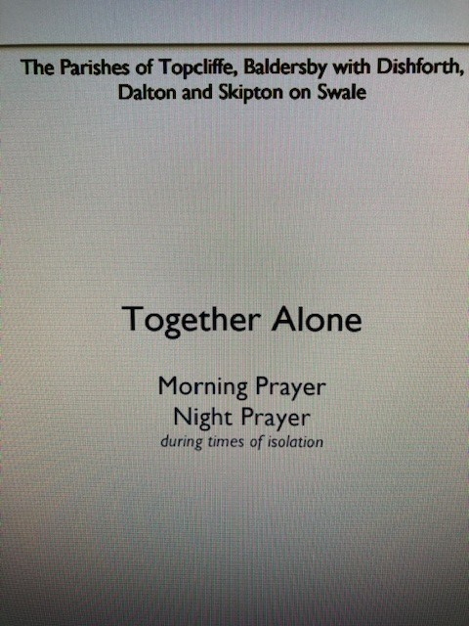
Together Alone are services of Morning and Night prayers for worship at home during a time of isolation. If you go onto the ‘A Church Near You’ website and enter the name of your local church you can print off the attachment one page at a time, and back it with the next page to get your own service booklet.

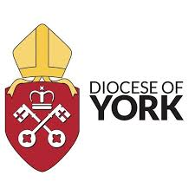

Suggestions for dealing with Anxiety duringt the Covid 19 Pandemic.
From the Archbishop’s Adviser in Pastoral Care, Revd Andrew de Smet

The following suggestions are not magic bullets but they may be of help to yourselves and those you minister to and with, they come from a range of sources including the Christian spiritual tradition.

Background anxiety:

From the Christian tradition:

Use a prayer phrase. Select a prayer phrase, maybe My God and my all (St Francis) or the Orthodox Church’s Jesus Prayer Lord Jesus Christ, son of God, have mercy on me, a sinner (can be shortened to Jesus mercy), or Maranatha (Come Lord Jesus) or Come Holy Spirit. Sit comfortably but upright and close your eyes. Breathe deeply and centre yourself. Slowly say the phrase over a breath for example Jesus (as you inhale) mercy (as you exhale) and continue in this way for 5 to 20 minutes. If you get distracted into thoughts just note that and return to the prayer phrase.

Still yourself and be aware of your breathing then say out loud, “Be still and know that I am God…….Be still and know….. Be still…….. Be……..” – and between each phrase just stay with the awareness of your breath.

Some kind of regular contemplative practice can help open us more to God’s grace, still us and reduce anxiety. Christian contemplation/meditation has many parallels to mindfulness meditation. For more information see contemplativeoutreachuk.com, www.johnmain.org, and www.christianmeditation.org.uk.

Gratitude. This is very much part of the Christian tradition - “Count your blessings”. Mindfulness books suggest keeping a gratitude diary. This is not a Monty Python-like “Look on the bright side”! It is living with paradox: yes there is a whole pile of grim stuff around, but alongside that things to give thanks for and opportunities. Linked to this is the question: what is the gift of this time?

Connecting with others in worship, study or prayer. There is plenty of online worship, prayer groups, study groups etc. becoming available. www.dioceseofyork.org.uk/onlineworship

Feel free to get in touch for confidential support or counselling: andrewdesmet@btinternet.com or 07583 279459.

Archbishop of York to preach in Church of England
national online service on 7th June

The Archbishop of York is to preach as part of the national online service broadcast by the Church of England on Sunday 7th June at 9.00am. This will be the last day in his role as Archbishop of York. His wife, the Revd Margaret Sentamu, will lead a time of prayer in the service.

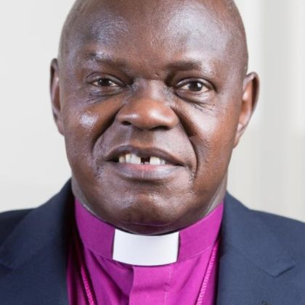
The Archbishop said, “I am pleased to have this opportunity for the second time to take part in this online service on what will be my last day in office. Like many of us, I too, am missing being able to worship alongside others. I hope that many will join us on 7th June as we continue this way of worshipping.

"We know that these times will pass and change will come, but our Lord and Saviour, King and Friend never changes. He is the same yesterday, today and for ever - and deserves our never-ending praise! ‘Come let us bow down, kneel and worship the Lord our Maker’ ”.

You will be able to watch the service live or on replay via the Church of England’s Facebook page or the Church of England website.

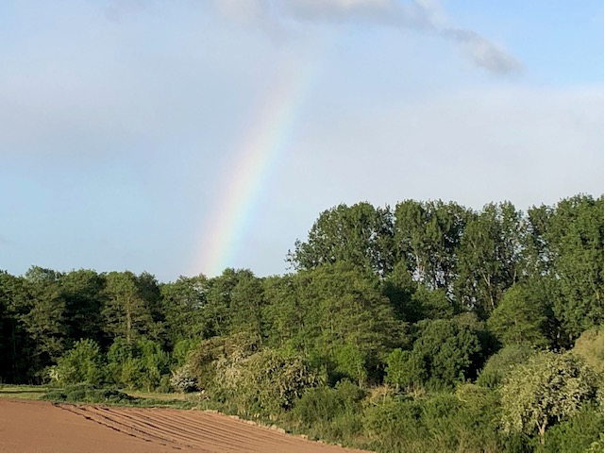
The Real Thing!!

Over the past eight weeks we have got used to pictures of rainbows in windows, on pavements and on flags.
On my walk to Asenby last Thursday I was delighted to see the real thing. Luckily, I had sunshine for my walk and avoided the showers!

© Richard Byas

If you have any uplifting photos you would like to share, please send them to richard@sandhillvet.co.uk

After having children, Adam and Eve started getting a lot of questions from their kids about why they no longer lived in Eden. Adam has a simple answer for this:
“Your mother ate us out of house and home.”

The Parishes of Topcliffe, Baldersby with Dishforth, Dalton and Skipton on Swale

During the interregnum our Area Dean is The Revd Fiona Mayer-Jones. on 07450 402953 or revdfmj@gmail.com
Items for next week’s Benefice Pew Sheet should be emailed to Richard Byas at richard@sandhillvet.co.uk

