**The Parishes of Topcliffe, Baldersby with Dishforth, Dalton and Skipton on Swale**

**Benefice Pew Sheet w/c 5th July 2020**

**Fourth Sunday after Trinity**

We are told that from 4th July churches can open for worship but with a number of important restrictions that must be followed. As yet detailed guidance on these restrictions have not been published but it is believed it will be some time before any singing is permitted, there will be no scope for “social interaction” or mingling before or after services, and there are likely to be limits on both numbers attending and the length of services. Once the information is available, our Area Dean, The Revd Fiona Mayer-Jones will be responsible for providing clergy to lead services and together with the wardens, in consultation with the church PCCs, to arrange when services will be held. Richard Byas

**Collect, Readings, Reflection and Blessing for the Fourth Sunday after Trinity**

**Collect for the Fourth Sunday after Trinity**

O God, the protector of all who trust in you,

without whom nothing is strong, nothing is holy:

increase and multiply upon us your mercy;

that with you as our ruler and guide

we may so pass through things temporal

that we lose not our hold on things eternal;

grant this, heavenly Father,

for our Lord Jesus Christ’s sake,

who is alive and reigns with you,

in the unity of the Holy Spirit,

one God, now and for ever. **Amen.**

**Readings for the Fourth Sunday after Trinity.**

**Genesis 24. 34-38, 42-49, 58-end**

So he said, ‘I am Abraham’s servant. The Lord has greatly blessed my master, and he has become wealthy; he has given him flocks and herds, silver and gold, male and female slaves, camels and donkeys. And Sarah my master’s wife bore a son to my master when she was old; and he has given him all that he has. My master made me swear, saying, “You shall not take a wife for my son from the daughters of the Canaanites, in whose land I live; but you shall go to my father’s house, to my kindred, and get a wife for my son.”

‘I came today to the spring, and said, “O Lord, the God of my master Abraham, if now you will only make successful the way I am going! I am standing here by the spring of water; let the young woman who comes out to draw, to whom I shall say, ‘Please give me a little water from your jar to drink,’ and who will say to me, ‘Drink, and I will draw for your camels also’—let her be the woman whom the Lord has appointed for my master’s son.”

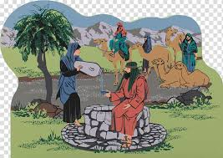‘Before I had finished speaking in my heart, there was Rebekah coming out with her water-jar on her shoulder; and she went down to the spring and drew. I said to her, “Please let me drink.” She quickly let down her jar from her shoulder, and said, “Drink, and I will also water your camels.” So I drank, and she also watered the camels. Then I asked her, “Whose daughter are you?” She said, “The daughter of Bethuel, Nahor’s son, whom Milcah bore to him.” So I put the ring on her nose, and the bracelets on her arms. Then I bowed my head and worshipped the Lord, and blessed the Lord, the God of my master Abraham, who had led me by the right way to obtain the daughter of my master’s kinsman for his son. Now then, if you will deal loyally and truly with my master, tell me; and if not, tell me, so that I may turn either to the right hand or to the left.’

And they called Rebekah, and said to her, ‘Will you go with this man?’ She said, ‘I will.’ So they sent away their sister Rebekah and her nurse along with Abraham’s servant and his men. And they blessed Rebekah and said to her,

‘May you, our sister, become thousands of myriads; may your offspring gain possession of the gates of their foes.’

Then Rebekah and her maids rose up, mounted the camels, and followed the man; thus the servant took Rebekah, and went his way.

Now Isaac had come from Beer-lahai-roi and was settled in the Negeb. Isaac went out in the evening to walk in the field; and looking up, he saw camels coming. And Rebekah looked up, and when she saw Isaac, she slipped quickly from the camel, and said to the servant, ‘Who is the man over there, walking in the field to meet us?’ The servant said, ‘It is my master.’ So she took her veil and covered herself. And the servant told Isaac all the things that he had done. Then Isaac brought her into his mother Sarah’s tent. He took Rebekah, and she became his wife; and he loved her. So Isaac was comforted after his mother’s death.

**Romans 7. 15-25a**

I do not understand my own actions. For I do not do what I want, but I do the very thing I hate. Now if I do what I do not want, I agree that the law is good. But in fact it is no longer I that do it, but sin that dwells within me. For I know that nothing good dwells within me, that is, in my flesh. I can will what is right, but I cannot do it. For I do not do the good I want, but the evil I do not want is what I do. Now if I do what I do not want, it is no longer I that do it, but sin that dwells within me.

So I find it to be a law that when I want to do what is good, evil lies close at hand. For I delight in the law of God in my inmost self, but I see in my members another law at war with the law of my mind, making me captive to the law of sin that dwells in my members. Wretched man that I am! Who will rescue me from this body of death? Thanks be to God through Jesus Christ our Lord!

**Matthew 11. 16-19, 25-end**

But to what will I compare this generation? It is like children sitting in the market-places and calling to one another,

“We played the flute for you, and you did not dance; we wailed, and you did not mourn.”

For John came neither eating nor drinking, and they say, “He has a demon”; the Son of Man came eating and drinking, and they say, “Look, a glutton and a drunkard, a friend of tax-collectors and sinners!” Yet wisdom is vindicated by her deeds.’

At that time Jesus said, ‘I thank you, Father, Lord of heaven and earth, because you have hidden these things from the wise and the intelligent and have revealed them to infants; yes, Father, for such was your gracious will. All things have been handed over to me by my Father; and no one knows the Son except the Father, and no one knows the Father except the Son and anyone to whom the Son chooses to reveal him.

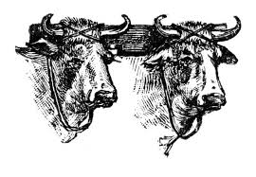

‘Come to me, all you that are weary and are carrying heavy burdens, and I will give you rest. Take my yoke upon you and learn from me; for I am gentle and humble in heart, and you will find rest for your souls. For my yoke is easy, and my burden is light.’

**Reflection**

The’ yoke’ Jesus is speaking about is the set of laws, interpretations and expectations laid upon us by God. Jesus says that God has “hidden these things from the wise and intelligent and has revealed them to infants.’’ Jesus is not being anti-education or anti-intellectual; rather included as wise is anyone who seeks to be humble and still teachable.

So, we are called to identify our own yokes, and ask ourselves if they are yoked to Christ or not.

As the world battles COVID-19, remember Jesus encourages us to latch on to Him and to follow His footsteps. We know that He has a plan to get us through it. He knows exactly what we need to keep us from being overwhelmed by what we hear and by what we see.

**A prayer for those caught up in**

**tragedy and disaster**

O Lord our God,

source of all goodness and love,

**Blessing** The peace of God which passes all understanding, keep our hearts and minds in the knowledge and love of God and of his Son Jesus Christ our Lord,

And the blessing of God Almighty,

the Father, the Son, and the Holy Spirit,

be among us and remain with us always. **Amen.**

accept the fervent prayers of your people

in this time of international upheaval.

In the multitude of your mercies look with compassion upon all who turn to you for help;

for you are gracious, O lover of souls,

and to you we give glory, Father, Son, and Holy Spirit, now and for ever. **Amen**

**Susanne’s Leaving**

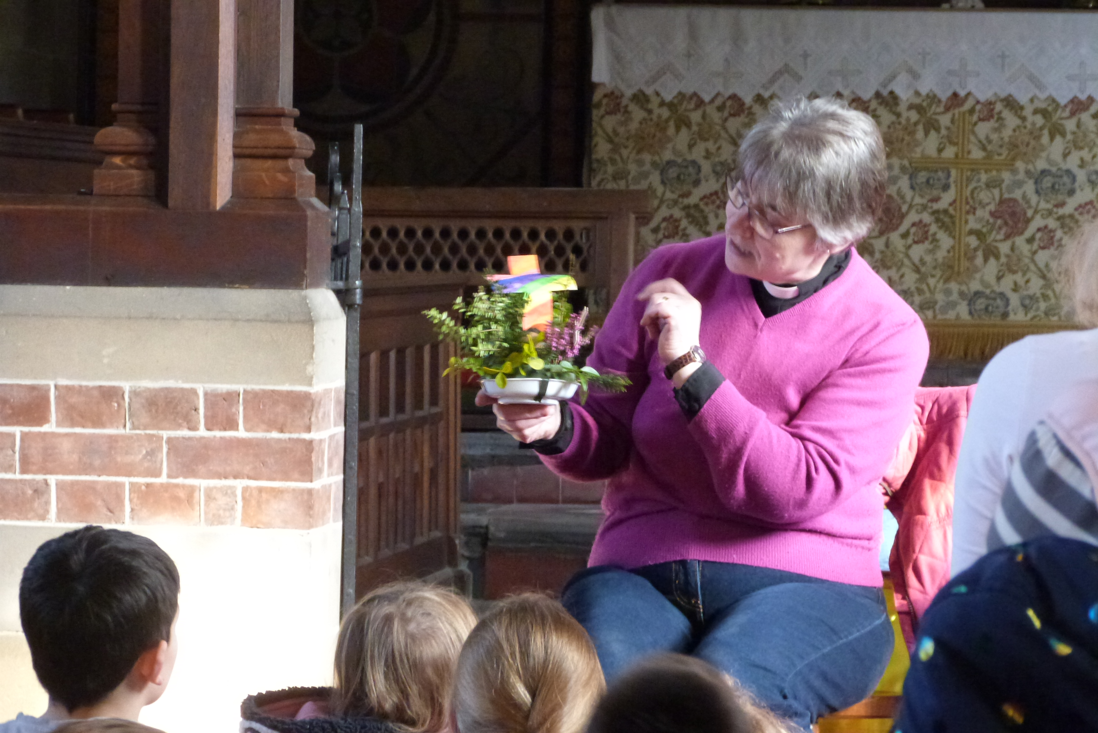

Susanne has now got a date for leaving Topcliffe - 7th July 2020

Unfortunately, it will not be possible for us to have a leaving party for her due to the present circumstances.

We are hoping instead to have a “leaving” party for her next year roundabout Easter time, possibly to coincide with her birthday, when, dependent upon circumstances, we will be able to present her with the gifts we have bought.

A collection for Susanne has been held across the Benefice and from the proceeds, after discussion with all the Churchwardens, we have bought some gifts from the “Mouseman” in Kilburn. The remainder (£1300+) will be given to Susanne when she leaves, hopefully to buy somethings for her new home and garden to remember us by. Terry Thorpe, Churchwarden, Dalton

**Church services after 4th July**

Last weekend the Government announced that some forms of public worship would be allowed to re-start with effect from Saturday 4th July, and since then the Church of England has worked hard at national level this week to examine the details of that announcement and their implications for parish churches.

We have received the following advice from **Canon Peter Warry, Diocesan Secretary and Chief Executive** on 25th June and 1st July

‘National advice (regarding church services after 4th July) has now been published, and following discussion with our bishops and archdeacons this morning I would like to commend it to you; as usual it can be found on the Church of England website at [www.churchofengland.org/coronavirus](http://www.churchofengland.org/coronavirus),

The national church has also revised its advice notes on Weddings, Baptisms, Funerals, Holy Communion, Confirmation and Private Prayer, accessible from the same web page.

Following a meeting of our bishops and archdeacons, I have been asked to share just a few immediate points:

* Please do not feel that you must reopen your church at the earliest opportunity. We recognise that it will be easier for some churches to meet the “Covid Safe” guidance than others and it may be that, particularly in multi-parish benefices, local arrangements could be made for some buildings to be opened for services whilst access to others remains more limited.
* The judgment of whether or not you are able to resume worship safely is for the incumbent and churchwardens to agree between them. Further information about this can be found in the “legal questions” annexe to the Conducting Public Worship document.
* We know that it may be some time before any singing is permitted, there will be no scope for “social interaction” or mingling before or after services.
* Please continue to offer opportunities to take part in prayer and worship for those who are not able (or don’t feel confident) to return to services in church buildings. Some of our forms of worship may still not be achievable for a while, and online options may still offer the best alternative. It may well be, for example, that all-age worship in our buildings needs to be rethought for the next few months while there continue to be limitations on singing, physical distancing, touching shared materials and interaction between households.
* The Government has also now released advice for multi-use buildings (including church halls) which permits the use of such premises for social activities and other meetings. It should be noted, whether considering your own activities or the hire of premises to third parties, that such activities are still subject to the conditions in relation to hygiene and cleaning, physical distancing and restricting social interaction between households. To that end, the PCC must ensure that appropriate risk assessments have been completed.
* While Government advice for multi-use buildings may allow short meetings of a PCC to take place in a church hall or a church, for the time being we would continue to advise that it would remain good practice to make/confirm decisions by correspondence if you have members who would otherwise continue to be precluded from participating (whether by Zoom or in person).
* We would reiterate the advice to those Clergy, licensed Lay Ministers and Church Officers over the age of 70 (or in other vulnerable categories) that was sent out earlier in the month by Bishop Paul. As we go back into our buildings, all colleagues in those categories are encouraged to decide for themselves the extent to which they might now carry out ministry involving face-to-face contact with those outside their own household, without feeling under any obligation to do so before they feel it is safe.

**Prayer on the announcement of the Archbishop of York Designate**

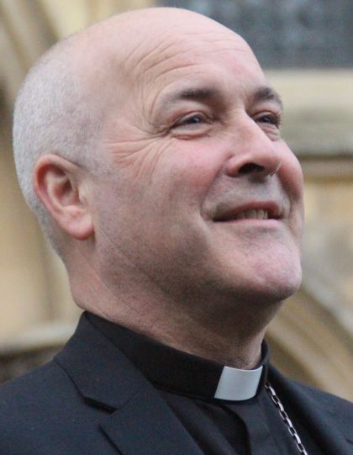Generous God, we give you thanks:

you have heard our prayer,

guided your people

and raised up Stephen

to serve as the next Archbishop of York.

By your Holy Spirit, grant to him

good counsel, holy insight and

joy in the gospel,

through Jesus Christ our Lord. **Amen.**

**Some TV Commentator’s bloomers:**

**‘**The lead car is absolutely unique, except for the one behind it which is identical’! (Murray Walker)

‘I owe a lot to my parents, especially my mother and father’ (Greg Norman)

‘The racecourse is as level as a billiard ball’ (John Francombe)



**Quail Update**

Just seven weeks to the day after hatching, the young quail have produced their first egg!

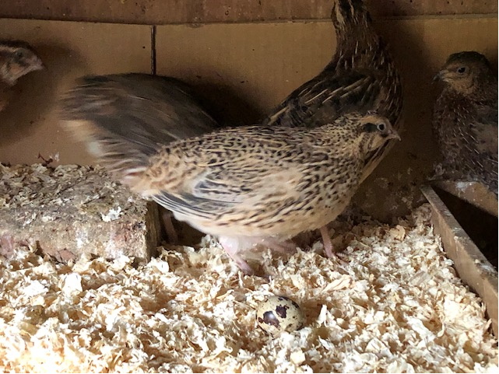

They will continue to lay until September when egg production stops as day length decreases. They could be kept in lay longer if they were given artificial light to extend the length of the day but I prefer to follow the natural cycle and will look forward to eggs again in April 2021.

Richard Byas



The Parishes of Topcliffe, Baldersby with Dishforth, Dalton and Skipton on Swale

There is currently no Vicar of the parish. Until one is appointed, please ring our Area Dean, The Revd Fiona Mayer-Jones

Tel: 07450 402953 or [revdfmj@gmail.com](mailto:revdfmj@gmail.com)

*Items for next week’s Benefice Pew Sheet should be emailed to Richard Byas at richard@sandhillvet.co.uk*