The Parishes of Topcliffe, Baldersby with Dishforth, Dalton and Skipton on Swale

Benefice Pew Sheet w/c 30th August 2020

Twelfth Sunday after Trinity

This is the last edition of the Benefice Pew Sheet. From September onwards a monthly edition of Cross Talk will be collated by Kit Norris to be sent to all those on the present email list and it will also be available on the web sites ACNY and baldersbychurch.com.
I would like to thank everyone who has supported the Benefice Pew Sheet either by contributions or simply by messages of support. They were all appreciated. I hope you will give Kit a similar support for the production of Cross Talk. Richard Byas

Collect, Readings, Reflection and Blessing for the Twelfth Sunday after Trinity

Collect for the Twelfth Sunday after Trinity


Almighty and everlasting God,
you are always more ready to hear than we to pray
and to give more than either we desire or deserve:
pour down upon us the abundance of your mercy,
forgiving us those things of which our conscience is afraid
and giving us those good things
which we are not worthy to ask
but through the merits and mediation
of Jesus Christ your Son our Lord,
who is alive and reigns with you,
in the unity of the Holy Spirit,
one God, now and for ever. Amen.

Readings for the Twelfth Sunday after Trinity.

Exodus 3. 1-15


Moses was keeping the flock of his father-in-law Jethro, the priest of Midian; he led his flock beyond the wilderness, and came to Horeb, the mountain of God. There the angel of the Lord appeared to him in a flame of fire out of a bush; he looked, and the bush was blazing, yet it was not consumed. Then Moses said, ‘I must turn aside and look at this great sight and see why the bush is not burned up.’ When the Lord saw that he had turned aside to see, God called to him out of the bush, ‘Moses, Moses!’ And he said, ‘Here I am.’ Then he said, ‘Come no closer! Remove the sandals from your feet, for the place on which you are standing is holy ground.’ He said further, ‘I am the God of your father, the God of Abraham, the God of Isaac, and the God of Jacob.’ And Moses hid his face, for he was afraid to look at God.
Then the Lord said, ‘I have observed the misery of my people who are in Egypt; I have heard their cry on account of their taskmasters. Indeed, I know their sufferings, and I have come down to deliver them from the Egyptians, and to bring them up out of that land to a good and broad land, a land flowing with milk and honey, to the country of the Canaanites, the Hittites, the Amorites, the Perizzites, the Hivites, and the Jebusites. The cry of the Israelites has now come to me; I have also seen how the Egyptians oppress them. So come, I will send you to Pharaoh to bring my people, the Israelites, out of Egypt.’ But Moses said to God, ‘Who am I that I should go to Pharaoh, and bring the Israelites out of Egypt?’ He said, ‘I will be with you; and this shall be the sign for you that it is I who sent you: when you have brought the people out of Egypt, you shall worship God on this mountain.’
But Moses said to God, ‘If I come to the Israelites and say to them, “The God of your ancestors has sent me to you”, and they ask me, “What is his name?” what shall I say to them?’ God said to Moses, ‘I am who I am.’ He said further, ‘Thus you shall say to the Israelites, “I am has sent me to you.” ’ God also said to Moses, ‘Thus you shall say to the Israelites, “The Lord, the God of your ancestors, the God of Abraham, the God of Isaac, and the God of Jacob, has sent me to you”: This is my name for ever.
Romans 12. 9-end

Let love be genuine; hate what is evil, hold fast to what is good; love one another with mutual affection; outdo one another in showing honour. Do not lag in zeal, be ardent in spirit, serve the Lord. Rejoice in hope, be patient in suffering, persevere in prayer. Contribute to the needs of the saints; extend hospitality to strangers.
Bless those who persecute you; bless and do not curse them. Rejoice with those who rejoice, weep with those who weep. Live in harmony with one another; do not be haughty but associate with the lowly; do not claim to be wiser than you are. Do not repay anyone evil for evil but take thought for what is noble in the sight of all. If it is possible, so far as it depends on you, live peaceably with all. Beloved, never avenge yourselves, but leave room for the wrath of God; for it is written, ‘Vengeance is mine, I will repay, says the Lord.’ No, ‘if your enemies are hungry, feed them; if they are thirsty, give them something to drink; for by doing this you will heap burning coals on their heads.’ Do not be overcome by evil but overcome evil with good.

Matthew 16. 21-end

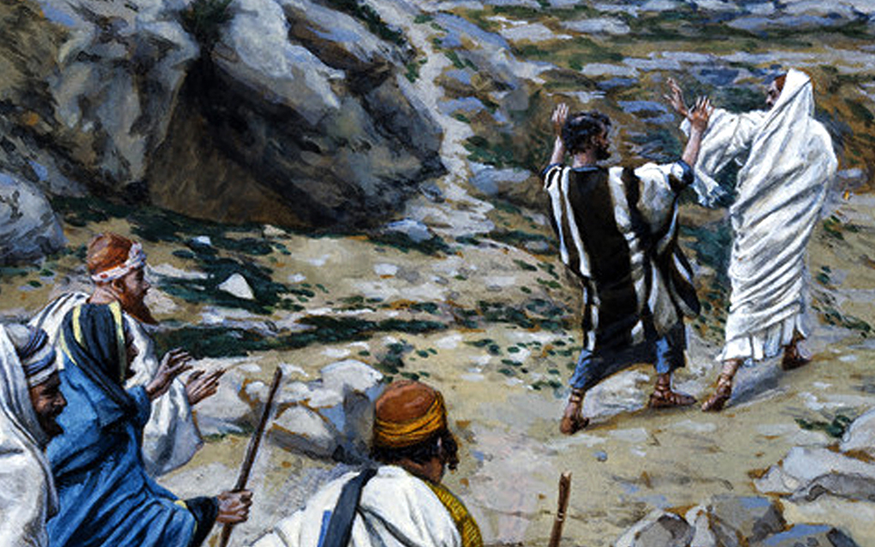
From that time on, Jesus began to show his disciples that he must go to Jerusalem and undergo great suffering at the hands of the elders and chief priests and scribes, and be killed, and on the third day be raised. And Peter took him aside and began to rebuke him, saying, ‘God forbid it, Lord! This must never happen to you.’ But he turned and said to Peter, ‘Get behind me, Satan! You are a stumbling-block to me; for you are setting your mind not on divine things but on human things.’
Then Jesus told his disciples, ‘If any want to become my followers, let them deny themselves and take up their cross and follow me. For those who want to save their life will lose it, and those who lose their life for my sake will find it. For what will it profit them if they gain the whole world but forfeit their life? Or what will they give in return for their life?
‘For the Son of Man is to come with his angels in the glory of his Father, and then he will repay everyone for what has been done. Truly I tell you, there are some standing here who will not taste death before they see the Son of Man coming in his kingdom.’

Reflection

In last week’s Gospel reading Jesus asked His disciples: “Who do you say I am?” and Peter gave the correct answer: “You are the Messiah, the Son of the living God.”
And in this week’s reading we see Jesus beginning to teach them what that means. But what it means is completely different to anything the disciples could ever have imagined.
“Yes,” Jesus says, “the Kingdom of God is coming soon. And yes, the Son of Man will be exalted as King. But the way to this Kingdom is by the exact opposite to what the disciples had in mind. It will involve suffering and death not the overthrow of the Roman authorities.

Jesus says he will be raised from the dead but neither Peter nor the others can understand what He might mean by that. They believe He is talking nonsense—dangerous nonsense. And so, Peter rebukes Jesus and shouts: “God forbid it Lord! This shall never happen to you!” in return Jesus calls Peter “Satan” and a stumbling block to Him.
When Peter said, “God forbid it, Lord! This shall never happen to you!” He was speaking the words of the world which says, “Why should I have to deny myself?” “My only concern is to look after myself”.
Surely the person who dies with the most possessions wins. Those who hoard and live in mansions while the masses starve outside their doors are doing just fine. Those who think only of themselves, bully others into getting their own way, wield all kinds of worldly power are the real winners in life. But as Peter learned, if we want to follow Jesus we must learn the Way of God rather than our way.

The Way of God, the Way of the Cross, means we seek to fulfil the needs of others above ourselves and thus become lost in God’s love for the human race.

According to scientific studies, helping other people makes us happy. But when we are caught up in human concerns; worried about ourselves and how to get ahead, worried about how to keep up with the Jones’ next door and how to impress others our life is a living hell.

And so, Jesus says there is another way, there is a better way. Following Him will cost us everything.
But as a great theologian once said, “In every generation there are, it seems, a few people who are prepared to take Jesus seriously, at His Word.” What would it be like if we were some of them?

A PRAYER OF THANKSGIVING
Blessing The peace of God which passes all understanding, keep our hearts and minds in the knowledge and love of God and of his Son Jesus Christ our Lord,
And the blessing of God Almighty,
the Father, the Son, and the Holy Spirit,
be among us and remain with us always. Amen.

God of all blessings, source of all life, giver of all grace:
We thank you for the gift of life: for the breath
that sustains life, for the food of this earth
that nurtures life, for the love of family and friends
without which there would be no life.

We thank you for the mystery of creation:
for the beauty that the eye can see, for the joy
that the ear may hear, for the unknown
that we cannot behold filling the universe with wonder,
for the expanse of space that draws us beyond the definitions of our selves.

We thank you for setting us in communities:
for families who nurture our becoming,
for friends who love us by choice,
for companions at work, who share our burdens and daily tasks,
for strangers who welcome us into their midst,
for people from other lands who call us to grow in understanding,
for children who lighten our moments with delight,
for the unborn, who offer us hope for the future.

We thank you for this day:
for life and one more day to love,
and one more day to work for justice and peace,
for neighbours and one more person to love
and by whom be loved, for your grace
and one more experience of your presence,
for your promise: to be with us,
to be our God, and to give salvation.

For these, and all blessings,
we give you thanks, eternal, loving God,
through Jesus Christ we pray. Amen.

Baldersby St. James – September Services:

There will be services at St. James’ Church, Baldersby on: Sunday 13th September at 10.45am
Sunday 27th September at 10.45am

St. Columba’s Topcliffe AMPC Meeting 17th August:
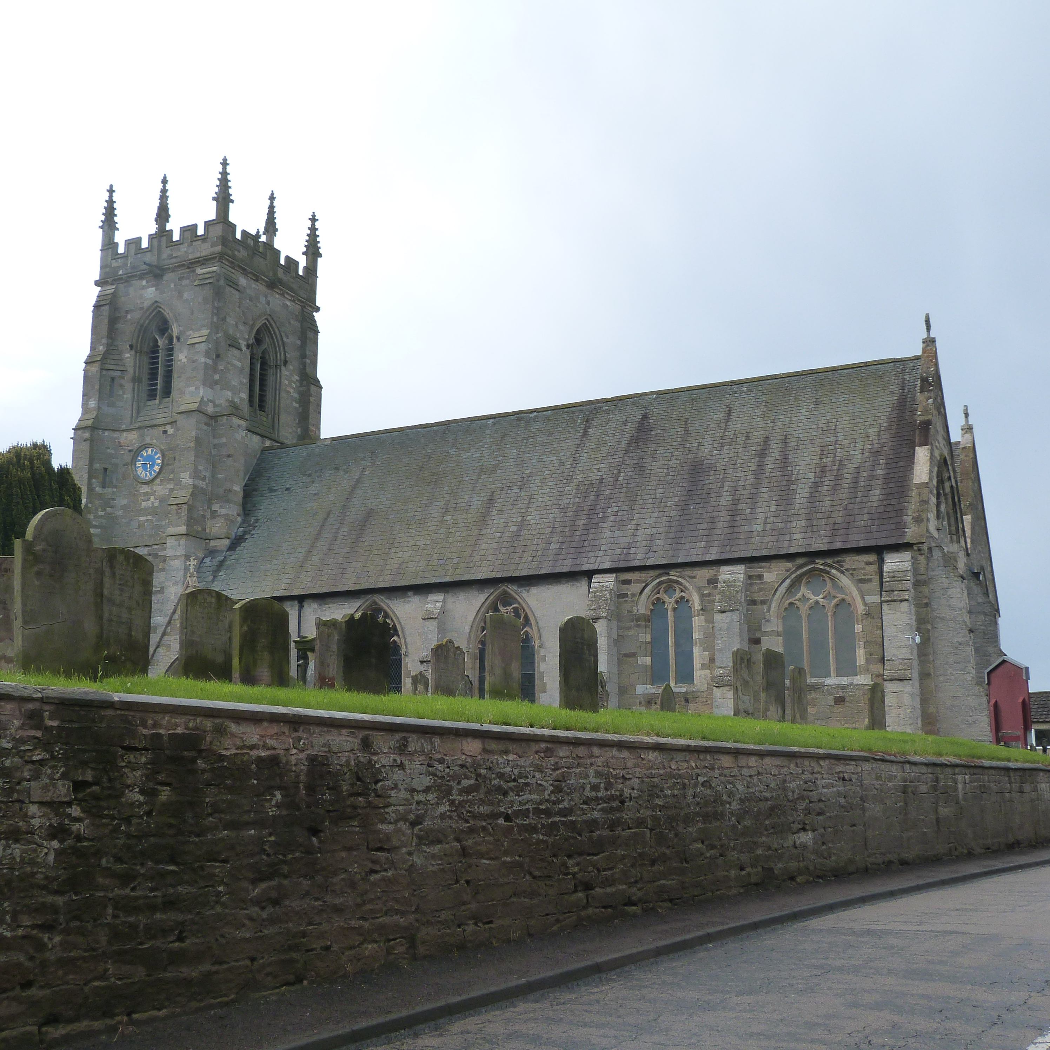
Linda Carver and Liz Marsh retired as Churchwardens at the APCM. The meeting passed a heartfelt and well received vote of thanks for all the work they have done for the church. Dave Marsh was also thanked for all his contributions as he leaves the PCC. Chris Hewlett was elected as sole Churchwarden as no one else stood for the appointment and John Philips was elected as Vice-Chair.

There is to be an extraordinary PCC meeting on Tuesday 1st September in church at 7 pm to discuss arrangements for opening church.

Monday 1st August – Saints day of Aidan, Bishop of Lindisfarne.

St. Aidan, the Apostle of Northumbria who died in 651AD, was the founder and first bishop of the Lindisfarne island monastery in England. He is credited with restoring Christianity to Northumbria. Possibly born in Connacht, Aidan was originally a monk at the monastery on the Island of Iona, founded by St Columba.

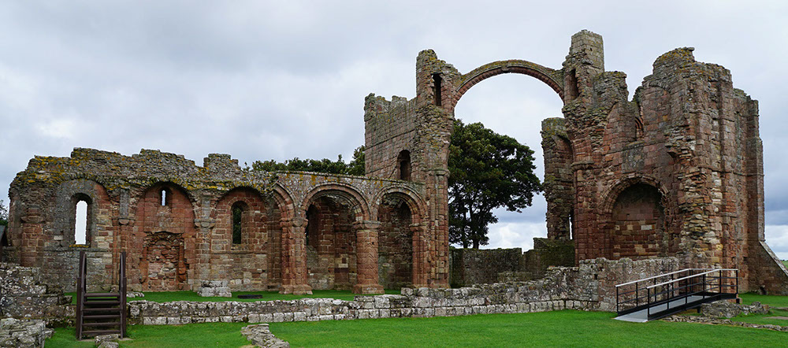
In the years prior to Aidan's mission, Christianity, which had been propagated throughout Britain but not Ireland by the Roman Empire, was being largely displaced by Anglo-Saxon paganism. In the monastery of Iona (founded by Columba), the religion soon found one of its principal exponents in Oswald of Northumbria, a noble youth who had been raised there as a king in exile since 616. Baptized as a Christian, the young king vowed to bring Christianity back to his people—an opportunity that presented itself in 634, when he gained the crown of Northumbria.

Owing to his historical connection to Iona's monastic community, King Oswald requested that missionaries be sent from that monastery instead of the Roman-sponsored monasteries of Southern England. At first, they sent him a bishop named Cormán, but he alienated many people by his harshness, and returned in failure to Iona reporting that the Northumbrians were too stubborn to be convicted. Aidan was soon sent as his replacement. He became bishop in 635.
The monastery he founded grew and helped found churches and other religious institutions throughout the area. It also served as centre of learning and a storehouse of scholarly knowledge.

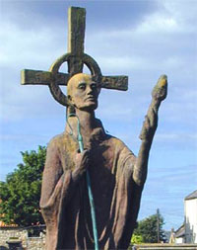
When Oswald died in 642, Aidan received continued support from King Oswine of Deira and the two became close friends. As such, the monk's ministry continued relatively unchanged until the rise of pagan hostilities in 651. At that time, a pagan army attacked Bamburgh and attempted to set its walls ablaze. According to legend, Aidan saw the black smoke from his cell at Lindisfarne Abbey, immediately recognized its cause, and knelt in prayer for the fate of the city. Miraculously, the winds abruptly reversed their course, blowing the conflagration towards the enemy, which convinced them that the capital city was defended by potent spiritual forces. Around this time, Oswine was betrayed and murdered. Two weeks later Aidan died, on 31 August 651. He had become ill while on one of his missionary tours and died leaning against the wall of the local church (now St Aidan's Church, Bamburgh).

After his death, Aidan's body was buried at Lindisfarne, beneath the abbey that he had helped found. Though his popularity waned in the coming years, "in the 11th century Glastonbury monks obtained some supposed relics of Aidan; through their influence Aidan's feast appears in the early Wessex calendars, which provide the main evidence for his cult after the age of Bede." His feast is celebrated on the anniversary of his death, 31st August.

Today, Aidan's significance is still recognized in the following saying by Joseph Lightfoot, Bishop of Durham "Augustine was the Apostle of Kent, but Aidan was the Apostle of the English."

The bishop was visiting a small-town parish to preach at the Sunday morning service.
The next day in the street a non-churchgoer asked one of the faithful whether his visit had made an impact.
‘Well’, came the reply, ‘I’d put it this way. At the end of his sermon there was a great awakening in the congregation.’





The Parishes of Topcliffe, Baldersby with Dishforth, Dalton and Skipton on Swale
There is currently no Vicar of the parish. Until one is appointed, please ring our Area Dean, The Revd Fiona Mayer-Jones
Tel: 07450 402953 or revdfmj@gmail.com

Items for Cross Talk should be emailed to Kit Norris at kitnorris@live.co.uk

