**Benefice Online Magazine**

**for the Parishes of Topcliffe, Baldersby with Dishforth, Dalton and Skipton on Swale**

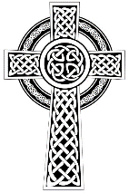 Cross Talk

**October 2021**

Cross Talk is published monthly and distributed by email. If you know of anyone who would like to be added to the email list please ask them to contact [kitnorris@live.co.uk](mailto:kitnorris@live.co.uk)

Cross Talk contains the weekly Collect and Readings together with details of Church services in the Benefice and news and items of interest supplied by our readers.

The magazine will also be available on the web sites: www.achurchnearyou.com/church/3447 and baldersbychurch.com.

**CHURCH SERVICES**

*The following services are planned subject to changes in the Covid-19 regulations.*

Strict measures will be in place for wearing of face masks, hand sanitisation before and after each service, and social distancing. Please observe spaced time of arrival and departure to avoid mingling.

**St. James’ Church, Baldersby St. James with Dishforth and Rainton**

**Sunday 3rd October, 10.45am Holy Communion** with hymns

**Sunday 10th October, 9.30am Breakfast Service** with croissants and coffee. We are looking forward to welcoming Padre Richard Hall (Engineers Regiment, Ripon) who some of you will remember taking services when he was posted at Dishforth. Richard will discuss with us how his faith has been tested looking after his soldiers in war situations around the world. He is an enthusiastic speaker and great fun. I am sure everyone will enjoy having breakfast with him.

**Sunday 17th October, 10.45am Harvest Festival Service** with hymns led by our regular vicar Revd. Terry Dyer to celebrate this year’s harvest and next year’s crops, which will no doubt be drilled and showing green shoots by then! Followed by coffee at 11.30am. If anyone has any fruit or vegetables left at this date we would welcome them.

**Sunday 24th October, 9.30am Morning Prayer.**  This is a quiet, spoken service in our Lady

Chapel, followed by coffee at 10.00am.

**Sunday 31st October, 10.45am Commemoration Service.**  We have chosen this day to especially remember all the many friends and family who died during the sad days when funerals were limited to small numbers and many of us were not able to pay our respects or celebrate their lives.

To let us know of loved ones, whose names you would like read out at this service, please either e-mail me [c.b.brown398@hotmail.co.uk](mailto:c.b.brown398@hotmail.co.uk) or fill in the form at the back of the church so that we can prepare the list before the service. During the service everyone will have the opportunity to light candles to form a large cross of remembrance. Please also include anyone else who has passed away whom you would like to remember. **Susan Brown.**

**Closure of St John’s Churchyard, Skipton on Swale, Thirsk, North Yorkshire**

Notice is hereby given that it is the intention of the Secretary of State for Justice, acting on an application by the incumbent and churchwardens, to apply to the Privy Council for an Order requiring the discontinuation of burials in the above churchyard.

Provision would be made without exceptions:

Any representations about the proposed closure should be sent to the Coroners and Burials Team, Ministry of Justice, 102 Petty France, London SW1H 9AJ or by email to: [coroners@justice.gov.uk](mailto:coroners@justice.gov.uk) (quoting reference CC/AUG21/012) within 21 days of this publication.

**St. Columba’s Church, Topcliffe**

**Sunday 3rd October, 6.30pm Choral Evensong for Harvest Festival.**  A service with harvest hymns and readings, giving us time to thank God for his abundant goodness and to appreciate the rural farming community in which we live. This will be followed by a ‘finger buffet’ and drinks, including wine.

**Sunday 10th October, 10.45am Holy Communion** with hymns.

**Sunday 17th October, 10.45am Choral Matins** (Book of Common Prayer) with hymns and readings

**Sunday 24th October, 10.45am Holy Communion** with hymns.

**Sunday 31st October**  No Service

**Tuesday 2nd November, 7.30pm Choral Requiem Mass for the Feast of All Souls.** November is the season of Remembrance, and on the second of November we are invited to remember those known to us who have died. This service is open to all, of any denomination or none, and provides the space and tranquillity to reflect on and give thanks for the lives of family and friends we see no more. The unaccompanied choir will sing the glorious and contemplative 1605 setting by Tomas Luis de Victoria composed in six-part harmony. During the service there will be an opportunity to light candles and have the names of loved ones read out, or, if preferred, silently remembered by the placing of names on the altar. As we emerge from the Covid pandemic, this will be particularly relevant and poignant.

**Sunday 14th November, 10.45am Remembrance Sunday. Holy Communion with**

**Act of Remembrance.**

With the cancellation of this service last year, it will be good to see it return to our calendar again, particularly as we remember the sacrifices our forces have endured in Afghanistan over the past twenty years. We hope that service personnel from Alanbrooke Barracks will join us and participate in the laying of wreaths.

**Charity Soup and Sweet Lunches at Topcliffe Village Hall, Topcliffe.**

Wednesday 13th & Wednesday 27th October at 12 noon.  *Details on page 7.*

**Collects and Readings for the 18th Sunday after Trinity to 4th Sunday before Advent**

*(Page numbers refer to the Common Worship Lectionary.)*

**Sunday 3rd October : 18th Sunday after Trinity**

**Collect**

Almighty and everlasting God,

increase in us your gift of faith

that, forsaking what lies behind

and reaching out to that which is before,

we may run the way of your commandments

and win the crown of everlasting joy;

through Jesus Christ your Son our Lord,

who is alive and reigns with you,

in the unity of the Holy Spirit,

one God, now and for ever.

**Readings** (Proper 22, **p.688**)

Genesis 2.18-24

Psalm 8

Hebrews 1.1-4; 2.5-12

Gospel: Mark 10.2-16

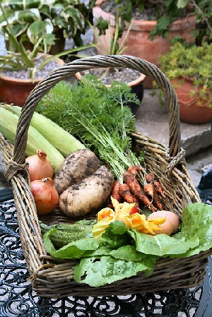**Sunday 10th October : 19th Sunday after Trinity**

**Collect**

O God, foreasmuch as without you

we are not able to please you,

mercifully grant that your Holy Spirit

may in all things direct and rule our hearts;

through Jesus Christ your Son our Lord,

who is alive and reigns with you,

in the unity of the Holy Spirit,

one God, now and for ever.

**Readings** (Proper 23, **p.693**)

Amos 5: 6-7, 10-15

Psalm 90: 12-17

Hebrews 4: 12-16

Gospel: Mark 10: 17-31

**Sunday 17th October : 20th Sunday after Trinity**

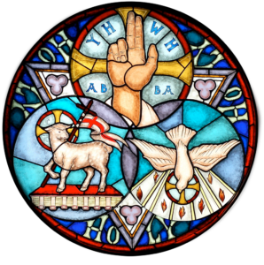**Collect**

God, the giver of life,

whose Holy Spirit wells up within your Church:

by the Spirit’s gifts equip us to live the gospel of Christ

and make us eager to do your will,

that we may share with the whole creation

the joys of eternal life;

through Jesus Christ your Son our Lord,

who is alive and reigns with you,

in the unity of the Holy Spirit,

one God, now and for ever.

**Readings** (Proper 24, **p.698**)

Isaiah 53: 4-12

Psalm 91: 9-16

Hebrews 5: 1-10

Gospel: Mark 10: 35-45

**Sunday 24th October : 21st Sunday after Trinity**

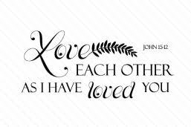**Collect**

Grant, we beseech you, merciful Lord,

to your faithful people pardon and peace,

that they may be cleansed from all their sins

and serve you with a quiet mind;

through Jesus Christ your Son our Lord,

who is alive and reigns with you,

in the unity of the Holy Spirit,

one God, now and for ever.

**Readings** (Proper 25, **p.704**)

Jeremiah 31: 7-9

Psalm 126

Hebrews 7: 23-28

Gospel: Mark 10: 46-52

**Sunday 31st October : Fourth Sunday before Advent**

**Collect**

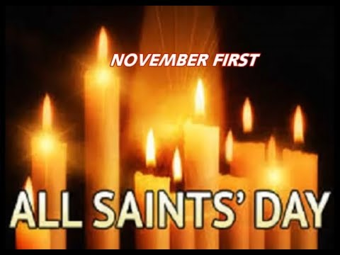Almighty and eternal God,

you have kindled the flame of love

in the hearts of the saints:

grant to us the same faith and power of love,

that, as we rejoice in their triumphs,

we may be sustained by their example and fellowship;

through Jesus Christ your Son our Lord,

who is alive and reigns with you,

in the unity of the Holy Spirit,

one God, now and for ever.

**Readings** (**p.712**)

Deuteronomy 6:1-9

Psalm 119: 1-8

Hebrews 9: 11-14

Gospel: Mark 12: 28-34

**October Reflection**

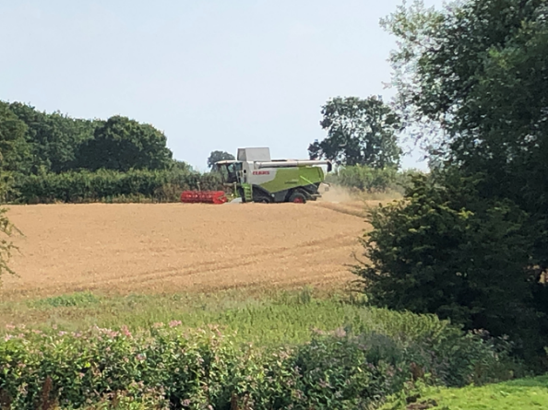Our Harvest Festivals, which traditionally are held in September and October, remind us that in addition to being dependant on the crops ‘being fed and watered by God’s almighty hand’ we are also very dependent on very many people, often unknown to us, to provide the food on our plates. And as the recent shortage of Carbon Dioxide proved, we may be dependent on people who have unexpected inputs into our food chain. We may recognize that our farmers need fertilizer to help the crops grow; maybe few of us realised that the carbon dioxide, a by-product of fertilizer manufacture, was needed in the chicken and pig slaughterhouses and the same source of carbon dioxide is used by the fizzy drink manufacturers.

Both individually and as a nation we are not self-sufficient. Our very existence, the food which we have come to expect in abundance, is only available because many people around the world of different nationalities and faiths contribute their skills to the common cause of making the world as we know it work. For us to ‘plough the fields and scatter’ we need not only the farmers doing the work on the land but all those who support them directly and indirectly - engineers to design and build the seed drills and harvesters, geneticists to develop varieties of crops for different situations and purposes, geologists that find the minerals and oils to make and power the farm machinery, computer scientists and satellite engineers responsible for GPS to direct the seed drills and harvesters as well as the lorries delivering seed to the farm ….. the list could continue for the rest of this page. And as we are beginning to learn, it only takes one piece in this jigsaw to fail, and we start to see problems.

Our interdependence has also been emphasised recently by the on-going Covid pandemic. The disease spread around the world at frightening speed, and as the first lockdown showed, it is not possible for us to continue our lives in isolation. At the practical level we needed to have access to food and medications, at the emotional level we need the fellowship of others, and we need to be able to get out for exercise if we are able. The Covid pandemic has also shown that we need others if we are to be protected from infection – not only the scientists monitoring the virus and producing the vaccines – but we need people in our local area to maintain social distancing and wear masks in situations that the scientific advisors believe are necessary and in turn we need to keep to the rules to protect others.

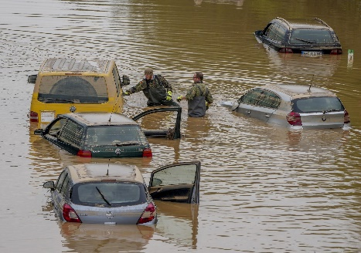Another feature of interdependence that has been very much in the news recently is the effect we all have on climate change. Our collective actions appear to be changing the world climate resulting in increased floods, droughts, and wildfires around the world. As with our food and Covid, it is becoming increasingly obvious that the neighbours we are called to love are not just the people in our street, our county or country but all the inhabitants of the world – their actions affect us and ours affect them. If the climate were to alter radically then our farmers may have difficulty growing the crops they now grow and what they may then harvest will be very different to what they harvest now.

In Matthew 22:35-40 Jesus tells us ‘You shall love the Lord your God with all your heart, and with all your soul, and with all your mind.' This is the greatest and first commandment. And a second is like it: 'You shall love your neighbour as yourself.' On these two commandments hang all the law and the prophets.’ Loving God is not only active worship at home and in church but respecting the gifts He has given us – particularly this earth and our fellow inhabitants.

We may not personally play any part of the food supply chain, but we can respect the gift of the food we have by avoiding waste; we may not be at the forefront of Covid science developing vaccines or typing new strains of the virus but we can help protect others from Covid by the actions we take and we may not fully understand the science behind climate change but we can find ways to reduce our carbon footprint. All these actions will show our love for our neighbours and our love for God by the respect we have for ‘all (the) good gifts around us’ that are ‘sent from heaven above’.

**Alfred the Great - not quite a saint?**

Looking for English saints whose feast days occur on October, on the Catholic Online website I came across St Alfred the Great whose feast day is given as the 26th October. Sharing this feast day are two other English saints. Saint Cedd who was a monk and bishop known as the apostle to the Middle Angles. Cedd was ordained by Saint Finan of the East Saxons in AD 644 at Lastingham, on the edge of the North York Moors. Also sharing the same feast day is Saint Eata of Hexham who was a monk and abbot, and was Bishop of Hexham from 678 until 681, and then Bishop of Lindisfarne from before 681 until 685. He then was translated back to Hexham where he served until his death in 685 or 686. He was the first native of Northumbria to occupy the bishopric of Lindisfarne.

A number of early English monarchs were recognised as saints including Edmund the Martyr who was King of East Anglia from about 855 until his death in 869AD. Edmund's cult flourished in the Early and High Middle Ages. St. Edmund was the original patron saint of England but was replaced by St. George when King Edward III formed the Order of the Garter in St. George’s name in 1350.

Another well-known English king recognised as a saint was Edward the Confessor who was one of the last Anglo-Saxon kings of England. Usually considered the last king of the House of Wessex, he ruled from 1042 to 1066.

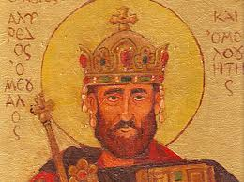Alfred the Great (849-899) is venerated as a saint in some Christian traditions but, athough he may have had something of a saint in him, he was never canonised and this put him at something of a disadvantage in the later medieval world. Henry VI attempted unsuccessfully to have him canonized by Pope Eugene IV in 1441; he was venerated sometimes in the Catholic Church; the Anglican Communion venerates him as a Christian hero and he may often be found depicted in stained glass in Church of England parish churches.

During a journey to Rome, Alfred was accepted as a godson by Pope Leo IV. He was a great scholar, translating classics for his people, and early on seemed destined for a career in the Church. Instead, he became king and was forced to spend most of his reign in conflict with the Danes who were then threatening England. His work as a patron of the arts, literature, and especially the Church made him a beloved figure in England.

After ascending the throne, Alfred spent several years fighting Viking invasions. He won a decisive victory in the Battle of Edington in 878 and made an agreement with the Vikings, creating what was known as the Danelaw in the North of England. Alfred also oversaw the conversion of Viking leader Guthrum to Christianity. He defended his kingdom against the Viking attempt at conquest, becoming the dominant ruler in England. Details of his life are described in a work by 9th-century Welsh scholar and bishop Asser.

Alfred had a reputation as a learned and merciful man of a gracious and level-headed nature who encouraged education, proposing that primary education be conducted in Old English rather than Latin and improving the legal system and military structure and his people's quality of life. He was given the epithet "the Great" in the 16th century.

Alfred died on 26th October 899 at the age of 50 or 51. How he died is unknown, but he suffered throughout his life with a painful and unpleasant illness. His biographer Asser gave a detailed description of Alfred's symptoms, and this has allowed modern doctors to provide a possible diagnosis. It is thought that he had either Crohn's disease or haemorrhoids.

It does seem that Alfred the Great was the ‘saint who nearly was’.

**Richard Byas**

**Final Advice**

The 98-year-old Mother Superior from Ireland lay dying. The nuns gathered around her bed, trying to make her last moments on earth more comfortable. They gave her some warm milk to drink but she refused, so one of the nuns took the glass back to the kitchen.

Then, remembering a bottle of Irish whiskey received as a gift the previous Christmas, she opened it and poured a generous amount into the warm milk. Back at Mother Superior's bed, she held the glass to her lips. Mother drank a little, then a little more and, before they knew it, she had drunk the whole glass down to the last drop.

'Mother,' the nuns asked earnestly, 'Please give us some final wisdom before you die.'

Mother Superior raised herself slowly up in bed and, with a pious look on her face, said: 'Don't sell that cow!'



**Dalton Church’s Pre-Raphaelite windows**

A few weeks ago, Dalton church was visited by Lord Andrew Lloyd Webber who commented that the William Morris, Edward Burne-Jones and Ford Maddox Brown windows were magnificent and of important value.  Quite a coup!

**Grand Attic Auction**

The Attic Auction in aid of St. Columba’s Church, Topcliffe, raised £1,260. Many thanks to John Phillips our auctioneer and his assistants, to those who donated items for the auction, and to those who supported the sale and came away with treasures and newly discovered items they hadn’t known they needed.

Charity Soup & Sweet Lunches

(Soup, bread, cakes, tea, coffee, etc)

12 noon Wednesdays 13th & 27th October

FREE LUNCH (but donations to the selected Charities would be welcome)

TOPCLIFFE VILLAGE HALL*e 65th Anniversary of the*

**PARISH DIRECTORY**

**The Parishes of Topcliffe, Baldersby with Dishforth, Dalton and Skipton on Swale**

There is currently no Vicar of the parishes. Until one is appointed, please ring our Area Dean,

The Revd Fiona Mayer-Jones tel: 07450 402953 or [revdfmj@gmail.com](mailto:revdfmj@gmail.com)

**BALDERSBY with DISHFORTH** - PCC Secretary: Mrs Jennifer Wharton [wharton370@btinternet.com](mailto:wharton370@btinternet.com)

**DALTON** - PCC Secretary: Mrs Hannah Bissett tel: 07739 382831 [spannerb79@gmail.com](mailto:spannerb79@gmail.com)

**SKIPTON-on-SWALE** – PCC Secretary: Mr Alan Kitching tel: 01845 567457

**TOPCLIFFE** – PCC Secretary: Mrs Roz Norris [RozNorris@aol.com](mailto:RozNorris@aol.com)