**Benefice Online Magazine**

**for the Parishes of Topcliffe, Baldersby with Dishforth, Dalton and Skipton on Swale**

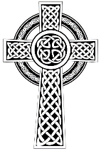 Cross Talk

**December 2021**

Cross Talk is published monthly by email. To receive a copy please contact [kitnorris@live.co.uk](mailto:kitnorris@live.co.uk)

Cross Talk contains the weekly Collect and Readings together with details of Church services in the Benefice and news and items of interest supplied by our readers.

The magazine will also be available on the web sites: www.achurchnearyou.com/church/3447 and baldersbychurch.com.

**CHURCH SERVICES**

*The following services are planned subject to changes in the Covid-19 regulations.*

Strict measures will be in place for wearing of face masks, hand sanitisation before and after each service, and social distancing. Please observe spaced time of arrival and departure to avoid mingling.

**St. James’ Church, Baldersby St. James with Dishforth and Rainton**

**Sunday 5th December, 10.45am Communion Service**

**Sunday 12th December, 9.30am Breakfast Service** with coffee and croissants.

**Sunday 19th December, 10.45am** Communion Service

**Friday 24th December, 6.30pm Carol Service**

**Sunday 26th December *NO SERVICE***

**Sunday 2nd January, 10.45am Communion Service**

**Sunday 9th January, 9.30am Breakfast Service with coffee and croissants.**

**Sunday 16th January, 10.45am Communion Service**

**Sunday 23rd January, 9.30am Morning Prayer** (short spoken service)

**Sunday 30th January *NO SERVICE***

***All services followed by coffee.***

**Salvation Army Christmas Collection**

*A big thank you to everyone who dropped presents into church for the Salvation Army in Ripon to distribute.*

*The presents are given to family members to individually wrap which makes it more personal. We had three tables full of a wide variety of nice presents, so when Stuart and Rosemarie dropped them in the Salvation Army volunteers asked them to pass on their thanks to everyone for their generosity.*

***St James Church wishes everyone a Very Happy Christmas and the Best of Health for 2022***

**St. Columba’s Church, Topcliffe**

**Sunday 5th December, 10.45am Choral Evensong** with hymns

**Sunday 12th December, 10.45am Holy Communion**

**Sunday 19th December, 10.45am Matins** (said)

**Sunday 19th December, 6.30pm Service of Nine Lessons and Carols.**

The traditional telling of the Christmas story with an abundance of congregational and choir carols. St Columba’s Choir led by Linda Hewlett, Organist: Matthew Atherton. Followed by refreshments including wine and finger food.

**Wednesday 22nd December, 7pm ‘Come and Sing’ Carols for all, around the Christmas Tree.**

Meet outside the Village Hall to start singing at 7pm. Followed by mince pies and mulled wine from 7.30pm inside the Village Hall.

**Christmas Eve, Friday 24th December, 2pm Crib Service**

An informal telling of the Christmas story. For all the family, especially those with young children.

**Christmas Eve, Friday 24th December, 11.30pm Midnight Mass.**

The First Christmas Eucharist to bring you into Christmas Day, with choir and congregational carols.

**Christmas Day, Saturday 25th December 9am**

An informal Christmas Day service for all the family, led by our Reader, Richard Byas.

**Sunday 26th December NO SERVICE**

**Sunday 2nd January, 6.30pm Choral Evensong**

*From all at St Columba’s, our very best wishes to you all for a very Happy and Blessed Christmas and 2022. We would also like to thank everyone for their support and understanding as we have negotiated both the Covid pandemic and the ongoing interregnum, awaiting the appointment of our new vicar.*

**St John the Evangelist Church, Dalton**

**Sunday 12th December, 11.00am Holy Communion**

**Friday 17th December, 7.00pm Carols by Candlelight** followed by mulled wine and mince pies, hot

chocolate and biscuits

**Christmas Fair**

Our Christmas Fair will be held on **Saturday 4th December, 10am to 12 noon.** Admission is £2 for adults and £1 for children (which includes a gift from Santa). There will be various stalls, a tombola, singing from Dalton Voices, and bacon butties! Come along and enjoy a browse through the stalls and a chat over a cuppa and butty. Sylvia Binks.

**100 Club Results**

The results for October were: £15 – Michaela Kitching (No.82); £10 – William Atkinson (No.100);

£5 – Joe Wood (No.24).

**Shine a Light**

If you would like a message on the village Christmas tree, please fill in a form which can be found at the bottom of the drive at Orchard View (next to the eggs for sale), and leave in the box. The cost is £2, which goes towards the cost of the tree and the electrician. Many thanks and happy Christmas.

**Collects and Readings for the 2nd Sunday of Advent to the 1st Sunday of Christmas**

*(Page numbers refer to the Common Worship Lectionary.)*

**Sunday 5th December : 2nd Sunday of Advent**

**Collect**

O Lord, raise up, we pray, your power

and come among us,

and with great might succour us;

that whereas, through our sins and wickedness

we are grievously hindered

in running the race that is set before us,

your bountiful grace and mercy

may speedily help and deliver us;

through Jesus Christ your Son our Lord

to whom with you and the Holy Spirit,

be honour and glory, now and for ever.

**Readings** (**p.738**)

Baruch 5.1-9 *or* Malachi 3.1-4

Canticle: Benedictus (Luke 1.68-79)

Philippians 1.3-11

Gospel: Luke 3.1-6

**Sunday 12th December : 3rd Sunday of Advent**

**Collect**

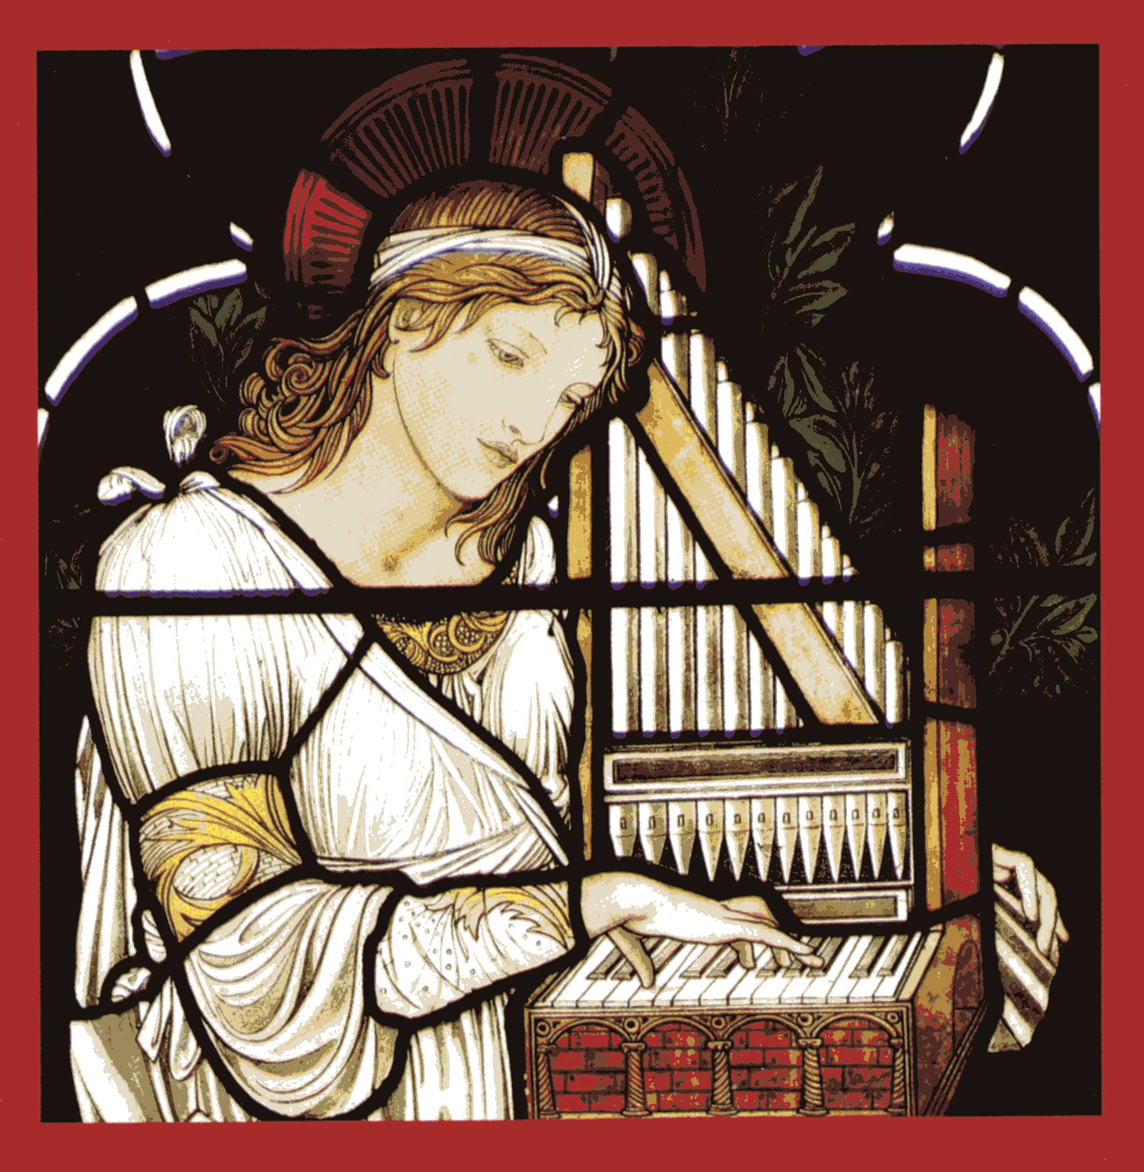O Lord Jesus Christ,

who at your first coming sent your messenger

to prepare your way before you:

grant that the ministers and stewards of your mysteries

may likewise so prepare and make ready your way

by turning the hearts of the disobedient

to the wisdom of the just,

that at your second coming to judge the world

we may be found an acceptable people in your sight;

for you are alive and reign with the Father

in the unity of the Holy Spirit,

one God, now and for ever.

**Readings** (**p.741**)

Zephaniah 3.14-20

Canticle: Isaiah 12.2-6 *or* Psalm146.4-9

Philippians 4.4-7

Gospel: Luke 3.7-18

**Sunday 19th December : 4th Sunday of Advent**

**Collect**

God our redeemer,

who prepared the Blessed Virgin Mary

to be the mother of your Son:

grant that, as she looked for his coming as our saviour,

so we may be ready to greet him

when he comes again as our judge;

who is alive and reigns with you,

in the unity of the Holy Spirit,

one God, now and for ever.

**Readings** (**p.744**)

Micah 5.2-5a

Canticle: Magnificat (Luke 1.46-55) *or* Psalm 80.1-7

Hebrews 10.5-10

Gospel: Luke 1.39-45, [46-55]

**Friday 24th December : Christmas Eve**

**Collect**

Almighty God,

you make us glad with the yearly remembrance

of the birth of your Son Jesus Christ:

grant that, as we joyfully receive him as our redeemer,

so we may with sure confidence behold him

when he shall come to be our judge;

who is alive and reigns with you,

in the unity of the Holy Spirit,

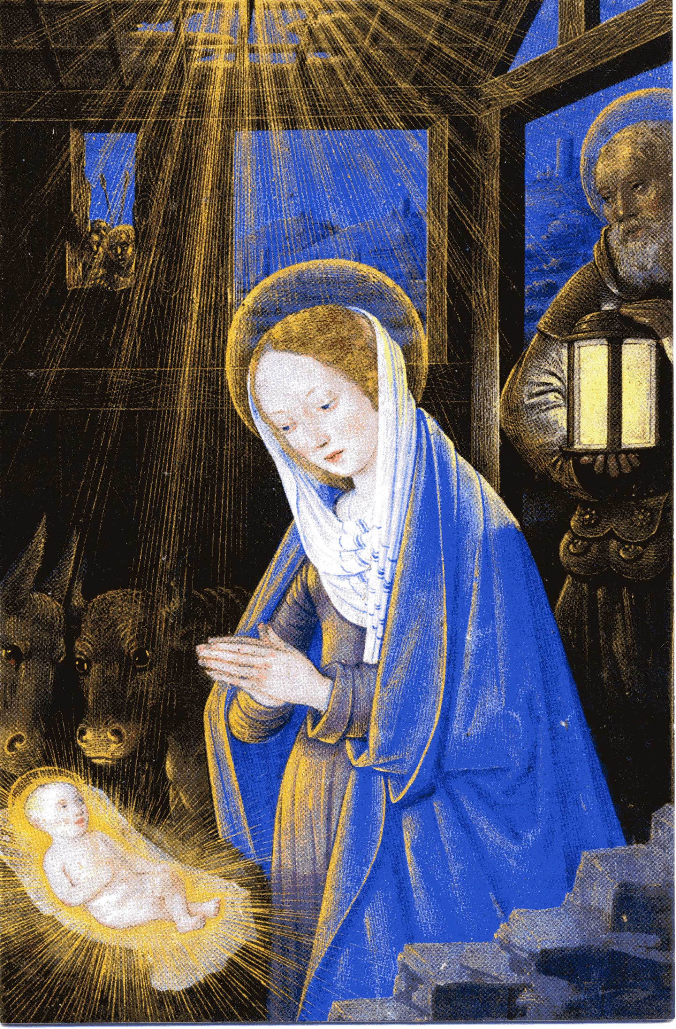one God, now and for ever.

**Readings** (**p.748**)

2 Samuel 7.1-5, 8-11, 16

Psalm 89.2, 21-27

Acts 13.16-26

Gospel: Luke 1.67-79

**Saturday 25th December : Christmas Day**

**Collect** (SET III)

Almighty God,

you have given us your only-begotten Son

to take our nature upon him

and as at this time to be born of a pure virgin:

grant that we, who have been born again

and made your children by adoption and grace,

may daily be renewed by your Holy Spirit;

through Jesus Christ your Son our Lord,

who is alive and reigns with you,

in the unity of the Holy Spirit,

one God, now and for ever.

**Readings (p.759)**

Isaiah 52.7-10

Psalm 98

Hebrews 1.1-4, [5-12]

Gospel: John 1.1-14

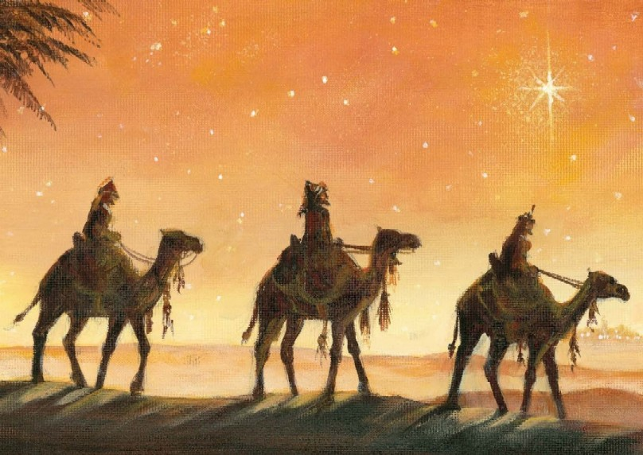**Sunday 26th December: 1st Sunday of Christmas**

**Collect**

Almighty God,

who wonderfully created us in your own image

and yet more wonderfully restored us

through your Son Jesus Christ:

grant that, as he came to share in our humanity,

so we may share the life of his divinity;

who is alive and reigns with you,

in the unity of the Holy Spirit,

one God, now and for ever.

**Readings** (**p.762**)

1 Samuel 2.18-20, 26

Psalm 148.[1-6,] 7-14

Colossians 3.12-17

Gospel: Luke 2.41-52

**Sunday 2nd January: 2nd Sunday of Christmas**

**Collect**

Almighty God,

in the birth of your Son

you have poured on us the new light of your incarnate Word,

and shown us the fullness of your love:

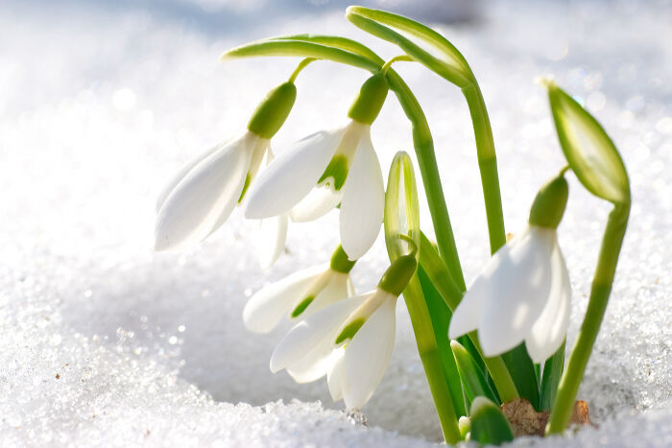help us to walk in his light and dwell in his love

that we may know the fullness of his joy;

who is alive and reigns with you,

in the unity of the Holy Spirit,

one God, now and for ever.

**Readings (p.765)**

Jeremiah 31.7-14

Psalm 147.13-21

Ephesians 1.3-14

Gospel: John 1.[1-9,] 10-18



**December Reflection**

In 1 Corinthians 13:13 we read ‘And now these three remain: faith, hope and love. But the greatest of these is love’. It is during this season of Advent that we focus on hope and with the Covid pandemic still claiming over 1000 deaths a week in the UK (with countless more across the world) and with the ‘climate crisis’ fresh in our minds after the recent COP26 conference in Glasgow we have a real need for hope in our lives. That is why what happened in Bethlehem 2,000 years ago is so important. It gives us hope. Hope in the midst of the many problems that surround us.

For Christians, our hope is centred on the Second Coming of Christ. Advent is not just about preparing for Christmas festivities to celebrate the coming of the Christ child. It is also about looking to the Second Coming of Jesus.

In the 19th century, there was a wave of enthusiasm for prophecies predicting the actual date for the Second Coming of Christ. One such prophet was an American Adventist leader name William Miller. After studying Daniel Chapter 8, Miller predicted that Christ would return on March 21st 1842, but then revised the date to April 3rd 1843. Over 3,500 of his followers filled the Boston Advent Temple only to be disappointed. Despite this disappointment the movement continued to grow and Miller decided to recalculate his date for the Second Coming and soon publicized a new date - April 18th 1844. When the messiah did not show up on that date, there was again frustration and some followers left but undeterred, Miller came up with a third date – October 22nd 1844. Despite opposition from established mainstream religious groups, thousands of people – including many clergy – began to prepare. One account noted that “Fields were left unharvested, shops were closed, people quit their jobs, paid their debts, and freely gave away their possessions with no thought of repayment.” But as we all know, this final ‘calculation’ also proved wrong.

Advent is a time when we are reminded of the certainty that Jesus entered the world to die on the cross for our sins and that he will return to establish the Kingdom of God in our midst. It is in the assurance of that hope upon which we stand, worship, serve and live – the timing of the Second Coming is not for us to know but we are to live in the knowledge that it will occur.

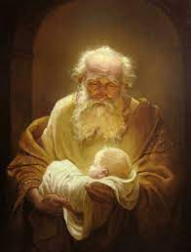Despite all the doom mongers, there is hope for this earth. Jesus taught in the Sermon on the Mount that the meek shall inherit the earth so there must be an Earth for the meek to inherit. There is hope for the Earth because Jesus came, which means there is also hope for us.

When Jesus was only eight days old his parents took him to the temple. An old man by the name of Simeon walked up to the young couple, took Jesus in his arms and said: ‘My eyes have seen your salvation, O Lord. A light for revelation to all people’.

Salvation for us all is wrapped up in this little baby. Not in some tradition, not in a certain religion but in the Christ Child. He is our Saviour. And all of us need to be saved from something. We all have weaknesses, sins, shortcomings, things we do know are wrong. All those things God says break relationships. And that’s why Jesus came: To save us from our sins. And to save us from our fears.

And the Good News is that Jesus not only came to save us from our sins but He also came to give us everlasting life. ‘God so loved the world that He gave his only Son that whoever believes on Him should not perish but have everlasting life’.

So, it is during this season of Advent that we focus on hope. Advent should be about slowing down to prepare ourselves for the coming of the Kingdom – first in our hearts through an infant saviour and then in joyful anticipation of that Second Coming.

Because Jesus came, we have hope, not only in this world, but also beyond the grave. Death is not the cruel monster it once was. Jesus came, died and returned to life in victory.

There is much in this world today trying to convince us not to have hope for the future. Yet, as people of faith, we are given a glimpse of God’s ‘Master Plan’ of a future filled with hope. In the little details of our daily living, we are invited to be about the business of bringing seeds of hope to the world. May we as a people of faith keep proclaiming and living God’s message of hope for ourselves and the whole world this Christmastide and beyond. Amen.

**Richard Byas**

**A Christmas Saint - St. Nicholas**

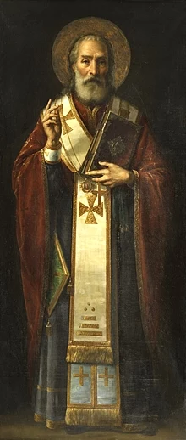December 6th is the day that the life of St. Nicholas is celebrated. St. Nicholas, who lived in the fourth century AD, only became associated with ‘Santa Claus’ and Christmas via Dutch and German American immigrants and that association then recrossed the Atlantic to the UK in the late 19th century.

The story goes that this fourth century bishop of Myra got three men being held in a prison tower under threat of execution pardoned and from this, it is believed, that the legend grew that he restored to life three children who had been butchered and pickled - which is a much more amazing story. Though this story seems bizarre and even horrifying to our ears, it was very popular throughout the late Middle Ages and widely beloved by ordinary folk. It is depicted in stained glass windows, wood panel paintings, tapestries, and frescoes. Eventually, the scene became so widely reproduced that, rather than showing the whole scene, artists began to merely depict Saint Nicholas with three naked children and a wooden barrel at his feet. Eventually, people who had forgotten or never learned the story began misinterpreting representations of it and the fact that Saint Nicholas was shown with children led people to conclude he was the patron saint of children; meanwhile, the fact that he was shown with a barrel led people to conclude that he was also the patron saint of brewers.

According to another story, during a great famine that Myra experienced in 311–312AD, a ship was in the port at anchor, loaded with wheat for the Emperor in Constantinople. Nicholas invited the sailors to unload some of the wheat to help relieve the famine. The sailors at first resisted because the wheat had to be weighed accurately and delivered to the Emperor. Only when Nicholas promised them that they would not suffer any loss did the sailors agree. When they arrived later in Constantinople, they made a surprising find: the weight of the load had not changed, although the wheat removed in Myra was enough for two full years and could even be used for sowing.

Another story concerning the saint is that he is said to have rescued three girls from being forced into prostitution by dropping a sack of gold coins anonymously through the window of their house each night for three nights so their father could pay a dowry for each of them. St Nicholas is also the patron saint of pawnbrokers, and the three golden balls are said to represent the bags of gold used to save the three girls.

Very little is known however about the historical Saint Nicholas. The earliest accounts of his life were written centuries after his death and contain many legendary elaborations. An early list makes him an attendee at the First Council of Nicaea in 325AD, but he is never mentioned in any writings by people who were actually at the council. A later legend, first attested in the fourteenth century over 1,000 years after Nicholas's death, tells that, during the Council of Nicaea, Nicholas lost his temper and slapped "a certain Arian" across the face. Later versions of the legend embellish it, making the heretic Arius himself and having Nicholas punch him rather than merely slapping him with his open hand. Traditionally St Nicholas died on 6th December 343AD aged 73 years old.

Whatever the truths about his life, it is obvious that he was well respected in his lifetime and, less than two hundred years after Saint Nicholas's probable death, the Eastern Roman Emperor Theodosius II ordered the building of the Church of Saint Nicholas in Myra, which thereby preserves an early mention of his name.

However, it is his connection with children and the story of his anonymous gift giving that have been combined into a new legend and now everybody knows what he does on Christmas eve!

**Richard Byas**

Happy Christmas

The vicar was opening his Christmas cards one December morning. Out of one the cards came a single sheet of paper on it was written only one word: 'Fool'. The following Sunday, in church, he announced to the assembled congregation, 'I have known many people who have written notes to me and forgotten to sign their names. But this week I received a note from someone who signed his name and had forgotten to write a letter.'



Charity Soup & Sweet Lunches

(Soup, bread, cakes, tea, coffee, etc)

12 noon Wednesday 8th December

FREE LUNCH (but donations to the selected Charities would be welcome)

TOPCLIFFE VILLAGE HALL*e 65th Anniversary of the a*

**PARISH DIRECTORY**

**The Parishes of Topcliffe, Baldersby with Dishforth, Dalton and Skipton on Swale**

There is currently no Vicar of the parishes. Until one is appointed, please ring our Area Dean,

The Revd Fiona Mayer-Jones tel: 07450 402953 or [revdfmj@gmail.com](mailto:revdfmj@gmail.com)

**BALDERSBY with DISHFORTH** - PCC Secretary: Mrs Jennifer Wharton [wharton370@btinternet.com](mailto:wharton370@btinternet.com)

**DALTON** - PCC Secretary: Mrs Hannah Bissett tel: 07739 382831 [spannerb79@gmail.com](mailto:spannerb79@gmail.com)

**SKIPTON-on-SWALE** – PCC Secretary: Mr Alan Kitching tel: 01845 567457

**TOPCLIFFE** – PCC Secretary: Mrs Roz Norris [RozNorris@aol.com](mailto:RozNorris@aol.com)

