**Benefice Online Magazine**

**for the Parishes of Topcliffe, Baldersby with Dishforth, Dalton and Skipton on Swale**

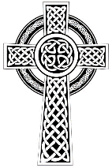 Cross Talk

**November 2021**

Cross Talk is published monthly by email. To receive a copy please contact [kitnorris@live.co.uk](mailto:kitnorris@live.co.uk)

Cross Talk contains the weekly Collect and Readings together with details of Church services in the Benefice and news and items of interest supplied by our readers.

The magazine will also be available on the web sites: www.achurchnearyou.com/church/3447 and baldersbychurch.com.

**CHURCH SERVICES**

*The following services are planned subject to changes in the Covid-19 regulations.*

Strict measures will be in place for wearing of face masks, hand sanitisation before and after each service, and social distancing. Please observe spaced time of arrival and departure to avoid mingling.

**St. James’ Church, Baldersby St. James with Dishforth and Rainton**

**Sunday 7th November, 10.45am Holy Communion**

**Sunday 14th November, 9.30am Breakfast Service** with coffee and croissants.

**Sunday 21st November, 10.45am Holy Communion**

**Sunday 28th November, 9.30am Morning Service**

**Salvation Army -- Ripon**

The Salvation Army have once again asked us to donate gifts for them to distribute to the families they support this Christmas. They would like gifts for adults, babies, and boys age 8-teens. Toys, sweets, chocolates, and toiletries are suggested, but no clothes this year. A table will be available at the back of the church. Please donate by 21st November.

Many thanks. Susan Brown.

**St. Columba’s Church, Topcliffe**

**Tuesday 2nd November, 7.30pm Choral Requiem Mass for the Feast of All Souls**

Officiant**: Revd Canon Keith Punshon.**

We are invited to remember those known to us who have died. This service is open to all, of any denomination or none, and provides the space and tranquillity to reflect on and give thanks for the lives of family and friends we see no more. The unaccompanied choir will sing the glorious and contemplative 1605 setting by Tomas Luis de Victoria composed in six-part harmony. During the service there will be an opportunity to light candles and have the names of loved ones read out, or, if preferred, silently remembered by the placing of names on the altar. As we emerge from the Covid pandemic, this will be particularly relevant and poignant. **All are most welcome.**

**Sunday 7th November, 10.45am Choral Evensong** with hymns

**Sunday 14th November, 10.45am Remembrance Sunday. Holy Communion with**

**Act of Remembrance** led by **Revd Lesley Ashton.**

With the cancellation of this service last year, it will be good to see it return to our calendar again, particularly as we remember the sacrifices our forces have endured in Afghanistan over the past twenty years. Service personnel from Alanbrooke Barracks will join us and participate in the laying of wreaths.

**Sunday 21st November, 10.45am Choral Matins** (Book of Common Prayer) with hymns and readings

**Sunday 28th November, 10.45am Holy Communion** with hymns

**St John the Evangelist Church, Dalton**

**Sunday 7th November, 11.00am Family Service**

**Sunday 28th November, 11.00am Holy Communion**

**Sunday 12th December, 11.00am Holy Communion**

**Friday 17th December, 7.00pm Carols by Candlelight** followed by mulled wine and mince pies, hot

chocolate and biscuits

**Autumn Lunch**

Our Autumn Lunch will be on **Sunday 21st November, 12 for 12.30pm**. Tickets are £12 per individual, a family of 2 adults and 2 primary school children will be £25. Tickets are available from Judy Spence on 01845 577607. Tickets are limited to 80 this year, so please get your order in as soon as possible.

**Christmas Fair**

Our Christmas Fair will be held on **Saturday 4th December, 10am to 12 noon.** Admission is £2 for adults and £1 for children (which includes a gift from Santa). There will be various stalls, a tombola, singing from Dalton Voices, and bacon butties! Come along and enjoy a browse through the stalls and a chat over a cuppa and butty. Sylvia Binks.

**100 Club Results**

We have re-started the 100 Club and the first results for September were:

£15 Nick Atkinson (No.97)

£10 Peggy Allen (No.66)

£5 Maureen Hardwick (No.57).

**Collects and Readings for the 3rd Sunday before Advent to the 1st Sunday of Advent**

*(Page numbers refer to the Common Worship Lectionary.)*

**Sunday 7th November : 3rd Sunday before Advent**

**Collect**

Almighty Father,

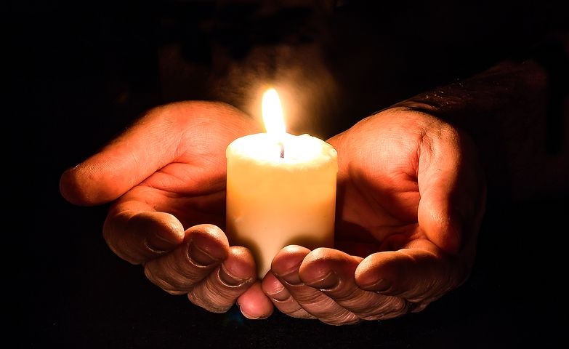whose will is to restore all things

in your beloved Son, the king of all:

govern the hearts and minds of those in authority,

and bring the families of the nations,

divided and torn apart by the ravages of sin,

to be subject to his just and gentle rule;

who is alive and reigns with you,

in the unity of the Holy Spirit,

one God, now and for ever.

**Readings** (**p.715**)

Jonah 3.1-5.10

Psalm 62.6-14

Hebrews 9.24-28

Gospel: Mark 1.14-20

**Sunday 14th November : 2nd Sunday before Advent**

**Collect**

Heavenly Father,

whose blessed Son was revealed

to destroy the works of the devil

and to make us the children of God and heirs of eternal life:

grant that we, having this hope,

may purify ourselves even as he is pure;

that when he shall appear in power and great glory

we may be made like him

in his eternal and glorious kingdom;

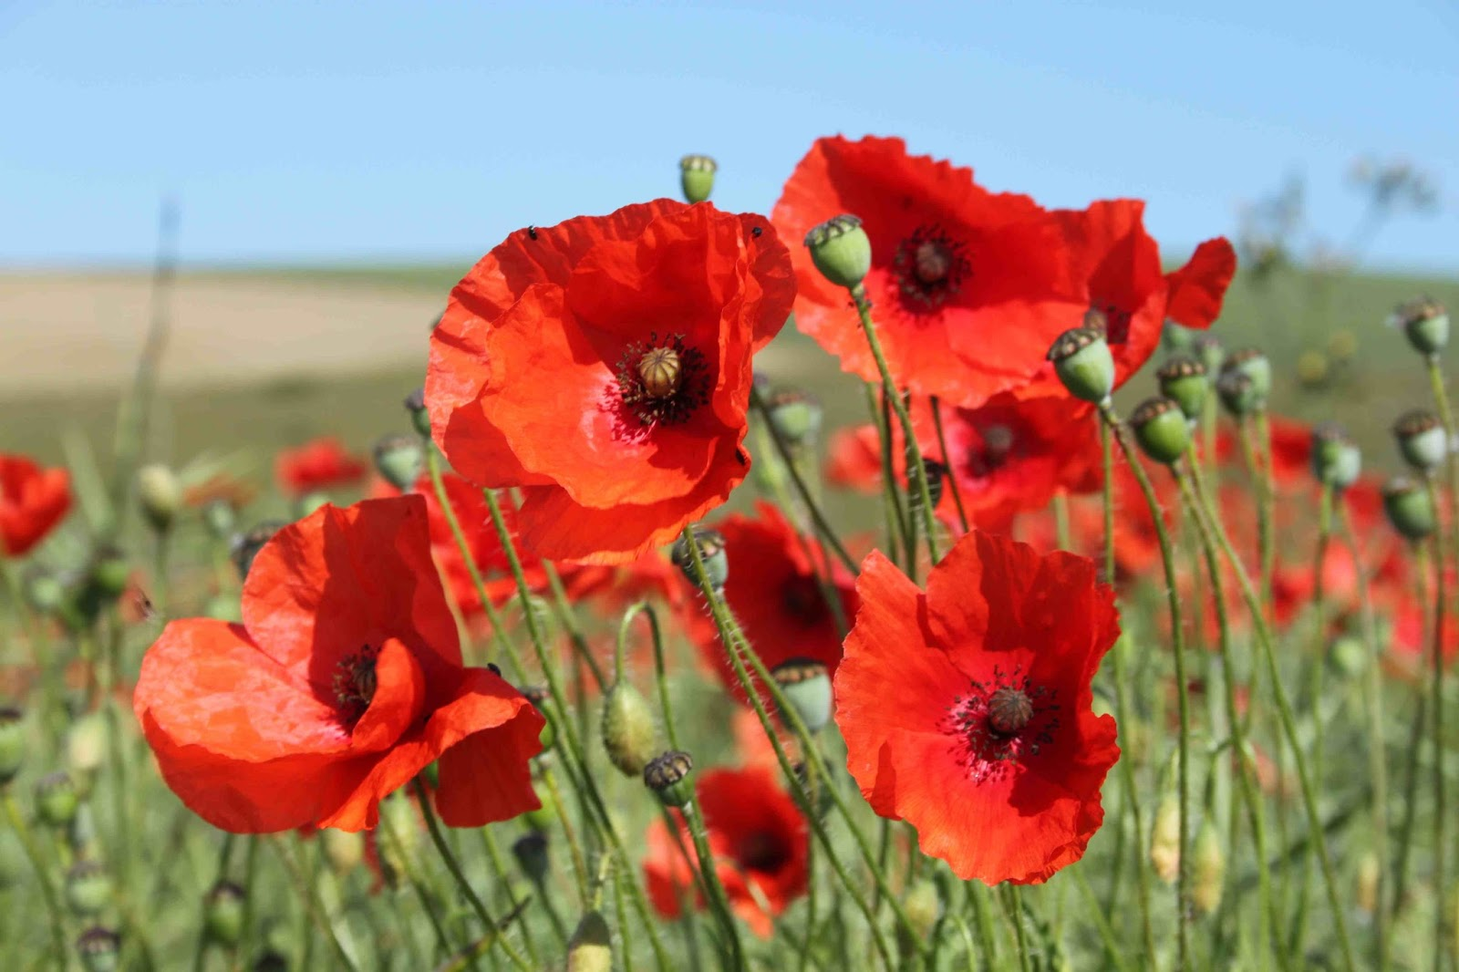where he is alive and reigns with you,

in the unity of the Holy Spirit,

one God, now and for ever.

**Readings** (**p.717**)

Daniel 12.1-3

Psalm16

Hebrews 10.11-14, [15-18,] 19-25

Gospel: Mark 13.1-8

**Remembrance Sunday**

**Sunday 21st November : Christ the King, the Sunday next before Advent**

**Collect**

Eternal Father,

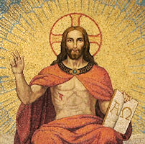whose Son Jesus Christ ascended to the throne of heaven

that he might rule over all things as Lord and King:

keep the Church in the unity of the Spirit

and in the bond of peace,

and bring the whole created order to worship at his feet;

who is alive and reigns with you,

in the unity of the Holy Spirit,

one God, now and for ever.

or

Stir up, O Lord, the wills of your faithful people;

that they, plenteously bringing forth the fruit of good works,

may by you be plenteously rewarded;

through Jesus Christ our Lord.

**Readings** (**p.720**)

Daniel 7.9-10, 13-14

Psalm 93

Revelation 1.4b-8

Gospel: John 18.33-37

**Sunday 28th November : 1st Sunday of Advent** [Year C begins]

**Collect**

Almighty God,

give us grace to cast away the works of darkness

and to put on the armour of light,

now in the time of this mortal life,

in which your Son Jesus Christ

came to us in great humility; 

that on the last day,

when he shall come again in his glorious majesty

to judge the living and the dead,

we may rise to the life immortal:

through him who is alive and reigns with you,

in the unity of the Holy Spirit,

one God, now and for ever.

**Readings** (**p.735**)

Jeremiah 33.14-16

Psalm 25.1-9

1 Thessalonians 3.9-13

Gospel: Luke 21.25-36

**November Reflection**

With All Saints' Day celebrated on 1st November, All Souls' Day celebrated on 2nd November, Armistice Day on 11th November and Remembrance Sunday on 14th November, the early part of November gives us numerous opportunities to think, reflect and pray for the future of humanity. And of course, every Sunday is a remembrance Sunday. Every Sunday we remember a dying and a death. At his final Passover supper, Jesus took bread, blessed and broke it, and gave it to his disciples, saying, ‘This is my body which is given for you; do this in remembrance of me’ It is individual and specific: one man's pain and darkness, one man's broken body and shed blood, one man's mother and best friend looking on in grief as his life ebbed away on the cross.

Remembrance is more than just keeping personal and collective memories alive. It is a time for giving thanks for those who have gone before us and whose lives have either directly or indirectly affected ours for the better; it is a time to recognize that in turn our lives will be affecting not only the people we immediately come into contact with, but our actions and decisions will affect the lives of people we may never meet and will affect the generations to come.

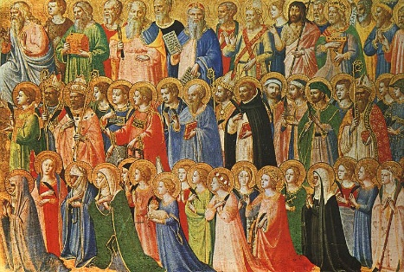As we celebrate the feasts of All Saints and All Souls, we are remembering those who specifically chose to follow Jesus, regardless in many cases of the dangers to them personally, and also the many others of God’s children whose lives and struggles allow us to have the lives we enjoy today.

It is good that we should have a season of the year for remembrance, a time when we feel that the veil between time and eternity is thin, and we can sense that greater and wider communion of saints to which we belong. The Church has placed this feast at a time when the pre-Christian Celtic religions were accustomed to think of and make offerings for the dead. The Church kept the day, but it changed the custom.

However, in our remembrance observances this year, as we remember the saints who have gone before us and those who have died or been injured in war, many of us will also be remembering those other feelings of loss that have been experienced by so many in the last eighteen months. And yet even in the darkest of times there were often those ‘poppy moments’ where hope pushed through and dared us to believe that renewal was possible. Even as Covid infections continue unabated, it does feel as though there is some restoration and regeneration happening and that we are beginning to learn what a renewed future might look like.

And yet we must not forget it will not be enough simply to go back to the way that things were before Covid. The landscape is very different now. We ourselves are different. In the midst of the hardship and the losses, we have rediscovered many important truths about living together well. Two which people often mention are simplicity and community. As we get busier again, we now look back with joy on the simplicity of a walk in the sunshine as well as the sense of community that we felt as we took time to look after each other as neighbours, heeding the restrictions of distancing, wearing masks and getting vaccinated to protect others as well as ourselves. In trying to recreate a pre-Covid landscape there is a danger that we will do away with these precious ‘poppy moments’.

That process of relearning what it is to live differently in the present, with hope for the future, is something that the first disciples of Jesus had to do. Where all had seemed hopeless, suddenly new life was breaking out, and the world they thought they knew was completely different. The life, death and resurrection of Jesus reminds us that nothing is beyond the power of God to make a difference, bringing hope and life even where there seems to be only death and desolation.

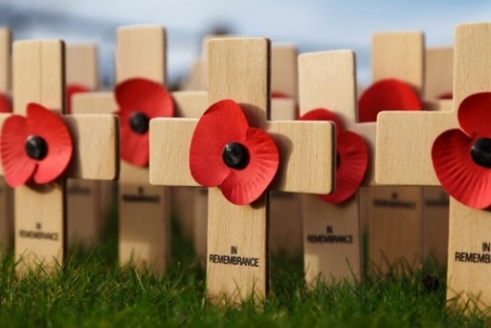And as we mark Armistice Day and Remembrance Sunday, we especially remember those who have given their lives, both those who died and those permanently scarred through war in service of our country. They left home and family, often to foreign lands, in the search of justice, freedom and peace; the effects of which we feel in our society today. The world could have been a very different place for us without their sacrifice, which cannot and should not be forgotten.

So, as we remember, reflect and pray for the future of humanity, we glimpse a future that could be different, indeed, will be different according to our Christian hope. In the Eucharist, we ‘remember forward’ to what will dawn one day: that other country whose ‘ways are ways of gentleness, and all her paths are peace’. It may seem as far away as ever for now. All the more reason, then, to make sure remembrance leads us into prayer for the future of humanity. And into reflection, so that we ask ourselves what we have learned from the past and how we intend to act on it. Memory, prayer and resolve are the antidote to despair. These are among the things that will make for a ‘good remembrance’.

Richard Byas

**The Sin of Lying**

A vicar told his congregation ‘Next week I plan to preach about the sin of lying. To help you understand my sermon, I want you all to read Mark 17.’

The following Sunday, as he prepared to give his sermon, the vicar asked for a show of hands. He wanted to know how many had read Mark 17. Every hand went up. The vicar smiled and said ‘Mark has only sixteen chapters. I will now proceed with my sermon on the sin of lying.’



**Sermon on Bible Sunday, 24th October, 2021**

A few years ago I had the privilege of serving as Headmaster of a boys’ grammar school. During my time at the school, our Second Master retired. He’d given the whole of his career, 40 years, to the one school and, quite properly, the Governors marked his retirement by giving a dinner in his honour. I was invited to speak at the dinner, and one of the things I spoke about was this colleague’s responsibility for discipline. I said that he had been very skilful and very effective at dealing with boys who had ‘followed too much the devices and desires of their own hearts’ The reaction of the Governors was revealing. Those above a certain age laughed; those below a certain age looked rather puzzled. One group knew their Cranmer and one group didn’t.

A similar point can be made about the Bible. We can no longer assume that the great stories of the Bible, let alone its phrases, are known by those being educated in most of our country’s schools. That is a cause for regret, because the texts which a culture teaches its children shape their imagination, their values and their aspirations.

In one of the great speeches of the 20th century, Martin Luther King used a quotation from the prophecy of Isaiah: ‘I have a dream that one day every valley shall be exalted, and every hill and mountain shall be made low, the rough places will be made plain, and the crooked places will be made straight; and the glory of the Lord shall be revealed and all flesh shall see it together.’ Jonathan Sacks once remarked that King’s speech was ‘a moment of history-changing power, and it would have been impossible had his audience not known the Bible.’

The three great monotheistic religions – Judaism, Christianity and Islam – are all religions of a book. Christians are not alone in disagreeing with each other about how our book is to be interpreted. It is a sadness that that which should unite us, that which tells our story, is so often that which divides us. Current disputes about such things as human sexuality, for example, have at their heart disagreement about the interpretation of scripture.

So, on this Bible Sunday, three things.

First, it is, I think, important to have some idea of what sort of text the Bible is. Far from being a book, the Bible is a library – a library which contains, not only different books, but different types of literature. We have heard this morning three different types of literature. Our passage from Isaiah is an example of prophetic literature. Our passage from 2 Timothy is part of a letter which Paul wrote to Timothy. And our Gospel passage, from John’s Gospel, is part of John’s account of a dispute which Jesus had with a group of Jews in Jerusalem.

The books of the Bible are the work of many different authors and were written, in different languages, during a period of many hundreds of years. In the early church, there were more gospels and more letters in circulation than we have in the New Testament, and it was not until the year 382 that the canon of scripture, or list of books regarded as authoritative, was finally agreed.

If the first point is that the Bible is a library rather than a book, the second point is that the Bible consists of texts which have to be interpreted. When we seek to interpret a passage of scripture, we must begin with the question of what kind of literature we are dealing with. For example, the crucifixion of Jesus is history, attested in non-biblical sources; the walking of Adam and Eve in the Garden of Eden is not history, and belongs to the literary genre known as myth. It is, I think, rather un-Anglican to interpret scripture in a fundamentalist sense, where every word is regarded as the infallible word of God. Fundamentalism and Anglicanism have never been happy bed-fellows. And that is because Anglicans have wanted to appeal to a three-fold authority – scripture, tradition and reason. Scripture, because of the belief that God speaks to us through the Bible. Tradition, because of the belief that the Spirit of God has been active in inspiring and guiding Christian thought through the centuries. And reason, because of the belief that human beings, made in God’s image, have rational minds which we are able to bring to bear on the questions and issues we face.

A library rather than a book. Texts which have to be interpreted. And third, texts which can truly be called the ‘word of God’. Christians speak of the Bible as the word of God because, in the Christian understanding of things, we have in the Bible, and particularly, of course, in the gospels, the primary witness to God’s revelation of himself in Jesus – the one who himself is the *logos*, the Word, of God. The Bible is the word of God, not because every word in it is a statement of historical fact or an infallible guide to the will and purposes of God, but because it witnesses to God’s revelation of himself in Jesus and because God continues to speak, inspire, nurture and guide through its pages.

In reading and engaging with scripture, the primary encounter is with a living being and not with a text. Scripture becomes the word of God for us when we experience that living encounter and are fed by the divine life speaking to us through what we read or hear. It becomes the word of God for us when, as Michael Ramsey once wrote, we allow ‘our imagination to be moved to wonder, our conscience to be pricked to penitence, our feelings to be moved to love, our will to be stirred to resolve, and our mind to whatever understanding we can muster.’ The Bible provides no easy short-cut to resolving difficult questions or heart-breaking dilemmas. And we shouldn’t expect it to. For part of what it means to be a human being is to have been given a heart, a mind, an imagination to try and perceive the nature and purposes of God – and to contribute to the community of faith’s ever developing understanding of God that word which we believe and trust God has given to us. And it is not, other than, perhaps, for those who are prophets, a matter of the individual over against the community; it is the individual in and with the community. It is as part of the community of faith that we seek through scripture, tradition and reason to discern the will and purposes of God. We need each other if we are to be helped to perceive and understand the will and purposes of God.

A library rather than a book. Texts which have to be interpreted. And texts which can truly be called the word of God. I’ve said enough, I trust, for it to be clear that part of our Christian discipleship must be to spend time with scripture – attentive, waiting for an encounter, receptive. Spending time with scripture. We do that individually – when we read our bibles to increase our knowledge and understanding and to aid our prayer and meditation. We do it corporately, when we gather together for worship. And we do it corporately, too, when we respond to the opportunities we are given, in such things as Lent courses, for example, to study, to discuss, and to learn – to grow in our knowledge and understanding of our sacred texts.

I end with an image which a monk I know is very fond of using. It is the image of the Christian as someone who is ‘pickled in scripture’. Amen.

***The Revd Canon Steven Harvey***

**November** (Thomas Hood 1799 – 1845)

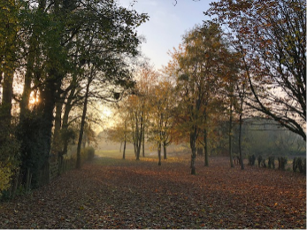

No sun - no moon! No morn - no noon - No dawn - no dusk - no proper time of day No sky - no earthly view – No distance looking blue - No road - no street - no 't'other side the way' - No end to any Row - No indications where the Crescents go - No top to any steeple - No recognitions of familiar people - No courtesies for showing 'em - No knowing 'em - No travelling at all - no locomotion, No inkling of the way - no notion - 'No go' - by land or ocean - No mail - no post - No news from any foreign coast - No Park - no Ring - no afternoon gentility - No company - no nobility - No warmth, no cheerfulness, no healthful ease, No comfortable feel in any member, No shade, no shine, no butterflies, no bees, No fruits, no flowers, no leaves, no birds, - November!

Thomas Hood was born, died and buried in London - his grave is in the Kensal Green Cemetery that features in Chesterton's poem, 'The Rolling English Road'. At the time Hood wrote 'November' London suffered from periodic smogs caused by air pollution that blackened the buildings, caused many premature deaths and rendered visibility to that of a 'pea soup'. In 1843, the year before Hood published the poem, a Parliamentary Select Committee set in motion the long journey that would culminate in the Clean Air Act of 1956. This ended London's smogs by enforcing smokeless zones.

Charity Soup & Sweet Lunches

(Soup, bread, cakes, tea, coffee, etc)

12 noon Wednesdays 10th & 24th November

FREE LUNCH (but donations to the selected Charities would be welcome)

TOPCLIFFE VILLAGE HALL*e 65th Anniversary of the a*

**PARISH DIRECTORY**

**The Parishes of Topcliffe, Baldersby with Dishforth, Dalton and Skipton on Swale**

There is currently no Vicar of the parishes. Until one is appointed, please ring our Area Dean,

The Revd Fiona Mayer-Jones tel: 07450 402953 or [revdfmj@gmail.com](mailto:revdfmj@gmail.com)

**BALDERSBY with DISHFORTH** - PCC Secretary: Mrs Jennifer Wharton [wharton370@btinternet.com](mailto:wharton370@btinternet.com)

**DALTON** - PCC Secretary: Mrs Hannah Bissett tel: 07739 382831 [spannerb79@gmail.com](mailto:spannerb79@gmail.com)

**SKIPTON-on-SWALE** – PCC Secretary: Mr Alan Kitching tel: 01845 567457

**TOPCLIFFE** – PCC Secretary: Mrs Roz Norris [RozNorris@aol.com](mailto:RozNorris@aol.com)