Benefice Online Magazine
for the Parishes of Topcliffe, Baldersby with Dishforth, Dalton and Skipton on Swale
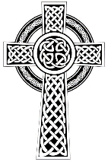
Cross Talk
February 2022
Cross Talk is published monthly by email. To receive a copy please contact kitnorris@live.co.uk
Cross Talk contains the weekly Collect and Readings together with details of Church services in the Benefice and news and items of interest supplied by our readers.
The magazine will also be available on the web sites: www.achurchnearyou.com/church/3447 and baldersbychurch.com.

CHURCH SERVICES
The following services are planned subject to changes in the Covid-19 regulations.
Strict measures will be in place for wearing of face masks, hand sanitisation before and after each service, and social distancing. Please observe spaced time of arrival and departure to avoid mingling.

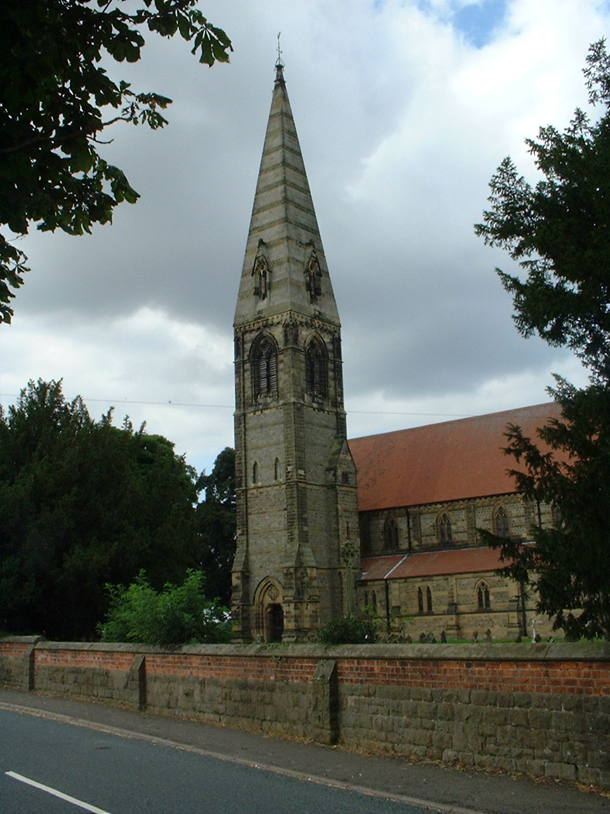
St. James’ Church, Baldersby St. James with Dishforth and Rainton
Sunday 6th February, 10.45am Communion Service
Sunday 13th February, 9.30am Breakfast Service with coffee & croissants.
Sunday 20th February, 10.45am Communion Service
Sunday 27th February, 9.30am Morning Prayer (short spoken service)
All services followed by coffee.

St. Columba’s Church, Topcliffe
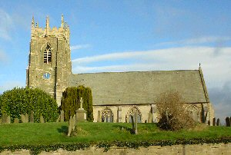
Sunday 6th February, 6.30pm Choral Evensong
[including a celebration of the 70th Anniversary of the accession to the throne of Queen Elizabeth II; organist: Matthew Atherton]
Sunday 13th February, 10.45am Holy Communion
Sunday 20th February, 10.45am Choral Matins
Sunday 27th February, 10.45am Holy Communion
Revd Canon Steven Harvey

St John the Evangelist Church, Dalton
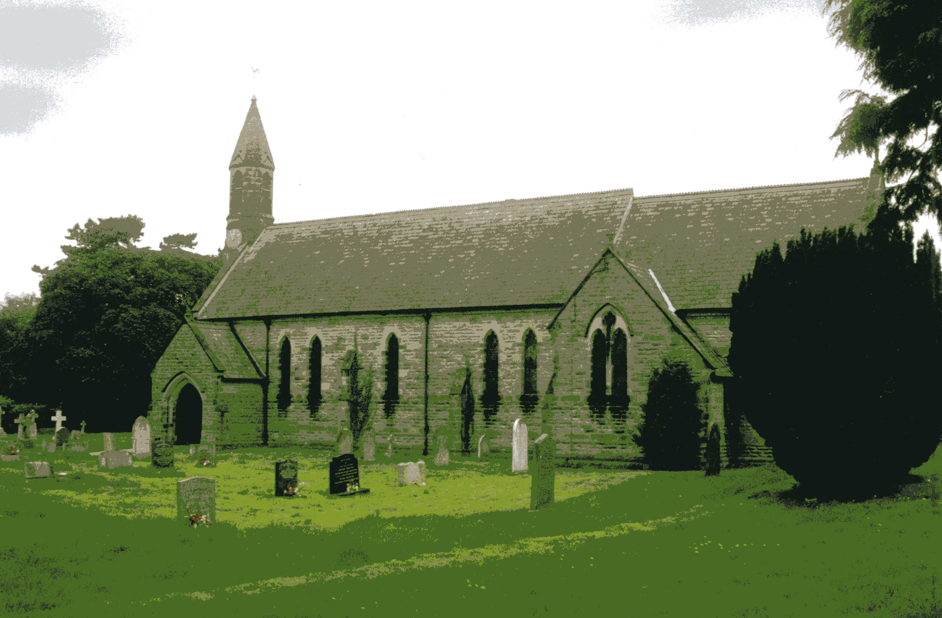
Sunday 6th February, 11am Morning/Family Service
Sunday 27th February, 11am Morning/Family Service

Dalton Events
Events are listed on page 8, including some in late January.

Collects and Readings for the 4th Sunday before Lent to the Sunday before Lent
(Page numbers refer to the Common Worship Lectionary.)

Sunday 6th February : 4th Sunday before Lent
Collect
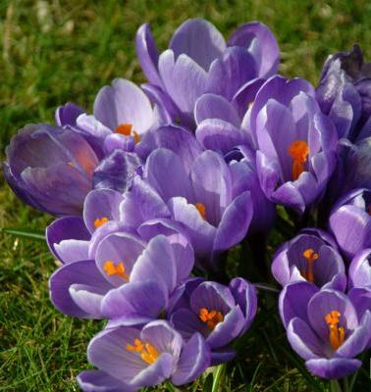
O God,
you know us to be set
in the midst of so many and great dangers,
that by reason of the frailty of our nature
we cannot always stand upright:
grant to us such strength and protection
as may support us in all dangers
and carry us through all temptations;
through Jesus Christ your Son our Lord,
who is alive and reigns with you,
in the unity of the Holy Spirit,
one God, now and for ever.

Readings Proper 1 (p.794)
Isaiah 6.1-8, [9-13]
Psalm 138
1 Corinthians 15.1-11
Gospel: Luke 5.1-11

Sunday 13th February : 3rd Sunday before Lent, Septuagesima
Collect
Almighty God,
who alone can bring order
to the unruly wills and passions of sinful humanity:
give your people grace
so to love what you command
and to desire what you promise,
that, among the many changes of this world,
our hearts may surely there be fixed
where true joys are to be found;
through Jesus Christ your Son our Lord,
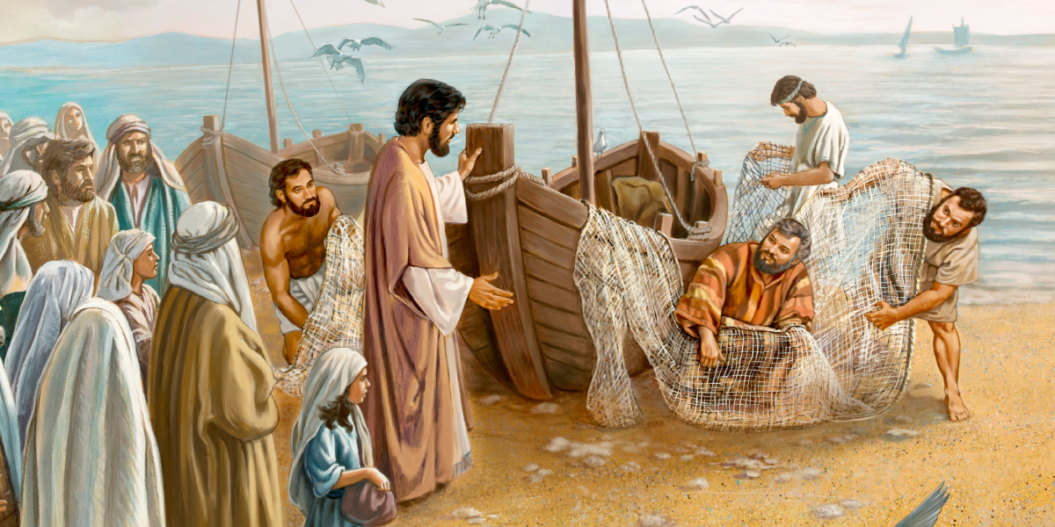
who is alive and reigns with you,
in the unity of the Holy Spirit,
one God, now and for ever.

Readings Proper 2 (p.797)
Jeremiah 17.5-10
Psalm 1
1 Corinthians 15.12-20
Gospel: Luke 6.17-26 I will make you fishers of men

Sunday 20th February : 2nd Sunday before Lent, Sexagesima
Collect
Almighty God
you have created the heavens and the earth
and made us in your own image:
teach us to discern your hand in all your works
and your likeness in all your children;
through Jesus Christ your Son our Lord,
who with you and the Holy Spirit
reigns supreme over all things,
now and for ever.

Readings (p.803)
Genesis 2.4b-9, 15-25
Psalm 65 The Garden of Eden
Revelation 4.1-11
Gospel: Luke 8.22-25

Sunday 27th February: Sunday next before Lent, Quinquagesima
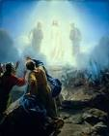
Collect
Almighty Father,
whose Son was revealed in majesty
before he suffered death upon the cross:
give us grace to perceive his glory,
that we may be strengthened to suffer with him
and be changed into his likeness, from glory to glory;
who is alive and reigns with you,
in the unity of the Holy Spirit,
one God, now and for ever.

Readings (p.807)
Exodus 34.29-35
Psalm 99
2 Corinthians 3.12-4.2 The transfiguration
Gospel: Luke 9.28-36, [37-43]

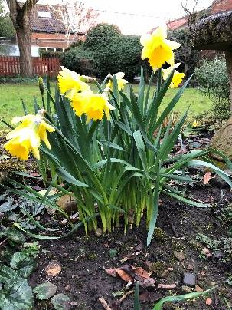
February Reflection
February can be a month of sharp contrasts when considering the weather. The old saying that ‘as the days lengthen the cold strengthens’ often seems very apt in February when we often get snow and frosty weather, but it is often the month when we feel that we get our first glimpse of spring with occasional warm sunny days and when we notice with delight the snowdrops, crocuses and daffodils coming into flower. Long before Christianity was present in this country, our Celtic ancestors celebrated their feast of Imbolc on the first of February to mark Spring’s awakening. Although we can see God’s hand in creation at all times of the year, it is often in Spring when we are most aware of it.
The fact that the conditions on earth are suitable for any life to exist are in themselves astounding. A recent statistical analysis by astrophysicist Erik Zackrisson from Uppsala University in Sweden arrived at the staggering figure that despite there being around 700 quintillion planets in the universe (that is a 7 followed by 20 zeros) there is only one planet like earth, and we are still faced with the mystery of how life arrived on this planet.
If the probability of earth being positioned to support life is practically impossible to measure, then the probability of life appearing by chance from non-life is even more remote. Science tries to offer a number of possibilities such as life arriving on meteorites but still as scientists have to admit “We don't know the mechanism whereby nonlife turns into life, so we have no way of estimating the odds of it happening. In which case, earth life may be unique in the observable universe."
This maybe explains why humans haven't yet managed to create life in the laboratory even though it appears in nature in as simple a form as a seed or egg. Even a simple single celled bacterium is hugely complex and far beyond our abilities to create from scratch.
If all this isn’t difficult enough to understand, then we have the development of intelligent human life on this unique planet. As mammals we are complex beyond our understanding; the whole ecosystem that is each of us with human body cells and bacteria and viruses working together form what we think of as ourselves.
Many people, including some Christians, question the Genesis account of creation and in recent times Christian interpretation of the Genesis creation account has focused on reconciling the creation account in Genesis with current scientific knowledge. However, we are looking at the creation account in the Bible through 21st century eyes rather than through the eyes of the children of Israel living in the second millennia BC. The biblical account puts the emphasis on a God who has both created humanity and provided all that we need for our existence.
To frame the account in scientific terms would be irrelevant to the scientifically ignorant children of Israel who would be more concerned with how they were going to survive in the inhospitable Sinai wilderness. The creation event in Genesis is not a scientific paper. It’s a message delivered to a scientifically ignorant group of slaves about the God who has both created humanity and provided all they need for their existence.
There is no question God is the Creator. He designed and created all that exists, and it is testimony to His creative handiwork, regardless of how human life developed on the earth, that we are here and that is testimony to the creative ability of our God.
That creation and the mechanisms that sustain life are too wonderful for us to understand is self-evident. God’s purpose for humanity and how He goes about achieving it should always be the major focus when studying the biblical account.
The invitation in the Bible is for us to respond positively to Him and choose to live as God wishes us to do. Humanity has every need met by God both physically and spiritually in this wonderful creation. How we act as stewards of the creation, how we ‘till the land’ if you like, without plundering it speaks of how we value the gift of creation. How we work with each other and support each other, seeing each as a unique and valued creation of God, speaks of how we are responding to the love that God bestows on us.
God’s title of Creator is not a one-off title. He remains and continues to create and sustain the whole universe. The question is ‘are we going to fulfil our role in creation or fight for our own selfish ends and damage and destroy the vision of what this created universe could be?’
Richard Byas
St. Matthias.
Matthias was, according to the Acts of the Apostles, chosen by the apostles to replace Judas Iscariot following Judas’s betrayal of Jesus and his suicide. He was therefore the thirteenth apostle and the only one who was not chosen personally by Jesus. Matthias is not mentioned in the synoptic gospels but according to Acts, he had been with Jesus from his baptism by John.
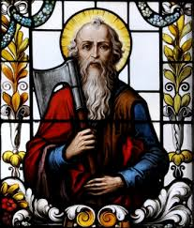
Very little is known for certain about St. Matthias. Some traditions say he died by crucifixion, another that he was beheaded with an axe (which led in the Middle Ages to him being the patron saint of carpenters and woodcutters) but according to Hippolytus of Rome, Matthias died of old age in Jerusalem. He is also, for reasons lost in the midst of time, the patron saint of alcoholics.
The tradition of the Greek Orthodox Church says that St. Matthias planted the faith around Cappadocia and on the coasts of the Caspian Sea, residing chiefly near the port Issus but according to Nicephorus, St. Matthias first preached the Gospel in Judaea, then in Aethiopia (by the region of Colchis, now in modern-day Georgia) where he is said to be buried.
The feast of Saint Matthias was included in the Roman Calendar in the 11th century and celebrated on the 24th February usually, but on the 25th February in leap years. In the revision of the General Roman Calendar in 1969, his feast was transferred to 14th May, so as not to celebrate it in Lent but instead in Eastertide close to Ascension Day, the event after which, the Acts of the Apostles tells us, Matthias was selected to replace Judas Iscariot.
Similarly, the Church of England's Book of Common Prayer, as well as other older common prayer books in the Anglican Communion, celebrate St. Matthias on 24th February but according to the newer Common Worship liturgy, St. Matthias is remembered in the Church of England with a Festival on 14th May (although he may be celebrated on 24th February, if desired).
A Gospel, which is now lost, is said to have been falsely put out under his name but the Early Church Fathers attributed it to heretical writings in the 2nd century. However, Clement of Alexandria while describing the Nicolaitanes (an early Christian heretical sect started by Nicolas the Deacon) quotes a sentence ascribed to Matthias urging asceticism: ‘we must combat our flesh, set no value upon it, and concede to it nothing that can flatter it, but rather increase the growth of our soul by faith and knowledge’.
For all the traditions about St Matthias, only one thing is certain. He was the man elected by the other eleven Apostles to make up their twelve again after the defection of Judas and until the twentieth century his feast day was (and in some Christian traditions remains) the 24th February.
` Richard Byas

Sunday in the Week of Prayer for Christian Unity
Today is the Sunday in this year’s Week of Prayer for Christian Unity; a week which involves Christians across the world and from almost every denomination.
The Week developed from eight days of prayer originally devised in 1908 by two Anglican priests, one American and one English. The former, Paul Wattson, became a Roman Catholic in 1909 because he had come to believe that Christian unity could be achieved only by other churches returning to the Roman Catholic fold. The Week came to be more widely observed in the 1930s through the work of a French Roman Catholic, Paul Couturier, who did not believe that it was necessary for all Christians to become Roman Catholics. He taught that ‘we must pray, not that others may be converted to us, but that we may all be drawn closer to Christ’.

The Week of Prayer for Christian Unity is a response to Christ’s prayer that ‘they may all be one’ (John 17:21) and that ‘there will be one flock, one shepherd’ (John 10:16).
It is clear from the New Testament that Christian belief in the early church varied from place to place. There were differences of opinion, and these differences resulted in dissension. Paul wrote in his First Letter to the Christians in Corinth: ‘......it has been reported to me......that there are quarrels among you, my brothers and sisters’ (1 Cor. 1:11). Hence his appeal ‘that all of you be in agreement and that there be no divisions among you, but that you be united in the same mind and the same purpose’ (1 Cor. 1:10).
Differences between Christians have existed throughout Christian history. The Anglican priest, writer and broadcaster, Angela Tilby, writes this in an article in this week’s church press: ‘The Week of Prayer for Christian Unity comes round each year, and we do our best to repent of the scandal of our divisions. These divisions’, she writes, ‘often originated in doctrinal differences, but they have endured more as cultural habits. Instead of merely lamenting this, as we have so often done, we could see it as a reflection of the different gifts and vocations that Churches now manifest’ (Church Times, 21.i.22). Tilby writes of learning from, and being enriched by, her experience of various Christian denominations and traditions. While the differences between denominations and traditions are, I think, rather more than cultural habits, she is surely right in saying that they are a reflection of different gifts and vocations. St Paul, in the chapter from which today’s New Testament passage is taken, has much to say about diversity within the Body of Christ – but insists that this diversity exists within a fundamental unity which comes from our baptism into this body (1 Cor. 12.13). Earlier in the chapter, Paul writes that there are ‘varieties of gifts, but the same Spirit, and there are varieties of services, but the same Lord, and there are varieties of activities, but it is the same God who activates all of them in everyone’ (1 Cor. 12.4-6).
The important point here is that unity does not mean the absence of diversity. We have in the Christian doctrine of the Trinity a model of diversity in unity. We mustn’t confuse unity with uniformity. Unity in faith does not mean uniformity in thought and practice.
In the Christian understanding of things there is already a fundamental and God-given unity between all people. In the very first chapter of Genesis, we are told that God created humankind in his image and likeness. This is one of the fundamental principles of Christian belief: that we are all brothers and sisters of the same heavenly Father – created in his image and likeness to share his life and love for ever.
Our concern as Christian people must be, not only with the unity of Christians, but with the unity of all things when God will be all in all (1 Cor 15:28). The Church is called to be a sign and instrument of that unity; and it does so, not by trying to suppress or exclude difference, but by demonstrating to the world how to live and love with and through difference.
Timothy Radcliffe, a Dominican friar whose writings I find helpful, has written that ‘our human vocation is to go on searching for new and deeper ways of belonging together,......which realize our capacity for communion more profoundly’ (What is the Point of Being a Christian? p159). He speaks of three stories – what he calls ‘my story’, ‘our story’ and ‘the story’. ‘My story’ is the story that I tell about myself and which articulates my own sense of identity. ‘Our story’ is the story that a group tells of itself to explore what it means to be a member of the group. And ‘the story’ is the story that goes from Creation to the Kingdom, which expresses God’s ultimate purpose for all that he has made.
Radcliffe says that when we can tell the story of humanity, then we shall have arrived at the Kingdom and we shall be fully one with each other. We cannot yet tell that story in its fulness. But we believe that it is given to us sacramentally, in the story of Christ’s life, death and resurrection. Now, gathered around the altar, we have the sign of what is to come. But we do not have the road map. We have no privileged information about what comes next. But we can edge our way towards that final story by speaking and acting in ways that embody what Radcliffe calls the ‘capaciousness of God’s Word’ (p162).

To reflect the capaciousness of God’s Word is the calling of God’s universal Church, the Body of Christ. There are differences of belief between the churches, and it is important that these are addressed on the journey towards that unity for which Christ prayed. So, for example, in a recent book (The Malines Conversations: The Beginnings of Anglican-Roman Catholic Dialogue) Rowan Williams opens up two particular issues: first, the role of the Pope as the successor of St Peter, and, second, the issue of how far doctrines which are said to be ‘inferred’ from other doctrines – the Roman Catholic doctrine of the Immaculate Conception, for example, as an inference from the doctrine of the Virgin Birth – should be binding for communion between the Roman Catholic Church and other denominations, rather than accepted as possible, and not mandatory, interpretations of faith.
Important though such discussions are, it is every bit as important, if we have to do with a capacious God, that God’s Church is capacious – a spacious home for all who have been baptised into Christ, whatever their denomination or tradition; a spacious home for all who have heard the music of the gospel and who want to join in the singing of its songs; a spacious home for those who, at this stage of the journey, find themselves in disagreement with each other but who in their relations with each other seek to reflect the capaciousness, the generosity and the courtesy of God.
The writer of the Letter to the Hebrews speaks about our having here no continuing city, for we seek one which is to come (Hebrews 13.14). The hope set before us is the city which is that unity when God will be all in all. We journey in partnership with all who seek the city of God and in faithful reliance on the God whose Spirit will, we trust, lead us into all truth. As we journey, with our different and partial understandings, let us thank God for the unity which is already ours as brothers and sisters in Christ; and, with God’s grace, by the way we live and love with and through our differences, let us seek to be a sign and instrument of that unity which is God’s will for all he has made. Amen.
The Revd Canon Steven Harvey

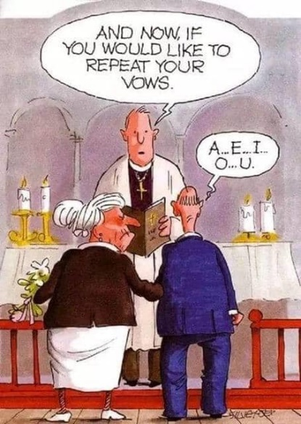

Dalton Events
Yarnbombing Dalton
Dalton village will be yarnbombed for the Queen’s Platinum Jubilee in June, and to that end a Domino Drive will be held next Saturday, 29th January at 7pm in the Village Hall for funds to buy wool. There will also be “Knit and Natter” sessions on Wednesday 26th January and Wednesday 9th February, 1pm until 3pm in the Village Hall for getting together to make things for the yarnbombing.
Mums and Tots
The Mums and Tots group has restarted every Friday morning in the Village Hall, 10am until 12 noon.
For more details contact Marta on 07715 988906.
Monthly Domino Drives
These are held at 7pm in the Village Hall on the first Saturday of every month (the next will be on 5th February). All welcome.
Craft Classes
On the first Wednesday of the month (2nd February) there will be a Craft Class from 9.30am until 3pm in the Village Hall. All crafts welcome for a get together and a cuppa. For more details contact Lois on 01423 325608.
Quiz and Bingo
There will be a Quiz and Bingo night in the Village Hall at 7pm on Saturday 12th February. All welcome.

PARISH DIRECTORY
The Parishes of Topcliffe, Baldersby with Dishforth, Dalton and Skipton on Swale
There is currently no Vicar of the parishes. Until one is appointed, please ring our Area Dean,
The Revd Fiona Mayer-Jones tel: 07450 402953 or revdfmj@gmail.com

BALDERSBY with DISHFORTH - PCC Secretary: Mrs Jennifer Wharton wharton370@btinternet.com

DALTON - PCC Secretary: Mrs Hannah Bissett tel: 07739 382831 spannerb79@gmail.com

SKIPTON-on-SWALE – PCC Secretary: Mr Alan Kitching tel: 01845 567457

TOPCLIFFE – PCC Secretary: Mrs Roz Norris RozNorris@aol.com

