Benefice Online Magazine

for the Parishes of Topcliffe, Baldersby with Dishforth, Dalton and Skipton on Swale
Cross Talk
March 2022
Cross Talk is published monthly by email. To receive a copy please contact kitnorris@live.co.uk
Cross Talk contains the weekly Collect and Readings together with details of Church services in the Benefice and news and items of interest supplied by our readers.
The magazine will also be available on the web sites: www.achurchnearyou.com/church/3447 and baldersbychurch.com.

CHURCH SERVICES
The following services are planned subject to changes in the Covid-19 regulations.
Strict measures will be in place for wearing of face masks, hand sanitisation before and after each service, and social distancing. Please observe spaced time of arrival and departure to avoid mingling.

St. James’ Church, Baldersby St. James with Dishforth and Rainton
Sunday 6th March, 10.45am Communion Service
Sunday 13th March, 9.30am Breakfast Service with coffee & croissants
Sunday 20th March, 10.45am Communion Service
Sunday 27th March, 9.30am Morning Prayer (short spoken service)

All services followed by coffee.

St. Columba’s Church, Topcliffe
Sunday 6th March, 6.30pm Choral Evensong

Wednesday 9 March, 7.30pm Compline

Sunday 13th March, 10.45am Holy Communion
Wednesday 16 March, 7.30pm Compline

Sunday 20th March, 10.45am Choral Matins
Wednesday 23 March, 7.30pm Compline

Sunday 27th March, 10.45am Holy Communion

Wednesday 30 March, 7.30pm Compline

St John the Evangelist Church, Dalton
Sunday 6th March, 11am Morning/Family Service
Sunday 27th March, 11am Mothering Sunday Service

Dalton Social Events are listed on page 8.
Lent Lunches at Topcliffe Village Hall for Christian Aid
Wednesdays at 12 noon on 9th, 16th, 23rd, and 30th March
The Soup and Sweet lunch is free, but donations can be made to Christian Aid

Collects and Readings for Ash Wednesday to the 4th Sunday of Lent / Mothering Sunday
(Page numbers refer to the Common Worship Lectionary.)

Ash Wednesday 2nd of March
Collect
Almighty and everlasting God,
you hate nothing that you have made
and forgive the sins of all those who are penitent:
create and make in us new and contrite hearts
that we, worthily lamenting our sins
and acknowledging our wretchedness,
may receive from you, the God of all mercy,
perfect remission and forgiveness;
through Jesus Christ your Son our Lord,
who is alive and reigns with you,
in the unity of the Holy Spirit,
one God, now and for ever.

Readings (p.810)
Joel 2.1-2, 12-17 or Isaiah 58.1-12
Psalm 51.1-18
2 Corinthians 5.20b-6.10
Gospel: Matthew 6.1-6, 16-21 or John 8.2-11

Sunday 6th March : 1st Sunday of Lent
Collect
Almighty God,
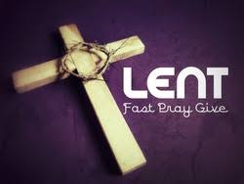
whose Son Jesus Christ fasted forty days in the wilderness,
and was tempted as we are, yet without sin:
give us grace to discipline ourselves
in obedience to your Spirit;
and, as you know our weakness,
so may we know your power to save;
through Jesus Christ your Son our Lord,
who is alive and reigns with you,
in the unity of the Holy Spirit,
one God, now and for ever.

Readings (p.816)
Deuteronomy 26.1-11
Psalm 91.1-2, 9-16 or Psalm 91.1-11
Romans 10.8b-13
Gospel: Luke 4.1-13
Sunday 13th March : 2nd Sunday of Lent
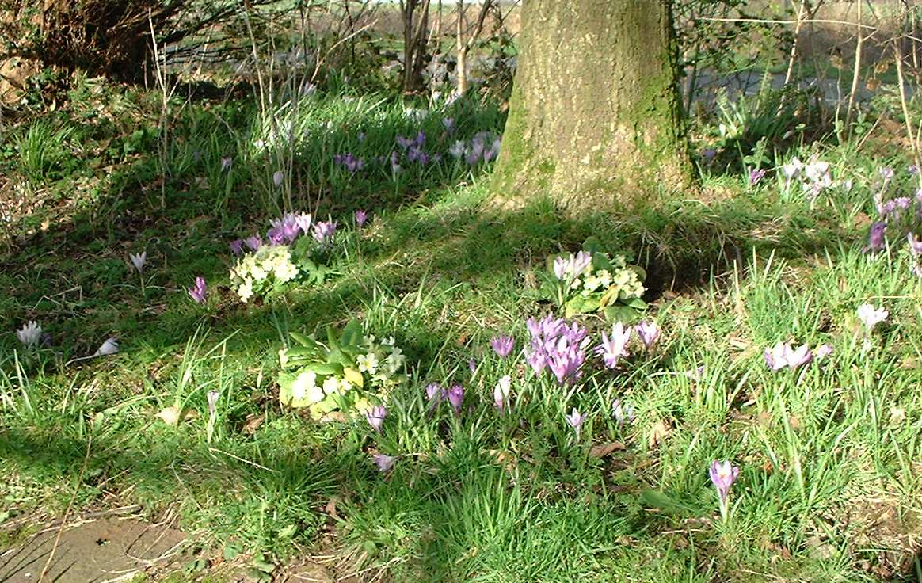
Collect
Almighty God,
you show to those who are in error the light of your truth,
that they may return to the way of righteousness:
grant to all those who are admitted
into the fellowship of Christ’s religion,
that they may reject those things
that are contrary to their profession,
and follow all such things as are agreeable to the same;
through our Lord Jesus Christ,
who is alive and reigns with you,
in the unity of the Holy Spirit,
one God, now and for ever.

Readings (p.820)
Genesis 15.1-12, 17-18
Psalm 27
Philippians 3.17-4.1
Gospel: Luke 13.31-35

Sunday 20th March : 3rd Sunday of Lent
Collect
Almighty God,
whose most dear Son went not up to joy
but first he suffered pain,
and entered not into glory before he was crucified:
mercifully grant that we, walking in the way of the cross,
may find it none other than the way of life and peace;
through Jesus Christ your Son our Lord,
who is alive and reigns with you,
in the unity of the Holy Spirit,
one God, now and for ever.

Readings (p.823)
Isaiah 55.1-9
Psalm 63.1-8
1 Corinthians 10.1-13
Gospel: Luke 13.1-9

Putting it politely
In the reign of Charles II, a certain worthy divine at Whitehall thus addressed himself to the congregation at the conclusion of his sermon:- “In short, if you don’t live up to the precepts of the Gospel, but abandon yourself to your irregular appetites, you must expect to receive your reward in a certain place which ’tis not good manners to mention here.” Tom Brown, Laconics.

Reminder : British Summer time begins – put clocks forward one hour
Sunday 27th March: 4th Sunday of Lent
Collect
Merciful Lord,
absolve your people from their offences,
that through your bountiful goodness
we may all be delivered from the chains of those sins
which by our frailty we have committed;
grant this, heavenly Father
for Jesus Christ’s sake, our blessed Lord and Saviour,
who is alive and reigns with you,
in the unity of the Holy Spirit,
one God, now and for ever.

Readings (p.827)
Joshua 5.9-12
Psalm 32
2 Corinthians 5.16-21
Gospel: Luke 15.1-3, 11b-32

Mothering Sunday 27th March
Collect
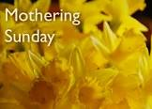
God of Compassion,
whose Son Jesus Christ, the child of Mary,
shared the life of a home in Nazareth,
and on the cross drew the whole human family to himself:
strengthen us in our daily living
that in joy and in sorrow
we may know the power of your presence
to bind together and to heal;
through Jesus Christ your Son our Lord,
who is alive and reigns with you,
in the unity of the Holy Spirit,
one God, now and for ever.

Readings (p.830)
Exodus 2.1-10 or 1 Samuel 1.20-28
Psalm 34.11-20 or Psalm 127.1-5
2 Corinthians 1.3-7 or Colossians 3.12-17
Gospel: Luke 2.33-35 or John 19.25b-27

March Reflection
Lent, this year, starts on the 2nd March and it is a time for us to consciously slow down and take stock of our lives. It is a time to reflect on the experience of waiting-- of waiting for God to act and for life to be restored.
In times past, Lent was a time of fasting; now we are encouraged to give something up as a sign of our desire to get closer to God. Lent as a season of self-denial and prayer is not just about hardship for the sake of it. We should try to deliberately set aside our usual priorities in order to see and experience more of God.
We may find it helpful to follow one of the many Lent courses available. ‘Live Lent: Embracing Justice’ is the Church of England's theme for Lent 2022. It invites us to examine our own lives truthfully, to see the world more deeply and to pray - for the church and the world far and near - that 'justice may roll down like waters, and righteousness like an ever-flowing stream' (Amos 4.24).
For each day of Lent, this booklet for adults offers a daily Bible reading, a short reflection and a prayer, as well as a practical challenge. Each week follows a different thread through the many stories of justice in the Bible to explore how God works with humanity to bring justice, wholeness and salvation to all.
The booklet is supported by a wide range of free digital resources for individuals, groups and churches available via www.churchofengland.org/livelent.
On 23rd March it will be two years since the first Covid lockdown began, and for many of us, the time since then has felt like an extended Lenten period. We have been denied time with family and friends. We have had to reinvent how we do everything, from shopping to schooling to our worship as a Church. Our Christmases have been very different, and for some very lonely.
And for those whose loved ones have died, the numbers who have been able to gather to grieve and to tell the stories have been restricted either by legal restraints or by the need to protect vulnerable members of society
And yet, this Lent we are reminded that we are invited into the story of a God who entered into the mess and suffering of the world so that He might bring new life and hope. We are reminded that Jesus was himself denied a proper burial, and yet out of that Good Friday scene of devastation and despair God breathed life, and Jesus broke free from the tomb so that we too might know the presence of God with us to bring transformation and life in whatever situation we might be facing.
We are not there yet. There is still much waiting to be done, both as we wait for the reality of the post lockdown world, but also as we wait for Jesus to return to reclaim and restore his precious creation.
And so we wait, but we wait as those who have hope. We live our lives as churches and individuals so that 'justice may roll down like waters, and righteousness like an ever-flowing stream'.
Christ has died: Christ is Risen: Christ will come again.
Richard Byas

MY REMEMBERER
My forgetter is getting better
But my rememberer is broke
To you that may sound funny
But to me, that‘s no joke
For when I‘m here, I‘m wondering
If I really should be there
And when I try to think it through
I haven‘t got a prayer.
Often there are times,
when I walk into a room
And think ‘What am I here for?’
I wrack my brain,
But all in vain
A zero is my score
At times I put something away
Where it is safe, but gee
The person it is safest from is generally me
When shopping I may see someone,
Say ‘Hi’ and have a chat
Then when the person walks away,
I ask myself ‘Who was that‘?
Yes, my forgetter is getting better
While my rememberer is broke
And it‘s driving me plumb crazy
And that really is no joke.
(Anon)
P.S. Send this to everyone you know, because I don‘t remember who I’ve sent it to

Richard Byas
Dalton Events
January 100 Club results
£15 John Barker (No.14); £10 Peggy Allen (No.66); £5 Linda Vale (No.63). February will be the “big prize one” at the end of the 6 months, results in next month’s issue.

Domino Drive
There will be a domino drive on Saturday 26th March at 7pm. There will be a raffle, funds going to the Village Hall. Tea and biscuits will be served in the interval. All ages welcome.
There will be an extra domino drive on Saturday 1st April at 7pm. The proceeds will be to buy more wool for the yarnbombing the village for the Queen’s Platinum Jubilee. If anyone would like to help knitting and needs wool, please contact Sharon on 577643.

Race Night
There will be a race night in the Village Hall on Saturday 5th March. Doors open at 6.30pm for first race at 7pm. The racing is “Horse on a string and reel it in”. Great fun for all the family! The bar will be open. Everyone welcome.
PARISH DIRECTORY
The Parishes of Topcliffe, Baldersby with Dishforth, Dalton and Skipton on Swale
There is currently no Vicar of the parishes. Until one is appointed, please ring our Area Dean,
The Revd Fiona Mayer-Jones tel: 07450 402953 or revdfmj@gmail.com

BALDERSBY with DISHFORTH - PCC Secretary: Mrs Jennifer Wharton wharton370@btinternet.com

DALTON - PCC Secretary: Mrs Hannah Bissett tel: 07739 382831 spannerb79@gmail.com

SKIPTON-on-SWALE – PCC Secretary: Mr Alan Kitching tel: 01845 567457

TOPCLIFFE – PCC Secretary: Mrs Roz Norris RozNorris@aol.com

