**Benefice Online Magazine**

**for the Parishes of Topcliffe, Baldersby with Dishforth, Dalton and Skipton on Swale**

 Cross Talk

**April 2022**

Cross Talk is published monthly by email. To receive a copy please contact [kitnorris@live.co.uk](mailto:kitnorris@live.co.uk)

Cross Talk contains the weekly Collect and Readings together with details of Church services in the Benefice and news and items of interest supplied by our readers. The magazine will also be available on the web sites: www.achurchnearyou.com/church/3447 and baldersbychurch.com.

**CHURCH SERVICES**

*The following services are planned subject to changes in the Covid-19 regulations.*

**St. James’ Church, Baldersby St. James with Dishforth and Rainton**

**Sunday 3rd April, 10.45am Communion Service**

*followed by coffee*

**Sunday 10th April, 9.30am Breakfast Service on Palm Sunday** *with ‘Coffee and Croissants’ taken by Dawn Ward, who is in the final lap of training before becoming a fully fledged vicar! She lives locally and has popped into services so you will probably recognise her.*

**Sunday 17th April, 10.45am Easter Day Holy Communion** *followed by coffee and hot cross buns.*

**Sunday 24th April, 9.30am Easter Sunday Holy Communion***followed by coffee and hot cross buns. Kindly taken by Peter Carrotte, who we all know very well as he regularly takes this service, always ending with a story  to make us smile.*

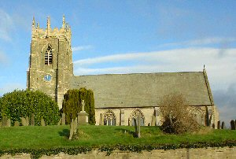**St. Columba’s Church, Topcliffe**

**Sunday 3rd April, 6.30pm Choral Evensong** *(BCP)*

**Wednesday 6th April, 7.00pm Compline** *A peaceful, reflective short service of prayers and readings for the end of the day*

**Sunday 10th April, 10.45am Palm Sunday Holy Communion**

**Wednesday 13th April, 7.00pm Compline**

**Saturday 16th April, 7.30pm Easter Vigil and First Mass of Easter.**

*This is perhaps the most glorious service in the church’s year, starting in near darkness with readings and unaccompanied singing by the choir, then the lighting of the Easter fire, the Paschal candle and candles throughout the church, and concluding with a special Holy Communion for Easter. After the service refreshments including finger food and wine will be served.*

**Sunday 17th April, 9.00am Easter Day Service** *(not Holy Communion. The Easter Eve Service concludes with our Easter Eucharist).*

**Sunday 24th April, 10.45am Holy Communion**

**St John the Evangelist Church, Dalton**

**Sunday 3rd April, 11am Family Service**

**Sunday 17th April, 11am Easter Service** *followed by an Easter Egg Hunt for children.*

**Collects and Readings for the 5th Sunday of Lent to 2nd Sunday of Easter**

*(Page numbers refer to the Common Worship Lectionary.)*

**Sunday 3rd April : 5th Sunday of Lent**

**Collect**

Most Merciful God,

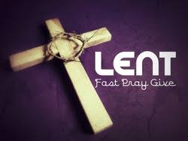who by the death and resurrection of your Son Jesus Christ

delivered and saved the world:

grant that by faith in him who suffered on the cross

we may triumph in the power of his victory;

through Jesus Christ your Son our Lord,

who is alive and reigns with you,

in the unity of the Holy Spirit,

one God, now and for ever.

**Readings (p.834)**

Isaiah 43.16-21

Psalm 126

Philippians 3.4b-14

Gospel: John 12.1-8

**Sunday 10th April : Palm Sunday**

**Liturgy of the Palms (p836)**

Gospel: Luke 19.28-40

Psalm 118.[1-2,] 19-24, [25-29]

**Liturgy of the Passion (p838)**

**Collect**

Almighty and everlasting God,

who in your tender love towards the human race

sent your Son our Saviour Jesus Christ

to take upon him our flesh

and to suffer death upon the cross:

grant that we may follow the example

of his patience and humility,

and also be made partakers of his resurrection;

through Jesus Christ your Son our Lord,

who is alive and reigns with you,

in the unity of the Holy Spirit,

one God, now and for ever.

**Readings** (**p.838**)

Isaiah 50.4-9a

Psalm 31.9-16, [17-18]

Philippians 2.5-11

Gospel: Luke 22.14-23.56 or Luke 23.1-49

**Good Friday 15th April**

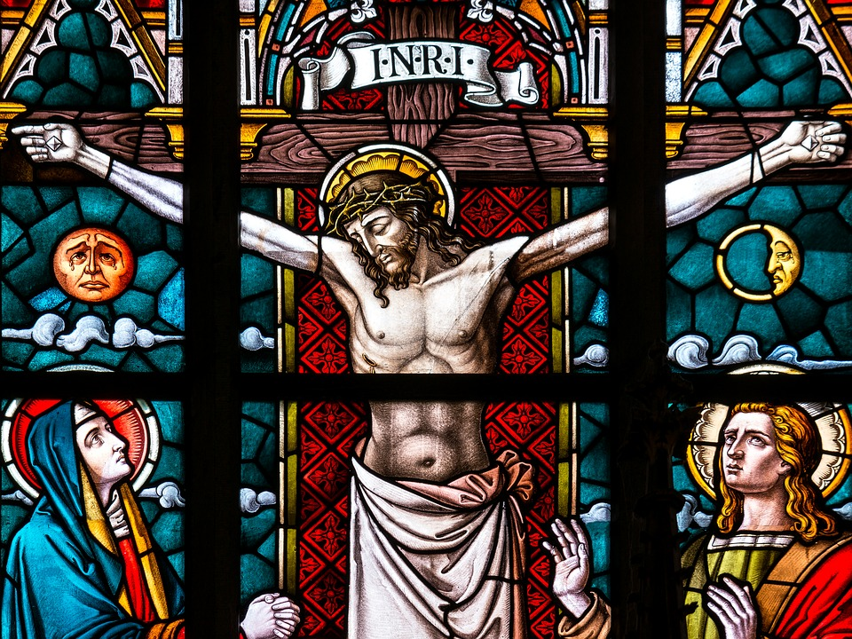**Collect**

Almighty Father,

look with mercy on this your family

for which our Lord Jesus Christ

was content to be betrayed

and given up into the hands of sinners

and to suffer death upon the cross;

who is alive and glorified

with you and the Holy Spirit

one God, now and for ever.

**Readings** (**p.860**)

Isaiah 52.13-53.12

Psalm 22, (or for a shorter text use 1-11 or 1-20)

Hebrews 10.16-25 or Hebrews 4.14-16; 5.7-9

Gospel: John 18.1-19.42

**Saturday 16th April : Easter Vigil**

**Collect**

Lord of all life and power,

who through the mighty resurrection of your Son

overcame the old order of sin and death

to make all things new in him:

grant that we, being dead to sin

and alive to you in Jesus Christ,

may reign with him in glory;

to whom with you and the Holy Spirit

be praise and honour, glory and might,

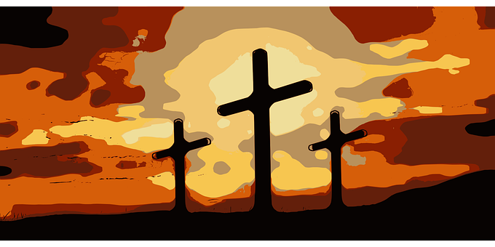now and in all eternity.

**Readings** (**p.873**)

Exodus 14.10-31; 15.20-21

Psalm 114

Romans 6.3-11

Gospel: Luke 24.1-12

**Sunday 17th April : Easter Day**

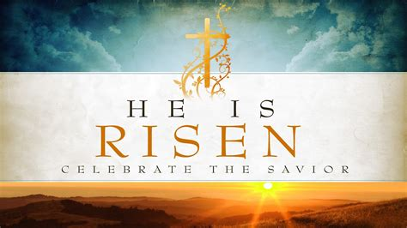**Collect**

Lord of all life and power,

who through the mighty resurrection of your Son

overcame the old order of sin and death

to make all things new in him:

grant that we, being dead to sin

and alive to you in Jesus Christ,

may reign with him in glory;

to whom with you and the Holy Spirit

be praise and honour, glory and might,

now and in all eternity.

**Readings** (**p.892**)

Acts 10.34-43 or Isaiah 65.17-25

Psalm 118.[1-2,] 14-24

1 Corinthians 15.19-26 or Acts 10.34-43

Gospel: John 20.1-18 or Luke 24.1-12

**Sunday 24th April: 2nd Sunday of Easter**

**Collect**

Almighty Father,

you have given your only Son to die for our sins

and to rise again for our justification:

grant us so to put away the leaven of malice and wickedness

that we may always serve you

in pureness of living and truth;

through the merits of your Son Jesus Christ our Lord,

who is alive and reigns with you,

in the unity of the Holy Spirit,

one God, now and for ever.

**Readings** (**p.898**)

Acts 5.27-32

Psalm 118.14-29 or Psalm 150

Revelation 1.4-8

Gospel: John 20.19-31

**Repentance, Citizenship, Transformation**

The Gospel for the Second Sunday of Lent tells of the lament of Jesus over the city of Jerusalem. He speaks in tones of abject disappointment and utter heartbreak over a ‘city that kills the prophets and stones those who are sent to it’ (Luke 13.34).

During these last days we will all have felt something of that abject disappointment and utter heartbreak over other peoples and places – those in Ukraine.

What is the gospel, the good news, this morning – for Ukraine, for Jerusalem, for the whole world?

Three words for you: repentance, citizenship, and transformation.

First, repentance. One of the Church’s Eucharistic Prayers speaks of our being led, during these 40 days of Lent, into ‘the desert of repentance’. ‘Desert’ is a good word here – with its associated imagery of wilderness and temptation and struggle. Repentance is far more than being sorry for something. It is about a fundamental reorientation; a turning around – a turning from, a rejection of, values, priorities and behaviours which are other than the values, priorities and behaviours of the Kingdom of God. It is not easy; it involves struggle. We live in a world where there is a profound need for repentance. Christian people are called to model such repentance, not least because of our second word – citizenship.

St Paul writes in our New Testament passage from Philippians that ‘our citizenship is in heaven’ (Phil. 3.20). What Paul is getting at, I think, has nothing to do with the fact that we are citizens of a country such as the United Kingdom. What he is getting at has to do with where we truly belong. It has to do with what we regard as the source and guiding principle of our values, our priorities and our behaviours. We constantly fall short of what this citizenship asks of us. The need for repentance is unending. But that doesn’t alter the fact that where we truly belong, what we regard as our ultimate allegiance, is not an earthly country but the Kingdom of God. And this is the way into our third word – transformation. An earthly country is by definition something with borders and boundaries; it is about divisions between people. But the Kingdom of God is all-embracing; it seeks to gather into one all into whom God has breathed the breath of life.

In his lament over Jerusalem, Jesus speaks of how often he desired to gather its children ‘as a hen gathers her brood under her wings’ (Luke 13.34). Here Jesus is articulating God’s passionate dream and compassionate desire to gather the human family closer and closer in his loving embrace. The divine purpose, Jesus seems to be saying, is to draw, embrace, include and welcome all people into the one family of humanity that God has intended from the dawn of Eden itself.

In this Year of Luke, our Gospel comes from Luke’s Gospel. Luke saw a persistent intention on the part of Jesus to bring in those cast out, to raise up those beaten down, to bring those on the extremities of the social order close to the heart of God. Luke sees this as the heart of the messianic message of Jesus. For it is in Luke that the good news of the Messiah is first told to shepherds. Shepherds represented those on the fringe, the margins of society. It is in Luke that we have the song of Mary, the Magnificat, with its talk of bringing down the powerful and lifting up the lowly. It is in Luke that Jesus tells of a prodigal son welcomed home by a father whose compassion is extravagant. It is in Luke that Jesus tells of a good Samaritan to people who despised Samaritans. It is in Luke that a thief finds the Kingdom of God while dying on a cross next to Jesus. And it is in Luke that, when he begins his ministry, Jesus identifies his work with the prophecy of Isaiah – the prophecy which saw the Spirit of God causing good news to be declared, lives changed and societies transformed. That declaration formed the beginning of a chain reaction of personal and social transformations which continues to this day, and which looks forward to the establishment of the Kingdom in its fullness.

Luke was also the author of the Acts of the Apostles. It is in Acts that we have the account of the first Pentecost. With the gift of the Spirit in their hearts and minds and lives, the followers of Jesus share in God’s work of creating a new humanity in Christ. As the good news of Jesus is proclaimed and the Holy Spirit of God is poured forth, a new human community emerges from the great variety and diversity of humanity. ‘That very variety is woven into a new tapestry so that the ancient longings of the prophets for a new humanity is realized’ (Michael Curry, *Feasting on the Word, Year C, Vol 2, p73*).

We are far from that new humanity. And so there is still heartbreak – the heartbreak of Jesus over the city of Jerusalem; heartbreak around the world at this time over Ukraine. The abject disappointment and utter heartbreak with which we began. We feel such things because, despite what the Christian Gospel has to say about repentance, citizenship and transformation, the Kingdom has yet to come in its fullness. But if you and I as Christian people have anything to say to a troubled world – both to the victims of inhumanity and to the perpetrators of inhumanity – it is surely about the possibility of change, of transformation. There is much suffering on the way – suffering not only in human hearts, but also in the heart of God. ‘And when human hearts are breaking, under sorrow’s iron rod, then they find that selfsame aching deep within the heart of God’ (Timothy Rees’ hymn *God is Love, let heaven adore him*). But to such suffering, what we bring is the gospel call for repentance, the gospel call for an all-embracing understanding of citizenship, and the gospel promise of transformation, of a new heaven and a new earth. In the face of abject disappointment and utter heartbreak, there is yet a gospel to proclaim – good news for all in all the world. Amen.

**The Rev’d Canon Steven Harvey**

**April Reflection**

**Christ has died: Christ is Risen: Christ will come again.**

These are words that we say as part of the Communion service as we acknowledge together the reality of what has already happened, but also they look forward to a future that is not here yet.

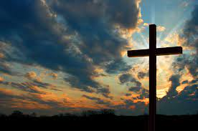In the Easter story, we have the decisive moment in the history of the world, but we are still waiting for the full effects of that moment to be worked out.

We had hoped that 2022 would be the year when we could concentrate on recovery after the Covid pandemic. We recognise that the virus is still circulating in our communities, and it could still mutate into something rather nasty, but we were hoping for better times. And then Russia invaded the Ukraine for reasons we don’t really understand, and our lives are again stressed as fuel prices rise sharply along with many other prices making life difficult or nearly impossible for many on low incomes.

And so we find ourselves living in the second paragraph of our opening sentence and waiting for Jesus to return to put right all that feels so disordered in our world today. We are not, of course, the first generation to look at the world and see so many problems. In the 14th century the English mystic, Julian of Norwich, lived through turbulent times.

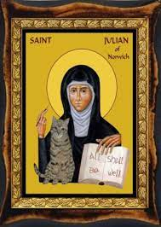Julian lived in Norwich which was then an important centre for commerce that also had a vibrant religious life. During her lifetime, the city suffered the devastating effects of the Black Death of 1348–1350, the Peasants' Revolt (which affected large parts of England in 1381), and the suppression of the Lollards. In 1373, aged 30 and so seriously ill she thought she was on her deathbed, Julian received a series of visions or ‘shewings’ of the Passion of Christ. She recovered from her illness and wrote two versions of her experiences, the earlier one being completed soon after her recovery and a much longer version, today known as the Long Text, was written many years later.

Julian was therefore living at a time when it was obvious that being a Christian was not a guarantee of a trouble-free life, but as a result of her visions she was able to write “He said not 'Thou shalt not be tempested, thou shalt not be travailed, thou shalt not be dis-eased'; but he said, 'Thou shalt not be overcome.”

Going further back in history, at the time of Jesus, the Jewish nation was living in stressful times under an occupying power (Rome) and a local government under Herod that was more interested in its own wellbeing than that of its fellow countrymen. Jesus spoke to his disciples in a time of fear and anxiety when he said to them ‘I am the Way, the Truth and the Life’. In our present situation both nationally and internationally we can find comfort in seeing Jesus as the Way

In describing Himself as The Way, Jesus is saying that He is so much more than a guide to life. To follow Jesus is a Way of Life. So, what might this Way of Life look like? Jesus Himself gives us a glimpse when He is asked what are the most important commandments- i.e., what are the key principles to living life well? His reply is astonishingly simple. Love God. Love your neighbour.

To love God is to recognise that we cannot do life on our own. It is to place our trust in the God who has made us, who knows us, and who loves us more than we can possibly imagine. Out of that place of security of knowing that we are loved and that we are significant, we can then reach out to those around us to affirm that they too are loved and that they too are significant.

As we face yet another time of uncertainty, we may need to relearn what it is to love God and to love our neighbour in what will feel like unfamiliar circumstances. So many of our familiar assumptions have disappeared, and our usual ways of doing things, both post covid and in light of the Russia / Ukraine war will need to be reinvented. And yet we need to re-emerge into our daily lives looking to Jesus as the one who knows what the Way ahead looks like. That Way will look different to each of us, but we travel in company with one another knowing that we can all look to Jesus and that, in Him, there is a Way through, and it is a Way that leads to life.

**Psalm 23**

Psalm 23 is not only the best known, but also the best loved of all the Psalms. It is usually assumed to be written by King David three thousand years ago out of his experience as a shepherd.

The theme of God as a shepherd was common in ancient Israel and Mesopotamia. For example, King Hammurabi, in the conclusion to his famous legal code, wrote: ‘I am the shepherd who brings well-being and abundant prosperity; my rule is just.... so that the strong might not oppress the weak, and that even the orphan and the widow might be treated with justice.’ This imagery and language was well known to the community that created the Psalm and was easily imported into its worship.

So why is the psalm so loved? Psalm 23 portrays God as a good shepherd, (our impression 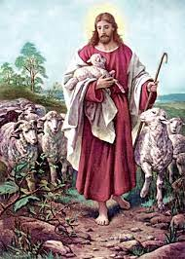enhanced by the gospels) feeding and leading his flock.

Some commentators see the shepherd imagery pervading the entire psalm. Some even suggest that ‘Thou preparest a table before me' refers to the ancient shepherding practice of using little raised tables to feed sheep and 'Thou anointest my head with oil' may refer to pouring oil on wounds to repel flies.

Another intriguing interpretation is that the Valley of the Shadow of Death was an actual geographic location in Israel, the Kidron Valley, which David would have known. Death threatened from the treacherous hairpins, and also from the opportunities for bandits to hide and attack the unwary. Whether this was intended or not, the image of being accompanied through death’s dark vale by the good shepherd has brought great comfort to many facing death or enduring bereavement.

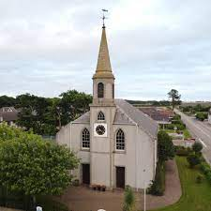For many of us, our familiarity with the text is reinforced by our love of the musical settings. The best-known tune for the hymn ‘The Lord’s my shepherd, I’ll not want’ is Crimond. Crimond is a village in Aberdeenshire. It is thought that this tune was composed by Jessie Seymour Irvine, daughter of Rev. Alexander Irvine, minister of the Crimond Parish. Jessie was a keen musician and was undergoing training as an organist. According to some accounts, she composed the tune in 1871 as an exercise for a composition class and it was first performed at evening worship at Auchterless Parish Church. Dissatisfied with her own harmonisation, she asked David Grant, a musician from Aberdeen to reharmonise it for her. A descant to Crimond was written for the Queen’s wedding in 1947.

Crimond is however not the only tune for this hymn. Brother James' Air is another by the Scottish composer James Leith Macbeth Bain. Later known as Brother James, he founded Crimond Church

‘The Brotherhood of Healers‘. They worked among the poor of Liverpool and often sang the tune to their patients. Another Psalm 23 version familiar from a secular setting was composed by Howard Goodall and became the theme music to TV's 'Vicar of Dibley'

Of course, there are people in parts of the world who have never seen a sheep - maybe even some UK city dwellers, though our culture is steeped in notions of the shepherd from Little Bo Peep onwards. Translators of the bible for obscure tribes have sometimes used other concepts related to their own society. Such is the universal message that the psalm has, that it has been adapted for various situations, such as the sailor's version, ‘The Lord is my pilot, I shall not drift.‘ Other examples are ‘The Lord is my choirmaster, I shall never be out of step with the music.' ‘The Lord is my compass and courier, I shall never be lost or abandoned‘ and even, a bit more tongue in cheek for family historians, ‘Genealogy is my pastime, I shall not stray. It maketh me to lie down and examine half-buried tombstones’. You might like to compose your own version!

**Richard Byas**

**Making peace with his penance**

A Catholic priest spied a parishioner enjoying some tasty smoked sausage on a Friday during Lent - a strict no-no in the church. The priest, being a pragmatic soul, told the man for his penance he was to bring a load of timber to the church to help repair the roof.

The man grumbled but went off to do his penance. He arrived at the church on the next Friday and proceeded to dump a huge load of sawdust at the front door.

"What's this?" the priest wanted to know. "I told you your penance was a load of timber, not sawdust."

The man replied coolly, "Well, if that sausage I ate was meat, then this sawdust is timber."



**Baldersby St James Church - Drop In and Chat**

Every Tuesday 10a.m. – 12 noon in the café area at the back of church. Drop in for a chat, book swap or have a quiet sit at our jigsaw table.  Our first two weeks have been very well attended – 24 people called by during the mornings and enjoyed a visit from pupils at Baldersby School, opposite the church, which was much appreciated.  Best of all its FREE but you might have to make your own coffee!

**Dalton Events**

**Mums and Tots**

The Mums and Tots group meets every Friday morning in the Village Hall from 10am to 12 noon. However, it will not be meeting on Good Friday 15th April.

**Domino Drive**

There will be a Domino Drive on Saturday 2nd April at 7pm to provide funds for the Dalton Yarnbombers. Admission is £2, tea and biscuits will be provided at the interval and there will be a raffle. Any donations for the raffle will be greatly appreciated and they can be brought to the village hall on the night. Please note there will not be a 5th Saturday Domino Drive in April.

**PARISH DIRECTORY**

**The Parishes of Topcliffe, Baldersby with Dishforth, Dalton and Skipton on Swale**

There is currently no Vicar of the parishes. Until one is appointed, please ring our Area Dean,

The Revd Fiona Mayer-Jones tel: 07450 402953 or [revdfmj@gmail.com](mailto:revdfmj@gmail.com)

**BALDERSBY with DISHFORTH** - PCC Secretary: Mrs Jennifer Wharton [wharton370@btinternet.com](mailto:wharton370@btinternet.com)

**DALTON** - PCC Secretary: Mrs Hannah Bissett tel: 07739 382831 [spannerb79@gmail.com](mailto:spannerb79@gmail.com)

**SKIPTON-on-SWALE** – PCC Secretary: Mr Alan Kitching tel: 01845 567457

**TOPCLIFFE** – PCC Secretary: Mrs Roz Norris [RozNorris@aol.com](mailto:RozNorris@aol.com)