**Benefice Online Magazine**

**for the Parishes of Topcliffe, Baldersby with Dishforth, Dalton and Skipton on Swale**

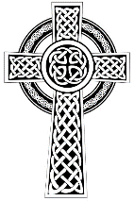 Cross Talk

**June 2022**

Cross Talk is published monthly by email. To receive a copy please contact [kitnorris@live.co.uk](mailto:kitnorris@live.co.uk)

Cross Talk contains the weekly Collect and Readings together with details of Church services in the Benefice and news and items of interest supplied by our readers.

The magazine will also be available on the web sites: www.achurchnearyou.com/church/3447 and baldersbychurch.com.

**CHURCH SERVICES**

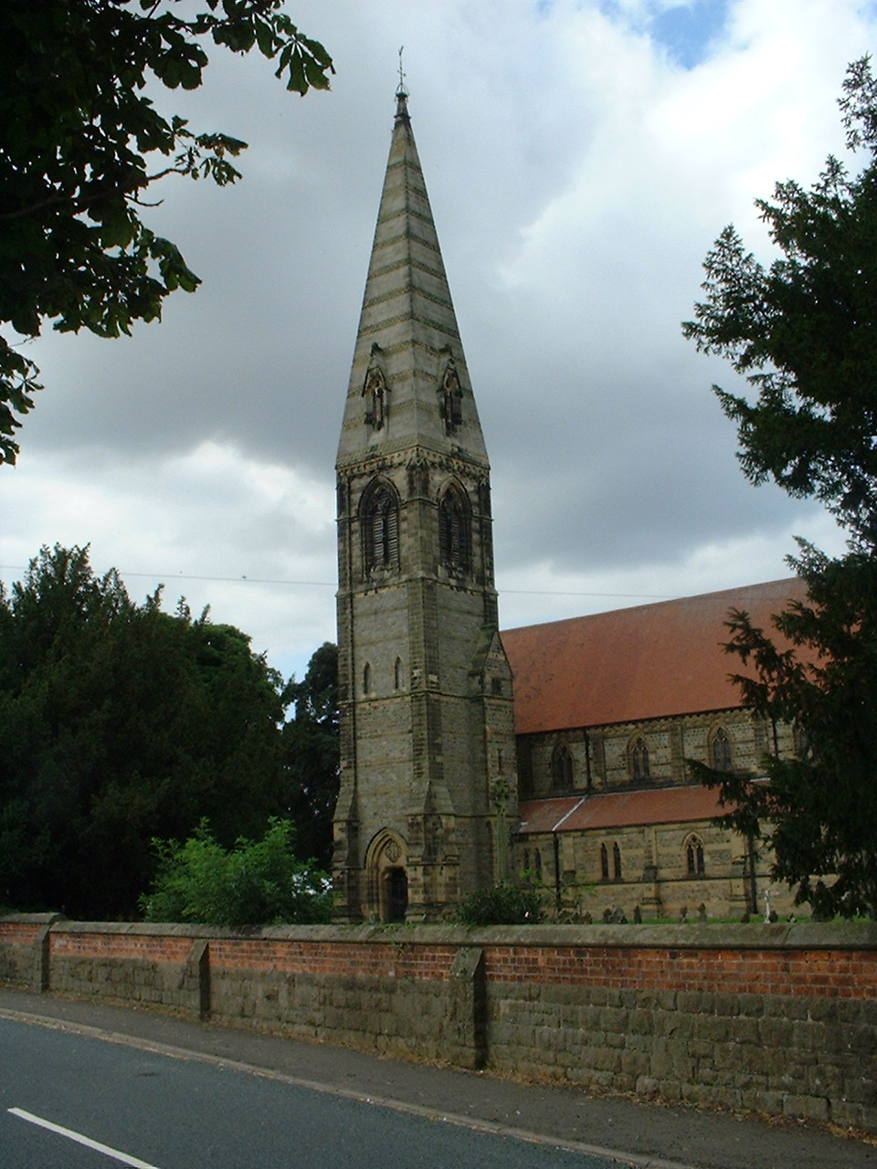**St. James’ Church, Baldersby St. James with Dishforth and Rainton**

**Sunday 5th June, 10.45am Communion Service** *with Revd. Sheelagh Williamson.*

*Coffee to follow*

**Sunday 12th June, 9.30am Breakfast Service** *with Kingsley Weber.*

***Coffee and Croissants***

**Sunday 19th June, 10.45am Communion Service** *with Revd. Sheelagh Williamson.*

*Coffee to follow*

**Sunday 26th June, 9.30am Morning Prayer** *with Reader Peter Carrott.* ***(*** *spoken service)*

*Coffee to follow*

**St. Columba’s Church, Topcliffe**

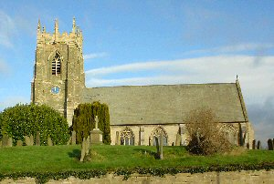**Sunday 5th June, 6.30pm Jubilee Choral Evensong** *with*

*Revd. Canon Keith Punshon*

*full details on p.7*

**Sunday 12th June, 10.45am Holy Communion** *with*

*Revd.Robert Williamson*

**Sunday 19th June, 10.45am Choral Matins**

**Sunday 26th June, 10.45am Holy Communion** *with*

*Revd.Robert Williamson*

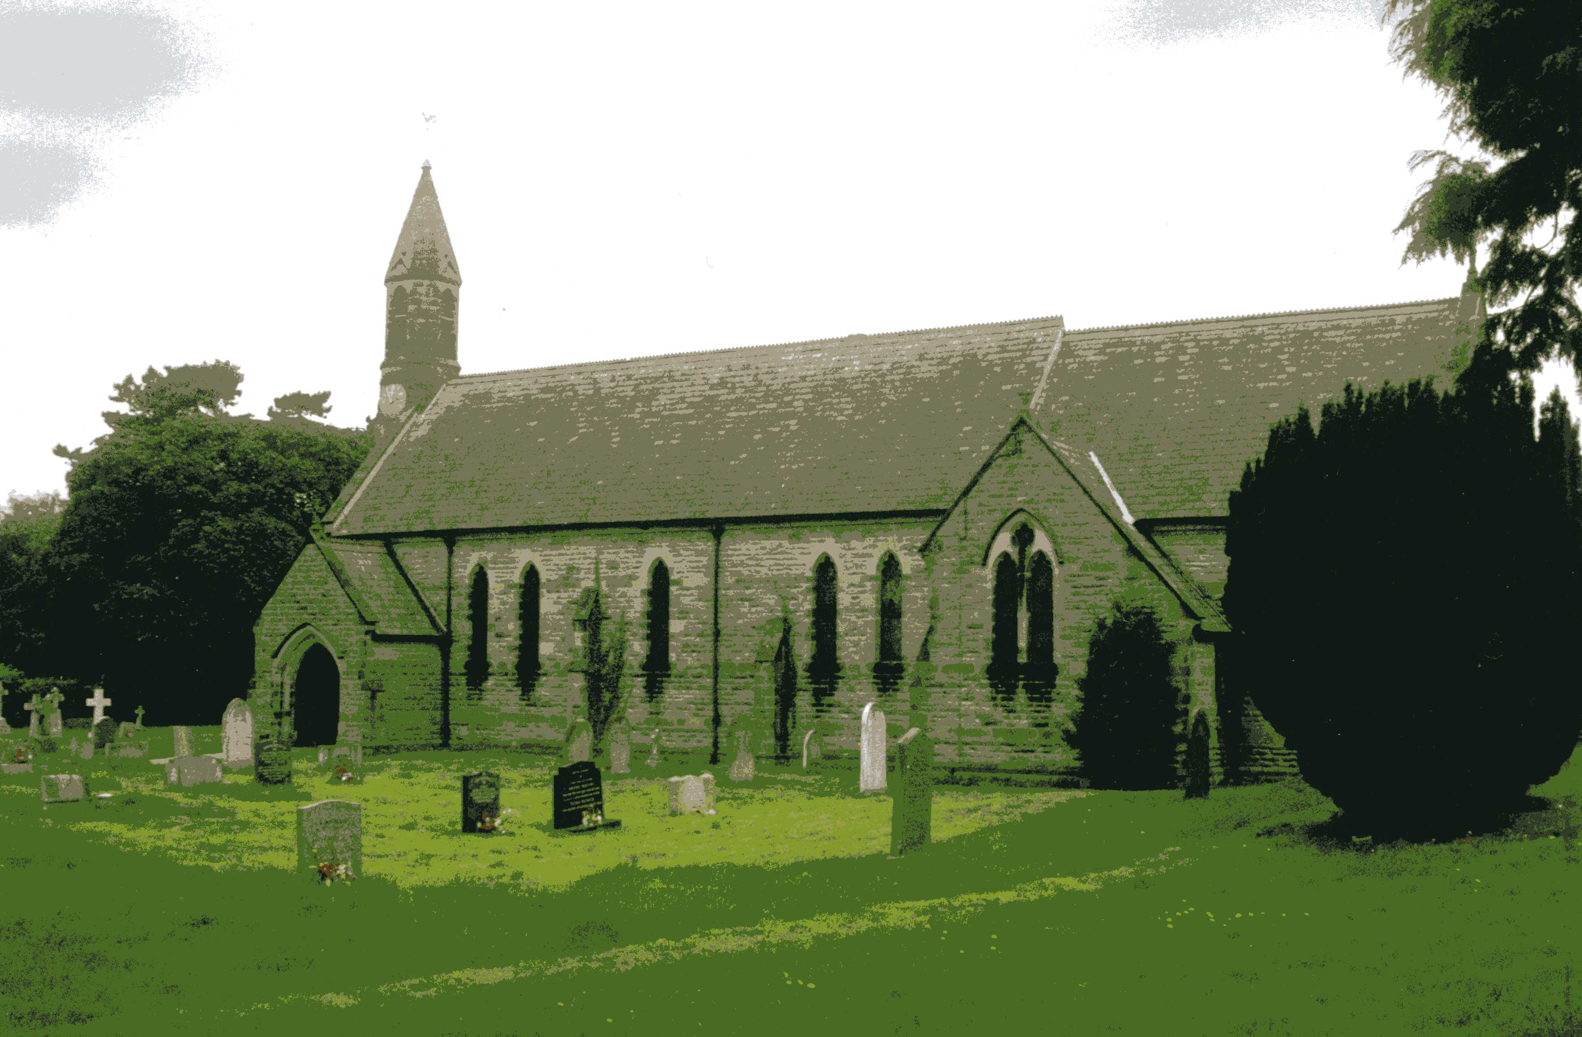**St John the Evangelist Church, Dalton**

**Sunday 5th June No Service**

**Sunday 12th June, 11am Family Service with baptism**

**Sunday 19th June, 11am Holy Communion**

**Baldersby St James News** is listed on page 6.

**Dalton Social Events** are listed on pages 6 and 7.

**Topcliffe Church Jubilee Weekend Events** see page 7

**Readings for Pentecost Sunday to 2nd Sunday after Trinity**

*(Page numbers refer to the Common Worship Lectionary.)*

**Sunday 5th June : Pentecost : Whit Sunday**

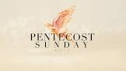**Collect**

God, who as at this time

taught the hearts of your faithful people

by sending to them the light of your Holy Spirit:

grant us by the same Spirit

to have a right judgement in all things

and evermore to rejoice in his holy comfort;

through the merits of Jesus Christ our Saviour,

who is alive and reigns with you,

in the unity of the Holy Spirit,

one God, now and for ever.

*The reading from Acts must be used as either the first or second reading*

**Readings (p.923)**

Acts 2.1-21 *or* Genesis 11.1-9

Psalm 104.25-35, [36,] 37

Romans 8.14-17 *or* Acts 2.1-21

Gospel: John 14.8-17, [25-27]

**Sunday 12th June : Trinity Sunday**

**Collect**

Almighty and everlasting God,

you have given us your servants grace,

by the confession of a true faith,

to acknowledge the glory of the eternal Trinity

and in the power of the divine majesty to worship the Unity: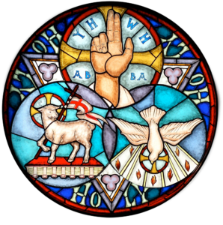

keep us steadfast in this faith,

that we may evermore be defended from all adversities;

through Jesus Christ your Son our Lord,

who is alive and reigns with you

in the unity of the Holy Spirit,

one God, now and for ever.

**Readings (p.928)**

Proverbs 8.1-4, 22-31

Psalm 8

Romans 5.1-5

Gospel: John 16.12-15

**Sunday 19th June : 1st Sunday after Trinity**

**Collect**

O God,

the strength of all those who put their trust in you,

mercifully accept our prayers

and, because through the weakness of our mortal nature

we can do no good thing without you,

grant us the help of your grace,

that in the keeping of your commandments

we may please you both in will and deed;

through Jesus Christ your Son our Lord,

who is alive and reigns with you,

in the unity of the Holy Spirit,

one God, now and for ever.

**Readings** (**p.969**) - **Proper 7, Related**

Isaiah 65.1-9

Psalm 22.18-27

Galatians 3.23-29

Gospel: Luke 8.26-39

**Sunday 26th June : 2nd Sunday after Trinity**

**Collect**

Lord, you have taught us

that all our doings without love are nothing worth:

send your Holy Spirit

and pour into our hearts that most excellent gift of love,

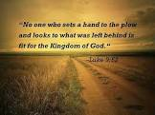the true bond of peace and of all virtues,

without which whoever lives is counted dead before you.

Grant this for your only Son Jesus Christ’s sake,

who is alive and reigns with you,

in the unity of the Holy Spirit,

one God, now and for ever.

**Readings** (**p.975**) **– Proper 8, Related**

1 Kings 19.15-16, 19-21

Psalm 16

Galatians 5.1, 13-25

Gospel: Luke 9.51-62

**Reflection, June 2022**

This year we celebrate Pentecost on the 5th June. It is celebrated on the 50th day (the seventh Sunday) from Easter Sunday. It commemorates the descent of the Holy Spirit upon the Apostles and other followers of Jesus while they were in Jerusalem celebrating the Feast of Weeks which is a Jewish harvest festival that is celebrated seven weeks and one day after the first day of Passover.

Pentecost is also called "Whit Sunday", "Whitsunday" or "Whitsun". Whitsuntide, the week following Whitsunday, was one of three holiday weeks for the medieval villein; on most manors he was free from service on the lord's demesne this week, which marked a pause in the agricultural year.

Until 1971, Whit Monday (the day following Whit Sunday) was a Bank Holiday but with effect from 1972, it was replaced with the Spring Bank Holiday on the last Monday in May and so Whitsuntide has been largely lost from the secular calendar.

For the Church however, Pentecost is the birthday of the Church, and we commemorate in our celebration God's gift of life through Jesus Christ. Birthdays should be happy events when we celebrate the gift and continuity of life - and that's certainly true of Pentecost celebrations.

Two major changes took place at Pentecost. The first change was what happened to the disciples. They still didn’t fully understand Jesus’ mission, they were confused and as a result they were timid. They had thought Jesus was going into Jerusalem to become a conquering earthly king but as we know he was killed instead. He of course rose from the grave three days later, and then ascended into Heaven a while after that, saying he would send someone to them after he was gone. As the disciples didn’t fully understand what it all meant they weren’t confident about sharing the Gospel with others.

But then Pentecost came. The disciples were together when the sound of a blowing wind came down from heaven. What seemed to be tongues of fire settled on their heads. They were all filled with the Holy Spirit and began to speak in foreign languages they had never learned before. A crowd gathered, people from all over the known world, and that crowd listened as the disciples praised God and preached the Gospel. The Apostle Peter stood up and addressed the crowd – he gave a sermon that the Holy Spirit inspired him to preach, a sermon that converted nearly 3000 people in one day.

No longer were the disciples confused. Now they understood the plan of salvation completely. No longer were they timid. Now, they were confident, speaking publicly. Two months earlier Peter was so afraid that he denied Jesus three times, now he was speaking to the crowd with confidence and understanding that he had never had before.

The second change was in the 3000 people who responded to Peter’s sermon and whose lives changed that day. Today there are many people looking to improve and change their lives for the better. That’s why there are so many self-help books available. That’s also why there are so many commercials for diet and exercise products. So many people are looking to improve, to change for the better but not always in the way God wants

God is interested in change. He’s interested in changing us. Our problem is, we often don’t think we need to be changed in the way God wants. “I’m alright the way I am,” we say to ourselves. “What do I need to change about myself?”

It is true we are Christians, but we still have sinful habits. We still have moments when we are selfish. We still have moments when we completely misunderstand what God is telling us in the Bible. We still have moments when we fail to share our faith because we’re too timid. We still need to become more and more the people that God wants us to be. We need to be Jesus-like people doing Jesus-like things.

The story of Pentecost reminds us that people are able to change if they are open to the prompting of the Holy Spirit. Pentecost was a one-time event. We do not expect the Holy Spirit to come with the loud sound of a wind, or with what looks like tongues of fire, or giving us the ability to speak in foreign languages

Today, the Holy Spirit comes to us through our asking him into our lives through prayer. On the surface, it doesn’t look like anything spectacular. But on the inside all kinds of changes are taking place. Change can be gradual or it can be sudden.

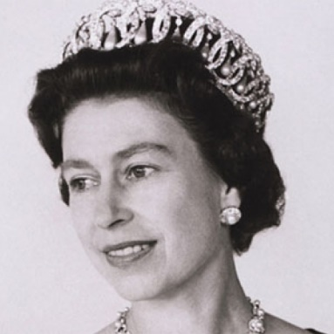As the Queen prepared spiritually for her coronation, the then Archbishop of Canterbury, Geoffrey Fisher, wrote *A Little Book of Private Devotions* to help her prepare for her new role. The book contained short daily meditations with Bible readings and prayers. In subsequent years the Queen has referred to the Bible on numerous occasions in her Christmas broadcasts and in other speeches. The Queen’s life has demonstrated the themes of joyful faith, service and sacrifice and has demonstrated a practical faith through her personal commitment as she follows in Jesus’ footsteps through the promptings of the Holy Spirit.

The Holy Spirit can also strengthen our faith, increase our love for Christ and our love for one another.

PRAYER: Father, thank you for sending your Holy Spirit. Even though we can't see him, we are thankful that we can hear him speak to our hearts, feel his presence in our daily lives, and see him moving us to do your will. Amen.

**Richard Byas**

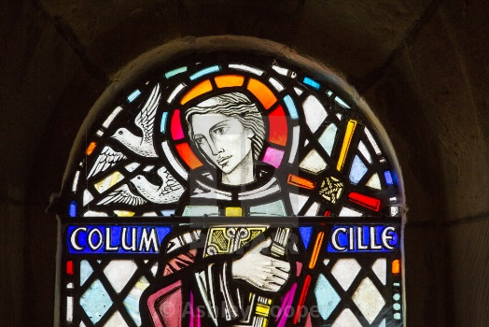**St Columba**

St. Columba’s day is celebrated on 9th June. St Columba was the ‘Apostle to the Picts’ and the founder of the Christian centre of Iona. He was of Royal birth in Ireland, was a poet and a learned man as monks were in those days. Much of the story of his early life in Ireland is disputed but he seems to have been involved in the Battle of Cúl Dreimhne in 561, during which many men were killed.

A synod of clerics and scholars threatened to excommunicate him for these deaths, but eventually, the process was deemed a miscarriage of justice. Columba's own conscience was uneasy, and on the advice of an aged hermit, Molaise, he resolved to resolve his uneasiness by leaving Ireland. In 563, he travelled to Scotland with twelve companions in a wicker currach covered with leather.

According to legend he first landed on the Kintyre Peninsula. However, being still in sight of his native land, he moved farther north up the west coast of Scotland.

The island of Iona was given to him by his kinsman Conall mac Comgaill, King of Dál Riata, who perhaps had invited him to come to Scotland in the first place.

There are many stories of miracles which he performed during his work to convert the Picts, the most famous being his encounter with an unidentified animal that some have equated with the Loch Ness Monster. In 565 it is said that he banished a ferocious ‘water beast’ to the depths of the River Ness after it had killed a Pict and then tried to attack Columba's disciple named Lugne.

Columba subsequently played a major role in the politics of the country. He was also very energetic in his work as a missionary, and, in addition to founding several churches in the Hebrides, he worked to turn his monastery at Iona into a school for missionaries. He was a renowned man of letters, having written several hymns and being credited with having transcribed 300 books. One of the few, if not the only, times he left Scotland was towards the end of his life, when he returned to Ireland to found the monastery at Durrow.

According to traditional sources, Columba died on Iona on Sunday, 9th June 597, and was buried by his monks in the abbey he created. Columba's relics were finally removed in 849 and divided between Scotland and Ireland.

Many prayers are attributed to St. Columba including this one:

Be O Lord,

a guiding star above me,

a smooth path below me, a kindly shepherd behind me

and a bright flame before me; today, tonight and forever. **Amen.**

**Temptation?**

‘Last Sunday I found a wallet packed with money near to the church.’

‘Did you give it back?’

‘Not yet. I'm still trying to decide if it's a temptation from the devil or the answer to a prayer.’



**Richard Byas**

**Baldersby St James News**

The **St James Organist** is leaving before the end of August.  If anyone would like to play on two Sundays each month, either the organ or piano, please get in touch with Rosemarie Carter our Church Warden on 01765 640360 or email [carter-stuart@btconect.com](mailto:carter-stuart@btconect.com) You will be warmly welcomed to our church which has great acoustics – come and try our piano or organ if you are interested**.**

**Music at Junction 50**

Wednesday 29th June is the date of our first concert at 7.00pm

**Tara Viscardi – Harp, and Robert Finegan - Saxaphone**

Another wonderful concert featuring two very talented young people. An event not to be missed.

Tickets from: Sue Brown [c.b.brown398@hotmail.co.uk](mailto:c.b.brown398@hotmail.co.uk) , 07840 381558 or collect at The Good Food Shop ,or Colin Reid – [colinreid97@yahoo.co.uk](mailto:colinreid97@yahoo.co.uk) , 07770 620897 or 01765 640624, or collect at the door.

**St James Coffee and Chat** on Tuesday mornings 10 until 12. A popular morning in church - swap your books at the same time.

**Dalton Events**

**Results of the 120 Club for April**

£15 Marion Tracey (No.84); £10 Ella and Jack Borchard (No.111); £6 Hannah Bisset (No.4).

**Queen’s Jubilee Picnic**

There will be a ‘bring your own’ picnic on the playing field for the Queen’s Jubilee on Friday 5th June, 11am until 3pm. There will be a bouncy castle, giant jenga and giant connect 4. Strawberries and cream and scones will be on sale in the village hall, and there will also be a bar.

**Dalton Fest**

This will be held on Saturday 11th June on the village hall playing field. Tickets are £10 and going fast. Contact Eleanor on 07841 036340 for tickets.

**Church Summer Lunch**

The lunch will be held on Sunday 26th June at 12 for 12.30. There will be cold meats, salads and warm potatoes, followed by lots of lovely home-made deserts. You won’t go home hungry! Tickets are £12 for adults, 2 adults and 2+ children costs £30, available from Judy on 01845 577607. Places are limited, so don’t wait.

**Sylvia Binks**

**St Columba’s Church, Topcliffe**

**Jubilee Weekend Events**

**Saturday 4th June :: 2pm to 5pm**

**Tower, Tours and Teas**

View Topcliffe in its Jubilee finery from the top of the church tower, explore its 1400 year history and take tea. All is free, but donations to church would be appreciated.

**Sunday 5th June** at **6.30pm**

**Jubilee Service of Choral Evensong**

led by **Rev’d Canon Keith Punshon**

**St Columba’s Choir** led by **Linda Hewlett**

with **Matthew Atherton (Organ)**

***followed by food and wine***

**PARISH DIRECTORY**

**The Parishes of Topcliffe, Baldersby with Dishforth, Dalton and Skipton on Swale**

There is currently no Vicar of the parishes. Until one is appointed, please ring our Area Dean,

The Revd Fiona Mayer-Jones tel: 07450 402953 or [revdfmj@gmail.com](mailto:revdfmj@gmail.com)

**BALDERSBY with DISHFORTH** - PCC Secretary: Mrs Jennifer Wharton [wharton370@btinternet.com](mailto:wharton370@btinternet.com)

**DALTON** - PCC Secretary: Mrs Hannah Bissett tel: 07739 382831 [spannerb79@gmail.com](mailto:spannerb79@gmail.com)

**SKIPTON-on-SWALE** – PCC Secretary: Mr Alan Kitching tel: 01845 567457

**TOPCLIFFE** – PCC Secretary: Mrs Roz Norris [RozNorris@aol.com](mailto:RozNorris@aol.com)