Benefice Online Magazine
for the Parishes of Topcliffe, Baldersby with Dishforth, Dalton and Skipton on Swale
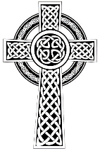
Cross Talk
May 2022 Update

Additional Service
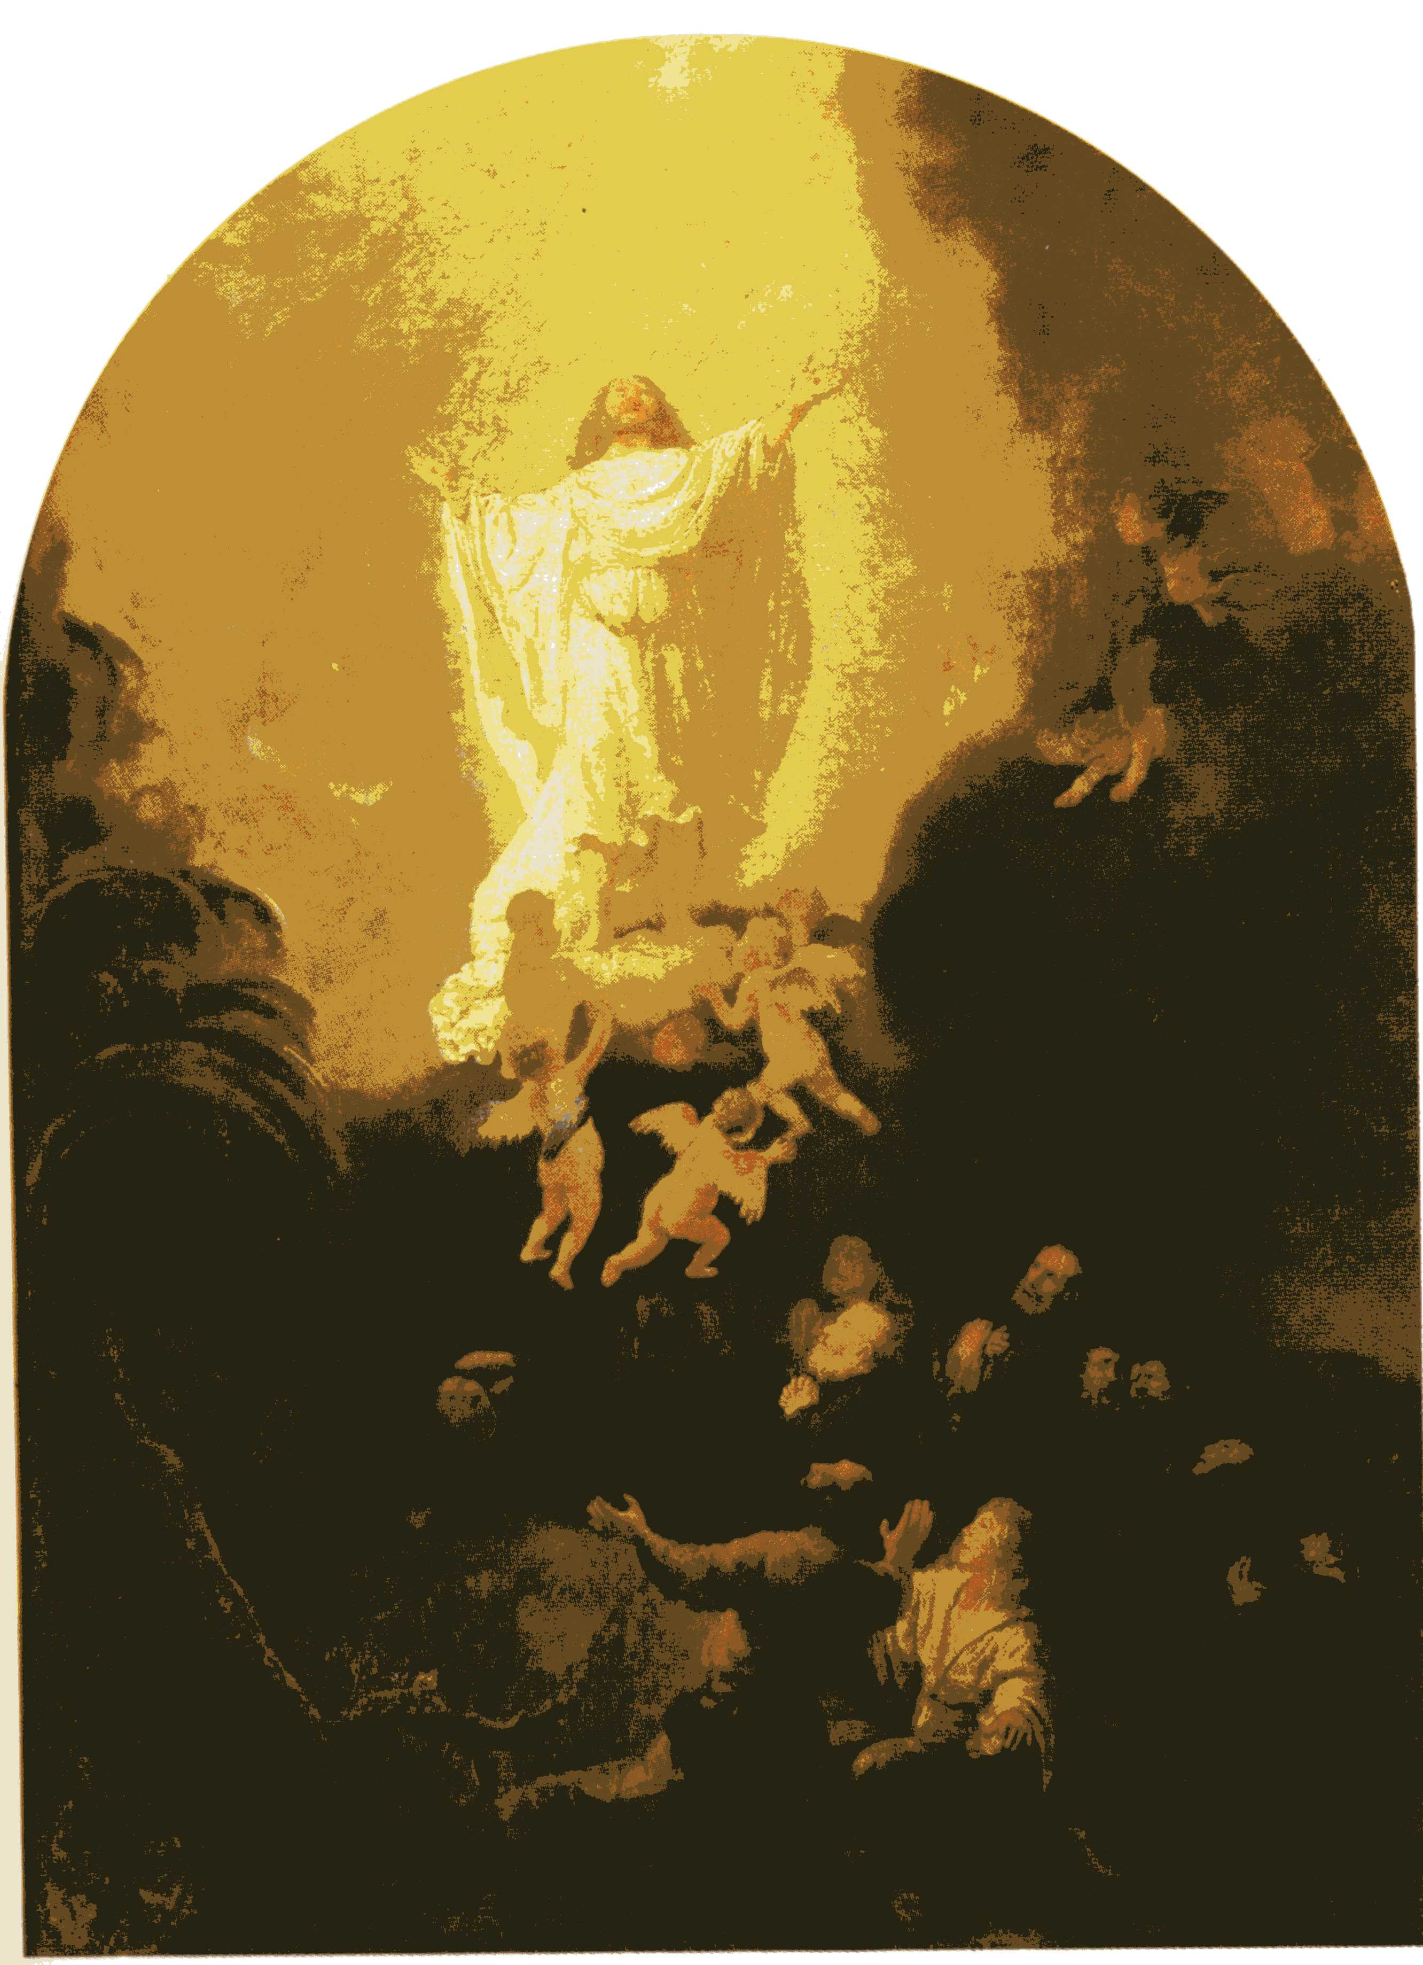
St. Columba’s Church, Topcliffe
Ascension Day
Thursday 26th May, 7.00pm Compline

A short reflective service at the end of the day.

Preserve us, O Lord, while waking, and guard us while sleeping, that awake we may watch with Christ, and asleep we may rest in peace.

Also a reminder that no service will be held on
Sunday 29th May

Jubilee Weekend Events at St. Columba’s Church

Saturday 4th June :: 2pm to 5pm
Tower, Tours and Teas
View Topcliffe in its Jubilee finery from the top of the church tower, explore its 1400 year history and take tea. All is free, but donations to the church would be appreciated.
Sunday 5th June at 6.30pm
Jubilee Service of Choral Evensong
led by Rev’d Canon Keith Punshon
St Columba’s Choir led by Linda Hewlett with Matthew Atherton (Organ)
followed by food and wine

