**Benefice Online Magazine**

**for the Parishes of Topcliffe, Baldersby with Dishforth, Dalton and Skipton on Swale**

 Cross Talk

**July 2022**

Cross Talk is published monthly by email. To receive a copy please contact [kitnorris@live.co.uk](mailto:kitnorris@live.co.uk)

Cross Talk contains the weekly Collect and Readings together with details of Church services in the Benefice and news and items of interest supplied by our readers. The magazine will also be available on the web sites: www.achurchnearyou.com/church/3447 and baldersbychurch.com.

**CHURCH SERVICES**

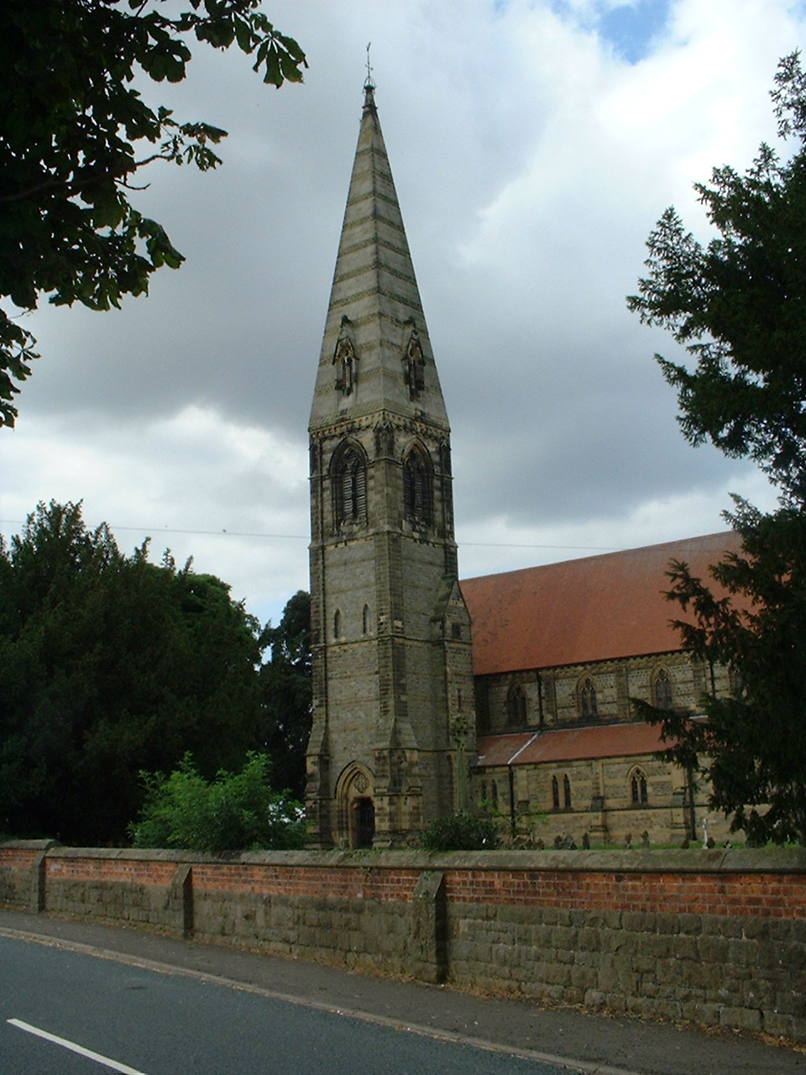**St. James’ Church, Baldersby St. James with Dishforth and Rainton**

**Sunday 3rd July, 10.45am Communion Service *followed by refreshments****.*

**Sunday 10th July, 9.30am Prayer Breakfast** *taken by Peter Carrotte*

Sunday 17th July, 10.45am Communion Service *followed by refreshments.*

Sunday 24th July, 9.30am Morning Prayer *followed by refreshments*

**Sunday 31st July No Service**

**St. Columba’s Church, Topcliffe**

*Corporate Member of the Prayer Book Society*

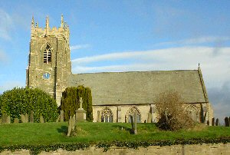**Sunday 3rd July, 6.30pm Choral Evensong** *with* *hymns*

**Sunday 10th July, 10.45am Holy Communion** *with hymns*

*Revd.Robert Williamson*

*followed by refreshments*

**Sunday 17th July, 10.45am Choral Matins** *with hymns*

*followed by refreshments*

**Sunday 24th July, 10.45am Holy Communion** *with hymns*

*Revd.Mary Rolls.*

*followed by refreshments*

**12.30pm Baptism**

**Sunday 31st July No Service**

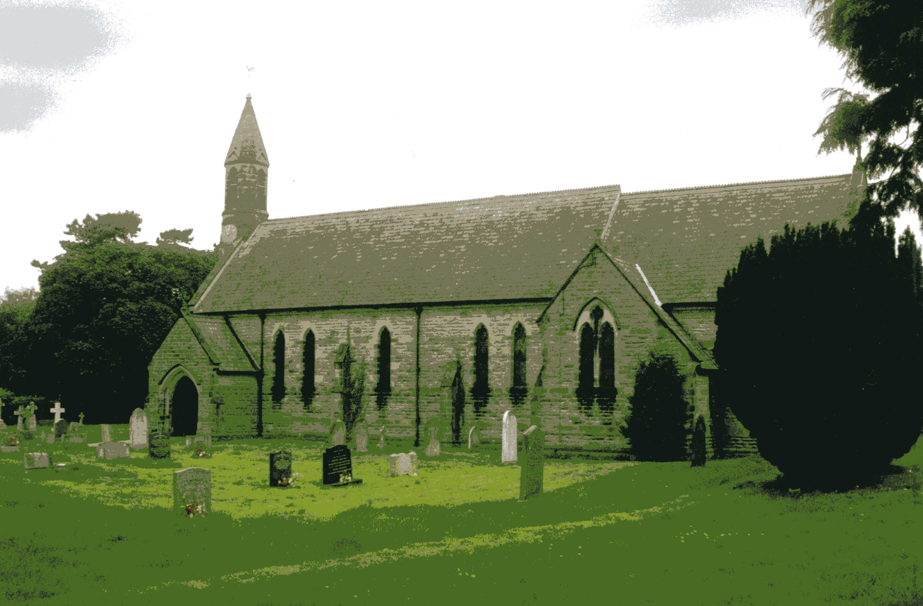**St John the Evangelist Church, Dalton**

**Sunday 3rd July, 11am Holy Communion**

**Sunday 17th July, 11am Holy Communion**

**Baldersby St James News** is listed on page 8.

**Dalton Social Events** are listed on page 8.

**Readings for 3rd Sunday after Trinity to 7th Sunday after Trinity**

*(Page numbers refer to the Common Worship Lectionary.)*

**Sunday 3rd July : 3rd Sunday after Trinity**

**Collect**

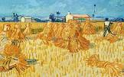Almighty God,

you have broken the tyranny of sin

and have sent the Spirit of your Son into our hearts

whereby we call you Father:

give us grace to dedicate our freedom to your service,

that we and all creation may be brought

to the glorious liberty of the children of God;

through Jesus Christ your Son our Lord,

who is alive and reigns with you,

in the unity of the Holy Spirit,

one God, now and for ever. ‘the harvest is plentiful, but the

labourers are few’ Luke 10.2

**Readings (p.981) – Proper 9, Related**

Isaiah 66.10-14

Psalm 66.1-8

Galatians 6.[1-6,] 7-16

Gospel: Luke 10.1-11, 16-20

**Sunday 10th July : 4th Sunday after Trinity**

**Collect**

O God, the protector of all who trust in you,

Without whom nothing is strong, nothing is holy:

Increase and multiply upon us your mercy;

that with you as our ruler and guide

we may so pass through things temporal

that we lose not our hold on things eternal;

grant this, heavenly Father,

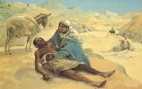for our Lord Jesus Christ’s sake,

who is alive and reigns with you

in the unity of the Holy Spirit,

one God, now and for ever.

**Readings (p.987) – Proper 10, Related**

Deuteronomy 30.9-14

Psalm 25.1-9

Colossians 1.1-14

Gospel: Luke 10.25-37 The Good Samaritan. Luke 10.25-37

**Sunday 17th July : 5th Sunday after Trinity**

**Collect**

Almighty and everlasting God,

by whose Spirit the whole body of the Church

Is governed and sanctified:

hear our prayer which we offer for all your faithful people,

that in their vocation and ministry

they may serve you in holiness and truth

to the glory of your name;

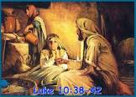through our Lord and Saviour Jesus Christ,

who is alive and reigns with you,

in the unity of the Holy Spirit,

one God, now and for ever.

**Readings** (**p.992**) - **Proper 11, Related**

Genesis 18.1-10a

Psalm 15

Colossians 1.15-28

Gospel: Luke 10.38-42

**Sunday 24th July : 6th Sunday after Trinity**

**Collect**

Merciful God,

you have prepared for those who love you

such good things as pass our understanding:

pour into our hearts such love toward you

that we, loving you in all things and above all things,

may obtain your promises,

which exceed all that we can desire;

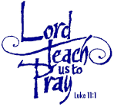through Jesus Christ your Son our Lord,

who is alive and reigns with you,

in the unity of the Holy Spirit,

one God, now and for ever.

**Readings** (**p.998**) **– Proper 12, Related**

Genesis 18.20-32

Psalm 138

Colossians 2.6-15, [16-19]

Gospel: Luke 11.1-13

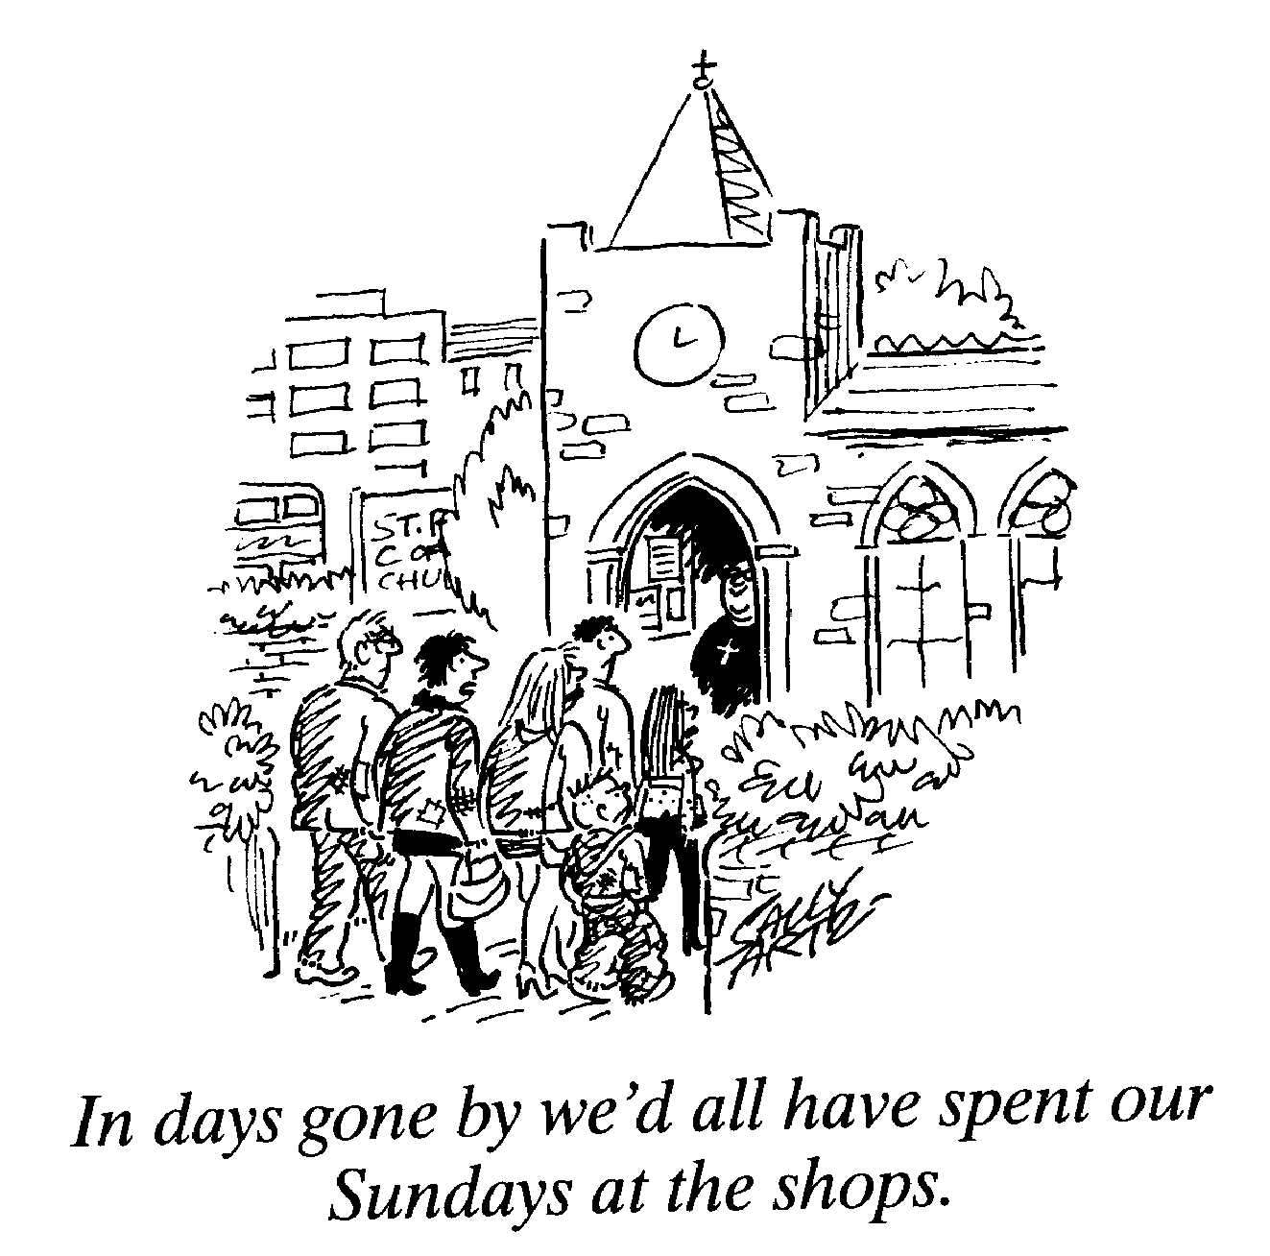**Sunday 31st July : 7th Sunday after Trinity**

**Collect**

Lord of all power and might,

the author and giver of all good things:

graft in our hearts the love of your name,

increase in us true religion,

nourish us with all goodness,

and of your great mercy keep us in the same;

through Jesus Christ your Son our Lord,

who is alive and reigns with you,

in the unity of the Holy Spirit,

one God, now and for ever.

**Readings** (**p.1003**) **– Proper 13, Related**

Ecclesiastes 1.2, 12-14; 2.18-23

Psalm 49.1-8, [9-11]

Colossians 3.1-11

Gospel: Luke 12.13-21

**Sermon at St Columba, Topcliffe, on Sunday 26th June 2022**

In the fall-out from Friday’s decision of the Supreme Court of the United States, much has been heard about freedom – about reproductive freedom, about the freedom of the individual to be autonomous, to be able to choose.

Paul opens our New Testament passage, from his letter to the Galatians, with the statement: ‘For freedom, Christ has set us free’ (Galatians 5.1). And he goes on to say: ‘……you were called to freedom, brothers and sisters’ (Galatians 5.13).

In the Jewish and Christian traditions, ‘freedom’ is an important word. One of the key biblical stories is the story of the Exodus – of Moses leading the Israelites out of slavery in Egypt to freedom in the Promised Land.

The story of the Exodus has inspired many down the centuries. When, for example, black Americans were struggling for their civil rights, the story of Moses was the story which nurtured and sustained their belief in the possibility of change and gave them courage.

For the Jews, the escape from Egypt, and, for black Americans, the civil rights campaign, certainly resulted in a particular form of freedom. But this form of freedom, essential for human dignity and flourishing though it is, is a freedom *from* something – slavery, oppression, injustice. It is, if you like, a negative freedom.

But there is also a positive freedom – which is not a freedom *from* something, but a freedom *for* something. And it is, I think, this freedom – freedom *for* something – which Paul is talking about in Galatians.

In much of Galatians, Paul is writing about Christian freedom *from* the demands of the law. Justification, he writes, comes through faith in Jesus Christ, not through the works of the law (Galatians 2.16). But the critical point Paul is making is that this freedom *from* something is freedom for a purpose – freedom *for* something. And, for Paul, this freedom is for love. Having told his readers that they are called to freedom, he immediately states: ‘……do not use your freedom as an opportunity for self-indulgence, but through love become slaves to one another. For the whole law is summed up in a single commandment, ‘You shall love your neighbour as yourself’’ (Galatians 5.13-14).

(You will have noticed the paradox here. Having argued that Christian people are free from the demands of the law, Paul now cites a summary of the law to support his case: ‘For the whole law is summed up in a single commandment, ‘You shall love your neighbour as yourself’.’ For Paul, this single command to love their neighbour as they love themselves is the fulfilment of the law – understood as what God requires of us. The summary of the law which Jesus gives in the gospels is, of course, to love God and to love neighbour.)

‘Love your neighbour as yourself.’ How are we to keep this all-embracing command? For Paul, the answer is by allowing the power of God’s Spirit to dwell in our hearts and minds and lives; to direct our lives. If we want to fulfil the law of love, the only way this can happen is by the operation of God’s Spirit.

In getting to this point, Paul draws a contrast between ‘the desires of the flesh’ (Galatians 5.16) and ‘the fruit of the Spirit’ (Galatians 5.22). He provides lists of both – catalogues of vices and virtues.

(Just a word of warning here. We should, I think, resist too-simple an opposition between the material and the spiritual, between the body and the soul. Paul does not use the term ‘flesh’ to mean that human bodies are inherently evil. There has been a tradition in Christianity which has tended to that view – and it has, I think, done a great deal of damage to many individuals. For Paul, ‘flesh’ is shorthand for self-centred living, as opposed to God-centred living.)

The distinction between flesh and spirit is not about the material over against the non-material. It is, rather, a matter of where our true identity lies; where our deepest and highest motivations and aspirations come from; where what shapes the people we are is to be found. What matters is that we are children of God, indwelt by the Spirit; free from the demands of legalism; free, at least when we are being our better and best selves, from what leads us to live according to the flesh; free for God – free to love him and to love our neighbours as ourselves; free to be led by the Spirit into a new way of life.

Paul’s whole vision here is of what happens to someone when they come through baptism and faith into the community of Christ’s people. For when God’s Spirit gets to work, people are changed and renewed. Their membership of the Body of Christ involves them in a movement which can be spoken of as a movement from death to new life. As Paul writes earlier in Galatians: ‘For through the law I died to the law, so that I might live to God……it is no longer I who live, but it is Christ who lives in me. And the life I now live in the flesh I live by faith in the Son of God’ (2.19-20). What is left behind in this death is the life in which the ‘flesh’ determines who we are and how we behave. Instead, Christ’s people ‘bear fruit’. The nine qualities which Paul lists are not things which, if we try hard enough, we can simply do without help, without the Spirit. The point is that when the Spirit is at work in a human life, this fruit will begin to appear. It is not that this process bypasses our thinking and our willing. We have to set our hearts and minds and intentions to be bearers of this fruit. We have to be open to the Spirit – in prayer, in worship, in bible reading, in our fellowship with, and our encouragement of, each other. We have to do all this – otherwise Paul would not have needed to tell the Galatians to ‘be guided by the Spirit’ (5.25). But, to quote Tom Wright, ‘the point is that when these qualities appear, with all their quiet joy, all their rich contribution to the sort of community God intends and will eventually produce……[t]hey will truly be part of who we will have become’ (*Paul for Everyone: Galatians and Thessalonians*, p73). God’s Spirit changes us, and nurtures freedom in us – freedom to love, to love God and to love neighbour; that freedom which is our purpose and our end. Amen.

***Revd Canon Steven Harvey***

**July Reflection, 2022**

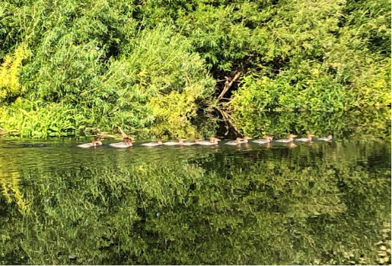Sitting by the River Swale recently I was fortunate enough to see a family of seventeen Goosanders swim by. The youngsters were the same size as the female and by doing a bit of research on the computer I learnt that a normal clutch size is 8-11 but 4-22 is also known! (So this one with 16 young has done well.) Another interesting point is that, although British birds are residents, the male of the species goes to Norway to moult and then returns which explains why there was no male present with the group.

When I take my morning walk, it is now noticeably quieter than earlier in spring with fewer small birds singing from the hedgerows and trees but I have been fortunate to see kingfishers flying up and down the Swale, to see and hear buzzards flying above Topcliffe, to see yellowhammers, goldfinches and skylarks as I walk down the old Cundall Lane together with curlew, oystercatchers and lapwing over the fields near the confluence of the Swale and Cod Beck. Of the 67 birds Red-listed in the UK (the Red List is a list of birds in the UK, Channel Islands and the Isle of Man in most urgent need of our help). I have seen 11 different species whilst walking around Topcliffe during June.

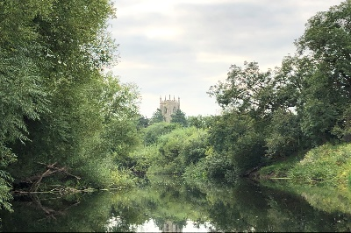I suppose my walks have reminded me, if it were needed, that conservation is not something new but under the heading of good stewardship was fundamental to how the Old and New Testament require us to manage the land not only for ourselves but for the whole of creation.

We can misunderstand the message of creation-care and creation’s redemption if we are not careful but some of the most famous verses in the Bible teach it. For example, John 3:16-17 says, ‘For God so loved the world, that he gave his only begotten Son, that whosoever believeth in him should not perish, but have everlasting life. For God sent not his Son into the world to condemn the world; but that the world through him might be saved.’ The word ‘world’ is the word ‘cosmos’ and it refers to all of the created order.

In creation we are intrinsically linked to the land and all living creatures. The prophet Hosea (4:1-3, NRSV) says ‘Hear the word of the Lord, O people of Israel; for the Lord has an indictment against the inhabitants of the land. There is no faithfulness or loyalty, and no knowledge of God in the land. Swearing, lying, and murder, and stealing and adultery break out; bloodshed follows bloodshed. Therefore, the land mourns, and all who live in it languish; together with the wild animals and the birds of the air, even the fish of the sea are perishing.’ Our actions and mistakes don’t only affect humanity.

But with the story of Christ, we see a new understanding of creation unfold and a change in the drama of the story. In Jesus, God is putting all of the cosmos back together. To make the cross of Jesus just about human salvation is to miss that God is interested in saving everything. Every star and rock and bird. All things.

Should we, the church, sit back and just wait for this restoration to occur? Do we have license to do whatever we will with God’s creation since God is ultimately in control? I don’t think so.

If God saw his creation as good, then we should see it as good as well. If the creation is valuable to God, then we should value it as well. If Christ was willing to sacrifice himself, not just for us, but for the restoration of all things, should we not be committed to the same goal?

I think we are all hearing the message of the ‘green agenda’ and we should be doing our part to reduce global warming. The basic message of Reduce waste, Reuse, and Recycle, buy Energy-Efficient Products when we replace household items and consider the impact of our purchases is a good place to start. However, it is important that we also become ‘informed stewards’ by which I mean that few ideas for ‘saving the planet’ are all positive and we need to think carefully about the full implications of our actions both on people throughout the world and the natural world.

Planting trees to take up carbon may be a good idea when the trees are planted in the right places but when we plant woodland on moorland or rough pasture we displace the animals, birds and insects which require tree-scarce areas to thrive. The curlew, lapwings and oystercatchers are directly threatened by the re-wilding of the Yorkshire Dales and Scottish Highlands. Trees in the wrong places can cause their own problems.

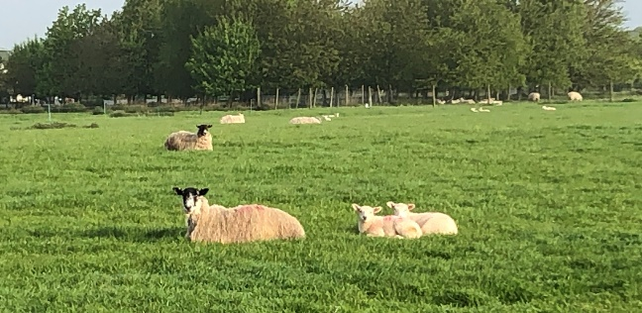Reducing our consumption of meat, especially intensively farmed meat, may be beneficial to the planet and our own health but the swallows flitting over the fields of livestock are not there because of the scenery but because the cattle and sheep grazing there help generate the flies on which the swallows and swifts exist. If there is no livestock in the fields, then the populations of many insect eating birds such as skylarks, swallows, swifts and the young of the grey partridge will suffer. As always, simple answers to any problem, in this case the climate crisis are rarely as good as they first appear.

The Bible teaches us that Christ has created the universe, gives it life and sustains it, and has reconciled everything to God, so our actions should participate in Christ’s creating, sustaining, and reconciling work.

**St Swithin – feast day 15th July**

St. Swithun (or Swithin in Old English) was Bishop of Winchester from his consecration on 30th October 852 until his death on 2nd July 863 (or 862 depending upon which authority is to be believed). However, he is scarcely mentioned in any document of his own time other than he is recorded as a witness to nine charters.

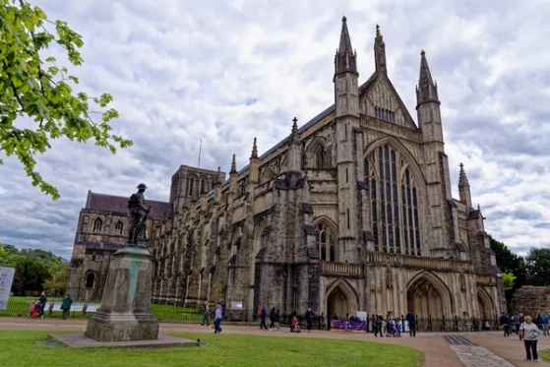More than a hundred years later, when Dunstan and Æthelwold of Winchester were inaugurating their church reform, Swithun was adopted as patron of the restored church at Winchester, formerly dedicated to St. Peter and St. Paul. Swithun was initially buried out of doors, rather than in his cathedral, apparently at his own request. William of Malmesbury recorded that the bishop left instructions that his body should be buried outside the church where it might be subject to the feet of passers-by and to the raindrops pouring from on high. His body was transferred to Æthelwold's new basilica on 15th July 971. According to contemporary writers, numerous miracles preceded and followed the move. The revival of Swithun's fame gave rise to a lot of legendary literature most of which contains little biographical fact. Swithun's best-known legendary miracle was his restoration on a bridge of a basket of eggs that workmen had maliciously broken.

St. Swithun is about the only saint whose feast day is known by the majority of the British population together with the legend that it will rain for forty more days if it is raining then:

St. Swithun's day if thou dost rain

For forty days it will remain St. Swithun's day if thou be fair For forty days 'twill rain nae mare

It is possible that the legend springs from a particularly heavy rainstorm on Saint Swithun’s Day in 1315, coupled with St Swithun’s supposed posthumous miracles.

However, the superstition may have evolved from pagan observations around the changing weather of the Midsummer period. This can be explained today by the patterns of the wind currents bringing weather fronts across the British Isles, known as jet streams. When the jet stream falls to the north of Britain, high pressure systems (usually associated with clear skies and calm weather) are able to move in. In contrast, when the jet stream lies over or beneath the British Isles, arctic air and low-pressure weather systems are more common and bring cloudy, rainy and windy weather. About this time of year, the position of the jet stream has historically remained constant for some period of time, which was no doubt observed by our ancestors.

**Richard Byas**

We all have to do our part for the environment. And there are many different ways one can save energy. I normally use the couch.



**Baldersby St James News**

**Drop in and Chat**

Our Tuesday morning drop in from 10am until 12 noon remains very popular, so a warm welcome to anyone who has not been before.

**Organist/Pianist**

We are still looking for a musician to play on the first and third Sundays of each month for the 10.45am service. Please contact Rosemarie Carter on 01765 640360.

**Book Sale**

**The Book Sale is on Saturday 10th and Sunday 11th September –** open from 10am to 5pm each day. If anyone has books to donate for the sale just drop them into the church. We will need lots of helpers from Thursday 8th to put out books, and on Sunday to tidy up. Details will be in the August and September magazine.

**Susan Brown**

**Dalton Events**

**Results of the 120 Club for May**

£15 Janice Smith (No.1); £10 Anne Barton (No.91); £6 John Dale (No.60)

**Results of the 120 Club for June**

£15 John Hall (No.5); £10 Jack & James Hudson (No.112); £6 Olivia Spence (No.46)

**Domino Drive**

There will be Domino Drives in the village hall on Saturday 23rd July at 7pm, and on Saturday 30th July at 7pm. Everyone welcome.

**Dalton Village Gala**

The Village Gala is on Saturday 16th July, from 2pm to 5pm. There will be children’s races, a photograph competition, and various stalls etc. Entry is free. All welcome. More details on Dalton Village Facebook page.

**Sylvia Binks**

**PARISH DIRECTORY**

**The Parishes of Topcliffe, Baldersby with Dishforth, Dalton and Skipton on Swale**

There is currently no Vicar of the parishes. Until one is appointed, please ring our Area Dean,

The Revd Fiona Mayer-Jones tel: 07450 402953 or [revdfmj@gmail.com](mailto:revdfmj@gmail.com) until 24th July.. Revd Mary Rolls will be commissioned as Area Dean on 25th July.

**BALDERSBY with DISHFORTH** - PCC Secretary: Mrs Jennifer Wharton [wharton370@btinternet.com](mailto:wharton370@btinternet.com)

**DALTON** - PCC Secretary: Mrs Hannah Bissett tel: 07739 382831 [spannerb79@gmail.com](mailto:spannerb79@gmail.com)

**SKIPTON-on-SWALE** – PCC Secretary: Mr Alan Kitching tel: 01845 567457

**TOPCLIFFE** – PCC Secretary: Mrs Roz Norris [RozNorris@aol.com](mailto:RozNorris@aol.com)