**Benefice Online Magazine**

**for the Parishes of Topcliffe, Baldersby with Dishforth, Dalton and Skipton on Swale**

 Cross Talk

**September 2022**

Cross Talk is published monthly by email. To receive a copy please contact [kitnorris@live.co.uk](mailto:kitnorris@live.co.uk)

Cross Talk contains the weekly Collect and Readings together with details of Church services in the Benefice and news and items of interest supplied by our readers. The magazine will also be available on the web sites: www.achurchnearyou.com/church/3447 and baldersbychurch.com.

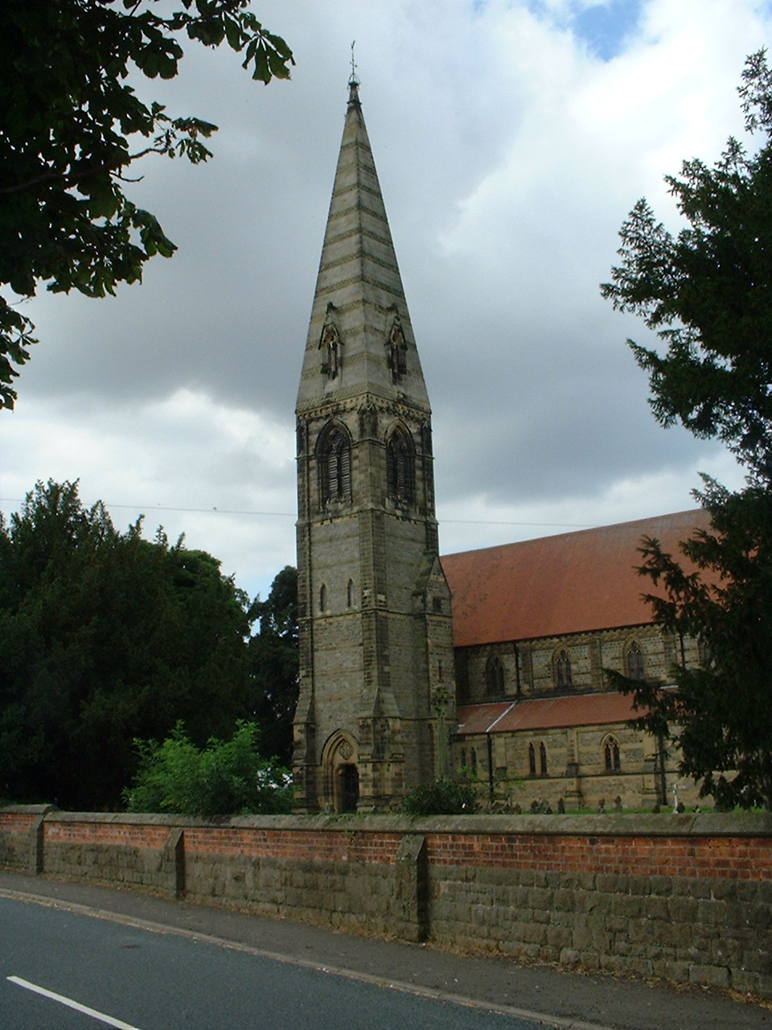**CHURCH SERVICES**

**St. James’ Church, Baldersby St. James with Dishforth and Rainton**

**Sunday 4th September, 10.45am Communion Service** *followed by refreshments.*

**Sunday 11th September No Service *(****Book Sale taking place)*

Sunday 18th September, 10.45am **Communion Service** *followed by refreshments.*

Sunday 25th September, 9.30am Morning Service *followed by refreshments*

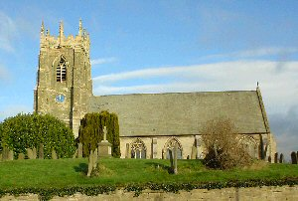**St. Columba’s Church, Topcliffe**

*Corporate Member of the Prayer Book Society*

**Sunday 4th August, 6.30pm Choral Evensong** *with* *hymns*

**Sunday 11th September, 10.45am Holy Communion** *with hymns*

*followed by refreshments*

**Sunday 18TH September, 10.45am Said Matins** *followed by refreshments*

**Sunday 25th September, 10.45am Holy Communion** *with hymns*

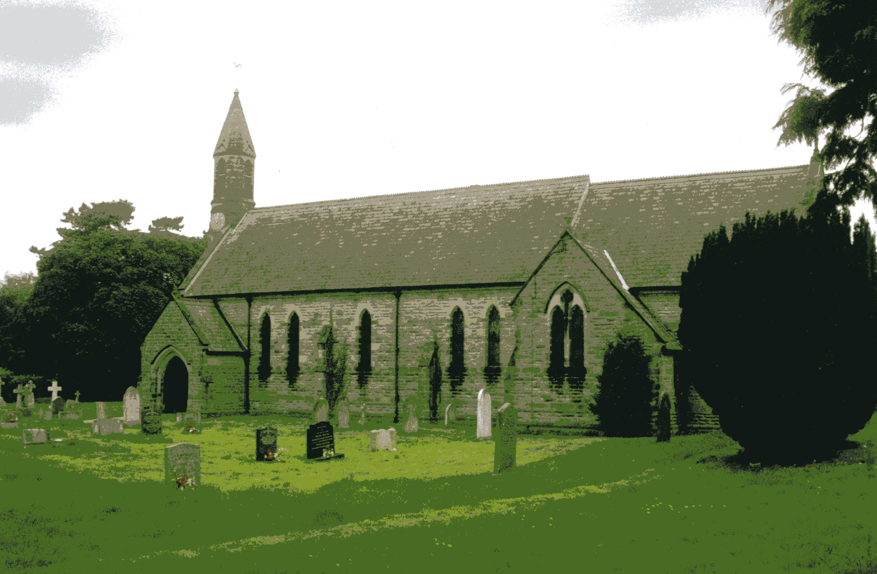 *followed by refreshments*

**St John the Evangelist Church, Dalton**

**Sunday 4th September, 11am Holy Communion**

**Friday 16th September, 7pm Harvest Festival and Supper**

**Sunday 18th September No Service**

**St John’s Church, Skipton on Swale**

**Sunday 18th September, 4pm Final Service with Bishop Paul Ferguson**

***Sadly St John’s Church is holding its final service before officially closing on 1st October. Bishop Paul will be leading the service. Everyone is welcome to join Skipton for one last service commemorating the life of this church and the many people who have worshipped there over the years. Refreshments will be served after the service. See also the article on pages 6-7.***

**Baldersby St James News** is listed on page 8.

**Dalton Social Events** are listed on page 8. **Readings for 12th Sunday after Trinity to 15th Sunday after Trinity**

*(Page numbers refer to the Common Worship Lectionary.)*

**Sunday 4th September : 12th Sunday after Trinity**

**Collect**

Almighty and everlasting God,

you are always more ready to hear than we to pray

and to give more than either we desire or deserve:

pour down upon us the abundance of your mercy,

forgiving us those things of which our conscience is afraid

and giving us those good things

which we are not worthy to ask

but through the merits and mediation

of Jesus Christ your Son our Lord,

who is alive and reigns with you,

in the unity of the Holy Spirit,

one God, now and for ever.

**Readings (p.1032) – Proper 18, Related**

Deuteronomy 30.15-20

Psalm 1

Philemon.1-21

Gospel: Luke 14.25-33

**Sunday 11th September : 13th Sunday after Trinity**

**Collect**

Almighty God,

who called your Church to bear witness

that you were in Christ reconciling the world to yourself:

help us to proclaim the good news of your love,

that all who hear it may be drawn to you;

through him who was lifted up on the cross,

and reigns with you in the unity of the Holy Spirit,

one God, now and for ever.

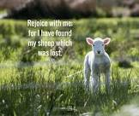**Readings (p.1037) – Proper 19, Related**

Exodus 32.7-14

Psalm 51.1-11

1 Timothy 1.12-17

Gospel: Luke 15.1-10

**Sunday 18th September : 14th Sunday after Trinity**

**Collect**

Almighty God,

whose only Son has opened for us

a new and living way into your presence:

give us pure hearts and steadfast wills

to worship you in spirit and in truth;

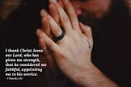through Jesus Christ your Son our Lord,

who is alive and reigns with you,

in the unity of the Holy Spirit,

one God, now and for ever.

**Readings** (**p.1042**) - **Proper 20, Related**

Amos 8.4-7

Psalm 113

1 Timothy 2.1-7

Gospel: Luke 16.1-13

**Sunday 25th September : 15th Sunday after Trinity**

**Collect**

God, who in generous mercy sent the Holy Spirit

upon your Church in the burning fire of your love:

grant that your people may be fervent

in the fellowship of the gospel

that, always abiding in you,

they may be found steadfast in faith and active in service;

through Jesus Christ your Son our Lord,

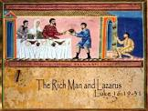who is alive and reigns with you,

in the unity of the Holy Spirit,

one God, now and for ever.

**Readings** (**p.1048**) **– Proper 21, Related**

Amos 6.1a, 4-7

Psalm 146

1 Timothy 6.6-19

Gospel: Luke 16.19-31

**September Reflection, 2022**

We all plan our prayer life in different ways. Possibly we use daily set prayers that we extend to include current areas of concern such as the war in Ukraine or people we know that are ill. A useful resource for prayer topics can be the many ‘International Days’ when we are asked to support a particular concern. Some are maybe relevant to only a limited number of people such as September 17th which is International Country Music Day (it is also International Red Panda Day) but others may have a greater relevance to our personal prayer diaries such as 5th September which is the International Day of Charity, the 12th September which is the UN Day for South-South Cooperation, the 15th September which is the International Day of Democracy and the 21st September which is the International Day of Peace.

Christian Aid has highlighted these four dates in September, for those of us who support its aims, to offer prayers in support of the aims of those days. We are asked to offer prayers as follows:

5th September - pray for the work of Christian Aid to bring significant, positive change in the lives of many around the world.

12th September - pray for good cooperation and shared learning between Christian Aid’s partners across countries in the global south.

15th September - pray for the governance work of Christian Aid’s partners calling those in political authority to account.

21st September - pray for courage and breakthrough for Christian Aid’s partners working to build peace in contexts of violence

Many of the world’s problems hit the headlines for only a few days (if at all) before being replaced by newer headlines but the problems and their aftermath can continue for many years and get little or no publicity in our national press. However, for charities such as Christian Aid, their commitment to help those in need continues, as does their need for donations to continue their work.

At present Christian Aid has five special emergency appeals trying to raise money in addition to their ‘routine’ world to help support the world’s poor.

These appeals are:

**East Africa Hunger Crisis Appeal.** After the worst drought in 40 years, millions of people across East Africa are facing the threat of famine. The severe conditions are being made worse by the climate crisis and the COVID-19 pandemic. Now, Russia’s invasion of Ukraine has amplified an increase in global food prices that has turned a tough situation into a dire crisis.

**Ukraine Humanitarian Appeal**. Over 5.2 million people have fled their homes as conflict intensifies in Ukraine. Since the Russian Federation launched a military offensive against Ukraine on 24 February 2022, at least 2,435 civilians have been killed and 2,946 injured. This is the fastest growing refugee crisis since World War II. An additional 7.7 million people have been displaced internally within Ukraine and over 12 million more have been affected in the areas hardest hit by the war.

**Afghanistan Crisis Appeal.** People are starving in Afghanistan. with more than 8 million on the brink of famine. Drought, the war in Afghanistan and the Covid-19 pandemic are causing a catastrophic rise in hunger. Children are dying today, and a million more under the age of five are at risk of dying over the next three months.

**Haiti Earthquake Appeal.** On Sunday 14th August, a 7.2-magnitude earthquake struck Haiti at Les Cayes, 75 miles west of the capital of Port-au-Prince. On Tuesday 16th August, Tropical Storm Grace, flash floods and mudslides caused further devastation on the island.To date the earthquake has claimed more than 2,200 lives, injured almost 12,000 people and destroyed 130,000 homes. At least 344 people are still missing. Families are seeking safety wherever they can with nothing but the clothes on their backs.People who have lost everything need emergency shelter, food, drinking water and access to healthcare.

**Coronavirus Emergency Appeal** Across the world, and especially in India, the most marginalised have been hit the hardest. From women and people with disabilities to informal and migrant workers and Dalit communities. They need soap, masks and hand sanitiser which are vital weapons against coronavirus. In India alone, more than 200,000 lives have been lost to the pandemic. Across the country, hospitals are overrun, and oxygen supplies are falling short of demand.

**Christian Aid** is just one charity we may wish to add to our prayer diary on 5th September which is the International day of Charity.

It is right that we should love our neighbours by considering celebrations and problems outside our own experience. Checking the dates of International Days for each month on our computers (even thinking about those that appear to be more light-hearted) is just one way of expanding our prayer diaries and maybe prompting us to support a cause of which we previously had little or no knowledge.

**Richard Byas**

For what we are about to receive

For what we are about to receive

The water we drink

The air we breathe

The fire of sun

The food of earth

This company. These people

This now. This here

May we be thankful

May we be aware

How every day is a gift

And every breath a prayer. *Martin Wroe*

**Money Goes To Church**

A well-worn pound note and a similarly distressed twenty-pound note arrived at the Bank of England to be retired. As they moved along the conveyor belt to be burned, they struck up a conversation.

The twenty-pound note reminisced about its travels all over the county. "I've had a pretty good life," the twenty proclaimed. "Why, I've been to the finest restaurants in London, performances at top theatres, and holidays at the best hotels in the country."

"Wow!" said the pound note. "You've really had an exciting life!"

"So tell me," says the twenty, "where have you been throughout your lifetime?"

The pound note replies, "Oh, I've been to the local Anglican Church, the Methodist Church, the Baptist Church, ...."

The twenty-pound note interrupts, "What's a church?"



**Richard Byas**

**Opening of the New Church at Skipton Bridge, 1842**

“On Tuesday, 22nd November, 1842, the ceremony of consecrating the new church at Skipton Bridge was performed by the Lord Bishop of Ripon, who officiated for his Grace the Archbishop of York. Notwithstanding the unfavourable weather, all the neighbouring clergy attended. There was a highly respectable congregation to witness the ceremony. After an eloquent and impressive sermon by the Rev. S. Coates, incumbent of Thirsk, from the second chap. of Isaiah, and part of the third verse, a collection was made in aid of the endowment, amounting to £36 7s 2d.

Skipton Bridge Church has been almost entirely built owing to the munificence of the Miss Elsleys, who, renting a house in the place, were determined, if possible, to remedy the evil of the inhabitants of Baldersby and Skipton being unable (from the distance of the parish church of Topcliffe) ever to enter a place of worship. We regret to add that no aid has been obtained from the Duke of Devonshire in the promotion of this desirable objective, though repeated applications have been made to His Grace on the subject, he being the principal proprietor of the parish. The altar window of stained glass was presented by Sir Robert and Lady Frankland Russell, and was executed by their daughters.”

*Yorkshire Gazette, November 26, 1842*

**Notes:**

*1. The ELSLEY family*

Elizabeth and Mary ELSLEY were respectively the eldest and youngest daughters of Revd Heneage ELSLEY, of Mount St. John, Felixkirk, who was for 45 years Vicar of Burneston until his death in 1832. Their maternal grandfather was Revd Heneage DERING, Dean of Ripon from 1711 to 1750.

With their sister Frances the two sisters lived locally for a number of years, and worked tirelessly to build the church and its adjacent Parsonage. All three sisters are buried in the churchyard and are commemorated by tablets in the nave; Mary is named as the “originator and assiduous promoter of the erection and endowment of this church”, and Elizabeth is remembered for her gift of £1000 towards the project.

*2. The FRANKLAND RUSSELL family*

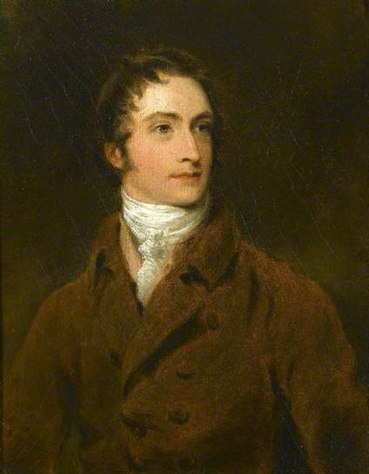Sir Robert Frankland RUSSELL (1784-1849), 7th Baronet, was born at Thirkleby Hall, near Thirsk, the only child of Sir Thomas FRANKLAND to survive to adulthood. He was elected M.P. for Thirsk in 1815, the year also of his marriage to Louisa Anne, daughter of Lord George MURRAY, Bishop of St. David’s Cathedral. Sir Robert succeeded to his title on the death of his father in 1831, but adopted the name RUSSELL in 1836 on inheriting property under the terms of the will of Sir Robert Greenhill RUSSELL, his cousin and also his predecessor in the House of Parliament. Sir Robert was appointed High Sheriff of Yorkshire in 1838.

Sir Thomas and in turn Sir Robert were patrons of the arts and Robert was himself a talented artist in watercolours. He studied painting for a time with Sir Thomas Lawrence, and his ability may be judged by the charming portraits he painted of himself, (*illustrated left*) his father, and three of his five young daughters. These young ladies appear to have followed in their father’s artistic footsteps, though further investigation is required to confirm whether they were responsible purely for endowing and commissioning the altar window at St. John’s, or for the actual design and construction of the stained glass panels.

*3. William George Spencer CAVENDISH, 6th Duke of Devonshire, the “Bachelor Duke”*

At the time St. John’s church was being planned and built, William Cavendish was Lord of the Manor and owner of the Baldersby estate, then, like Skipton, part of the ancient parish of Topcliffe and likewise without its own place of worship. He had inherited his title from his father in 1811 along with vast estates and a number of stately homes. The rather barbed reference in the newspaper item to the failure of the Duke of Devonshire to provide any contribution to the building of the new church is perhaps a sly dig at the straitened circumstances – and questionable priorities - of the 6th Duke. This had arisen in part as a result of his mother’s extravagant gambling habits: during her lifetime Lady Georgiana amassed enormous debts, occasionally losing friends through her failure to repay their loans, and at her death her heirs faced the daunting and lengthy task of repaying her often unacknowledged debts and restoring the family’s reputation. The Duke himself also spent many years rebuilding and refurbishing his estates and gardens – especially Chatsworth House and the nearby village of Edensor, on which he lavished vast sums. This constant drain on the family finances eventually led inevitably to the sale of several large landholdings, manors and estates, among them Londesbrough and Baldersby, which were both sold in 1845 to George Hudson, the “Railway King”.

*4. Revd William SWEETING*

The first clerical appointment to the new church was Reverend William SWEETING. He was a Bedale man by birth, the eldest son of a linen and woollen draper in the town. Having graduated from Trinity College, Dublin, he later studied at Durham for a License in Theology and was ordained at Bishopthorpe Palace in 1842. In August 1850 Revd Sweeting married Caroline, daughter of the late Joseph DRESSER, who had been a prosperous miller in Topcliffe and co-founder of the Thirsk Bank. Revd SWEETING and his wife had no children, but lived at the Parsonage for many years, supported by a succession of domestic helpers. His memorial states simply that Revd Sweeting was the first incumbent of the church; he was in fact Perpetual Curate of the new parish from his appointment until his death at the age of 61. He died on 18th December 1873 and is buried in the churchyard of the little church he steered on its course for 30 years.

**Roz Norris**

**Baldersby St James News**

**COFFEE and CHAT**

Drop in every Tuesday morning between 10am until 12 noon.

**MUSIC AT JUNCTION 50**

Thursday 1st September at 7pm. We welcome Sirocco Winds – three young professional musicians playing the flute, clarinet and bassoon. Tickets £10. Pay on the door or collect from The Good Food Shop in Baldersby. To reserve tickets contact Colin Reid, tel: 07770620897.

**BOOK SALE**

**The Book Sale is on Saturday 10th and Sunday 11th September** from 10am to 5pm each day. Free entry. Helpers are needed to put out books on Thursday 8th / Friday 9th prior to the event and set out tables etc on the Wednesday evening. If you can help please contact Stuartt/Rosemarie on 01765 640360, e-mail: [carter-stuart@btconnect.com](mailto:carter-stuart@btconnect.com) for further details.

**Susan Brown**

**Dalton Events**

**120 Club August six months result**

£100 G & R Balderston (No.9); £50 Linda Dallinson (No.102); £30 Doris Jackson (No.29); Olivia Spence (No.46); £6 Michaela Kitching (No.82).

**Pop-Up Cafe**

On Saturday 24th September from 9.30am until 11.30am there will be a Pop-Up Cafe in the Village Hall. There will be bacon and sausage sandwiches and cups of tea and coffee on sale. As an extra, there will be a free training session on the use of the defibrillator taking place in the committee room.

**80s Evening**

There will be an 80s evening with disco and fancy dress on Saturday 1st October from 7pm in the village hall. Tickets are £5 available from Eleanor on 07841.

**Domino Drive**

A Domino Drive will be held in the village hall on Saturday 24th September at 7pm. All welcome. Proceeds will be in aid of church funds.

**Harvest Service and Supper**

Our Harvest Service and Supper will be on Friday 16th September at 7pm.

**Annual Vintage Teas**

On Saturday 17th September we will be holding our Annual Vintage Teas in church from 2pm until 4pm. Everyone is welcome to come along and enjoy a cup of tea or coffee with sandwiches and cakes.

**PARISH DIRECTORY**

**The Parishes of Topcliffe, Baldersby with Dishforth, Dalton and Skipton on Swale**

There is currently no Vicar of the parishes. Until one is appointed, please contact our Area Dean,

Revd Mary Rolls, tel: 01845 400480 email: revmaryrolls@gmnail.com.

**BALDERSBY with DISHFORTH** - PCC Secretary: Mrs Jennifer Wharton [wharton370@btinternet.com](mailto:wharton370@btinternet.com)

**DALTON** - PCC Secretary: Mrs Hannah Bissett tel: 07739 382831 [spannerb79@gmail.com](mailto:spannerb79@gmail.com)

**SKIPTON-on-SWALE** – PCC Secretary: Mr Alan Kitching tel: 01845 567457

**TOPCLIFFE** – PCC Secretary: Mrs Roz Norris [RozNorris@aol.com](mailto:RozNorris@aol.com)