**Benefice Online Magazine**

**for the Parishes of Topcliffe, Baldersby with Dishforth, Dalton and Skipton on Swale**

 Cross Talk

**November 2022**

Cross Talk is published monthly by email. To receive a copy please contact [kitnorris@live.co.uk](mailto:kitnorris@live.co.uk)

Cross Talk contains the weekly Collect and Readings together with details of Church services in the Benefice and news and items of interest supplied by our readers. The magazine will also be available on the web sites: www.achurchnearyou.com/church/3447 and baldersbychurch.com.

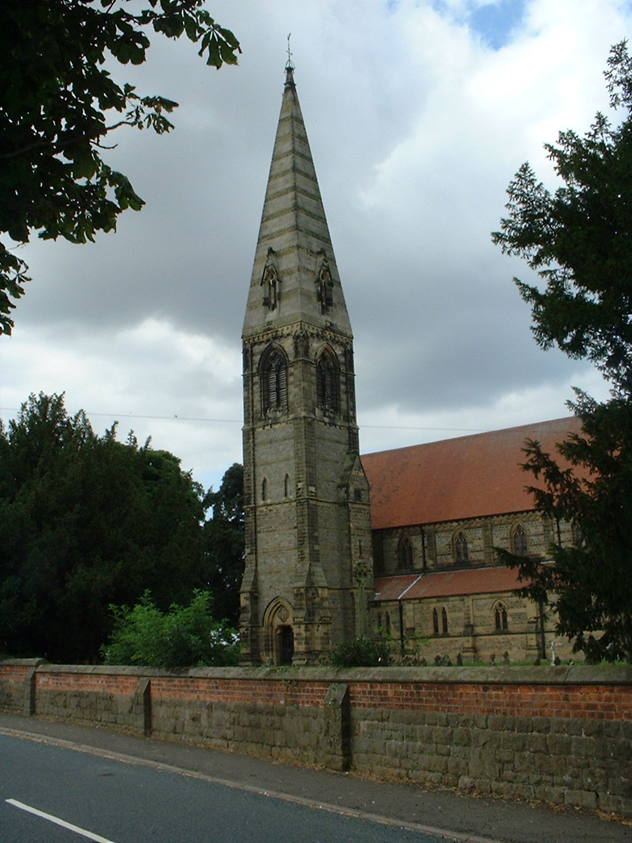**CHURCH SERVICES**

**St. James’ Church, Baldersby St. James with Dishforth, Rainton**

**and Skipton on Swale**

**Sunday 6th November, 10.45am Holy Communion** *followed by refreshments.*

**Sunday 13th November, 9.30am Breakfast Service** *with Coffee and Croissants*

**Sunday 20th November, 10.45am**  Holy **Communion** *followed by refreshments.*

**Sunday 27th November, 9.30am** Morning Service *followed by refreshments*

**St. Columba’s Church, Topcliffe**

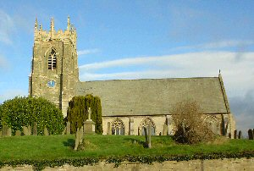*Corporate Member of the Prayer Book Society*

**Wednesday 2nd November, 7pm Compline for the Feast of All Souls**

*with commemoration of the departed*

**Sunday 6th November, 6.30pm Choral Evensong**

**Sunday 13th November, 10.45am Service of Remembrance**

**11.45am Holy Communion with Baptism**

*- Revd Robert Williamson*

*followed by refreshments*

**Sunday 20th November, 10.45am Choral Matins** *followed by refreshments*

**Sunday 27th November, 10.45am Advent Sunday Holy Communion** *with hymns*

*- Revd Robert Williamson*

*followed by refreshments*

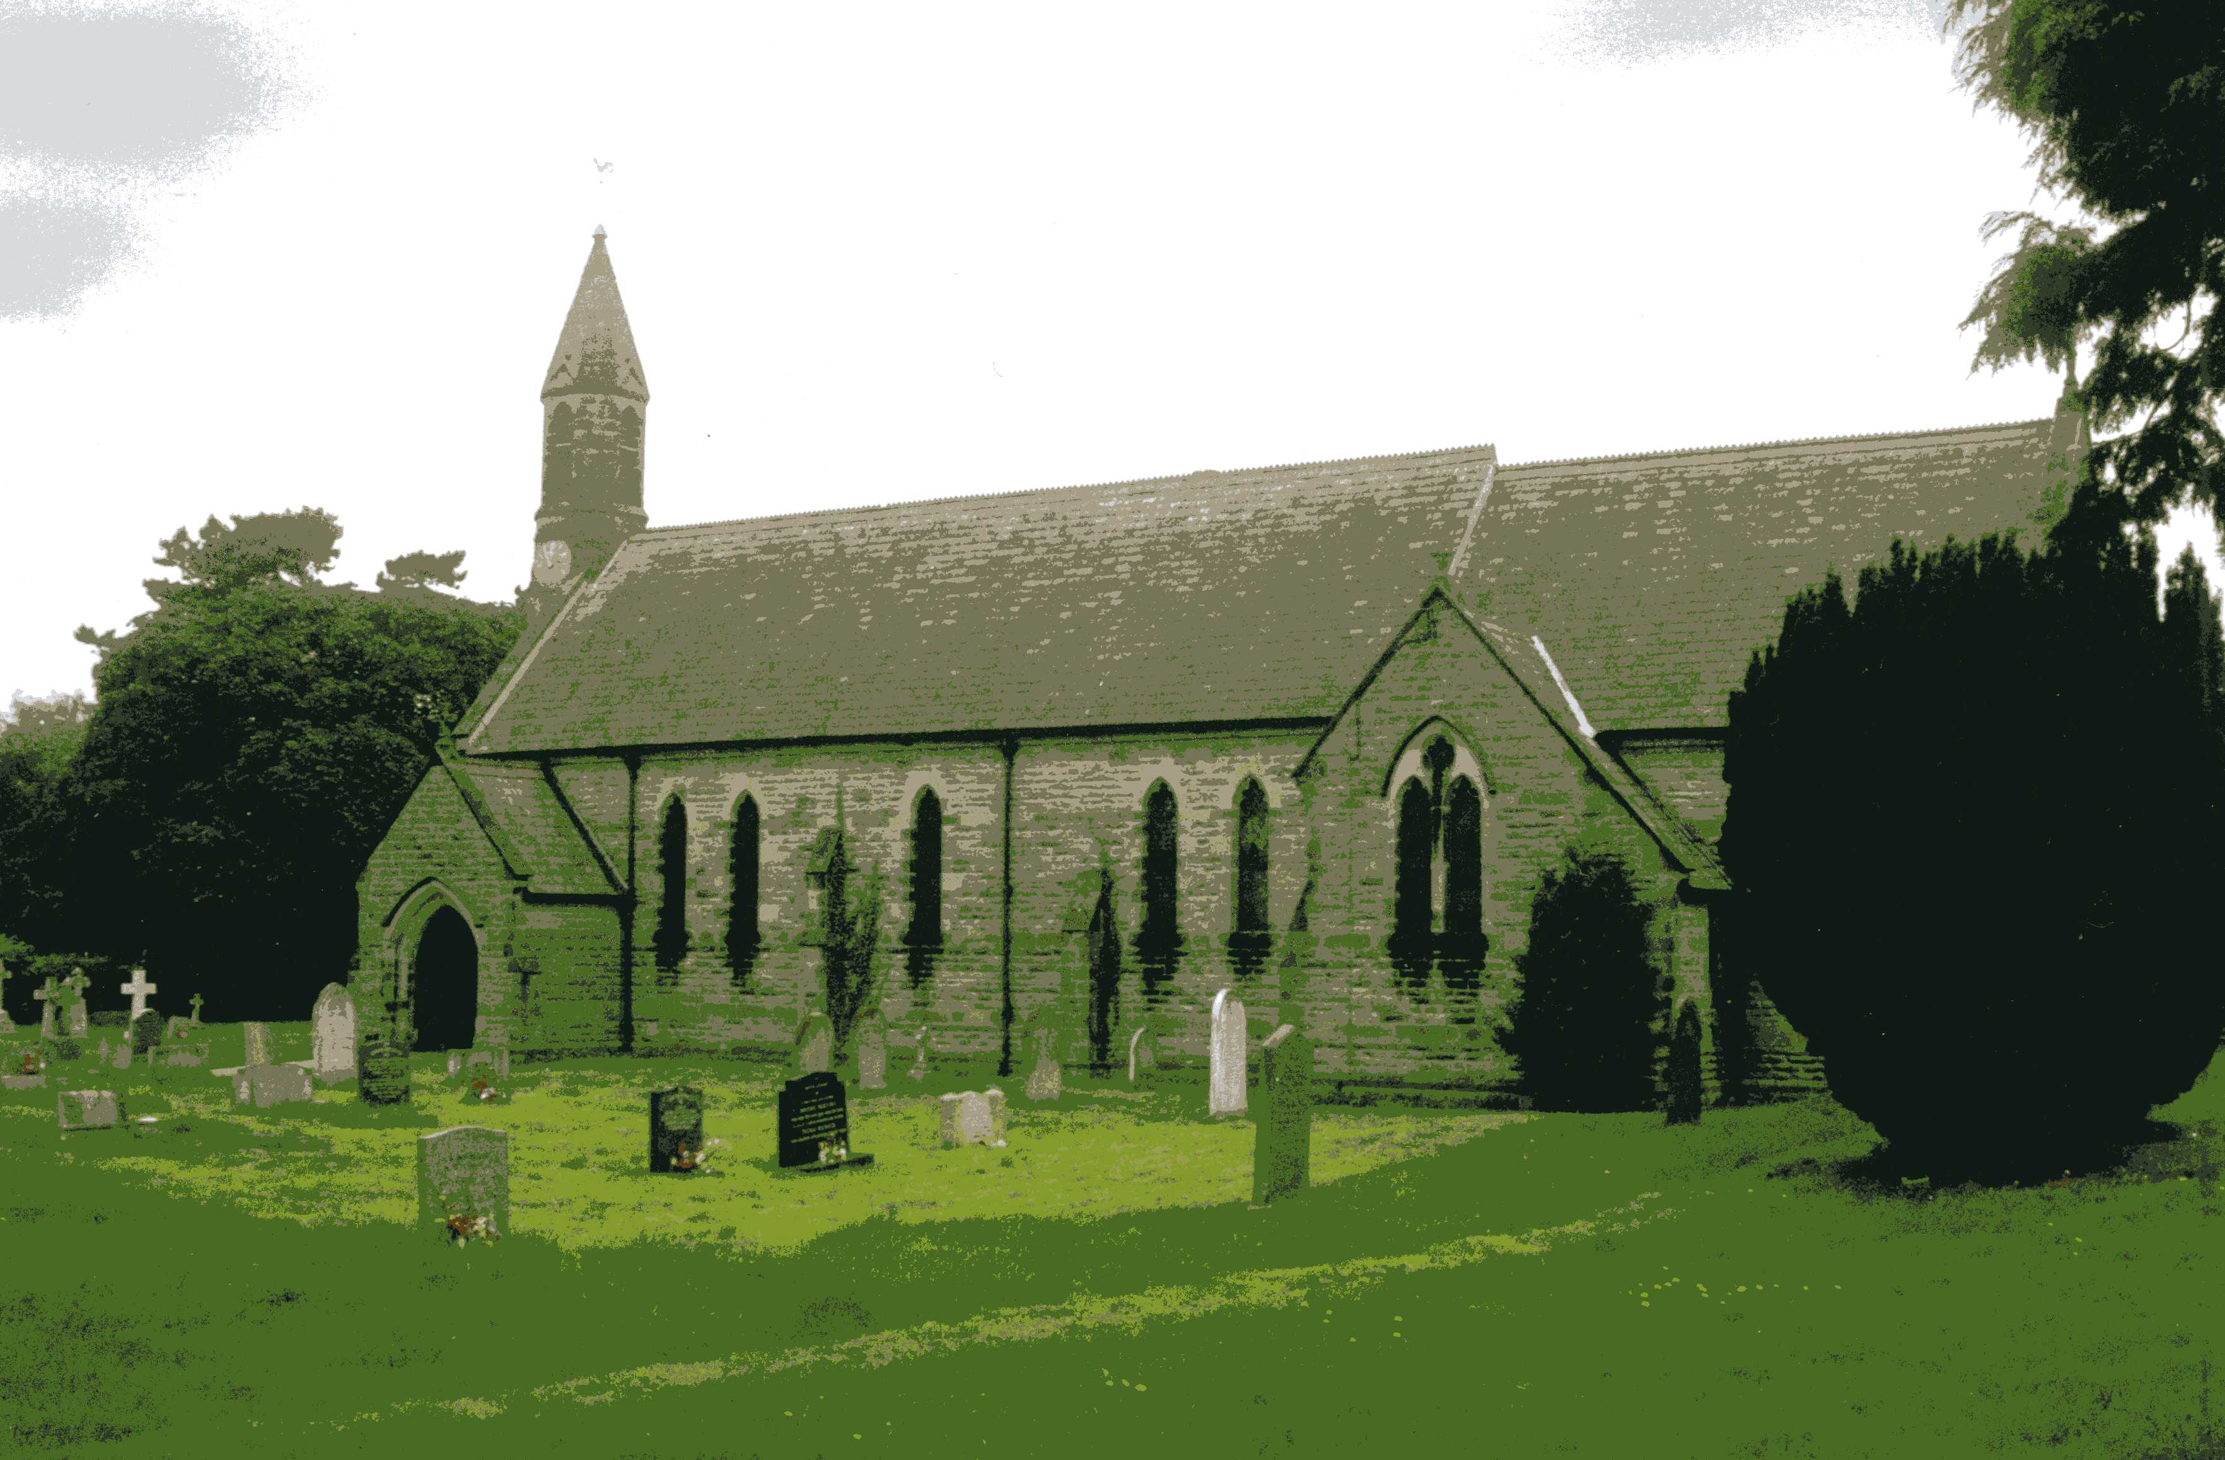

**St John the Evangelist Church, Dalton**

**Sunday 6th November, 11am Holy Communion**

**Baldersby St James News** is listed on page 6.

**Dalton Social Events** are listed on pages 6 and 7.

**Topcliffe St Columba News** see page 7

**Readings for 3rd Sunday before Advent to 1st Sunday of Advent**

*(Page numbers refer to the Common Worship Lectionary.)*

**Sunday 6th November : 3rd Sunday before Advent**

**Collect**

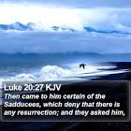Almighty Father,

whose will is to restore all things

in your beloved Son, the king of all:

govern the hearts and minds of those in authority,

and bring the families of the nations,

divided and torn apart by the ravages of sin,

to be subject to his just and gentle rule,

who is alive and reigns with you,

in the unity of the Holy Spirit,

one God, now and for ever.

**Readings (p.1080)**

Job 19.23-27a

Psalm 17.1-8, [9]

2 Thessalonians 2.1-5, 13-17

Gospel: Luke 20.27-38

**Sunday 13th November : Remembrance Sunday, 2nd Sunday before Advent**

**Collect**

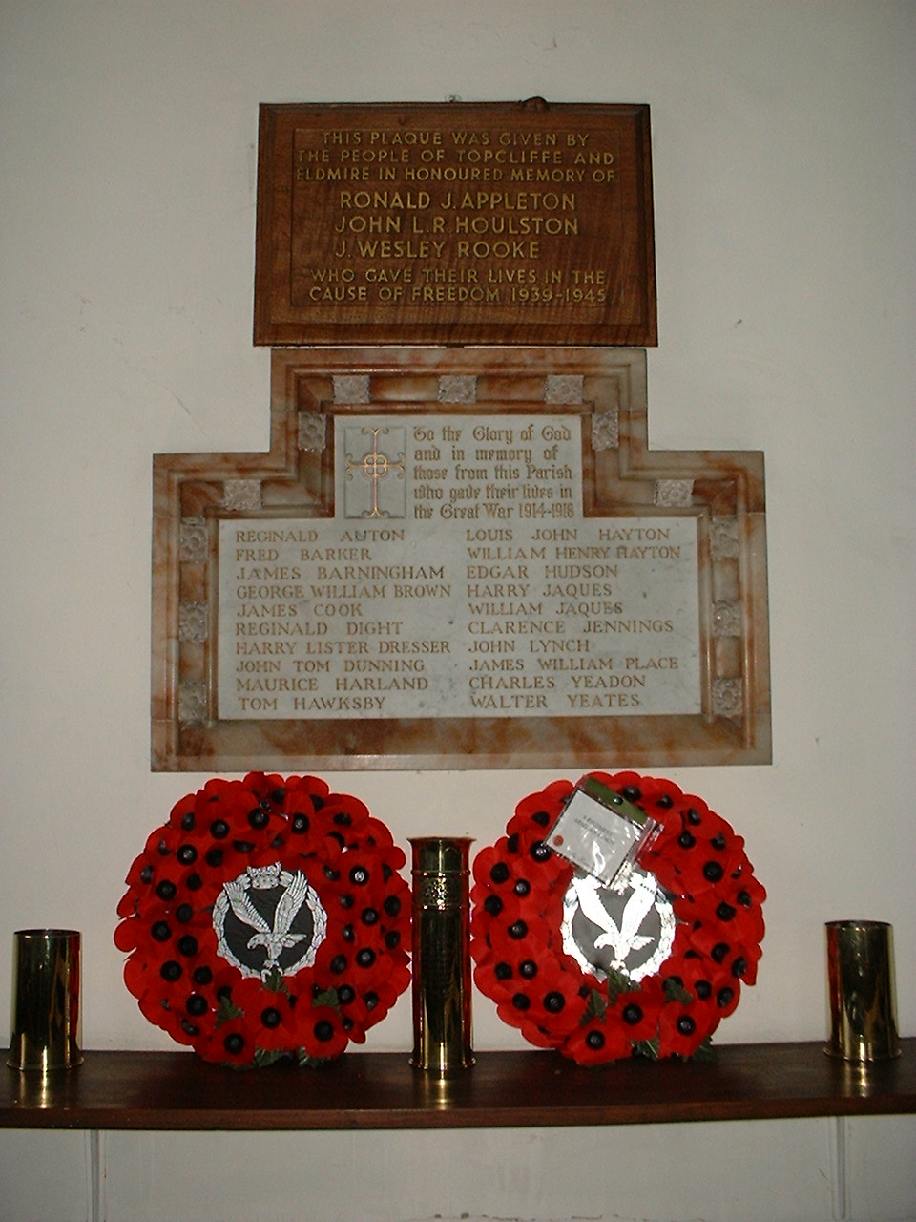Heavenly Father,

whose blessed Son was revealed

to destroy the works of the devil

and to make us the children of God and heirs of eternal life:

grant that we, having this hope,

may purify ourselves even as he is pure;

that when he shall appear in power and great glory

we may be made like him

in his eternal and glorious kingdom;

where he is alive and reigns with you

in the unity of the Holy Spirit,

one God, now and for ever.

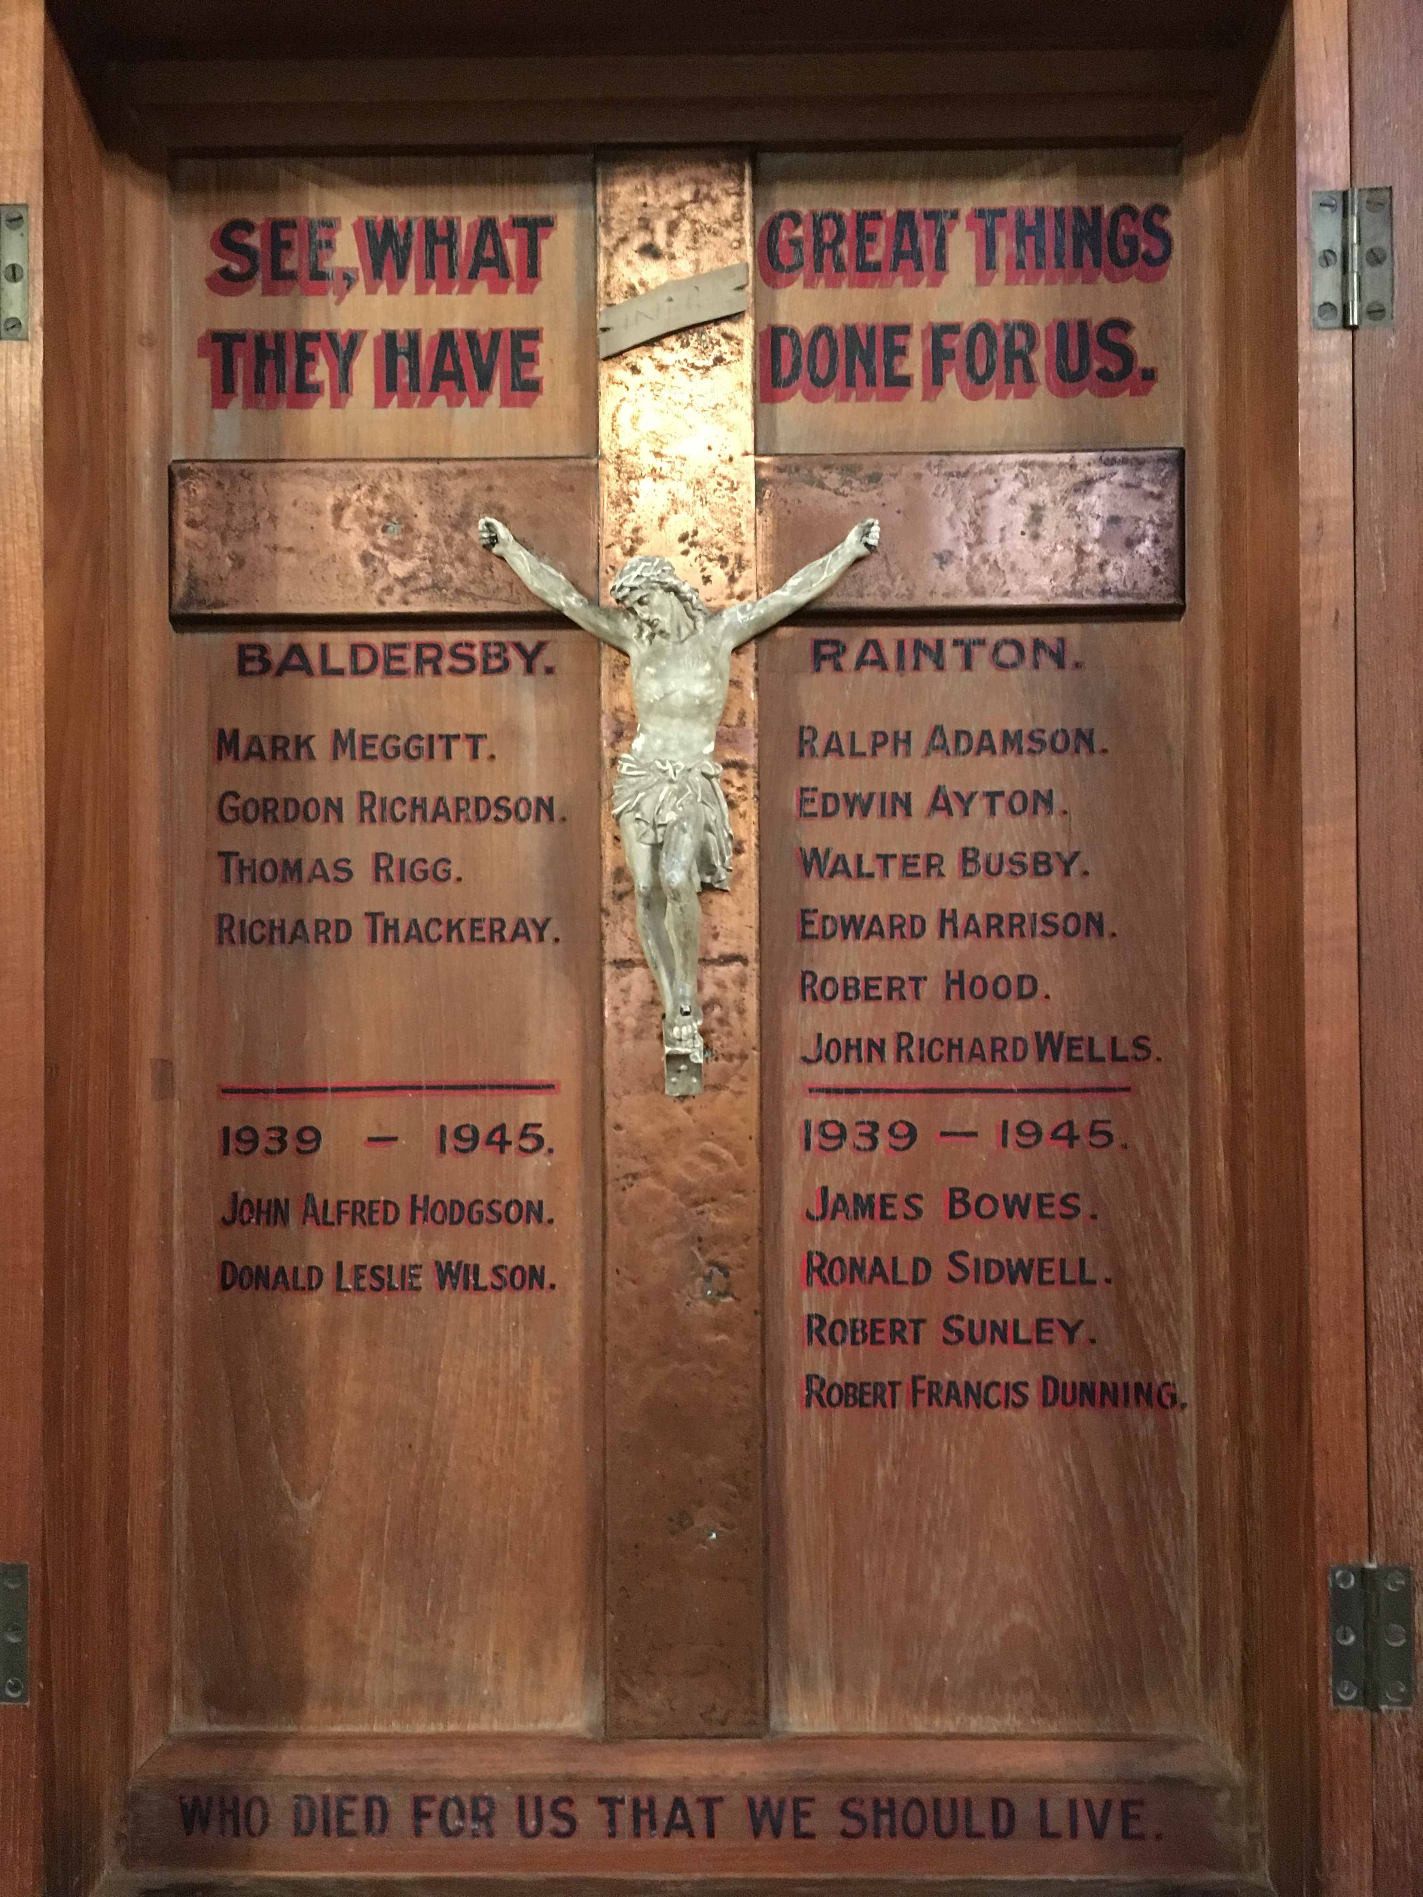**Readings (p.1083)**

Malachi 4.1-2a

Psalm 98

2 Thessalonians 3.6-13

Gospel: Luke 21.5-19

**Sunday 20th November : Christ the King, Sunday next before Advent**

**Collect**

Eternal Father,

whose Son Jesus Christ ascended the throne of heaven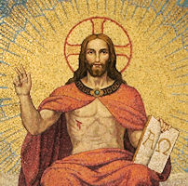

that he might rule over all things as Lord and King:

keep the Church in the unity of the Spirit

and in the bond of peace,

and bring the whole created order to worship at his feet;

who is alive and reigns with you,

in the unity of the Holy Spirit,

one God, now and for ever.

**Readings** (**p.1086**)

Jeremiah 23.1-6

Psalm 46

Colossians 1.11-20

Gospel: Luke 23.33-43

**Sunday 27th November : The First Sunday of Advent**

**Collect**

Almighty God,

give us grace to cast away the works of darkness

and to put on the armour of light,

now in the time of this mortal life,

in which your Son Jesus Christ

came to us in great humility;

that on the last day,

when he shall come again in his glorious majesty

to judge the living and the dead,

we may rise to the life immortal;

through him who is alive and reigns with you,

in the unity of the Holy Spirit,

one God, now and for ever.

**Readings** (**p.3**) *Year A of the cycle of Readings begins*

Isaiah 2.1-5

Psalm 122

Romans 13.11-14

Gospel: Matthew 24.36-44

**November Reflection, 2022**

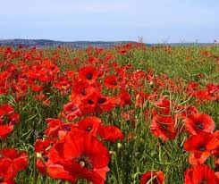This year Remembrance Day is on Friday 11th November and Remembrance Sunday is on 13th November. When the fighting stopped at 11am on 11th November 1918, at the end of the First World War, what was left behind was a shattered landscape bearing the deep scars of the previous four years of conflict. One of the first things to reclaim and repopulate this devastation, was the poppy. It inspired the famous poem by the Canadian doctor, Lieutenant Colonel John McCrae ‘In Flanders Field’ and was then taken up as the symbol of Remembrance symbolising both the loss of life in war, but also the fact there was hope even in the midst of devastation.

In our Remembrance observances this year, even as we remember those who have died in subsequent wars, many of us will also be remembering other feelings of loss, or even devastation, that have been the experience of so many in the last two and a half years. Those lost to the Covid pandemic, the loss of life in Ukraine and the possible loss of life due to cold and hunger in this country during the coming winter. And yet even in the darkest of times there are often those ‘poppy moments’ where hope pushes through and dares us to believe that renewal is possible.

Even as Covid infections continue and are expected to rise again along with Flu infections, even as the war in Ukraine shows no sign of ending soon and many people in this country face hardships over the winter months, we know that some restoration and regeneration is possible and that we need to begin to learn what a renewed future might look like.

There is hope. We have a proven national vaccination programme for the most vulnerable. The reduction in fighting in Ukraine over the winter months may give the opportunity for some form of peace to be established and throughout our country communities are coming together to provide warm spaces and food for the most vulnerable.

And yet we must not forget the ground in which this hope is being born. It will not be enough simply to go back to the way that things were before Covid, the Ukrainian war and the economic crisis. The landscape of our lives has changed. We ourselves are different. In the midst of the hardship and the losses, we are discovering many important truths about living together well particularly the importance of community and the importance of living more simply. Communities and individuals are learning the value of supporting those who are suffering hardships due to economic pressures, and the threat of electricity blackouts as well as the cost of fuel are encouraging many to live a simpler life, more aware of their use of limited natural resources.

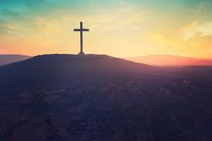That process of relearning what it is to live differently in the present, with hope for the future, is something that the first disciples of Jesus had to do as they came to terms with the devastation of his crucifixion and burial, and then the bewilderment and joy of his resurrection. Where all had seemed hopeless, suddenly new life was breaking out, and the world they thought they knew was completely different. The life, death and resurrection of Jesus reminds us that nothing is beyond the power of God to make a difference, bringing hope and life even where there seems to be only death and desolation.

There were many times after the resurrection when the disciples went back to their old ways and habits, and yet the story of the New Testament is how God began to shape those early Christians as those who lived differently in the light of all that God had done in the person of Jesus. Because Jesus was alive there could be no simple returning to how things were, but rather a more challenging and exhilarating relearning of what life was all about.

Many of us will be feeling exhausted as a result of the turmoil of the last two and a half years and worries of what might be. And yet we are reminded that there is hope. As we look to God, we pray that we will each know healing for the hurts and exhaustion of the past, new life in the present, and a resilient hope for the future. Our future can be full of hope if we dare to remember well.

**Nature Notes for November**

Last November in Cross Talk, Thomas Hood’s poem ‘November’ was reproduced. It does give a rather grim view of the month starting with ‘No sun - no moon! No morn - no noon, No dawn - no dusk - no proper time of day’ and finishing ‘No shade, no shine, no butterflies, no bees, No fruits, no flowers, no leaves, no birds, - November!’ But in November the natural world is just as active and interesting as at any time of the year.

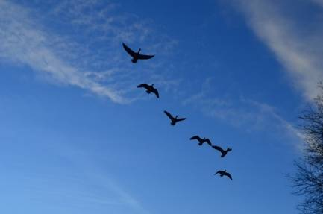We see many of the birds that migrate to spend winter here for the first time in late October or early November. Winter visitors come to the UK from the north and east for the mild climate and abundance of food, and then return north and east to breed. Winter visitors include fieldfares, redwings, bramblings, Bewick's and whooper swans and many kinds of ducks, geese and wading birds. Many water birds also spend the winter on the sea around the UK coast, including common scoters, great northern divers and red-necked grebes. In addition, some birds that we regard as resident such as blackbirds will have resident numbers increased by blackbirds that live in the Scandinavian countries but who fly south-west to spend the winter with us. The colder climate further north would make food hard to come by, so these birds fly to the UK during autumn for our less severe winter.

Redwings and fieldfares may be seen in our gardens when the weather gets very cold eating the berries from holly bushes and cotoneasters in addition to fallen fruit. So it is good not to have picked up all the windfall apples as these provide food for the redwings and fieldfares and also the blackbirds.

The food on our bird tables and in feeders is very important to birds during winter, when natural food sources are few and far between, so it is important to keep feeders clean and full.

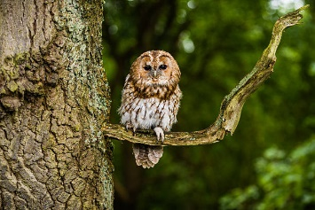Bird song is not a noted feature of the November soundscape, however the robin will often be heard singing. Contrary to the implications of Glen Miller’s song ‘Why do robins sing in December?’ the reason for the robin's unseasonal outpouring of song is that they are in fact the ultimate loner. To survive the winter, they need to defend a feeding territory from other robins, and song is their weapon of choice to demonstrate ownership. Another bird we may hear calling in November, and for a very similar reason to the robin, is the tawny owl. Tawny owls hold their territories throughout the autumn, and younger birds will be looking to establish their own turf. The calls you hear may be for the purpose of establishing or reinforcing their territory, or to communicate with the mate with whom they hold their territory.

The classic ‘twit twoo’ is a duet. The female goes ‘twit’ or more accurately ‘keewheat’ and males make a more classic ‘ho ho ho hoooo’ call.

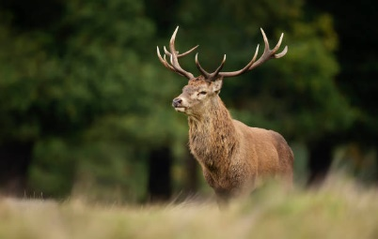In addition to all the bird activity, November can be an excellent time to see mammals. Although bats and hedgehogs will be in hibernation many other mammals will be active and are more likely to be seen as the vegetation offers less cover. The red deer breeding season, the rut, comes to an end in November. During the rut, males bellow to proclaim their territory and will fight over the females. This activity may be seen in the red deer at Studley Royal near Ripon. The wild deer we see around the villages are mainly roe deer and as vegetation in the woods decreases as winter approaches, they are more likely to be seen in the fields next to the woods especially near dawn and dusk.

In November foxes are on the move. Males particularly start to roam far and wide in search of new territories ahead of breeding in a few months’ time.

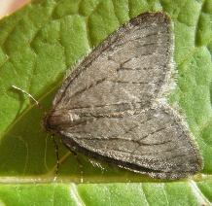Insect activity is much less in November than over the summer months with many insects hibernating. Now that the colder November weather has set in and the ladybird's natural food supply has dried up, we may see more ladybirds coming into our homes. This isn't always the best place for a ladybird to hibernate. In a more natural environment, they would sleep through to March or April, but the heating in our homes can wake them up prematurely. If they wake up in the middle of winter and there are no aphids for them to eat, they simply starve to death. It's a good idea to move them to an outdoor habitat such as a shed or garage where they'll remain frost free and where they won't be attacked by predators. However, though it may surprise you, there are still moths flying at night! Some species can keep active on colder nights and the aptly named November Moth is one to look out for on your lit windows.

As some plants lose their splendour, others are bursting into colour and providing an essential food source for wildlife. Hedgerows still have rosehips, haws and sloes, forming a supply of food for birds through the winter. There's also an abundance of fungi, superbly named species such as scarlet elf cup, sulphur tuft and turkey tail plus many more can be seen in November.

So there is a lot of activity in the natural world in November, contrary to what Thomas Hood would have us believe. A walk in the countryside or simply looking around our garden can be as interesting in November as at any other time of the year.

**Richard Byas**

Why did the scarecrow win the Nobel Prize?

Because he was out-standing in his field.



**Baldersby St James News**

Tuesdays from 10am to 12 noon – drop in for coffee and a chat

**Christmas Collection**

Revd Sheelagh Williamson is going back to Uganda in January to visit a Women’s Charity which she has helped for many years. We are collecting crayons, pencils, rubbers, pencil cases etc. to give to the children in the local school. We are also collecting wash bags, toothbrushes, toothpaste, soaps, hand creams and deodorants for the women she supports. Revd Sheelagh has been taking our Communion Services every month and we are delighted to be able to support her church charity in Uganda by sending gifts from our parish. A table at the back of church is filling up with gifts, and you can leave items there. The church is open all day.

**Susan Brown**

**Dalton Events**

**Autumn Lunch**

The church’s Autumn Lunch will be on Sunday 20th November, 12 noon for 12.30pm. There will be hot food, to include turkey, roast beef, ham and lots of vegetables, followed by many, many sweets. You will not go home hungry! Tickets are £12 per head, with a family ticket for 2 adults and 2+ children at £30, will be available from Judy on 01845 577607. Space is limited, so don’t wait to get your tickets.

**120 Club results for October**

£15 Barbara Fleming no. 118; £10 Pam Laycock no. 83; £6  Bob Clay no. 69

**Christmas Fair**

Our church Christmas Fair will be held on Saturday 3rd December, 10am to 12 noon. There will be various stalls, a tombola, bacon butties, and a visit by Santa with presents for the children. All welcome. contact Silvia on 01845 577020. There will also be an opportunity to put a message on the village Christmas tree, at a cost of £2 – please take your message to Sylvia at 30 Chapel Garth.

**Christmas Pantomime**

Our annual Panto this year will be Cinderella, to be held in the village hall on Saturday 22nd December at 6.30pm. Tickets are £9 for adults and £5 for children. The bar will be open. Availability is limited, so if you would like a ticket please contact Eleanor on 07841 036340.

**St Columba’s Church, Topcliffe**

**Wednesday 2nd November : Compline to celebrate the Feast of All Souls**

This is the occasion in the church calendar when the faithful departed are remembered. Compline is a quiet reflective service of evening prayers which on this occasion will last about 25 minutes. Those who would like to do so can remember their loved ones by name during the service. Everyone is most welcome to attend. Names of those to be remembered can be added to the list before the start of the service or, if preferred, may be emailed beforehand to

John Phillips – [johnphillips05@gmail.com](mailto:johnphillips05@gmail.com) or Chris Hewlett – [celhewlett@outlook.com](mailto:celhewlett@outlook.com)

**Remembrance Day**

On 13th November at 10.45am we will hold a Remembrance Sunday Service, with Act of

Remembrance at 11am. This will be followed by a separate service of Holy Communion with a Baptism at 11.45am.

**Rainton Christmas Fair**

**Sunday 27th November 11am to 1pm**

Handmade wreaths, Christmas decorations, unwanted gifts and toys being sold in aid of the village play park and village hall. Refreshments of bacon sarnies, mince pies and cakes. Come and have brunch and a shop!

**PARISH DIRECTORY**

**The Parishes of Topcliffe, Baldersby with Dishforth, Dalton and Skipton on Swale**

There is currently no Vicar of the parishes. Until one is appointed, please contact our Area Dean,

Revd Mary Rolls, tel: 01845 400480 email: revmaryrolls@gmail.com.

**BALDERSBY with DISHFORTH and SKIPTON-ON-SWALE** - PCC Secretary: Mrs Jennifer Wharton [wharton370@btinternet.com](mailto:wharton370@btinternet.com)

**DALTON** - PCC Secretary: Mrs Hannah Bissett tel: 07739 382831 [spannerb79@gmail.com](mailto:spannerb79@gmail.com)

**TOPCLIFFE** – PCC Secretary: Mrs Roz Norris [RozNorris@aol.com](mailto:RozNorris@aol.com)