**Benefice Online Magazine**

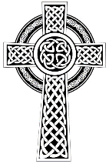**for the Parishes of Topcliffe, Baldersby with Dishforth and Skipton on Swale, and Dalton**

 Cross Talk **December 2022**

Cross Talk is published monthly by email. To receive a copy please contact [kitnorris@live.co.uk](mailto:kitnorris@live.co.uk)

Cross Talk contains the weekly Collect and Readings together with details of Church services in the Benefice and news and items of interest supplied by our readers. The magazine will also be available on the web sites: www.achurchnearyou.com/church/3447 and baldersbychurch.com.

**CHURCH SERVICES**

**St. James’ Church, Baldersby St. James with Dishforth, Rainton**

**and Skipton on Swale**

**Sunday 4th December, 10.45am Holy Communion** *followed by refreshments.*

**Sunday 11th December, 9.30am Breakfast Service** *with Coffee and Croissants*

**Sunday 18th December, 10.45am**  Holy **Communion** *followed by refreshments.*

**Saturday 24th December, 6.30pm** CANDLELIT CAROL SERVICE – *All Welcome*

**Sunday 25th December, Christmas Day No Service**

**Sunday 1st January, 2023 New Year’s Day – Service to be confirmed**

**HAPPY CHRISTMAS TO EVERYONE FROM ST JAMES’ CHURCH**

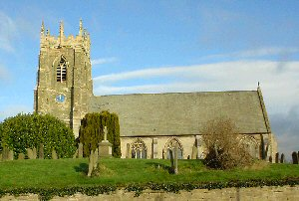**St. Columba’s Church, Topcliffe**

*Corporate Member of the Prayer Book Society*

**Sunday 4th December, 6.30pm Choral Evensong**

**Sunday 11th December, 10.45am Holy Communion** *with hymns*

*- Revd Robert Williamson*

*followed by refreshments*

**Sunday 18th December, 6.30pm Service of Nine Lessons & Carols**

*With St Columba’s Choir, led by Linda*

*Hewlett, with Matthew Atherton, organ*

**Saturday 24th December, 2pm Crib Service** *with Rev’d Dawn Ward*

**Saturday 24th December, 10.30pm Midnight Mass***- Revd Robert Williamson*

**Sunday 25th December, Christmas Day No Service**

**Sunday 1st January, 2023 No Service**

**St John the Evangelist Church, Dalton**

**Sunday 4th December, 11am Advent Service with Communion**

*led by Area Dean, Revd Mary Rolls*

**Friday 16th December, 7pm CAROLS BY CANDLELIGHT,** *bring torch.*

*with children’s special singing*

*performance led by Jo Hudson*

**Saturday 24th December, 10pm Midnight Mass,** *led by Revd Mary Rolls*

**Sunday 1st January, 2023 No Service**

**Dalton social events** and **St Columba’s Church event details** are listed on page 7.

**Readings for 2nd Sunday of Advent to 1st Sunday of Christmas**

*(Page numbers refer to the Common Worship Lectionary.)*

**Sunday 4th December : 2nd Sunday of Advent**

**Collect**

O Lord, raise up, we pray, your power

and come among us,

and with great might succour us;

that whereas, through our sins and wickedness

we are grievously hindered

in running the race that is set before us,

your bountiful grace and mercy

may speedily help and deliver us;

through Jesus Christ your Son our Lord,

to whom with you and the Holy Spirit,

be honour and glory, now and for ever.

**Readings (p.6)**

Isaiah 11.1-10

Psalm 72.1-7, [18-19]

Romans 15.4-13

Gospel: Matthew 3.1-12

**Sunday 11th December : 3rd Sunday of Advent**

**Collect**

O Lord Jesus Christ,

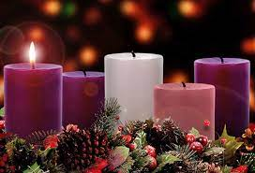who at your first coming sent your messenger

to prepare your way before you:

grant that the ministers and stewards of your mysteries

may likewise so prepare and make ready your way

by turning the hearts of the disobedient

to the wisdom of the just,

that at your second coming to judge the world

we may be found an acceptable people in your sight;

for you are alive and reign with the Father

in the unity of the Holy Spirit,

one God, now and for ever.

**Readings (p.9)**

Isaiah 35.1-10

Psalm 146.4-9 *or* Magnificat : Luke 1.46-55

James 5.7-10

Gospel: Matthew 11.2-11

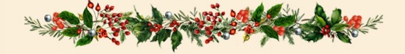**Sunday 18th December : 4th Sunday of Advent**

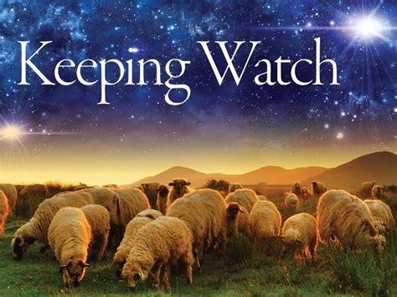**Collect**

God our redeemer,

who prepared the Blessed Virgin Mary

to be the mother of your Son:

grant that, as she looked for his coming as our saviour,

so we may be ready to greet him

when he comes again as our judge;

who is alive and reigns with you,

in the unity of the Holy Spirit,

one God, now and for ever.

**Readings** (**p.13**)

Isaiah 7.10-16

Psalm 80.1-7, [16-18]

Romans 1.1-7

Gospel: Matthew 1.18-25

**Saturday 24th December : Christmas Eve**

**Collect**

Almighty God,

You make us glad with the yearly remembrance

of the birth of your Son Jesus Christ:

grant that, as we joyfully receive him as our redeemer,

so we may with sure confidence behold him

when he shall come to be our judge;

who is alive and reigns with you,

in the unity of the Holy Spirit,

one God, now and for ever.

**Readings** (**p.15**)

2 Samuel 7.1-5, 8-11, 16

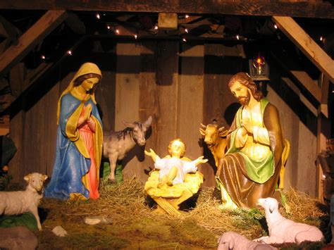Psalm 89.2, 21-27

Acts 13.16-26

Gospel: Luke 1.67-79

**Sunday 25th December : Christmas Day : Set 1**

**Collect**

Almighty God,

you have given us your only-begotten Son

to take our nature upon him

and as at this time to be born of a pure virgin:

grant that we, who have been born again

and made your children by adoption and grace,

may daily be renewed by your Holy Spirit;

through Jesus Christ your Son our Lord,

who is alive and reigns with you,

in the unity of the Holy Spirit,

one God, now and for ever.

**Readings** (**p.19**)

Isaiah 9.2-7

Psalm 96

Titus 2.11-14

Gospel: Luke 2.1-14, [15-20]

**Sunday 1st January : 1st Sunday of Christmas**

**Collect**

Almighty God,

who wonderfully created us in your own image

and yet more wonderfully restored us

through your Son Jesus Christ:

grant that, as he came to share in our humanity,

so we may share the life of his divinity;

who is alive and reigns with you,

in the unity of the Holy Spirit,

one God, now and for ever.

**Readings (p30)**

Isaiah 63.7-9

Psalm 148.[1-6], 7-14

Hebrews 2.10-18

Matthew 2.13-23

**December Reflection, 2022**

You cannot turn on the TV or read a newspaper at this time of year without being bombarded by Christmas adverts encouraging us to buy gifts for our loved ones. For all the suggestions made in the adverts, I am surprised by how few I would consider buying and, for a few of the suggestions, just for whom they may be appropriate.

In receiving gifts, it is interesting to see what other people feel are appropriate for us. Shortly after starting my business here in Topcliffe, virtually everything I received was decorated with either chicken or game birds as if my only interest was the animals I treated! I have to say however, I enjoyed the items I received, and I still have many of them. It is not the monetary value of the present that is important, but rather the thought behind it that lets us know that we are known and that we are loved. The important thing about a present is that it shows that the other person has bothered to think about what we like and has understood us. As Mahatma Gandhi said, ‘Action expresses priorities.’

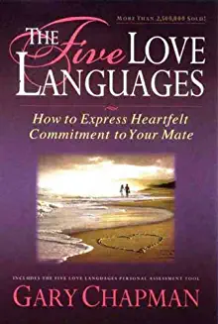Gary Chapman is the author of a book called *The Five Love Languages*. In it he puts forward the idea that there are five basic ways in which we are reassured that we are loved. As already mentioned, one love language is the thoughtful gift. The others are:

1. Time - having someone spend quality time with us.

2. Words of affirmation - having someone tell us that we are loved and appreciated.

3. Acts of service – e.g., having a cup of tea made for us when we are stressed, or an errand done for us.

4. Touch – e.g., a reassuring hug or holding hands.

Gary Chapman‘s theory is that we will all receive love and express our love for others through all of these means, but we will tend to have one or two that we prefer. The problem comes when we have one preference and the person to whom we are trying to show our love has a different preference. Sometimes we will need to learn to speak another love language to communicate our love well.

Whilst *The Five Love Languages* is about love between individuals, it is also possible for groups of people to express their love for others. The Church, as the body of Christ, is in an important position to do this. As we read in James 2: 26 ‘As the body without the spirit is dead, so faith without deeds is dead’. It is good to read that many churches are among the more than 3,700 public spaces which are opening up this winter as a Warm Space for people amid surging energy bills. Very many people, not all church goers, are active this winter in supporting their neighbours so it is heart breaking to hear of people who just a year ago were donating to foodbanks but are now using them themselves. The economic situation has changed in a very short time. I do not doubt that in addition to our prayers for those for whom this is going to be a very hard winter, God is calling us, if we are able, both individually and as the body of Christ his Church, to be active in expressing His love through our support for our neighbours in need in whatever of the Five Love Languages is appropriate.

‘For God so loved the world that He gave His only Son…‖ (John 3: 16)’ is probably the most famous verse in the Bible. In it we are told that the way that God has definitively shown His love for us is in the person of Jesus, the ultimate gift to a world in need of love.

One of the dominant characteristics of the life of Jesus is that He had time for people, and often for those for whom no-one else had time. He spent time with tax collectors, prostitutes and lepers, and in doing so brought to them new hope and life. Importantly, he wasn‘t afraid to touch those from whom others shied away. Whether it was lepers who received the touch of healing, or the widow‘s son whom He raised to life; the touch of Jesus was utterly transforming.

Wherever Jesus went He proclaimed the good news that the Kingdom of God was at hand, that God loved them and wanted to welcome them into that Kingdom. In parables and preaching Jesus constantly told people of the love of God for them. And finally, the ultimate act of service, in giving of Himself on the Cross. God‘s longing to communicate His love for us means that in Jesus each of us can be communicated with in a language that we can understand. God loves every one of us.

As we celebrate Christmas this year, I hope each of us will know afresh that love of God for us and through the reassurance that we are known and loved it will give us the encouragement that we need to step into the New Year with hope and life to express that love to our neighbours.

A Happy and Peaceful Christmas to all.

**Richard Byas**

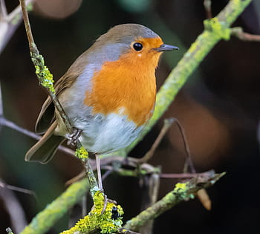**The Life and Legends of our Christmas Robin**

Why do we associate robins with Christmas? Have you ever wondered why robins are associated with Christmas?

Some fables link the robin to Christianity. The story goes that the robin was once a plain, brown bird. The bird went to sing to Jesus who was dying on the cross. Blood from Jesus’ wounds then stained the breast of the bird and from that moment on, the robin passed its red breast down through the generations.

Another legend places the robin at the birth of Jesus. On a chilly night in Bethlehem, a brown bird fanned the flames of a fire to keep the baby Jesus warm. Scorched by the fire, the breast of the bird turned red forever more.

However, it seems like the real reason for the robin’s association with Christmas can be traced back to Victorian times. In Victorian Britain, postmen were nicknamed “robins” because of their red-breasted coloured uniforms. From there, the robin on the Christmas card came to represent the postman who delivered the card.

A robin’s red breast is actually orange. The bird was named before the English language had a word for the colour ‘orange’. Many things that were really orange were called red instead even though we did have the word for ‘orange’ as in the fruit. The colour orange was not named as a colour in English until the 16th century. The name for the colour comes from the fruit.

The robin is one of the most common and best-loved garden birds in the UK with both males and females having the characteristic red breast, although young robins only develop the colouring as they get older.

Robins sing all year round and contrary to the suggestions in Glenn Millers song ‘why do robins sing in December, long before the springtime is here?’ they are singing to defend their territory (which they do fiercely) and as spring approaches, attract a mate. At present the species is thriving, with a 45% increase in the robin population recorded since 1970.

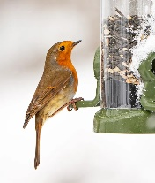This is good, as the robin experiences a high natural mortality rate. Many don’t make it through the winter due to a scarcity of food. A garden supply of winter bird feed can really help the robin to survive a particularly cold spell of weather. With fat balls and seed mixes on offer, robins can be regular garden visitors throughout the festive season.

**Richard Byas**



Andrew was watching his father, a Vicar, write a sermon for the Christmas service.

'How do you know what to say?' Andrew asked.

‘Why, God tells me', this father replied.

'Oh, then why do you keep crossing things out?'



**HAPPY CHRISTMAS TO EVERYONE**



**Dalton Events**

**120 Club Draw results for November**

£15 Sarah Williams (No. 104); £10 Hannah Bissett (No. 4); £6  Stu - D.gap (No. 43).

**Christmas Fair**

Our church Christmas Fair will be held on **Saturday 3rd December**, 10am until 12 noon. There will be lots of stalls, tombola, bacon butties, and a visit by Santa with gifts for the children. All welcome. Admission £2 for adults and £1 for children which includes a drink and mince pie or biscuit.

**Christmas Pantomime Extra Date**

Due to popular demand we have added a second date for our Pantomime, Cinderella.

The extra date is **Monday 12th December** at 7pm in the village hall. Tickets are £9 for adults and £5 for children, available from Eleanor on 07841 036340.

**HAPPY CHRISTMAS TO EVERYONE FROM DALTON CHURCH**

**St Columba’s Church, Topcliffe**

**Christmas Services**

**Sunday 18th December at 6.30pm**

Traditional Service of Nine Lessons and Carols, with St Columba’s Choir, led by Linda Hewlett, accompanied by Matthew Atherton, organ. Carols old and new and an opportunitty to come and sing your favourites. Followed by finger buffet and wine.

**Saturday 24th December, Christmas Eve**

**Crib Service at 2pm** with Rev’d Dawn Ward. An informal telling of the Christmas Story for everyone to enjoy, particularly those with children.

**Midnight Mass at 11.30pm** with Rev’d Robert Williamson. The Christmas Service of Holy Communion for everyone.

**Carol Singing in the Village**

**Thursday 22nd December, 7.30pm outside the Village Hall :**

**‘Carols around the Christmas Tree’, for Everyone.** Do come along and sing!!

Please arrive in good time so that we can start promptly at 7.30 and please bring torches to read the carol sheets that will be provided. Brass accompaniment, as last year, kindly provided by the Barber family, and singing will be aided by members of St Columba’s Choir. At 8pm join us for mulled wine and mince pies inside the Village Hall, offered with seasonal good wishes from all at St Columba’s. Our Christmas Charity is MacMillan Nurses, and any donations will be gratefully received.

**The PCC, Churchwarden Chris and our Congregation wish all in our two villages a very Happy and Blessed Christmas and our very best wishes for the New Year.**

**PARISH DIRECTORY**

**The Parishes of Topcliffe, Baldersby with Dishforth and Skipton on Swale, and Dalton.**

There is currently no Vicar of the parishes. Until one is appointed, please contact our Area Dean,

Revd Mary Rolls, tel: 01845 400480 email: revmaryrolls@gmail.com.

**BALDERSBY with DISHFORTH and SKIPTON-ON-SWALE** - PCC Secretary: Mrs Jennifer Wharton [wharton370@btinternet.com](mailto:wharton370@btinternet.com)

**DALTON** - PCC Secretary: Mrs Hannah Bissett tel: 07739 382831 [spannerb79@gmail.com](mailto:spannerb79@gmail.com)

**TOPCLIFFE** – PCC Secretary: Mrs Roz Norris [RozNorris@aol.com](mailto:RozNorris@aol.com)