**Benefice Online Magazine**

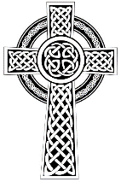**for the Parishes of Topcliffe, Baldersby with Dishforth and Skipton on Swale, and Dalton**

Cross Talk

**September 2023**

Cross Talk is published monthly by email. To receive a copy please contact [kitnorris@live.co.uk](mailto:kitnorris@live.co.uk)

Cross Talk contains the weekly Collect and Readings together with details of Church services in the Benefice and news and items of interest supplied by our readers. The magazine will also be available on the web sites: www.achurchnearyou.com/church/3447 and baldersbychurch.com.

**CHURCH SERVICES**

**St. James’ Church, Baldersby St. James with Dishforth, Rainton & Skipton on Swale**

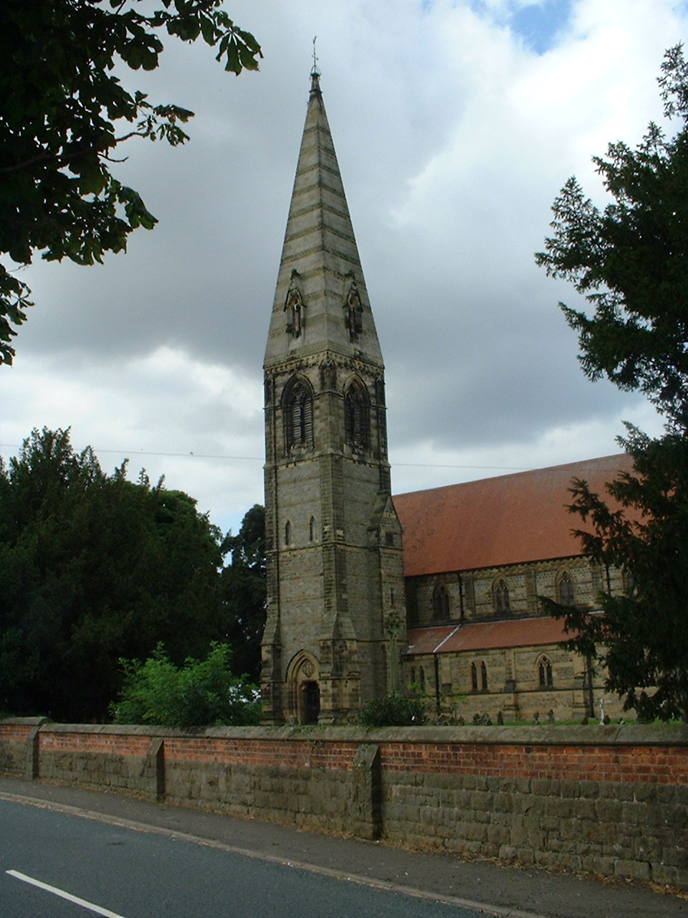**Sunday 3rd September, 10.45am Holy Communion** *followed by coffee*

**Sunday 10th September NO SERVICE – BOOK SALE**

**Sunday 17th September, 10.45am**  **Holy Communion** *followed by coffee*

**Sunday 24th September, 10.45am PET SERVICE IN CHURCH** *taken by Sheilagh and Peter. All pets welcome.*

**Sunday 1st October, 10.45am Harvest Festival during Holy Communion**

**St. Columba’s Church, Topcliffe**

*Corporate Member of the Prayer Book Society*

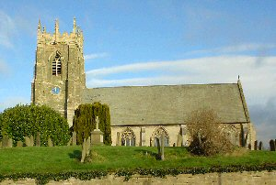**Sunday 3rd September,** 6.30pm **Choral Evensong** *(BCP)*

*Anthem:*

**Sunday 10th September, 10.45am Holy Communion**

**Sunday 17th September, 10.45am Choral Matins** (BCP)

**Sunday 24th September, 10.45am Holy Communion**

**Sunday 1st October, 6.30pm Choral Evensong** *(BCP)*

**St John the Evangelist Church, Dalton**

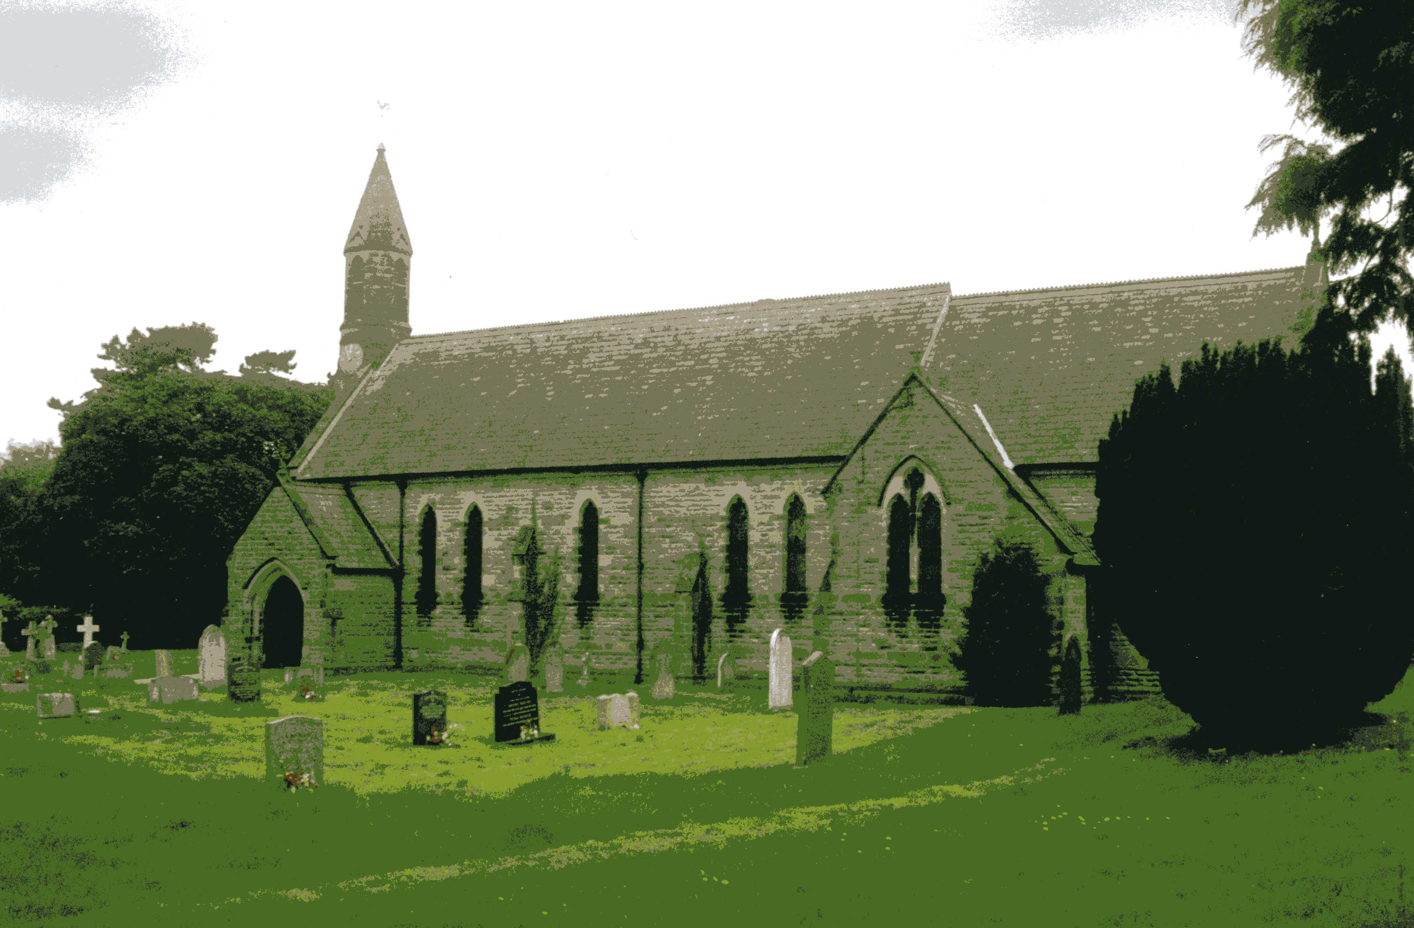**Sunday 3rd September, 11am Holy Communion**

**Friday 15th September, 7pm Harvest Service** followed by

**Supper.** All Welcome.

**Sunday 17th September, 11am Family Service**

**Sunday 1st October, 11am Holy Communion**

**Baldersby News and Events see page 6**

**Dalton News see page 7**

**‘Pearl of Africa’ Ugandan Children’s Choir, Topcliffe, see page 6**

**Readings for the 13th Sunday after Trinity to 17th Sunday after Trinity**

*(Page numbers refer to the Common Worship Lectionary.)*

**Sunday 3rd September: 13th Sunday after Trinity**

**Collect**

Almighty God,

who called your Church to bear witness

that you were in Christ reconciling the world to yourself:

help us to proclaim the good news of your love,

that all who hear it may be drawn to you;

through him who was lifted up on the cross,

and reigns with you in the unity of the Holy Spirit,

one God, now and for ever.

**Readings** (**p.295 Proper 17 Related**)

Jeremiah 15.15-21

Psalm 26.1-8

Romans 12.9-21

Gospel: Matthew 16.21-28

**Sunday 10th September: 14th Sunday after Trinity**

**Collect**

Almighty God,

whose only Son has opened for us

a new and living way into your presence:

give us pure hearts and steadfast wills

to worship you in spirit and in truth;

through Jesus Christ your Son our Lord,

who is alive and reigns with you,

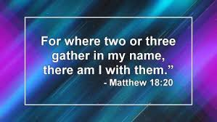in the unity of the Holy Spirit,

one God, now and for ever.

**Readings (p300, Proper 18 Related)**

Ezekiel 33.7-11

Psalm 119.33-40

Romans 13.8-14

Gospel: Matthew 18.15-20

**Sunday 17th September: 15th Sunday after Trinity**

**Collect**

God, who in generous mercy sent the Holy Spirit

upon your Church in the burning fire of your love:

grant that your people may be fervent

in the fellowship of the gospel

that, always abiding in you,

they may be found steadfast in faith and active in service;

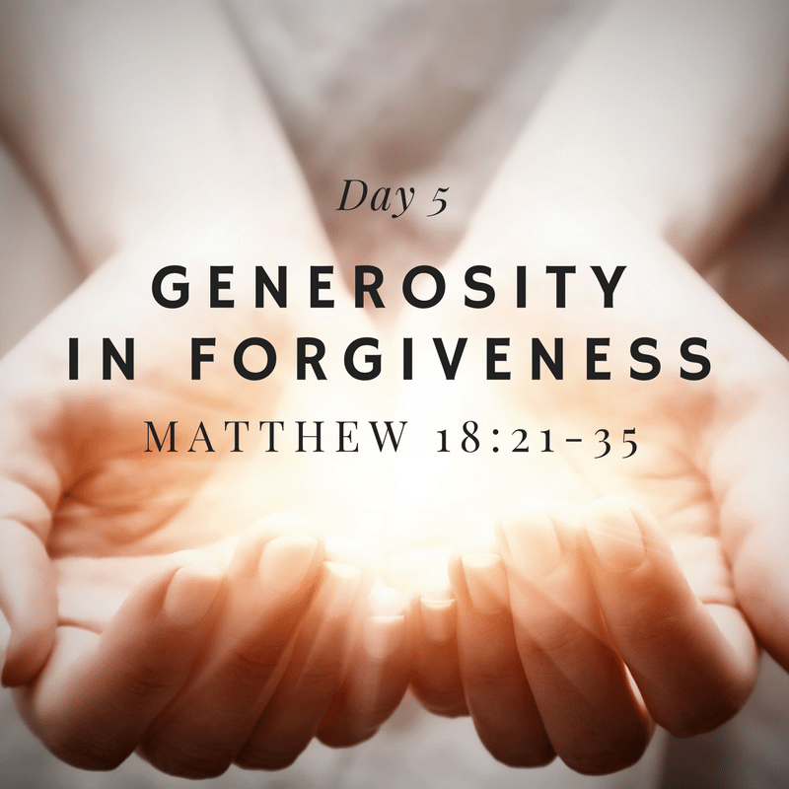through Jesus Christ your Son our Lord,

who is alive and reigns with you,

in the unity of the Holy Spirit,

one God, now and for ever.

**Readings (p306 Proper 19 Related)**

Genesis 50.15-21

Psalm 103.[1-7,] 8-13

Romans 14.1-12

Gospel: Matthew 18.21-35

**Sunday 24th September: 16th Sunday after Trinity**

**Collect**

O Lord, we beseech you mercifully to hear the prayers

of your people who call upon you;

and grant that they may both perceive and know

what things they ought to do,

and also may have grace and power

faithfully to fulfil them;

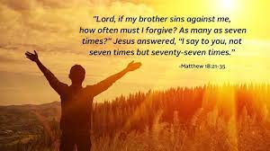through Jesus Christ your Son our Lord,

who is alive and reigns with you,

in the unity of the Holy Spirit,

one God, now and for ever.

**Readings (p311 Proper 20 Related)**

Jonah 3.10-4.11

Psalm 145.1-8

Philippians 1.21-30

Gospel: Matthew 20.1-16

**Sunday 1st October: 17th Sunday after Trinity**

**Collect**

Almighty God,

you have made us for yourself,

and our hearts are restless till they find their rest in you:

pour your love into our hearts and draw us to yourself,

and so bring us at last to your heavenly city

where we shall see you face to face;

through Jesus Christ your Son our Lord,

who is alive and reigns with you,

in the unity of the Holy Spirit,

one God, now and for ever.

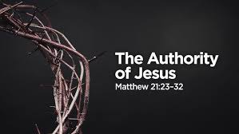**Readings (p317 Proper 21 Related)**

Ezekiel 18.1-4, 25-32

Psalm 25.1-8

Philippians 2.1-13

Gospel: Matthew 21.23-32

**September Reflection, 2023**

September is the month when ‘things get back to normal’. Children go back to school after the summer holidays, the new parliamentary session gets underway and many clubs which have had a summer break restart. August used to be described in the press as the ‘silly season’ - a period in the summer months known for frivolous news stories in the mass media as there was a lack of serious news stories but in recent years this does not seem to have been the case. There have been enough stories of wars, political upheavals, wildfires and floods to keep us bombarded with the world’s problems in whichever media we use to get our news.

And for most of the problems it feels as if there is precious little we can do personally to improve the situation.

Whilst the news focuses primarily on the effects of problems as they relate to people, God’s focus is on the whole of creation. In the Bible verse John 3:16 ‘For God so loved the world ……………..’the original word translated as ‘world‘ is actually ‘kosmos‘, a word which means the whole of creation and not just humanity.

As we look out at the many crises that the world is experiencing, the problems seem too vast, and we may question what on earth we can do that will make a difference. I came across this story recently (you may have already heard it, but I think it is worth repeating)

A man was walking along the shore after a big storm and found the beach littered with starfish as far as the eye could see. In the distance, the man noticed a small boy approaching. As the boy walked, he paused every so often and as he got closer, the man could see that he was occasionally bending down to pick up an object and throw it into the sea.

When the boy had come closer still, the man called out, ‘Good morning! May I ask what it is that you are doing?’

The young boy paused, looked up, and replied. ‘Throwing starfish into the ocean. The tide has washed them up onto the beach and they are unable to return to the sea by themselves.

The old man replied, ‘But there must be thousands of starfish on this beach. I‘m afraid you won‘t really be able to make much of a difference’.

The boy bent down, picked up yet another starfish and threw it as far as he could into the ocean. Then he turned, smiled, and said, ‘It made a difference to that one’!

Sometimes it might not feel as though we are making much of a difference either to our fellow humans or to God’s creation. And yet with the help of God, as each of us does what we can, we suddenly find that individuals doing what they can really does change the world. In fact, it is the only thing that ever has.

**Richard Byas**

**Beverley Minster and St. John.**

Here in North Yorkshire, we have numerous ecclesiastical sites; Whitby, Fountains, Rievaulx, Jervaulx, Lastingham, Byland and others that remind us of our early Christian forebears.

Many of the sites chosen for the foundation of monasteries were in the more remote areas suggesting North Yorkshire was not densely populated in medieval times. In fact, before the industrial revolution, it was the East Riding of Yorkshire that tended to be the more prosperous area and so there are still many larger churches from the medieval period including two of the largest in England, Beverley Minster and Hull Minster.

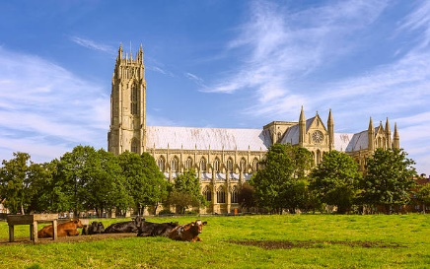The origins of Beverley Minster can be traced back to John of Beverley (c640 – 721AD).

John of Beverley was one of five men who become bishops after being trained for the priesthood by Hilda of Whitby. He was the bishop of Hexham and then the bishop of York, which was the most important religious designation in the area at that time. In his sixties John retired from his role as Bishop of York to a monastery he had founded at In-Derawuda (meaning the wood in Deira) and the town of Beverley grew up around the monastic church. John was associated with miracles during and after his lifetime and was canonised a saint by the Catholic Church in 1037.

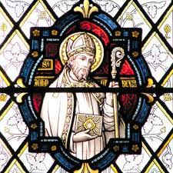John’s early life is not well recorded but later traditions claim he was born of noble parents at Harpham, in the East Riding of Yorkshire. One of the few churches dedicated to him is still there. He won renown as a preacher, displaying marked erudition in expounding Scripture. Many miracles of healing are ascribed to John, whose pupils were numerous and devoted to him, and the popularity of his cult was a major factor in the prosperity of Beverley during the Middle Ages. He was celebrated for his scholarship as well as for his virtues. In his writings, Bede shows John to be a humble man who was open to showing the love of God to all kinds of people.

A shrine to John was erected in Beverley Minster but in 1541 the shrine was destroyed on the orders of Henry VIII as part of the English Reformation. In 1664, workmen discovered a vault under the floor of the minster's nave. Made of stone, it was 15 ft long (4.6 m) and 2 ft wide (0.61 m) at the head and 1 ft wide (0.30 m) at the base. Encased in lead, were found ashes, six beads, three great brass pins and four large iron nails. The lead had the following inscription:

‘In the year from the incarnation of our Lord, 1188, this church was burnt in the month of September, the night after the feast of St Matthew the Apostle and in the year 1197, the 6th of the ides of March, there was an inquisition made of the relics of the Blessed John in this place, and these bones were found in the east part of this sepulchre, and redeposited; dust mixed with mortar was found likewise and re-interred.’

In 1738, when the present minster floor was laid, the same relics were dug up and replaced in the same position with an arched brick vault over them. This was covered by a marble slab, similar to others in the nave. The inscription on the tomb now reads:

HERE LIES THE BODY OF SAINT JOHN OF BEVERLEY FOUNDER OF THIS CHURCH

BISHOP OF HEXHAM AD 687–705 BISHOP OF YORK A.D. 705–718 HE WAS BORN AT HARPHAM AND DIED AT BEVERLEY AD 721

In recent times, the feast of St John has been marked in Beverley in two ways. On the Thursday nearest 7th May the choir and members of the congregation of Beverley Minster go to the church at Harpham and process to the well. The well is decorated (before the event) with flowers. After singing an anthem and praying, the procession returns to the church for choral evensong.

On the Sunday nearest 7th May the civic dignitaries process in full regalia with mace bearers to Beverley Minster. The procession enters by the Great West Door. During the service, children from Harpham present primroses gathered from the woods around the village. The flowers are placed around John's tomb.

In addition to the Minster, Beverley has another fine church of St Mary’s, which is at the north end of the town with the Minster being at the south end. Both are worth visiting and have interesting histories to tell.

**Definitions from church life.**

**PEW:** A medieval torture device still found in some churches.

**PROCESSION:** The ceremonial formation at the beginning of a formal Sung Eucharist, consisting of altar servers, the celebrant, and late parishioners looking for seats.

**SIDESMEN:** The only people in the parish who don’t know the seating capacity of a pew.



**Richard Byas**

**Baldersby News and Events**

**Baldersby St James Church**

Church is **open** again for everyone to visit, which we are all pleased about, and the ceiling is repaired. If you would like to make a donation please visit - Just Giving.com/Baldersby Church or leave your donation with our treasurer: Mrs Jennifer Wharton, Briar Dene, Topcliffe, Thirsk, YO7 3RW or ring 0771 545 8215. The cost is in the region of £8,000 and we are nearly half way there with donations, which is brilliant! So a lot of improvements completed this year.

**Junction 50 Recitals**

**Saturday 2nd September** at 2.30pm in church. **Mary Reid playing Harp with Ainsley Hamill**, a renowned folk vocalist, will be entertaining us to “Tea and Tunes”. This will be a delightful afternoon, we love having Mary return to play. There is no charge but donations would be welcome. Afternoon tea after the recital. Everyone welcome.

**Thursday 28th September** at 7.00pm in church – The All Sorts. Four wonderful young lady vocalists, all soloists in their own right, come together in a concert of well-known songs from opera and some surprises. We are so lucky to have them to Baldersby and it will be a lovely evening with a break for supper. Tickets £12 which can be paid on the door or collect from the Good Food Shop in Baldersby.

**Book Sale**

**Saturday 9th and Sunday 10th September** 10.00am to 5pm each day.

On Thursday and Friday previous the church is open all day to put books out, and on Sunday from 4pm we will tidy away. This requires much help and many hands so please drop in – it is our big fund raiser of the year and the last few years has covered the cost of our new, warm, quiet heaters installed this spring.

We hope everyone has a lovely September.



**‘Pearl of Africa’ Ugandan Children’s Choir**

**Fundraising Concert, Monday 25th September in St Columba’s Church, Topcliffe,** with Topcliffe Academy,

Further details to follow shortly. Save the date.

**Dalton Events**

**120 Club Results, August**

£100 – Karen Bumby (No.85); £50 – Freda Dennis (No.71); £30 – Matthew Spence (No.49);

£15 – Jessica Atkinson (No.5); £6 – G & R Balderson.

**Pop up Café**

There will be a pop up café on Saturday 9th September, 9.30 until 11am. Bacon and sausage sarnies with tea and coffee. Come along and have a natter with friends and neighbours. There will also be a session of **defibrillator training** in the committee room at the same time.

**St John’s Church Harvest Service**

The Harvest Service will be in church on Friday 15th September at 7pm, followed by a supper. All welcome.

**Vintage Afternoon Teas**

The Vintage Afternoon Teas are back after being cancelled last year due to the passing away of Queen Elizabeth. They will be held in church on Saturday 16th September 2pm until 4pm. Come along and have a chat and enjoy sandwiches, cakes, scones and tea and coffee. Donations welcome.

**Through the Decades Disco**

The Disco will be in the Village Hall on Saturday 30th September. Songs from the 60s through to the 2020s. Tickets are £5 available from Eleanor on 07841 036340.

**Mums and Tots**

Unfortunately, Mums and Tots has now closed.

**Vacancy for Village Hall Secretary**

We are looking for a new Secretary for the Village Hall. It is an enjoyable and rewarding position on a friendly committee. If you would be interested, please contact Eleanor on 07841 036340.

**Knit and Natter**

The knit and natter group is going strong, well on the way to knitting 1000 poppies for the next Remembrance Day. The next session is on Wednesday 13th September in the Village Hall from 1pm until 3pm.

**PARISH DIRECTORY**

**The Parishes of Topcliffe, Baldersby with Dishforth and Skipton on Swale, and Dalton.**

There is currently no Vicar of the parishes. Until one is appointed, please contact our Area Dean,

Revd Mary Rolls, tel: 01845 400480 email: revmaryrolls@gmail.com.

**BALDERSBY with DISHFORTH and SKIPTON-ON-SWALE** - PCC Secretary: Mrs Jennifer Wharton [wharton370@btinternet.com](mailto:wharton370@btinternet.com)

**DALTON** - PCC Secretary: Mrs Hannah Bissett tel: 07739 382831 [spannerb79@gmail.com](mailto:spannerb79@gmail.com)

**TOPCLIFFE** – PCC Secretary: Mrs Roz Norris [RozNorris@aol.com](mailto:RozNorris@aol.com)