**Benefice Online Magazine**

**for the Parishes of Topcliffe, Baldersby with Dishforth and Skipton on Swale, and Dalton**

Cross Talk

**April 2024**

Cross Talk is published monthly by email. To receive a copy please contact [kitnorris@live.co.uk](mailto:kitnorris@live.co.uk)

Cross Talk contains the weekly Collect and Readings together with details of Church services in the Benefice and news and items of interest supplied by our readers. The magazine will also be available on the web sites: www.achurchnearyou.com/church/3447 and baldersbychurch.com.

**CHURCH SERVICES**

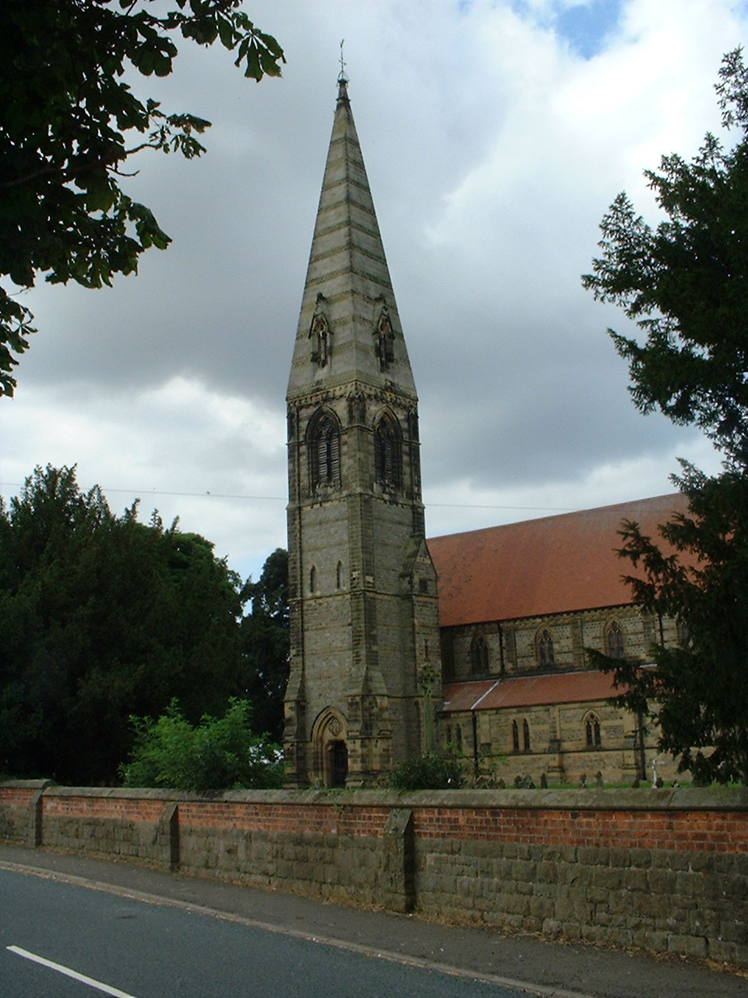**St. James’ Church, Baldersby St. James with Dishforth, Rainton**

**and Skipton on Swale**

**Sunday 7th April, 10.45am Holy Communion**

**Sunday 14th April, 9.30am Breakfast Service.**

**Sunday 21st April, 10.45am Holy Communion**

**Sunday 28th April, 9.30am Morning Service**

*All followed by refreshments*

**St. Columba’s Church, Topcliffe**

*Corporate Member of the Prayer Book Society*

**Sunday 7th April, 6.30pm Choral Evensong**

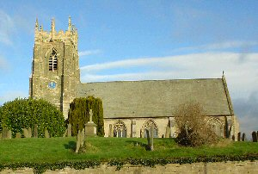

**Sunday 14th April, 10.45am Holy Communion** *led by*

*Rev’d Robert Williamson*

**Sunday 21st April, 10.45am Sung Matins**

**Sunday 28th April, 10.45am Holy Communion** *led by**Rev’d Robert Williamson*

*Refreshments after the morning services*

**St John the Evangelist Church, Dalton**

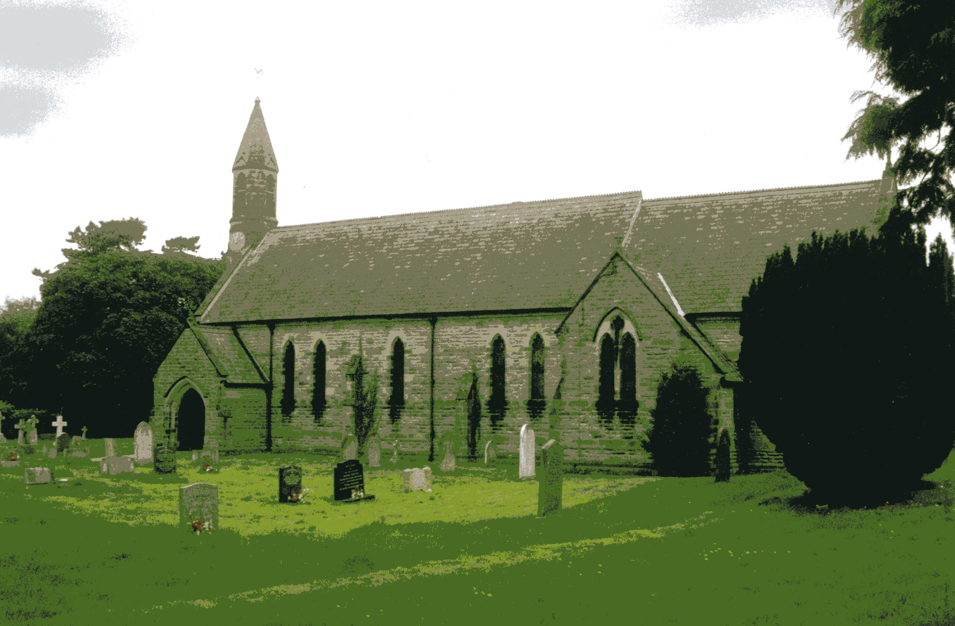**Sunday 7th April, 11am** No Service

**Sunday 21st April, 11am Family Service/Communion**

**Village News** see page 8.

**Readings for the 2nd Sunday of Easter to 5th Sunday of Easter**

*(Page numbers refer to the Common Worship Lectionary.)*

**Sunday 7th April, The 2nd Sunday of Easter**

**Collect**

Almighty Father,

you have given your only Son to die for our sins

and to rise again for our justification:

grant us so to put away the leaven of malice and wickedness

that we may always serve you

in pureness of living and truth;

through the merits of your Son Jesus Christ our Lord,

who is alive and reigns with you,

in the unity of the Holy Spirit,

one God, now and for ever.

**Readings (p538)**

Acts 4.32-35

Psalm 133

1 John 1.1-2.2

Gospel: John 20.19-31

**Sunday 14th April, The 3rd Sunday of Easter**

**Collect**

Almighty Father,

who in your great mercy gladdened the disciples

with the sight of the risen Lord:

give us such knowledge of his presence with us,

that we may be strengthened and sustained

by his risen life

and serve you continually in righteousness and truth;

through Jesus Christ your Son our Lord,

who is alive and reigns with you,

in the unity of the Holy Spirit,

one God, now and for ever.

**Readings (p541)**

Acts 3.12-19

Psalm 4

1 John 3.1-7

Gospel: Luke 24.36b-48

**Sunday 21st April: 4th Sunday of Easter**

**Collect**

Almighty God,

whose Son Jesus Christ is the resurrection and the life:

raise us, who trust in him,

from the death of sin to the life of righteousness,

that we may seek those things which are above,

where he reigns with you,

in the unity of the Holy Spirit,

one God, now and for ever.

**Readings (p544)**

Acts 4.5-12

Psalm 23

1 John 3.16-24

Gospel: John 10.11-18

**Sunday 28th April : 5th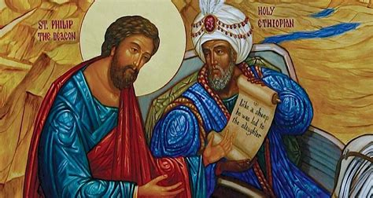 Sunday of Easter**

**Collect**

Almighty God,

who through your only-begotten Son Jesus Christ

have overcome death and opened to us

the gate of everlasting life:

grant that, as by your grace going before us

you put into our minds good desires,

so by your continual help

we may bring them to good effect;

through Jesus Christ your Son our Lord,

who is alive and reigns with you

in the unity of the Holy Spirit,

one God, now and for ever.

**Readings (p.546)**

Acts 8.26-40

Psalm 22.24-30

1 John 4.7-21

Gospel: John 15.1-8

**Reflection April 2024**

Once we are back into the month of March, it is time for me to start thinking about getting the garden tidied up again after leaving it to its own devices over winter. So already I’ve begun to tidy the borders and to get some of my early seeds sown (in pots in the greenhouse).

However, I’m aware that not everyone likes gardening. As one vicar was heard to say, ‘I can’t understand how some people seemed to be able to take a Genesis curse (Genesis 3: 17-19) and turn it into a hobby!’

Clearly that is not the view expressed in the Bible, as it is full of gardening images. In fact, Jesus describes himself as the Gardener in John 15, and He uses a lot of plant images to help people understand the Kingdom of God.

One of the most famous is when He describes the Kingdom of God as being like a mustard seed. In it He says, ‘The kingdom of heaven is like a mustard seed that someone took and sowed in his field; it is the smallest of all the seeds, but when it has grown it is the greatest of shrubs and becomes a tree, so that the birds of the air come and make nests in its branches.’ The image of the mustard tree is maybe not one that dedicated gardeners would like to dwell on too much. If you like an orderly garden, then a mustard tree is more of a messy scrub-like bush than a tree. And as it grows and develops seeds, it fires those seeds out into the surrounding ground where more messy scrub-like bushes are then able to grow. The parable strongly suggests that the Kingdom of God is not grown in neat straight lines, but rather takes root wherever the seed finds soil in which to grow.

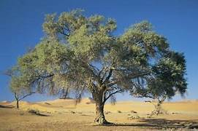And it is in this messiness that the birds of the air find a home. The image here is again of any and every species of bird gathering to be able to find a space to call home. Jesus wants to remind us that there is space for all in the Kingdom of God and a place which we too can call home.

If it is not careful, the Church can give the impression that you have to be a certain sort of person to be able to belong, or that you need to behave in a certain way. In church, even if not always in our own lives, we do tend to like order and neatness.

If you have ever attended a church, maybe when you are on holiday, which has made you feel that you aren’t welcome then remember that is not how it is supposed to be. And how ever at home we feel in our own churches we need to be aware of how newcomers will perceive us. The Kingdom of God is for everyone, so if our churches are reflecting the truth of the gospel, they may be messy at times. In church we gather in the presence of God who longs for each of us to find a home in Him, and who longs to see us flourish as the people that we have been created to be.

If our churches truly reflect the welcome that God has for each of us, not only will we see our faith grow into something that we never thought possible, but we too can be part of welcoming others into this wonderful, amazing, messy adventure that we call life with Jesus.

**Richard Byas**

**Thornborough Henges.**

The Thornborough Henges are part of a wider Neolithic complex on the Ure-Swale plateau which also include The Devil’s Arrows at Boroughbridge. The complex includes many large ancient structures including a cursus, henges, burial grounds and settlements with Thornborough Henges comprising the three aligned henges that give the site its name.

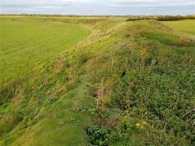They are thought to date from between 3500 and 2500 BC and whilst being one of the oldest pre-historic sites locally, it is the most recent historic site to be open to the public. Until 2023, when two of the henges passed into the control of Historic England, the site had been in private ownership and the site is now managed by English Heritage. However, the third henge remained in private ownership until February 2024 when English Heritage announced that it had acquired it.

The complex has been called 'The Stonehenge of the North'. Historic England considers its landscape comparable in ceremonial importance to better known sites such as Stonehenge, Avebury, and Orkney.

The three henges are almost identical in size and composition, each having a diameter of approximately 240 metres with two large entrances situated directly opposite each other. The henges align on an approximate northwest-southeast axis and the monument extends for more than a mile.

Like other henges across Britain, the Thornborough henges are each surrounded by an earthen bank. The banks at Thornborough originally stood up to 4 metres high and were broken by the two opposing entrances. We know from excavations that these inner banks were probably plastered with gypsum, a mineral dug from nearby pits, which would have made them a striking brilliant white.

The monument includes a cursus which is almost a mile long and runs from Thornborough village, under the central henge and terminates close to the river Ure in a broadly east/west alignment. Cursuses are monumental Neolithic structures resembling ditches or trenches and relics found within them indicate that they were built between 3400 and 3000 BC, making them among the oldest monumental structures in the British Isles.

Typically, burial mounds and mortuary enclosures are found alongside cursus monuments, indicating that they probably had a ceremonial function.

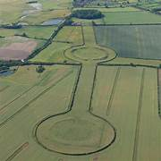There is a 'dogleg' in the layout of the henges at Thornborough which causes the layout of the henges to mirror the three stars of Orion's Belt. The exact purpose of the henges is unclear though archaeological finds suggest that they served economic and social purposes as well as astronomical ones. It also reflects the different perpendicular alignments of midwinter sunset and midsummer sunrise. One of the legs also aligns, via another henge site at Nunwick with the Devil's Arrows 17.7km away at Boroughbridge.

People gathered at the henges for ceremonies and funeral rituals for at least 2,000 years. The earthworks are thought to have been part of a ‘ritual landscape’ and form part of the most important concentration of Neolithic monuments in the North of England.

The northern henge now joins the central and southern henges within the National Heritage Collection and under the care of English Heritage. It is thought to be the first time that all three henges have been under one single owner for at least 1,500 years.

Entry to Thornborough Henges is free although the northern henge is currently closed. A number of trees were damaged in the recent storms, and work is being carried out to ensure that the site is safe for visitors.

There are still many unanswered questions about the henges and their associated monuments. When exactly were the henges built? Did they have several phases of construction? What features were inside? Does the Centre Hill cover a Neolithic monument? What more can we learn about the nearby settlements and where the people who built the henges might have come from? Further research and possibly excavations may answer some of these questions in the coming years.

**Richard Byas**

A lady received a card, originally bought at a Christian bookshop, with the verse ‘if you have faith the size of a mustard seed, you will tell this mountain, ‘Move from here to there,’ and it will move. Nothing will be impossible for you’. *(Matthew 17:20)*

Inside the card was a packet containing a few seeds.

A few months later she wrote to the card company ‘you may be interested to know that I planted the seeds in the card, they germinated and are now producing a nice crop of tomatoes’.



**Dalton News**

**130 Club February**

£100 Nigel Binks (No. 50); £50 G & R Balderson (No.10); £30 Sharon Spence (No.48);

£15 Sally Chignell (No. 107); £6 John Boddy (No. 13).

**130 Club March**

£15 Eleanor Atkinson (No. 39); £10 Terry Thorpe (No. 25); £6 George & Millie Robson (No.55).

**Baldersby St. James Church**

**Drop in and Chat** Every Tuesday from 10.00am to 12.00am in Church.

**Uganda.** Sheilagh is collecting for her families in Uganda as she is going out to visit them this spring. This year they would like to receive -- towels, Pashmina type scarves, tablets of soap, small umbrellas, school pens, pencils etc. We would be very grateful if you would leave donations on the table at the back of church.

**Rogation Sunday** is on **Sunday 5th May** at **10.45am**

Following on from our successful “Plough Sunday” in January, we are looking forward to holding a Rogation Service, which is a traditional service that “asks for God’s protection of the agricultural industry, livestock and crops.” This will be led by Rev’d Sheilagh and Peter alongside various members of our congregation. We will follow it with our popular “Bring and Share Lunch”.

After a wet winter and spring our farm crops and everyone involved need support from us all.

**St. Columba’s Church, Topcliffe**

**The Northallerton Male Voice Choir** concert on Saturday 16th March raised over £900 for the church fabric fund (for much needed building repairs). Already a number of small jobs have been tackled, including replacement of missing slates on the church hall, repairs to leaking gutters on the church and the rehanging of one of the main gates. For the latter thanks go to Will Lowe in Asenby for his repair some months ago of the broken hinge pin. It is good to see that job completed at last.  
  
**Churchyard grounds maintenance**As spring arrives and the grass begins to grow (all too rapidly) it's time to start thinking of getting the mowers out of storage and organising ground maintenance teams to help keep the churchyard looking neat and tidy. There'll be appeals for assistance in the next few weeks and hopefully, as last year, there'll be plenty of volunteers prepared to put in an hour or two to help out.

**PARISH DIRECTORY**

**The Parishes of Topcliffe, Baldersby with Dishforth and Skipton on Swale, and Dalton.**

There is currently no Vicar of the parishes. Until one is appointed, please contact our Area Dean,

Rev’d Mary Rolls, tel: 01845 400480 email: revmaryrolls@gmail.com.

**BALDERSBY with DISHFORTH and SKIPTON-ON-SWALE** - PCC Secretary: Mrs Jennifer Wharton [wharton370@btinternet.com](mailto:wharton370@btinternet.com)

**DALTON** - PCC Secretary: Mrs Hannah Bissett tel: 07739 382831 [spannerb79@gmail.com](mailto:spannerb79@gmail.com)

**TOPCLIFFE** – PCC Secretary: Mrs Roz Norris [RozNorris@aol.com](mailto:RozNorris@aol.com)